

PRODUCT DESIGN

& DEVELOPMENT LAB

CREO FOR INDUSTRIAL

STUDENT MANUAL

**PRODUCT DESIGN AND DEVELOPMENT LABORATORY**

This lab allows you to visualize your imagination in a virtual environment and which can be further developed and optimized. PTC Creo software package is used to achieve this and which helps you to save time, money and effort to develop new concepts and bring them into reality. In any design cycle, product design and development is the critical stage to bring life to any conceptual model.

T

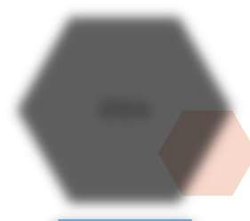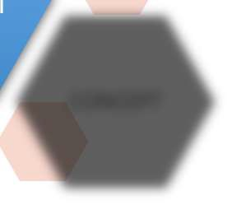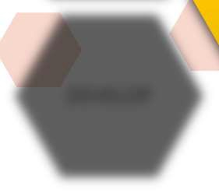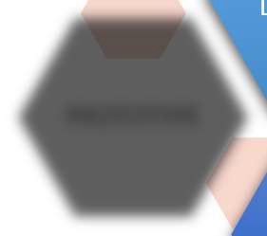

IDEA

TESTING

DEFINE

DESIGN &

DEVELOPMEN

PROTOTYPE

CONCEPT

DEVELOP

In this lab you will be learning basic modeling of parts (solids, sheet metals and Class – A surfaces), Assembly, Drafting, creating of different tools and dies for manufacturing special parts and also MathCAD to create report of your mathematical calculations related to your design.

The list of courses offered,

|  |  |  |
| --- | --- | --- |
| **S. No** | **Name of the Course** | **Duration** |
| 1 | Creo for Design | 108 Hours |
| 2 | Creo for Industrial | 72 Hours |
| 3 | Specialization program for Tool and Die design | 40 Hours |
| 4 | MathCAD | 40 Hours |

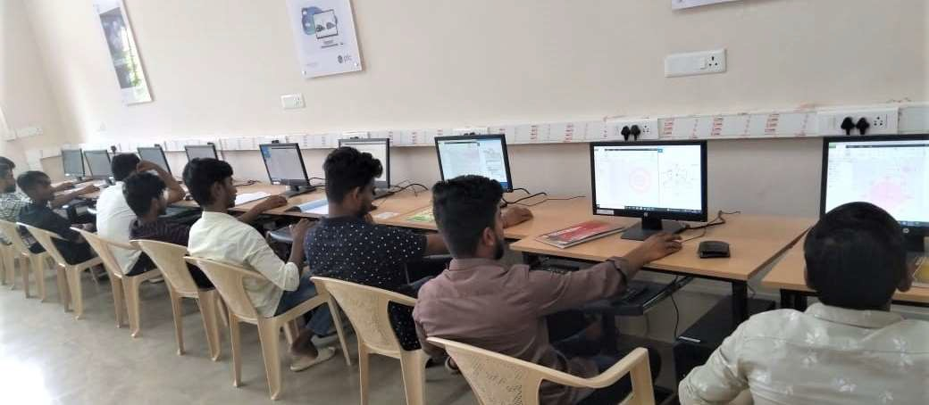

**CREO FOR INDUSTRIAL**

Creo for Industrial course is designed for users who are new to use CAD tools to design complicated designs with the help of surfacing tools and freeform modelling tools. This course will introduce users to design parts with more degree of curvatures and also to analyse the surface curvatures. The users will equip the skill to enhance themselves in a broader way in the design field. The users will also skill themselves to work on the dump models.

**LABWISE HOURLY DISTRIBUTION:**

|  |  |  |
| --- | --- | --- |
| **S. No** | **Name of the Course** | **Duration** |
| 1 | Creo for Industrial | 72 Hours |

**HARDWARE / SOFTWARE PACKAGES:**

Creo parametric 6.0.3.0

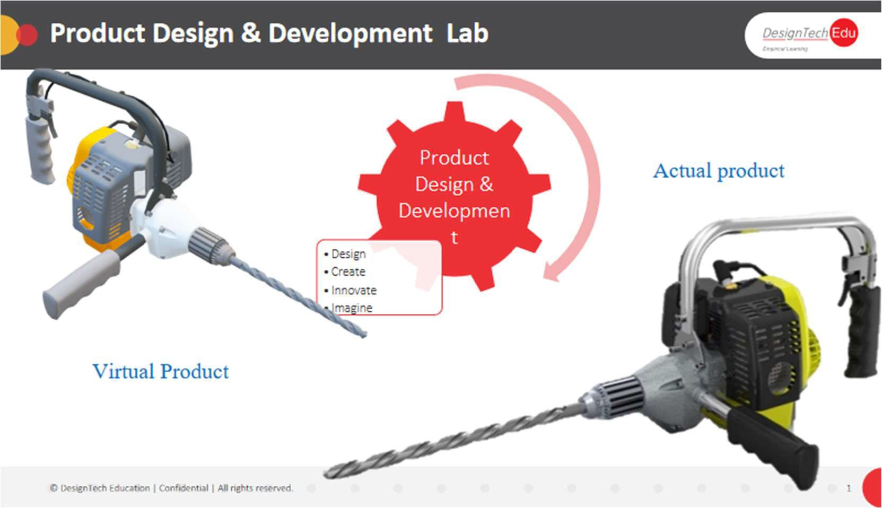

**CONTENTS**

MODULE 1 - SURFACE MODELLING OVERVIEW 7

introduction to surfacing 7

surface modeling uses 7

surface modeling paradigms 7

blending surface modeling paradigms 8

surfacing terms 8

MODULE 2 - ADVANCED DATUM FEATURES 9

creating datum graphs 9

creating datum coordinate systems 10

creating points on or offset from entities 11

creating points at intersections 11

creating points using an offset coordinate system 12

sketching geometry datums 13

creating curves through a point or vertex 14

creating a curve through a point array 15

creating a curve from a cross-section 17

creating a curve from equation 18

creating composite curves 19

creating a curve from curve intersections 20

creating a curve at surface intersection 21

projecting and wrapping curves 22

trimming curves 23

creating offset curves 24

creating cosmetic sketches 25

MODULE 3 - BASIC SURFACING TOOL 27

creating surface extrude features 27

creating surface revolve features 29

creating fill surfaces 31

creating sweep surfaces with open trajectories 32

creating sweep surfaces with closed trajectories 33

creating blend surfaces by selecting parallel sections 34

creating blend surfaces by selecting non-parallel sections 36

creating blend surfaces by sketching sections 38

analyzing blend surface section tools 39

analyzing blend surface options 41

analyzing blend surface tangency 42

creating rotational blend surfaces by selecting sections 43

creating rotational blend surfaces by sketching sections 44

analyzing rotational blend surface options 46

analyzing rotational blend surface tangency 47

MODULE 4 - BOUNDARY BLEND SURFACES 49

understanding boundary curve concepts 49

creating boundary blends in one direction 49

creating boundary blends in two directions 50

analyzing blended surface boundary conditions 51

analyzing blended surface constraint options 52

analyzing blended surface control points 53

creating boundary blends with influencing curves 55

analyzing approximate blended surface options 56

creating a blend tangent to surfaces 56

MODULE 5 - ANALYZING SURFACE CURVATURE 61

analyzing surfaces theory 61

defining curvature 61

defining curvature continuity 61

analyzing curvature of curves 61

analyzing curvature of surfaces 63

analyzing curvature using sections 66

analyzing curvature using normals 68

using shaded curvature analysis for surfaces 69

using shaded section curvature analysis 71

creating curvature continuous surfaces 72

analyzing connections 75

MODULE 6 - EXTENDING AND TRIMMING SURFACES 79

extending surfaces 79

extending surfaces using measurements 80

analyzing extend surface options 81

creating a surface trim 82

trimming surfaces with geometry 83

trimming surfaces with quilts options 84

trimming surfaces with the silhouette trim option 85

trimming surfaces with the vertex round option 85

MODULE 7 - MANIPULATING SURFACES 87

copying and pasting surfaces 87

offsetting surfaces 90

offsetting surfaces with the expand option 91

offsetting surfaces with draft 93

moving and rotating quilts 93

mirroring quilts 96

merging surfaces 97

untrimming surface copies 98

flattening quilts 98

**MODULE 8:** CREATING AND EDITING SOLIDS USING QUILTS 100

thickening surface quilts 100

solidifying quilts to add material 101

solidifying quilts to remove material 101

solidifying quilts to replace material 102

offsetting surfaces using the replace option 102

creating rounds on surfaces 103

converting solid rounds to surfaces 103

**MODULE 9 -** INTRODUCTION TO THE STYLE SURFACE MODELING PROCESS 108

introduction to freeform surface modeling 108

understanding surface modeling paradigms 108

combining style and parametric modeling 108

typical style modeling process 109

**MODULE 10 -** UNDERSTANDING STYLE SURFACE MODELING CONCEPTS 115

understanding the style tool 115

understanding style features 115

understanding datum features within style 115

understanding the style modeling environment 115

using style tool shortcut menus 116

using style tool key combinations 116

understanding active planes 116

understanding the style tool 4-view layout 117

understanding style preferences 119

MODULE 11 - CREATING INITIAL STYLE CURVES 123

understanding style curves 123

creating basic style curves 123

creating style curves as circles or arcs 126

manipulating style point locations 128

connecting curves using soft points 130

manipulating soft points 132

defining endpoint tangency 134

defining soft endpoint tangency 136

editing curves 139

creating radial path planar curves 142

using the 4-view layout to modify curves 144

analyzing curves 145

MODULE 12 - DEVELOPING STYLE SURFACE MODELS 148

understanding style surfaces 148

creating boundary surfaces 148

creating loft surfaces 150

using multiple curves as a single boundary 151

creating a blend surface using the radial option 153

creating a blend surface using the uniform option 154

using surfaces to define curves 155

creating a curve on surface type curve 156

intersecting to create a curve on surface 158

creating a curve using curve from surface 159

manipulating curve on surface type curves 162

trimming surfaces in the style tool 165

MODULE 13 - INTRODUCTION TO CREO DIRECT 167

understanding direct modeling 167

understanding the user interface 169

understanding the live toolbar 169

opening and creating a creo direct model 170

orienting and positioning the model 171

understanding selection behavior 171

using marquee selection 173

understanding datum and sketch display 173

MODULE 14 - CREATING SKETCHES IN 2-D MODE 174

understanding 2-d mode 174

configuring the 2-d grid 174

sketching using precision panels 175

sketching using guides 175

sketching lines 176

sketching arcs 176

sketching rectangles and parallelograms 178

sketching circles 179

sketching fillets 180

sketching chamfers 181

sketching construction geometry 181

sketching text 181

sketching ellipses 182

sketching splines 183

using sketched geometry tools 183

MODULE 15 - CREATING GEOMETRY SHAPES 186

understanding sketches and sketch regions 186

creating extrude geometry 186

creating revolve geometry 188

creating snapped geometry depth 189

removing material and specifying the side 190

projecting 3-d geometry into a sketch 191

creating sweep geometry 192

MODULE 16 - EDITING 3-D GEOMETRY 194

using shape selection 194

understanding shape selection types 194

leveraging geometry selection rules 195

understanding the dragger 196

moving and rotating geometry 197

moving geometry by dimension 198

analyzing side surface options 200

offsetting geometry 200

managing tangency 201

modifying analytic surfaces 202

removing geometry 203

MODULE 17 - WORKING WITH ASSEMBLIES 205

analyzing component display 205

editing component position 207

creating assemblies and inserting components 210

creating components 213

designing components in assembly 215

# *MODULE 1 - SURFACE MODELLING OVERVIEW*

## *INTRODUCTION TO SURFACING*

Surface modelling is a technique for engineering freeform surfaces with a CAD. The technology has encompassed two main fields. Either creating aesthetic surfaces (class A surfaces) or technical surfaces. Surface modelling mainly related to Geometric shapes with High Curvatures, Shapes which are impossible to create with solid modelling. Creating shapes with more smoothness and tangency.

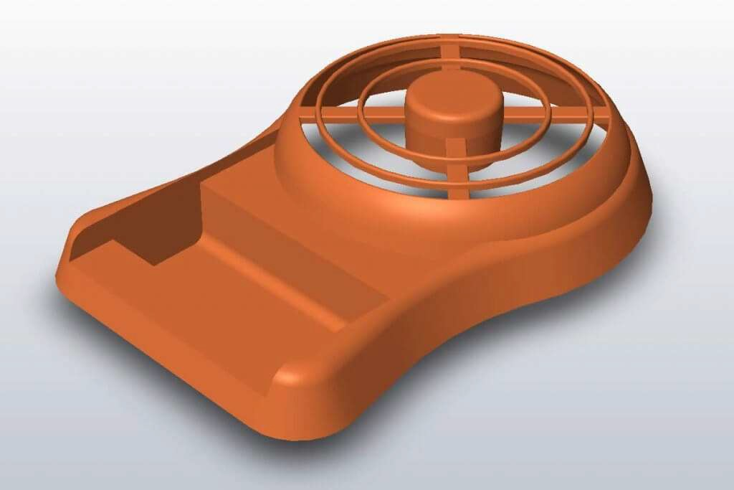

## *SURFACE MODELING USES*

Surface modelling is used in various fields like Automobile sector, Aerospace, Ship Building structures, etc.

Surface Modelling is used to create conceptual design, complicated shapes, Design small Features, Complex shapes, etc.

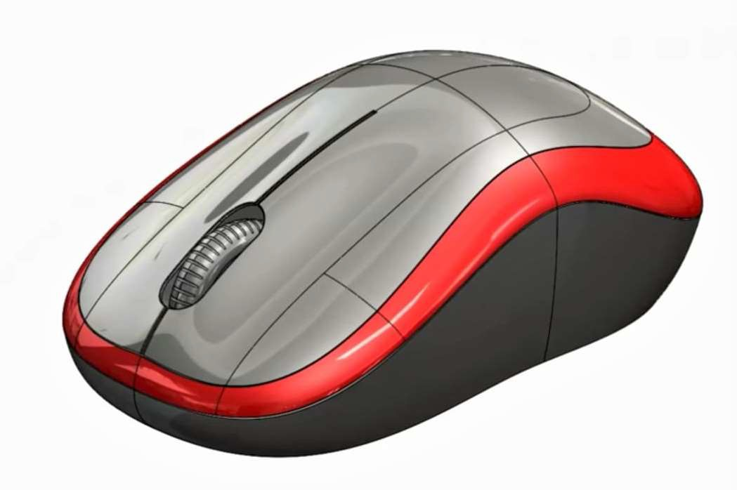

## *SURFACE MODELING PARADIGMS*

Surface Modelling also uses various technical approaches to complete function like parametric surface modelling driven by Dimension and Geometric Constraints, Mathematical Expressions. Surface modelling is also based on Design Input and Output



## *BLENDING SURFACE MODELING PARADIGMS*

In Surface Modelling many complex shapes are created with the combination of parametric surface modelling and freeform surface features. Parametric models comprising of freeform curves and shapes.

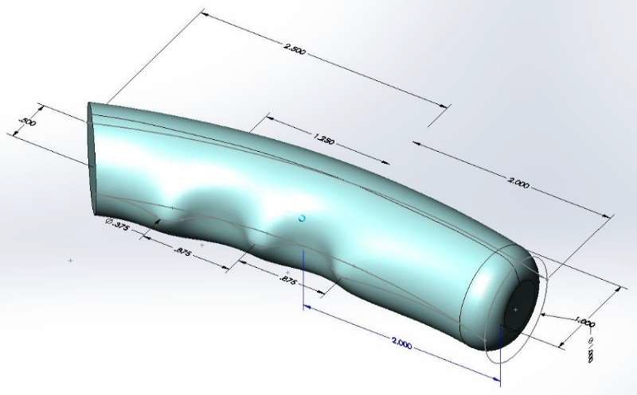

## *SURFACING TERMS*

Surfacing terms are very important to know as these terms are the base of surface modelling. For e.g. Surface Patch, Solid surface, Edges, Curves etc.

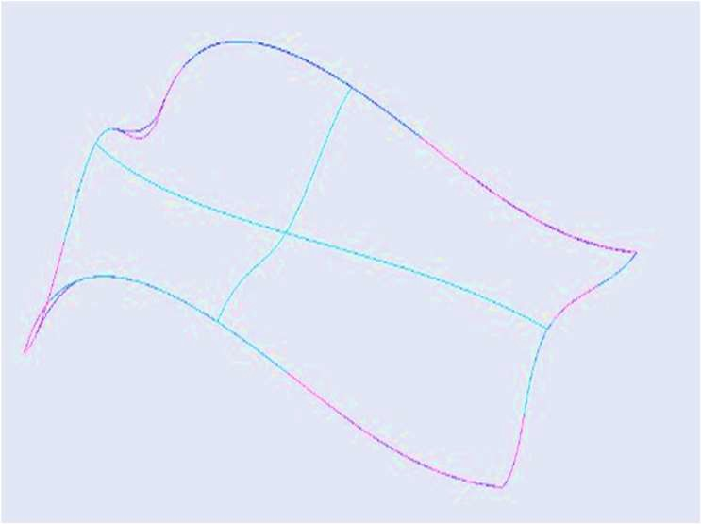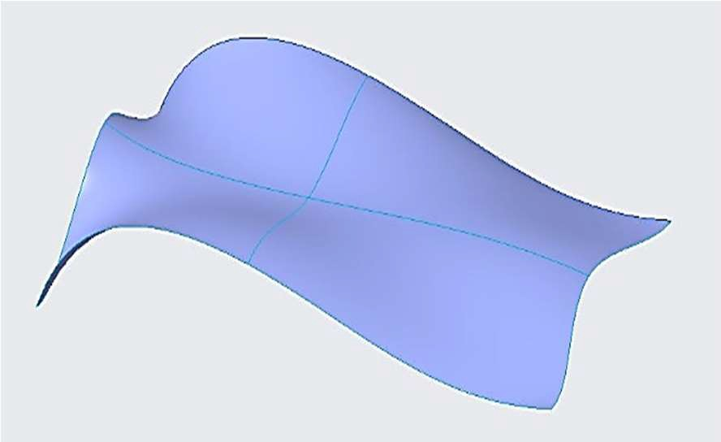

Viewing a Surface in Wireframe Mode Viewing a Surface in Shaded Mode

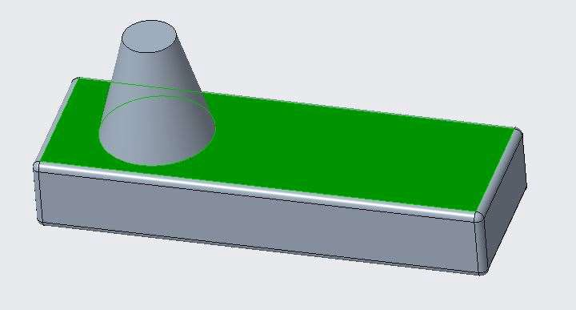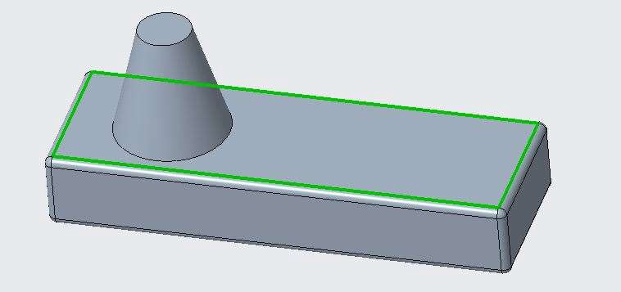

Selecting a Surface Selecting an Edge

# *MODULE 2 - ADVANCED DATUM FEATURES*

*For the activity files browse to folder Advance Datum Features.*

## *CREATING DATUM GRAPHS*

Datum Graph is used to create the main body. Datum Graph is the reference which we need sometimes to create the main design. The datum graph is created like a Sketch Feature but it is not visible.

1. To Create a Datum Graphs, Select Graph Command from Datum Group.
2. ENTER the Name of the Feature and Click on Check mark. (A 2-D Sketch mode will open).
3. Draw two centrelines and add a datum CSYS at the intersection of centrelines.
4. Create the following Graph as shown below in Figure 3.

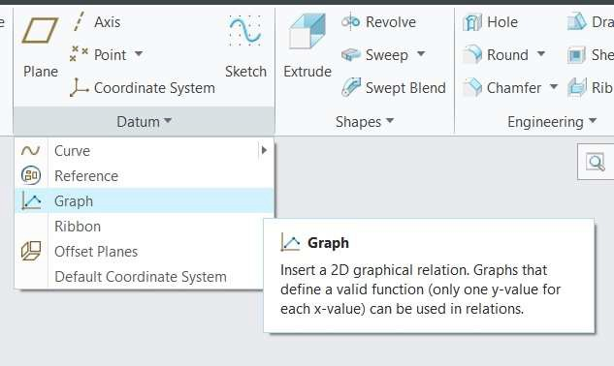 **Fig. 1 -** Graph Command

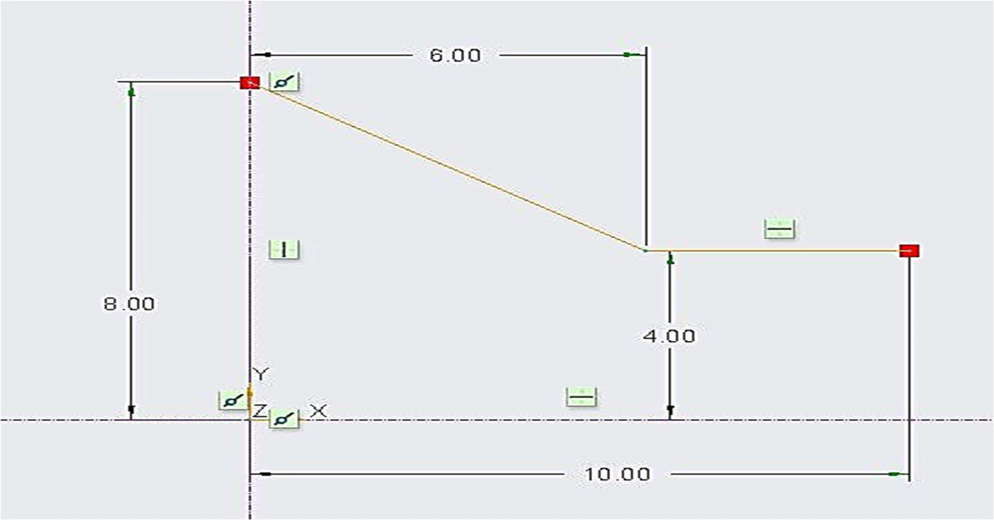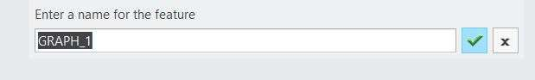**Fig 2 -** Name for Graph Feature

**Figure 3 -** Create the Graph

## *CREATING DATUM COORDINATE SYSTEMS*

A coordinate system in a plane is a coordinate system that specifies each point uniquely by a pair of numerical coordinates, which are the signed distances to the point from two fixed perpendicular oriented lines, measured in the same unit of length.

In Creo we place the CSYS by specifying the linear position in two directions. Datum CSYS can be created with Reference to Plane, Point, Axis.

1. 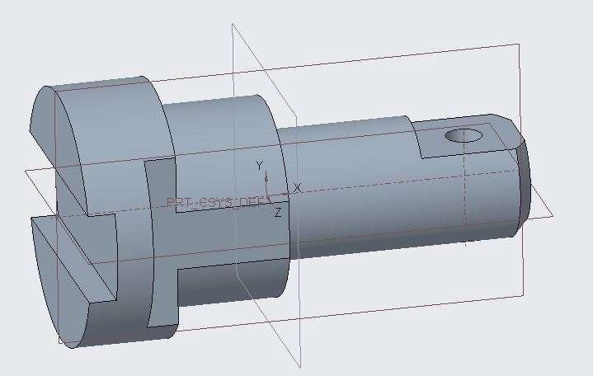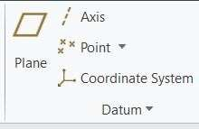Open CSYS.prt.
2. Select the Coordinate System Command from Datum Group
3. Select A_2 axis and A_3 axis from the solid feature and click ok to CSYS dialog box. CS0 is created.
4. Again, Select the Coordinate System Command from Datum Group
5. Select CS0 from the Model tree and in origin tab ENTER offset value of Y -30. CS1 is created
6. Again, Select the Coordinate System Command from Datum Group
7. Select the front datum plane and top datum plane. CS2 is created at the intersection of plane.
8. In below figure you can observe the created CSYS.

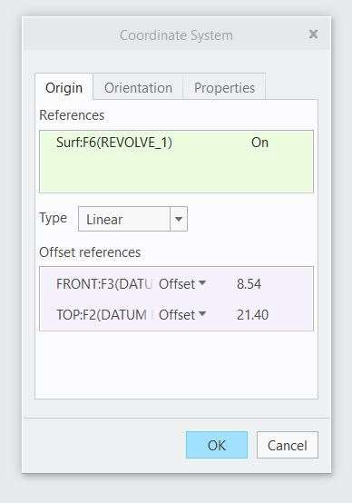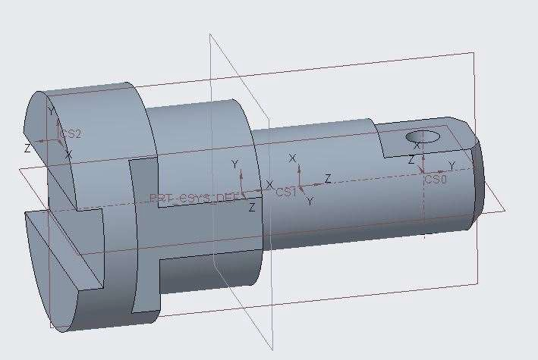

## *CREATING POINTS ON OR OFFSET FROM ENTITIES*

Datum Points can be created on or offset from entities. Datum Points are used to create Axis, Planes, CSYS and helps in creation of various geometries.

1. Open Datum_point.prt. Select Point command from the datum group.

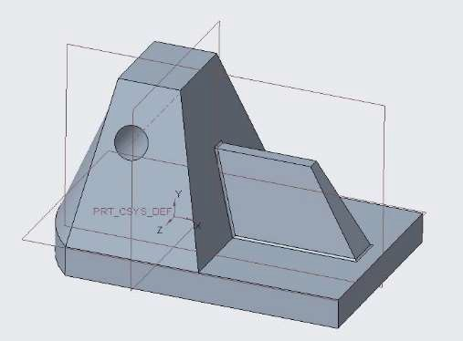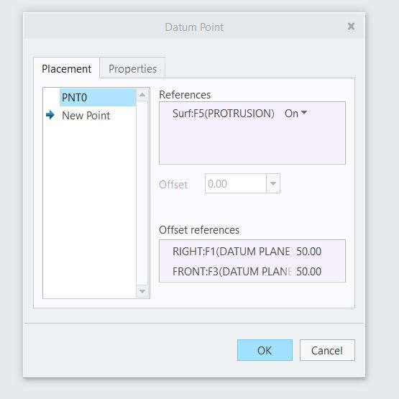

1. Select the top surface. In Datum point dialog box, click on Offset references box.
2. Press CTRL, select front and right plane and ENTER the offset value from both planes as 50. PNT0 is created.
3. In Datum point dialog box click on new point.
4. Select A_1 axis from the solid geometry. In Datum point dialog box, click on Offset references box.
5. Select the front plane and ENTER the offset value as 50. PNT1 is created.
6. Select the curve on the curved surface of the geometry.
7. 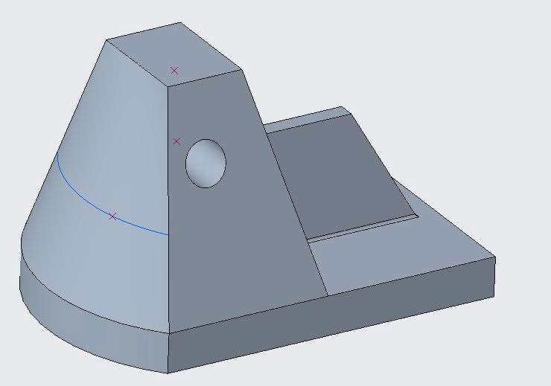In Datum point dialog box ENTER offset value as 0.3 as the offset ratio. PNT2 is created.

## *CREATING POINTS AT INTERSECTIONS*

Datum Points can be created by combination of other datums or other entities. You just need imagine the how different entities can be combined to create points. Combinations can be like three planes, two curves, two edges, etc.

1. Open Datum_point.prt. Select Point command from the datum group.
2. Select all the three datum planes. PNT0 is created at the intersection of planes.
3. Select A_1 axis and front datum plane. PNT1 is created at the intersection axis and plane.
4. Select the curve on the curved surface of the geometry and front datum plane. PNT2 is created.

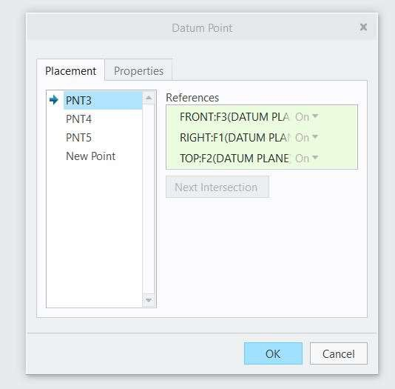 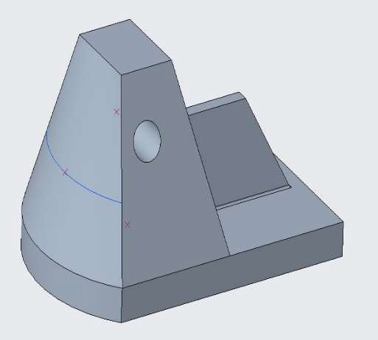

## *CREATING POINTS USING AN OFFSET COORDINATE SYSTEM*

Datum Points can be created using an offset CSYS. Points can be created with reference to CSYS.

1. Open Offset_Csys.prt. Select Offset Coordinate System from point drop down option under Datum Group.

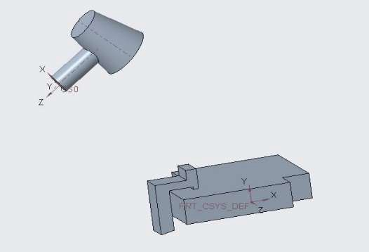 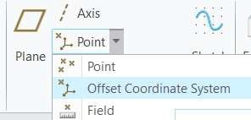

1. Select Coordinate System PRT_CSYS_DEF from the screen.
2. Select Coordinate system type as Cartesian.
3. Click under name tab in the Datum Point dialog box. Point PNT0 is defined.
4. Similary click under name tab below PNT0. PNT1 is created. Update the values as shown below.
5. Create the following points as shown below with the respective values.

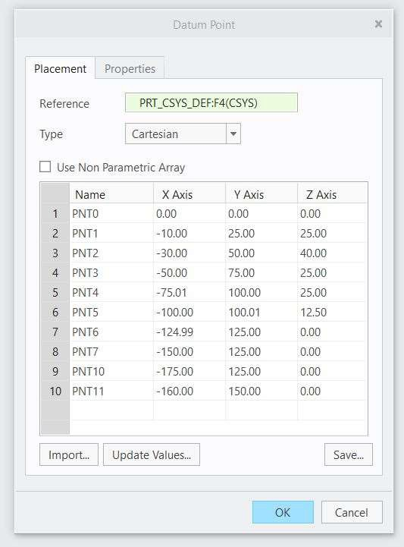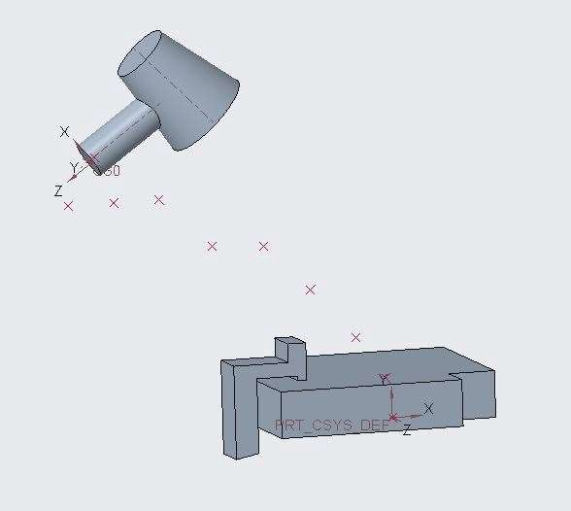

1. Click ok to Datum Point dialog box. Coordinate System is created.

## *SKETCHING GEOMETRY DATUMS*

When you create any geometry, different points, Axis, CSYS is created internally. You use these to create datum geometries.

1. 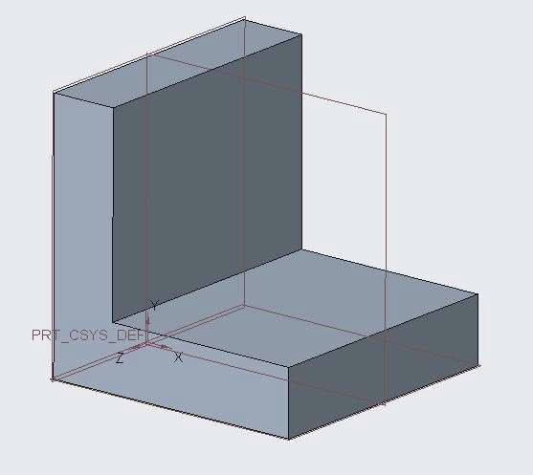Open Geometry_Datums.prt
2. Select Sketch 1 from the model tree and Edit Definitions.
3. Select the Point command from the datum group.
4. Create four points as shown below. Click finish feature. Geometry points are created.

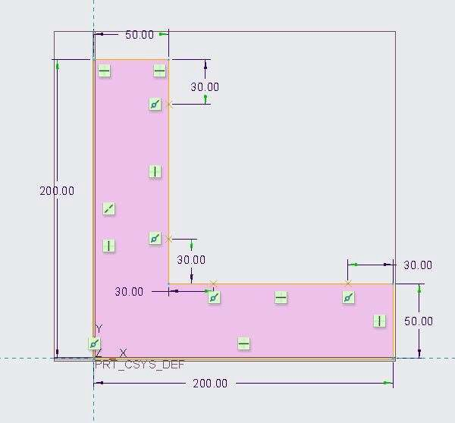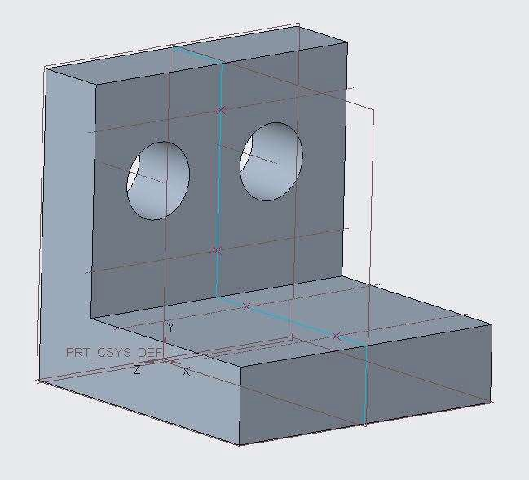

1. Create two circular holes on the vertical inside face of the geometry.
2. Notice two inter axes are created.
3. Create a datum axis passing through two points in the horizontal base face.
4. Select CSYS command from the datum group.
5. Select the two axis crossing each other in the base face. CSYS is created at the intersection of the axes.

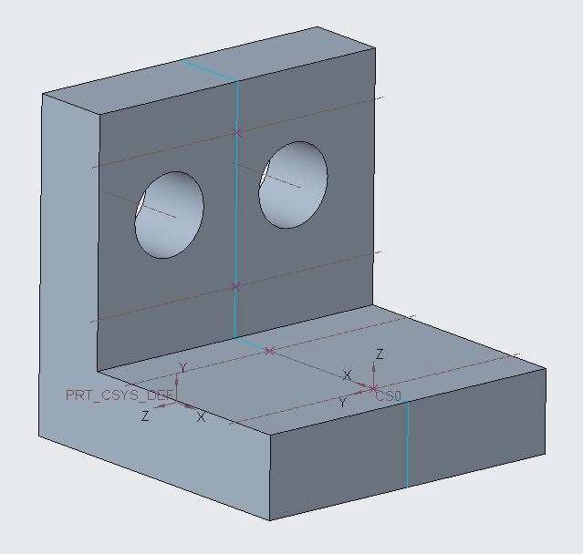

## *CREATING CURVES THROUGH A POINT OR VERTEX*

A curve can be created with minimum two datum points or vertices.

1. Open Curve.prt
2. Select the Curve through Points Command from the Curve group under Datum group.
3. Select the two vertices as shown.
4. A curve will be created as shown.

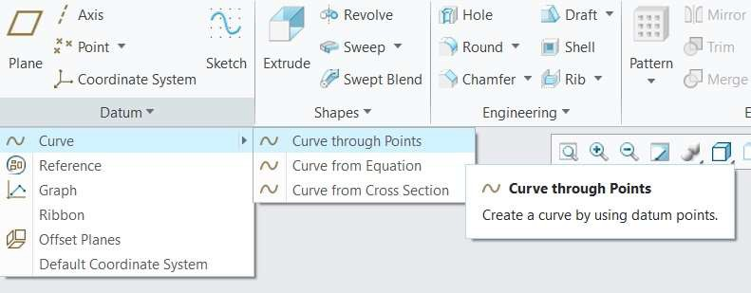

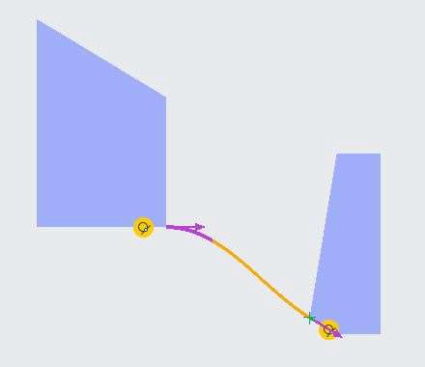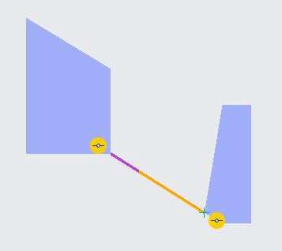

Two Vertices

Tangent Curve is Created Straight Curve Is Created

## *CREATING A CURVE THROUGH A POINT ARRAY*

A curve can be created through a N no. of points. The more no. of points, the more smoothness curve will achieve.

1. Open Curve_Point_Array.prt. Display only the datum point and datum CSYS.
2. Select Curve through points from curve group under Datum group.

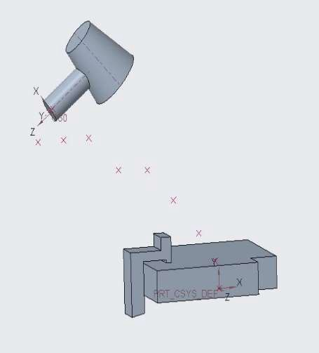

1. Select Datum Point id 252 from the model tree.
2. Click Finish Feature. Curve is created through point array.

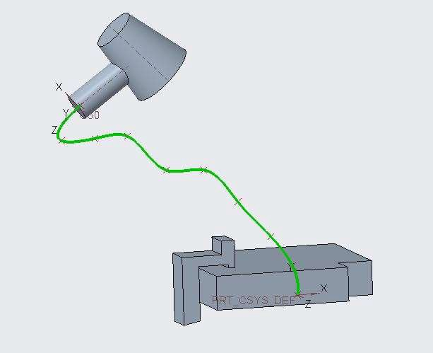

1. Select Curve 1 under model tree and Edit Definition.
2. In the Curve through points dashboard, select Use line to connect the points to the previous point. 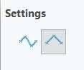
3. 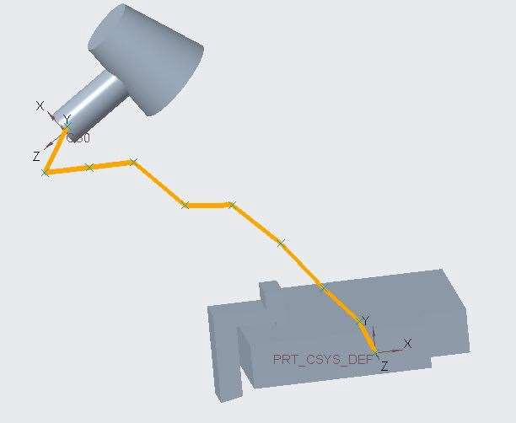Straight line curve created without smoothness.
4. In the Curve through points dashboard, select Rounds curve by specified value. 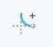
5. In the placement tab ENTER the Radius value as 10. The corners are smoothened.

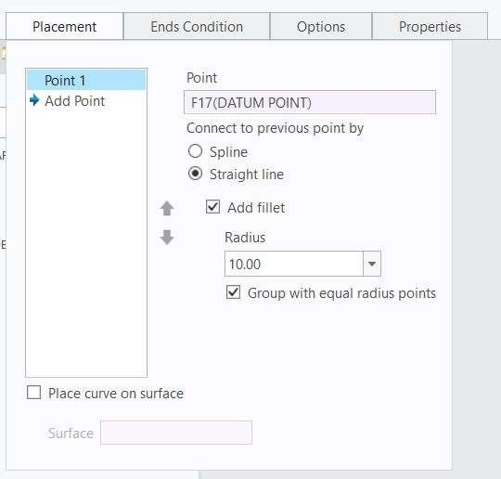 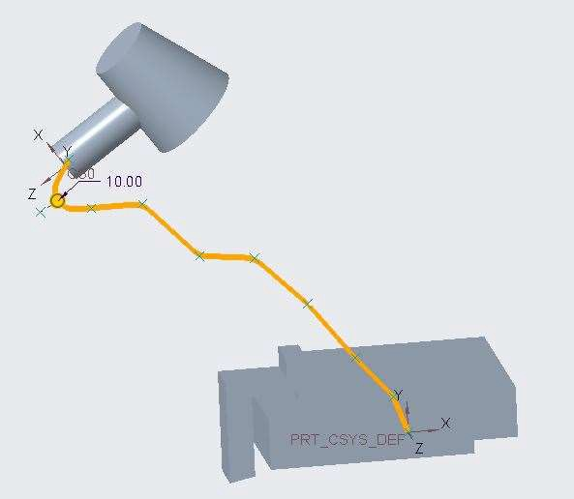

## *CREATING A CURVE FROM A CROSS-SECTION*

A curve can also be created with the inter section of a plane and cross-section of a surface feature.

1. Open Helmet.prt. Select Curve from Cross Section from curve group under Datum group.
2. In the Curve dashboard, select cross section XCEC0001 from the drop-down list.
3. Curve is created.

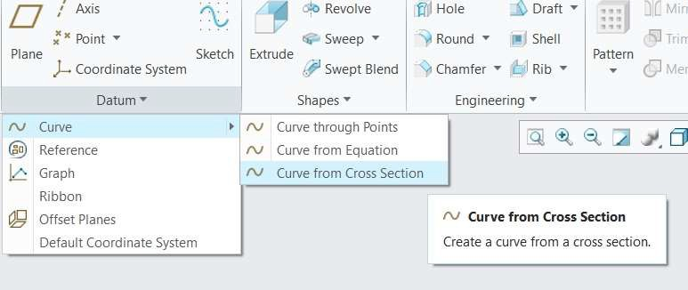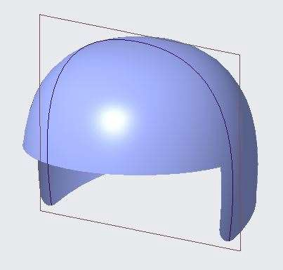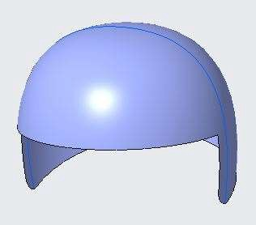

## *CREATING A CURVE FROM EQUATION*

A curve can also be created by equation.

1. Create a new file.
2. 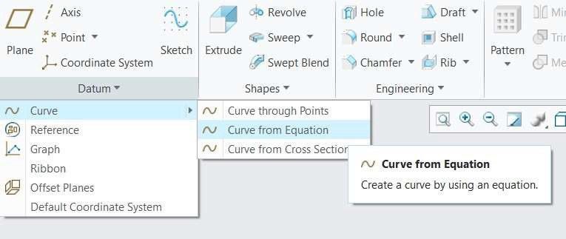Select Curve from Equation from curve group under Datum Group.
3. In settings option, Select Cartesian CSYS.
4. In the reference tab, Select PRT_DEF_CSYS.
5. In dashboard, Click on Equation option.

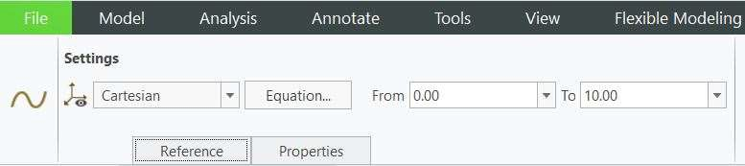

1. 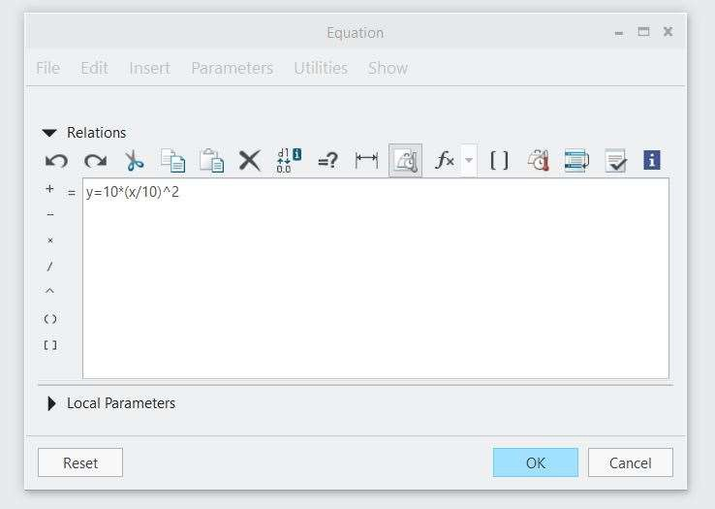Write the following equation in Equation dialog box. y=10*(x/10) ^2.
2. In dashboard ENTER the lower limit as 0 and upper limit as 10.
3. Click finish feature. Parabola curve is created.

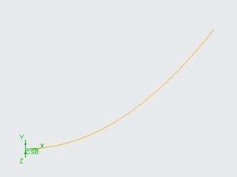

1. Select Curve 1 from model tree and Edit Definition.
2. Change the lower limit to -10.
3. Click finish Feature. Curve is updated.
4. Select Curve 1 from model tree and Edit Definition.
5. In dashboard, Click on Equation option.
6. Write the following equation in Equation dialog box. y=100*sin(2*x)+10
7. In dashboard ENTER the lower limit as 0 and upper limit as 360.
8. 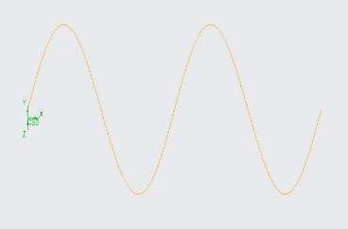Click finish feature. Sine curve is created.

## *CREATING COMPOSITE CURVES*

You can copy and paste selected edges or edge chains from a solid or surface model to create a composite

datum curve.

1. Open Composite_Curves.prt
2. Select the front edge of the surface geometry.
3. Click copy and click paste from the operations group.

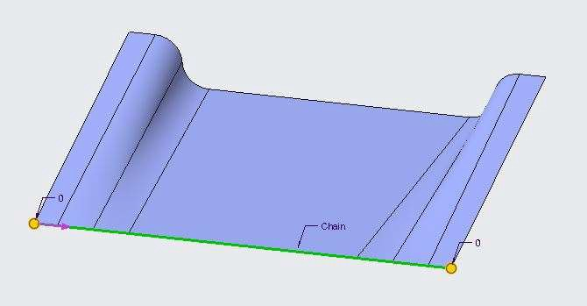 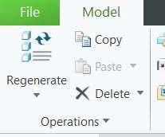

1. 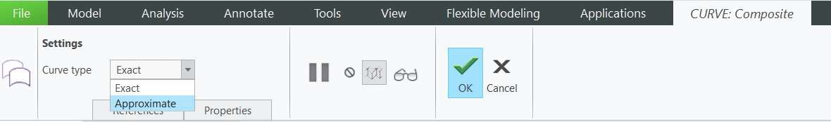In the dashboard, select exact from the curve type list.
2. Notice the Copy 1 feature in the model tree.
3. Select the Back edge of the surface geometry.
4. 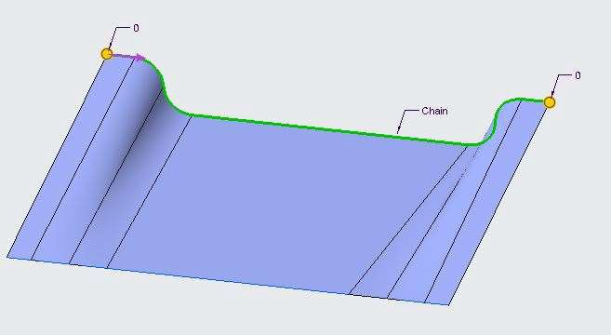Click copy and click paste from the operations group.
5. In the dashboard, select approximate from the curve type list.
6. Notice the Copy 2 feature in the model tree.

## *CREATING A CURVE FROM CURVE INTERSECTIONS*

A curve can also be created with the intersection of two Curves.

1. 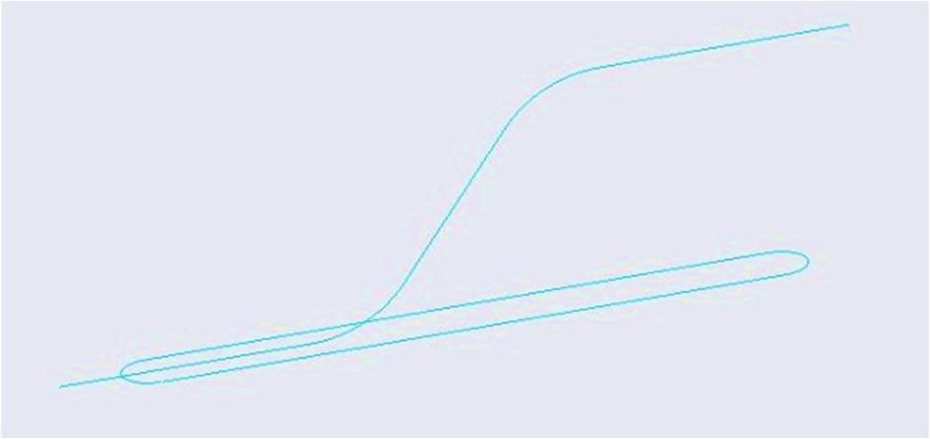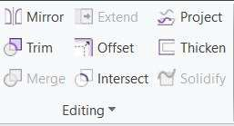Open Intersection_Curve.prt. Disable all the datum types.
2. Select Sketch 1 and Sketch 2 from the model tree.
3. Select Intersect command from the Editing group.
4. 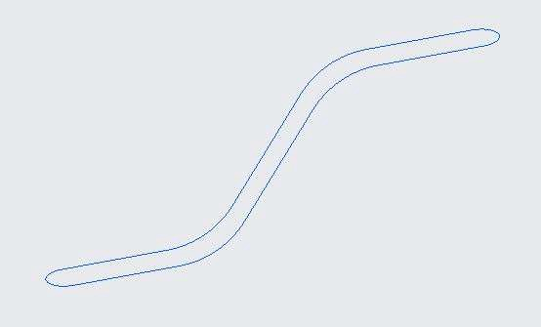Curve is created as a result of intersection of Sketch 1 and Sketch 2.

## *CREATING A CURVE AT SURFACE INTERSECTION*

A curve can also be created with the intersection of two Surfaces.

1. Open Curve_Intersection.prt.
2. Press CTRL and select both the surface geometry.
3. Select the Intersect command from the Editing Group.

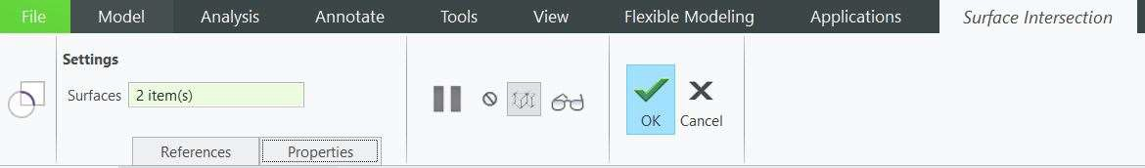

1. The Curve is created at the intersection of surface geometries.

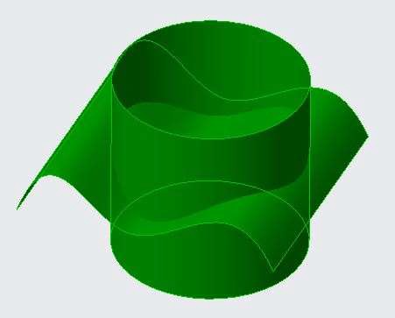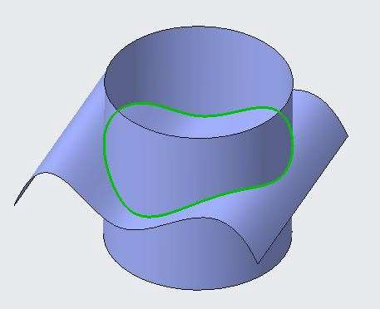

## *PROJECTING AND WRAPPING CURVES*

Project Command allows the user to create curves by projecting the selected curves onto the face of the user-defined solid or surface geometry.

1. Open Project_Wrap.prt
2. Select Sketch 2 from the model tree.
3. Select project command from the Editing group.

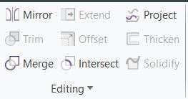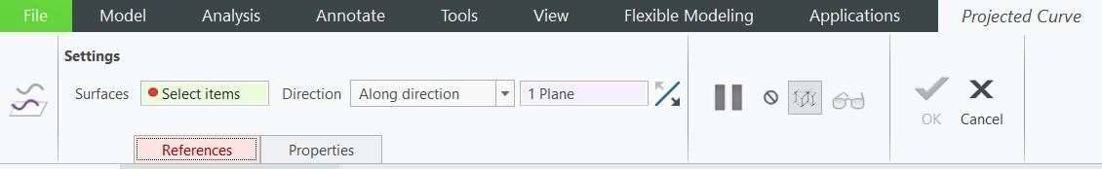

1. 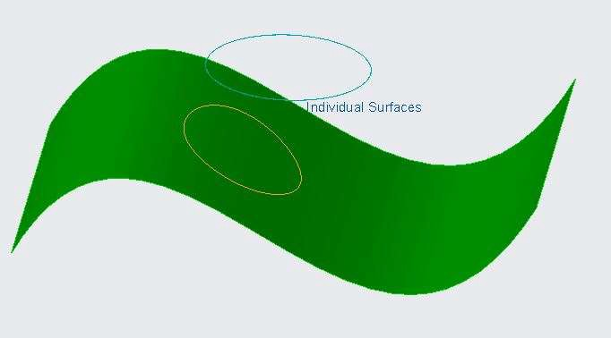Select the surface geometry. The curve is projected.
2. In the dashboard, select Normal to surface from the direction group. Observe the result. To Use the Wrap tool to drop a sketch onto geometry.
3. Open Project_Wrap.prt
4. Select Sketch 2 from the model tree.
5. Select Wrap command from the Editing group drop down.

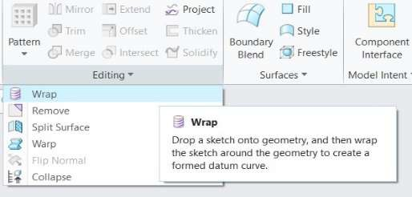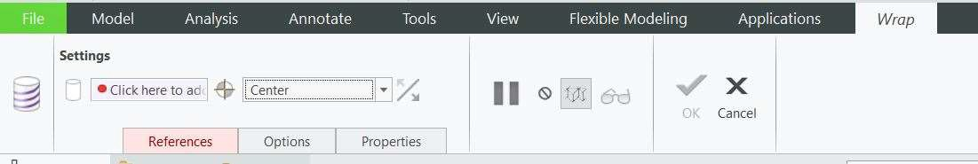

1. 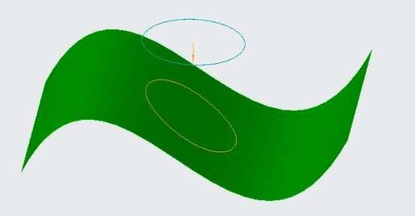The curve is wrapped on to the surface geometry.

## *TRIMMING CURVES*

The Trim command is used to remove the objects, which meet the edges of other objects. It is used to remove extra lines or extra parts of an object.

1. Open Trim_Curves.prt. Display only Datum point options.

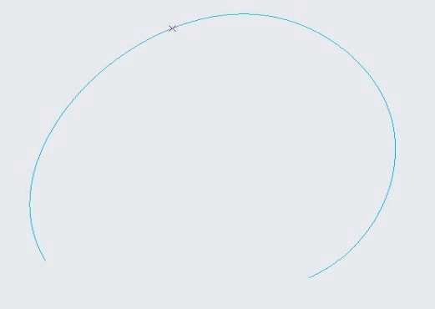 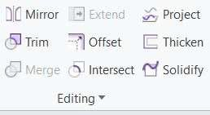

1. Select the sketch 1 from the model tree.
2. Select Trim command from the Editing group.
3. Select the Datum point PNT0 from the model tree as the trim tool. Use flip options to change the trim side.

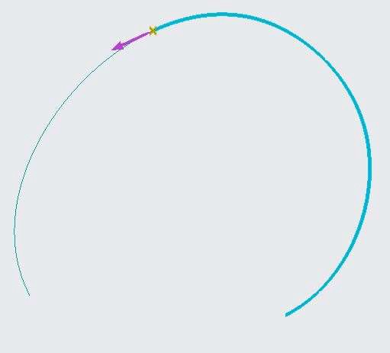 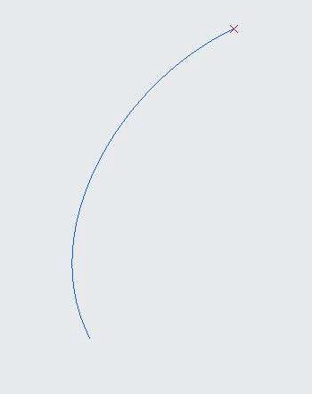

1. Click finish feature. Curve is trimmed.
2. Select Trim 1 from the model tree and Edit Definition.
3. Display the datum plane types.
4. Select the Right plane. The curve is trimmed along the plane. Use flip options to change the trim side.

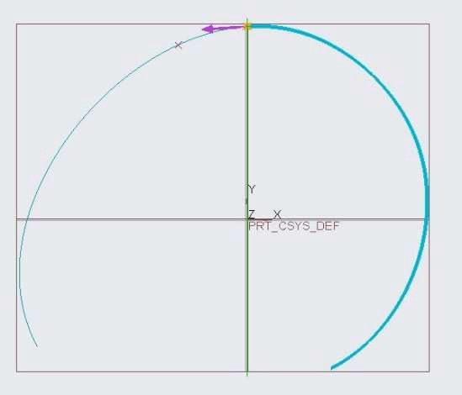 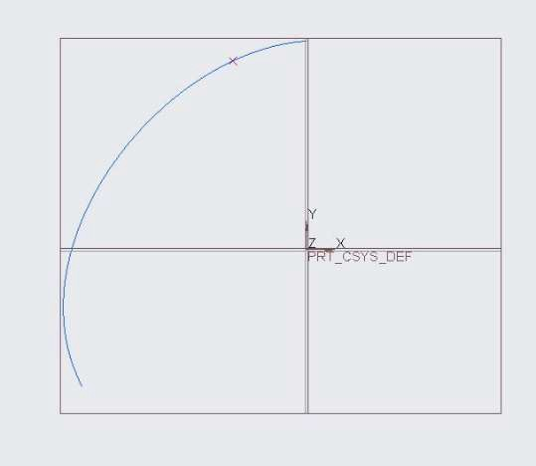

## *CREATING OFFSET CURVES*

With the help of Offset command, you can a Curve along the surface or Normal to the surface by selecting the edge of surface geometry.

1. Open Offset_curves.prt. Disable all the datum types.

2. 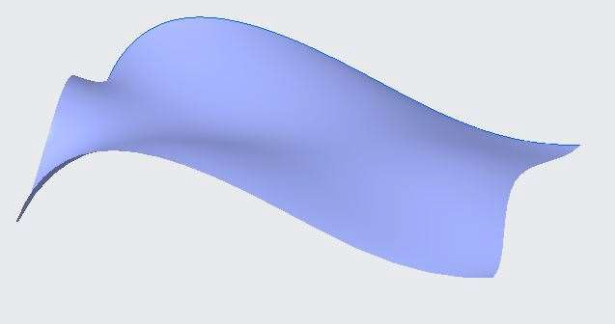 

1. Select an edge of the surface geometry as shown. Select Offset command from the Editing

group.

1. ENTER the offset value as 100.
2. Click finish feature. Curve is created.

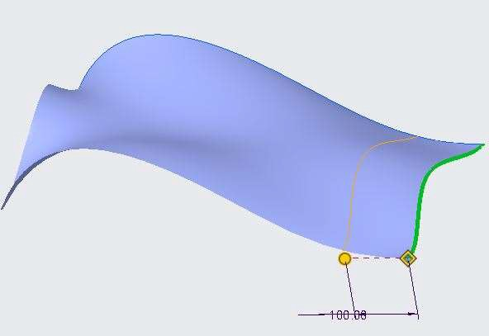

1. Select Offset 1 from the model tree and Select Offset command from the Editing group.
2. 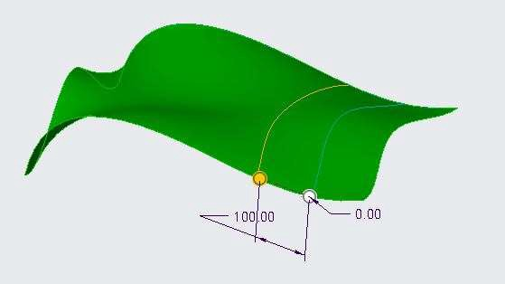ENTER the offset value 100. Use flip options from the dash board to change the offset side.
3. Click finish feature. Curve is created along the surface.
4. Select Offset 2 from the model tree and Edit Definition.
5. From the settings option change it to Normal to Surface. 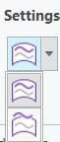
6. 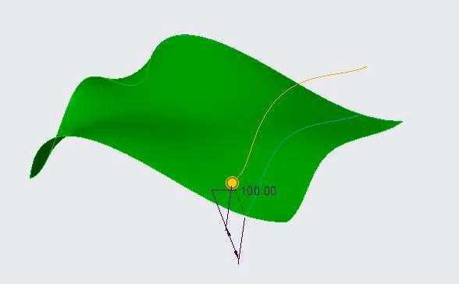ENTER the offset value to 100. Use flip options to change the offset side.

## *CREATING COSMETIC SKETCHES*

Cosmetic sketches are "drawn" on the surface of a part. Cosmetic sketches cannot be used as a reference by many features.

1. Open Cosmetic_Sketch.prt. Disable all the datum Types.
2. Select Cosmetic Sketch command from the Engineering group drop down.

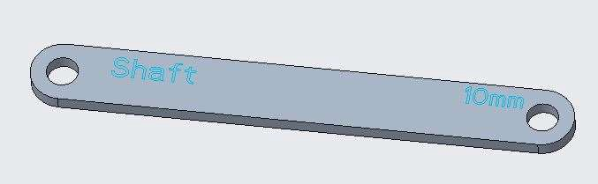 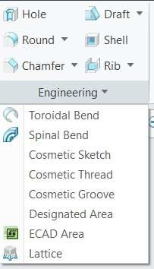

1. Select the top face and Click on sketch in the Cosmetic Sketch dialog box.
2. Select Text command and write 10mm as shown below in figure.
3. Click Finish feature. Cosmetic Sketch is created highlighted in orange color.

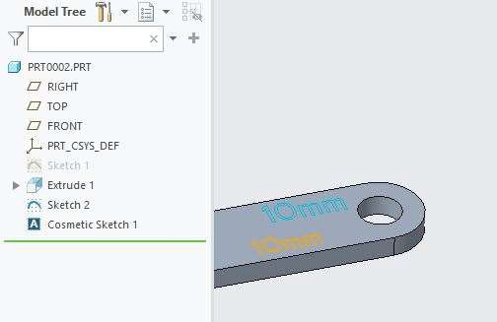

1. Select the same face again and Select Cosmetic Sketch command.
2. From the Setup group drop down Enable Under-Constrained Node.
3. Create an I section profile as shown. Observe that dimension is not appeared.

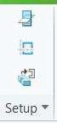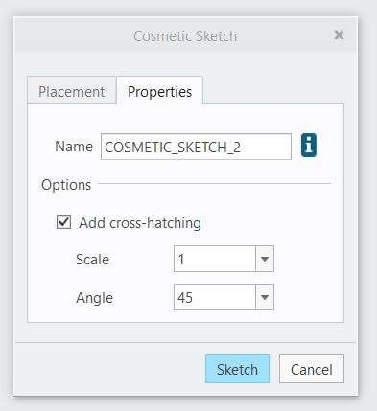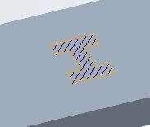

Setup from the setup group.

1. Select Sketch
2. In Cosmetic Sketch dialog box, go to properties tab, ENTER Scale value 1
3. Click finish feature. Under constraint Sketch is created.

# *MODULE 3 - BASIC SURFACING TOOL*

*For the activity files browse to folder Basic Surfacing Tool.*

## *CREATING SURFACE EXTRUDE FEATURES*

An extrude feature is based on a two-dimensional sketch. It linearly extrudes a sketch perpendicular to the sketching plane. Extrude can be done on an open sketch or on a closed sketch. You Extrude the closed sketch with a open geometry or a closed geometry.

1. Open Extrude_closed_Section.prt. Select Extrude command from the shapes group.

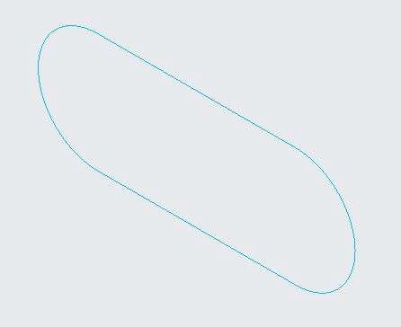 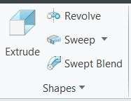

1. From the Extrude dashboard select the Surface option.

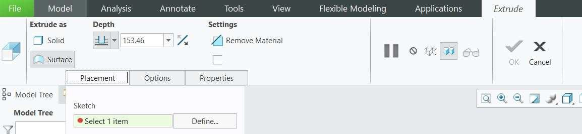

1. Select the closed cross-section displayed on the screen, and ENTER the depth value as 300.

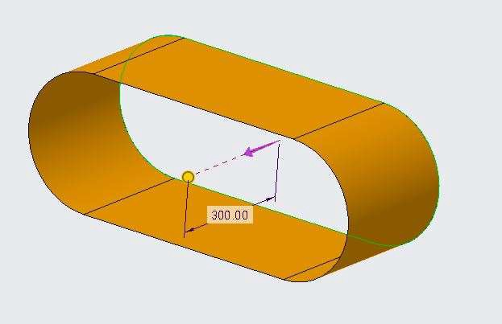

1. Click middle mouse button to complete the operation. Open Surface geometry is created.
2. From the model tree, Select Extrude 1, right click and select Edit definition.

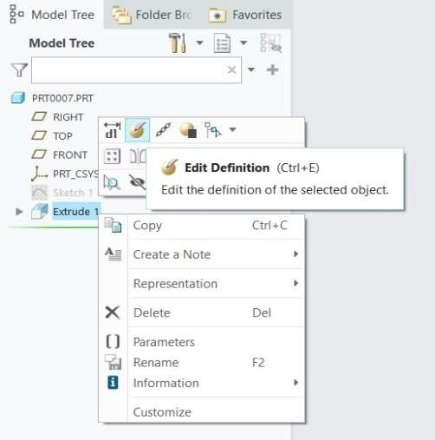

1. From the option tab in Extrude dashboard activate Capped Ends option.

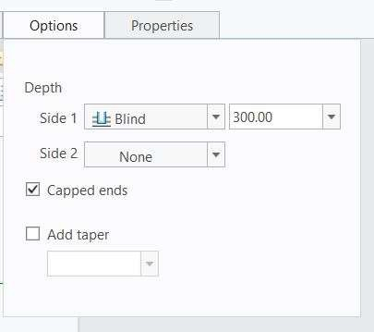 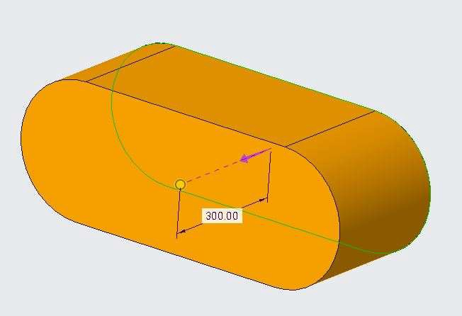

1. Click middle mouse button to complete the operation. Closed Surface geometry is created.
2. Close the part.
3. Open Extrude_open_section.prt. Select Extrude command from the shapes group.

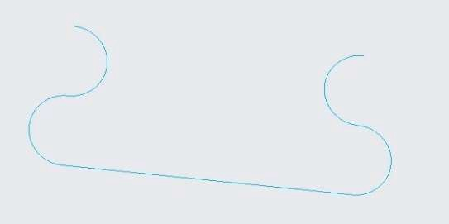 

1. From the Extrude dashboard select the Surface option as shown above.
2. Select the Open-section displayed on the screen, and ENTER the depth value as 300.

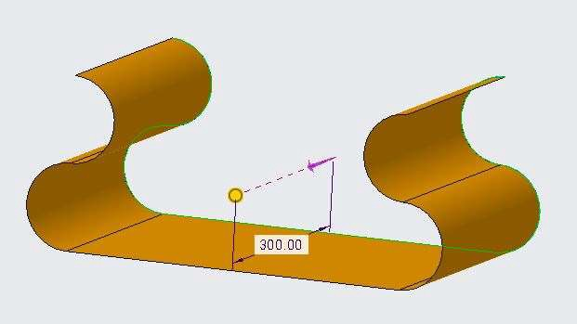

1. Click middle mouse button to complete the operation. Closed Surface geometry is created.
2. Close the part.

## *CREATING SURFACE REVOLVE FEATURES*

An Revolve feature is based on a two-dimensional sketch. It Projects a sketch Axially to the along the specified axis. Revolved axis can be Datum Axis, Linear Curve. Revolve can be done on an open sketch or on a closed sketch.

1. Open Revolve_closed_Section.prt. Select Revolve command from the shapes group.

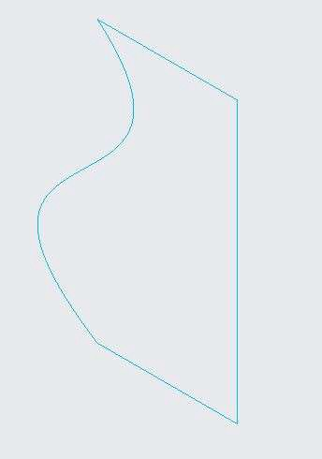 

1. From the Revolve dashboard select the Surface option.

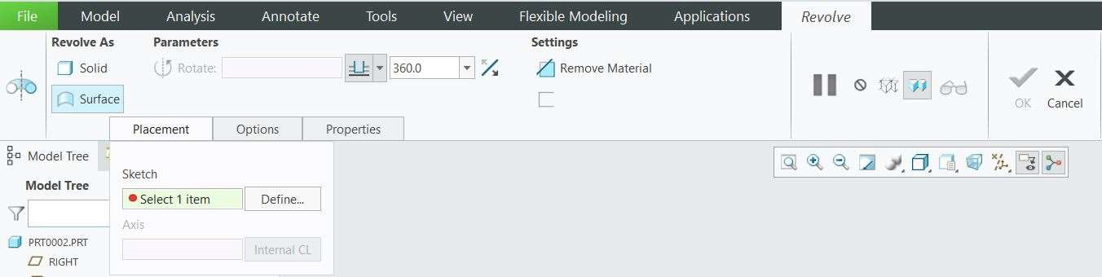

1. Select the closed cross-section displayed on the screen. The section revolves around the vertical axis forming a closed surface geometry with revolve angle 360 degrees.

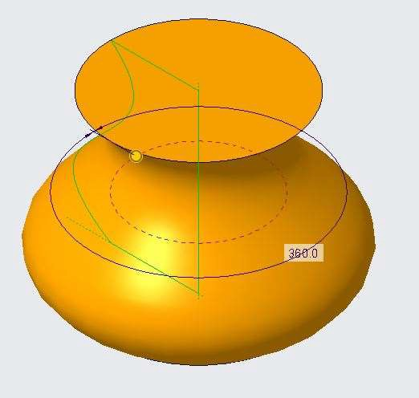

1. Change the revolving angle to 180 degrees and observe the open surface geometry.
2. From the option tab in Revolve dashboard activate Capped Ends option. Surface Geometry is capped.

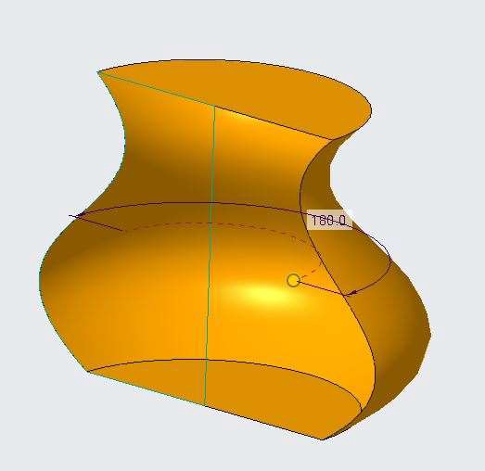 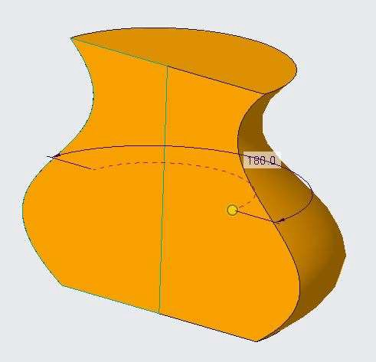

1. Click middle mouse button to complete the operation. Closed Surface geometry is created.
2. Ctrl+Z until only sketch is displayed on the screen.
3. Repeat the steps by selecting revolving axis as horizontal. Revolving can be selected in placement tab in revolve dash board by clicking on internal CL option.

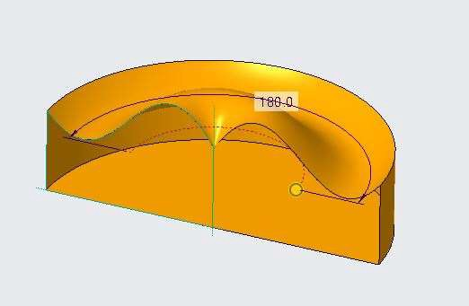

1. Observe the Result. The shape of the surface geometry is changed with the change in revolving axis.
2. Close the part.
3. Open revolve_open_section.prt. Select Revolve command from the shapes group.

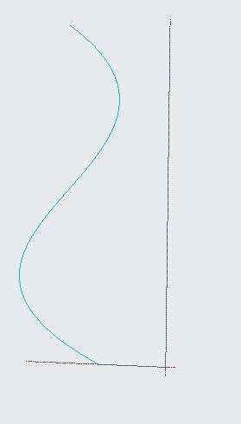 

1. From the Revolve dashboard select the Surface option as shown above.
2. Select the open section displayed on the screen. The section revolves around the vertical axis forming a open surface geometry with revolve angle 360 degrees.
3. Click middle mouse button to complete the operation.
4. Close the part.

## *CREATING FILL SURFACES*

A Fill feature is simply a flat surface, closed-loop feature that is defined by its boundaries. You create a Fill feature by Selecting an existing Sketch feature.

1. Open Fill_single_loop.prt. Select the fill command from the Surfaces group.

 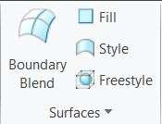

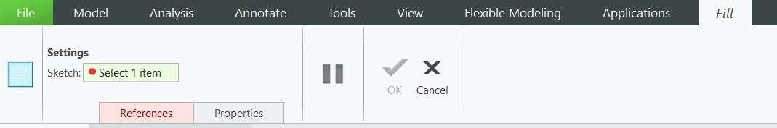

1. Select the Star cross-section displayed on the screen. The cross-section is filled and a surface geometry is created. Click middle mouse button to finish the operation and observe the result.

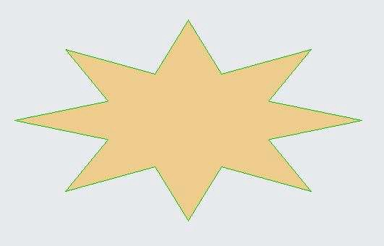 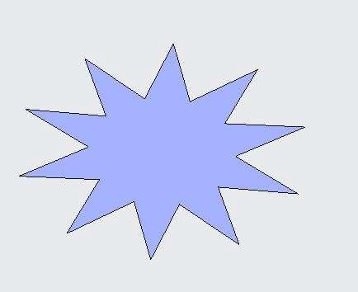

1. Close the part.
2. Open Fill_multiple_loop.prt. Select the fill command from the Surfaces group.

 

1. Select the Star cross-section with circle displayed on the screen. The cross-section is filled with a hole and a surface geometry is created. Click middle mouse button to finish the operation and observe the result.

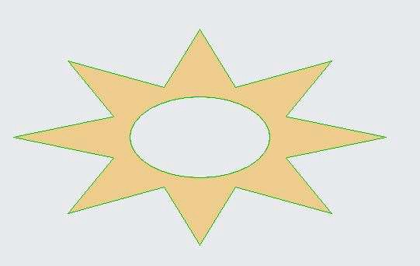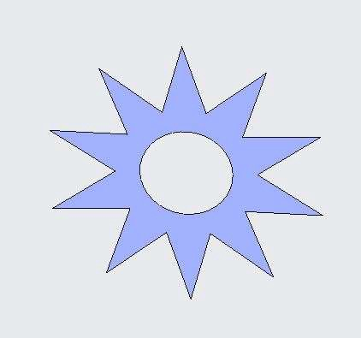

## *CREATING SWEEP SURFACES WITH OPEN TRAJECTORIES*

Sweep features are defined by using custom 2D cross-section (or face) moved along a pre-set path to create a 3D shape or surface. Sweep Surfaces are surfaces that are generated from a section curve positioned along a path.

Sweep Trajectories can be closed or open.

1. Open sweep_open_trajactory.prt. Select Sweep command from the shapes group.

 

1. Select the surface option the sweep command dashboard.

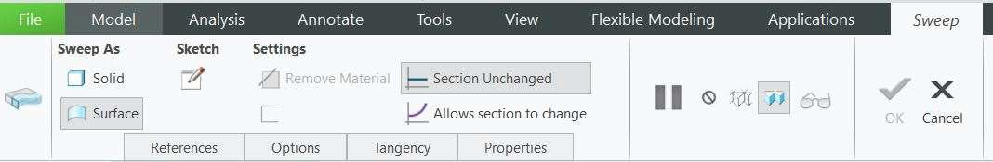

1. Select the Arc displayed an the screen as the open trajactory and click on sketch option in Sweep Dashboard.
2. Draw the I-section from the pallete command as shown in figure. Finish the sketch.

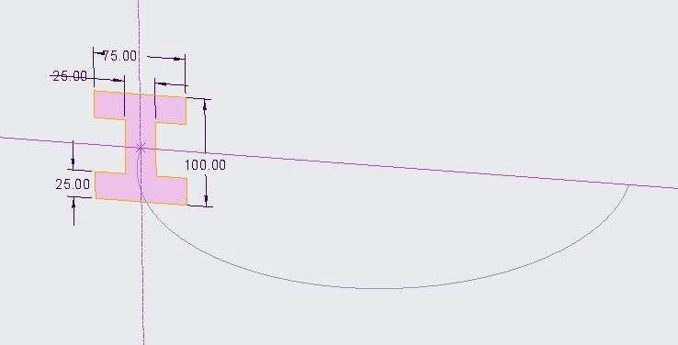

1. Surface geometry is created with I-shape cross-section and open geometry.

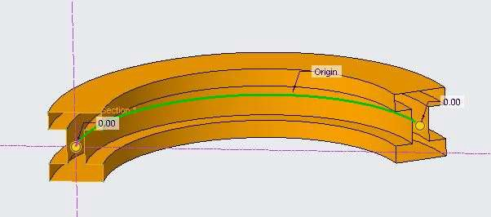 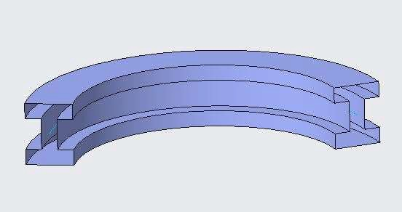

1. From the option tab, Select capped ends. Closed surface geometry is created.

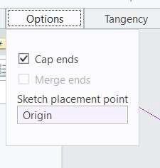 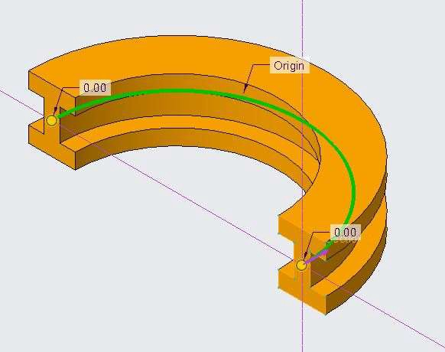

1. Click middle mouse button to finish the operation and observe the part.

## *CREATING SWEEP SURFACES WITH CLOSED TRAJECTORIES*

A sweep Section can be created with closed trajectories.

1. Open sweep_close_trajactory.prt. Select Sweep command from the shapes group.

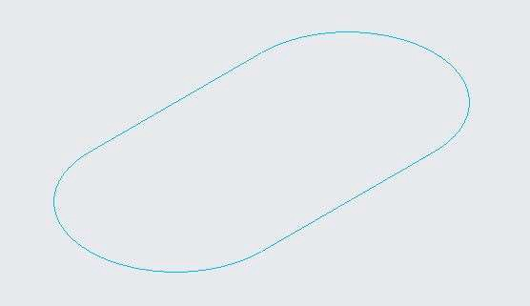 

1. Select the surface option the sweep command dashboard as in the previous activity. Select the closed cross-section displayed an the screen as the closed trajactory and click on sketch option in Sweep Dashboard.
2. Draw the section as shown in figure. Finish the sketch.

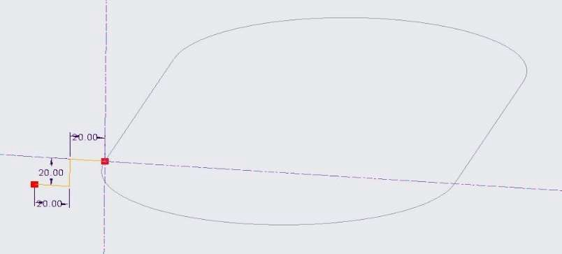

1. Surface Geometry is created.

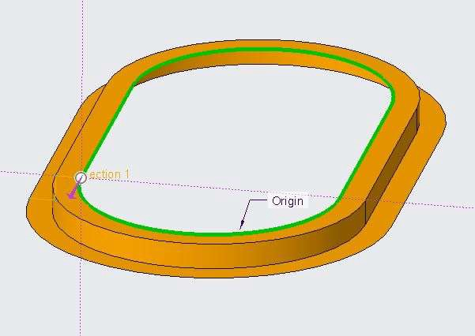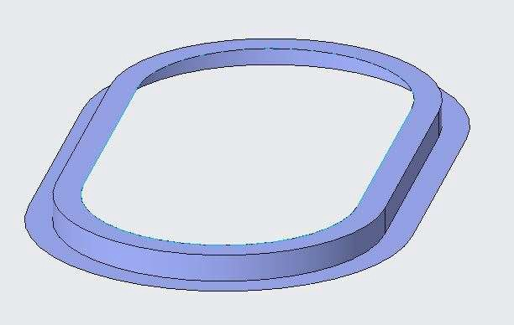

## *CREATING BLEND SURFACES BY SELECTING PARALLEL SECTIONS*

The blend function in Creo is commonly known as a loft in generic CAD terms. In its simplest form we would have multiple parallel 2D sections which are spaced apart from each other.

1. Open Blend.prt. Select the Blend command from the shapes group.

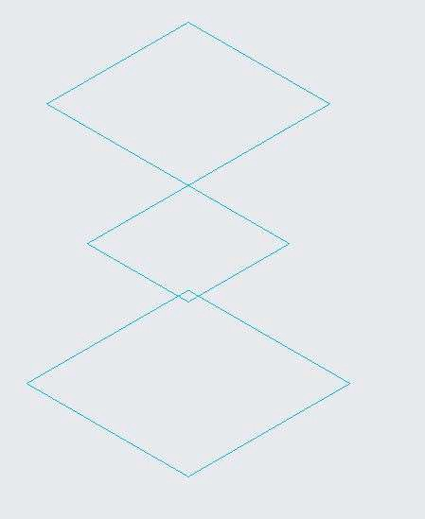 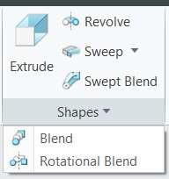

1. From the Blend tool dashboard, select Blend as Surface option and Blend with Selected

Sections.

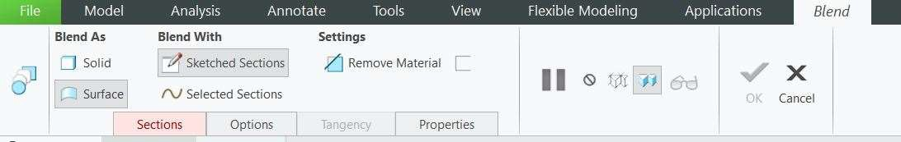

1. In the Dashboard open the sections tab

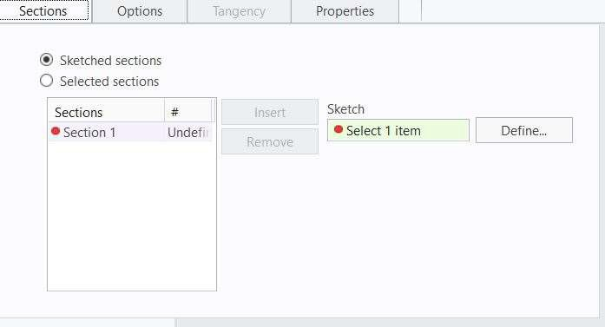

1. Select sketch 1 as the first section, then click insert in the section tab.
2. Select sketch 2 as the second section, then click insert in the section tab.
3. Select sketch 3 as the third section.
4. Observe the created surface geometry.
5. Click middle mouse button to finsh the operation.

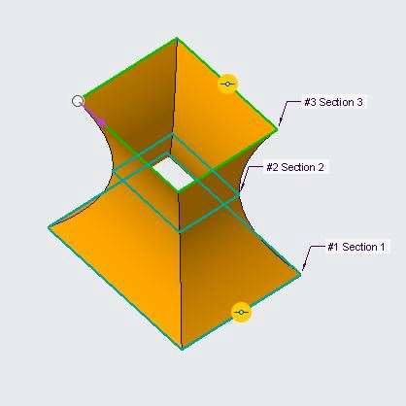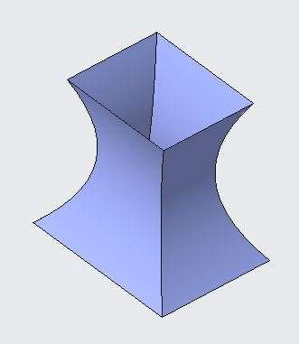

1. Edit Definition Blend 1 from the model tree.
2. From the section tab select the second section.
3. Drag the start point to adjacent corner of the section.
4. Surface geometry is created with twisted shape as start point is misaligned.

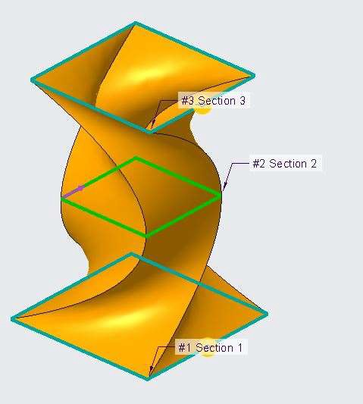 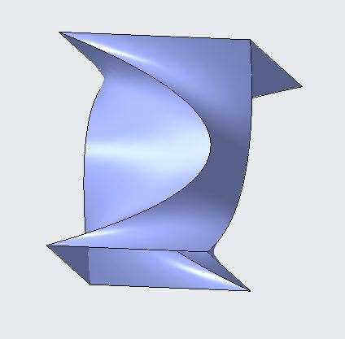

## *CREATING BLEND SURFACES BY SELECTING NON-PARALLEL SECTIONS*

Blend function can also be applied in multiple Non parallel Sections.

1. Open blend_nonparallel.prt. Select Blend command. Select the Blend command from the shapes group.

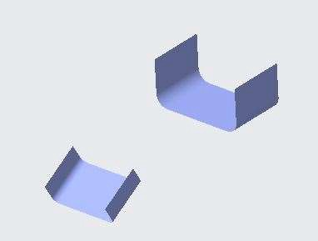 

1. From the Blend tool dashboard, select Blend as Surface option and Blend with Selected Sections.
2. Open the sections tab.
3. As shown in figure, place the pointer on the bigger surface edge, right click to highlight the complete edge, click to select the edge.
4. Click insert in the sections tab.
5. As shown in figure, place the pointer on the smaller surface edge, right click to highlight the complete edge, click to select the edge.

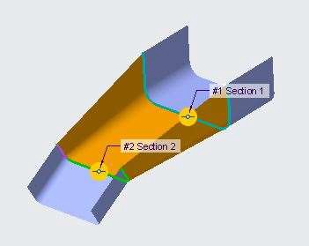

1. Surface is created between the non-parallel sections.
2. Click middle mouse button to finish the operation and observe the result.
3. Delete Blend 1 from the model tree.
4. From the model tree, Select sketch 4 and unhide it.

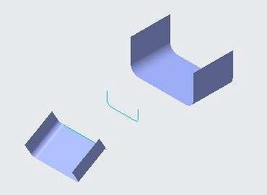

1. Select the Blend command from the shapes group.
2. From the Blend tool dashboard, select Blend as Surface option and Blend with Selected Sections.
3. Select the bigger surface edge as first section, sketch 4 as second section, and smaller surface edge as the third section.

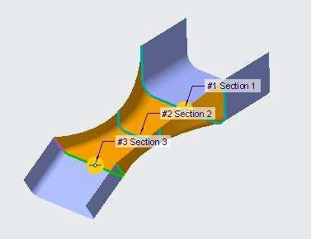

1. Surface with three non-parallel section is created.
2. Click middle mouse button to finish the operation and observe the result.

## *CREATING BLEND SURFACES BY SKETCHING SECTIONS*

Blend command can also be used on Sketched sections.

1. Open Creo Parametric. Select Blend Command from the shapes group.
2. From the Blend tool dashboard, select Blend as Surface option and Blend with Sketched Sections.



1. Open Sections tab, click on define and select the top plane to sketch.



1. Sketch a square of 200 X 200. Finish the sketch.
2. From the sections tab ENTER offset from (Section 1) value=100. Click on sketch option.
3. Draw a square of 100 X 100. Align the start point arrow with first section arrow. Finish the sketch.
4. From the sections tab click on insert option and ENTER offset from (Section 2) value=100. Click on sketch option.
5. Draw a square of 150 X 150. Align the start point arrow with first section arrow. Finish the sketch.
6. Surface Geometry is created with sketched sections.
7. Click middle mouse button to finish the operation and observe the result.

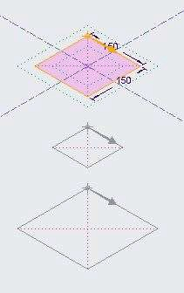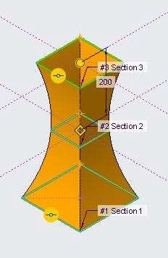

## *ANALYZING BLEND SURFACE SECTION TOOLS*

Sections with different no. of sides can be blend to create surface Geometries.

1. Open Sweep_blend_vertx.prt. Disable all the datum types. Select Blend command from the shapes group.

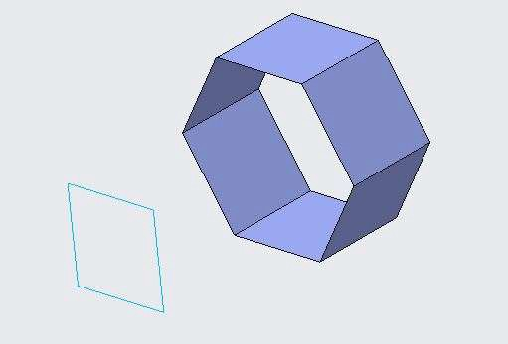

1. From the Blend tool dashboard, select Blend as Surface option and Blend with Selected Sections.
2. Open sections tab, Select the front edge of the surface body. Move the pointer on one edge, right click to highlight other edges, select it.
3. Click insert option in sections tab.
4. Select sketch 2 for section 2.
5. Drag the start point arrow as shown in figure.

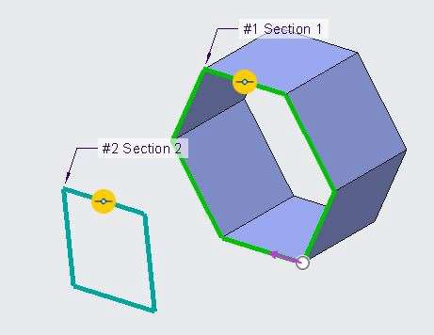 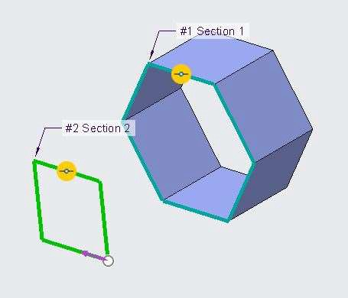

1. From the Sections tab, click Add Blend Vertex, Drag the point to opposite corner of the section.
2. Again, click on Add Blend Vertex.

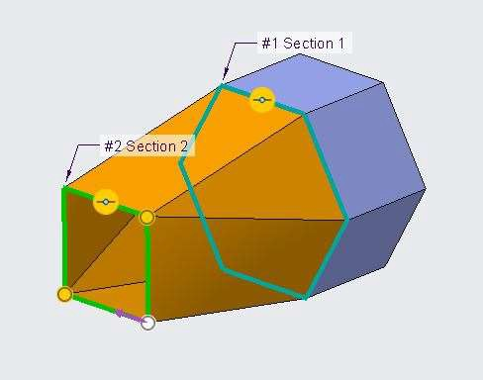 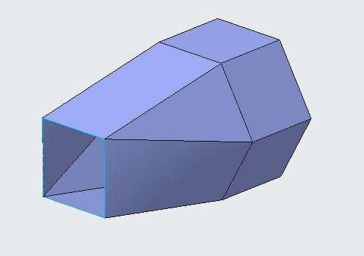

1. Surface Geometry is created, observe that two corners of first section is attached with one corner of second section. This is due to Blend Vertex.
2. Click middle mouse button to finish the operation and observe the result.
3. Unhide DTM1 from the model tree.
4. Select Select Blend command from the shapes group.
5. From the Blend tool dashboard, select Blend as Surface option and Blend with Sketched Sections.
6. Open sections tab, Click define, Select DTM1 as sketch plane.
7. From the sketching group select project command, and project 4 edges of square section.

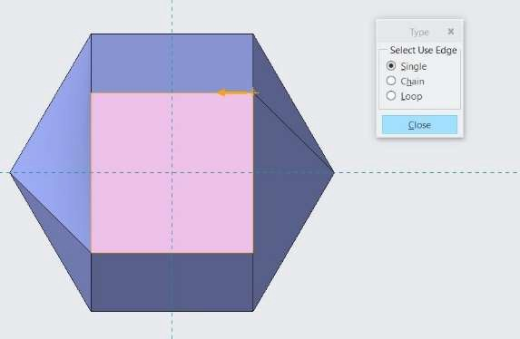

1. Finish the sketch.
2. In the section tab, ENTER 100 as offset from distance and click on sketch to activate the sketch plane.

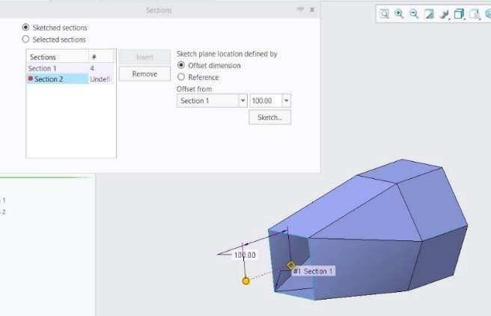

1. Specify a point from the sketching group at the axis intersection point and finish the sketch.

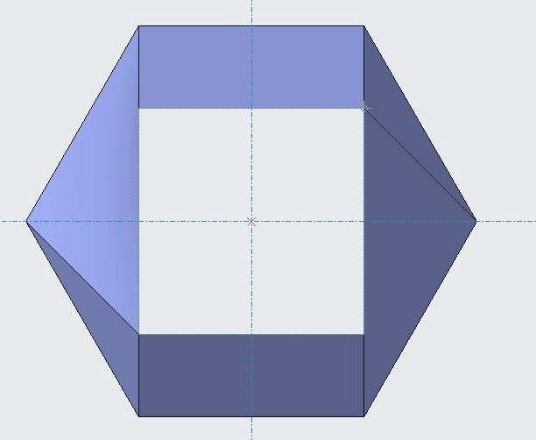

1. All the four corners of square section are attached to the point.

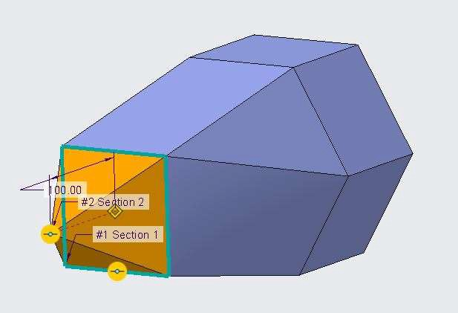

1. Click middle mouse button to finish the operation and observe the result.

## *ANALYZING BLEND SURFACE OPTIONS*

Geometries created can be straight or smooth.

1. Open Blend_options.prt.
2. Select Blend 1 from model tree, and Edit Definition.
3. In Blend tool dashboard open option tab.
4. Select Blend surfaces as Straight. Smoothness of the surface geometry changes to straight.

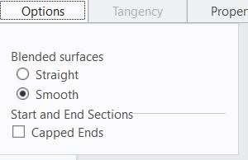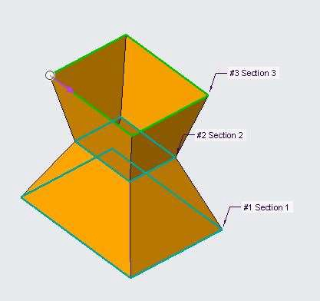

1. Check capped ends in the option tab. Surface geometry is created with capped ends.

 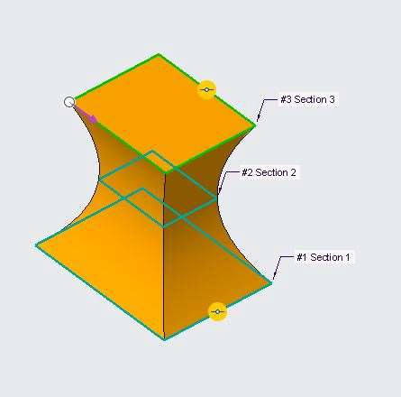

## *ANALYZING BLEND SURFACE TANGENCY*

### The tangency option creates a tangent transition between the surfaces of the blend feature and the surfaces

**of adjacent feature geometry.**

1. Open Blend_surface_tangency.prt.

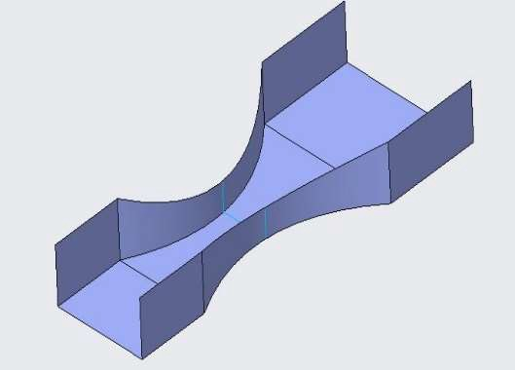 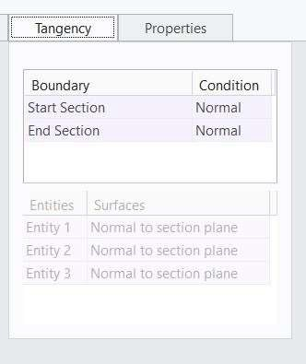

1. Select Blend 1 in model tree and Edit Definition.
2. Open Tangency tab in Blend tool Dashboard.
3. Change start section from normal to tangent. Select all the three faces bigger surface geometry.
4. Change start section from normal to tangent. Select all the three faces smaller surface geometry.
5. Click middle mouse button to finish the operation.

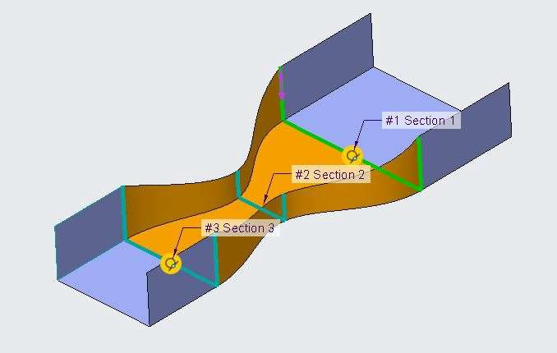

## *CREATING ROTATIONAL BLEND SURFACES BY SELECTING SECTIONS*

A rotational blend is created using sections that are rotated about an axis of revolution. You define the section orientation in relation to other sections.

1. Open Rotational_Blend.prt. Display all the datum types. Select Rotational Blend tool from Shapes group.

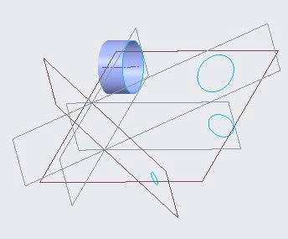 

1. From the Rotational Blend tool dashboard, select Blend as Surface option and Blend with Selected Sections.

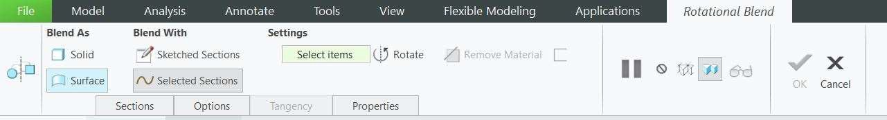

1. Open Sections tab.

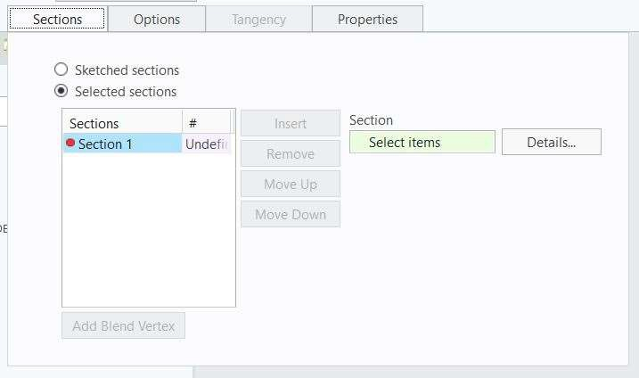

1. Select front edge of the suraface geometry as section 1.
2. Click insert option fron the sections tab and select sketch 2 as section 2.
3. Again, Click insert option fron the sections tab and select sketch 3 as section 3.
4. Again, Click insert option fron the sections tab and select sketch 4 as section 4.

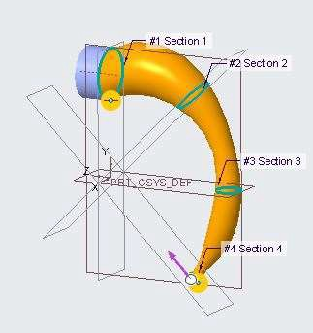 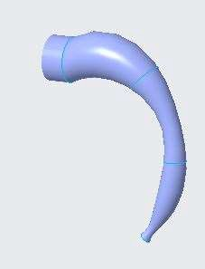

1. Click middle mouse button to finish the operation. And observe the result.

## *CREATING ROTATIONAL BLEND SURFACES BY SKETCHING SECTIONS*

Rotational Blend can also be created by sketching the section inside the command tool.

1. Open a new file in Creo Parametric.
2. Select Rotational Blend Command from the shapes group.



1. From the Rotational Blend tool dashboard, select Blend as Surface option and Blend with Sketched Sections.

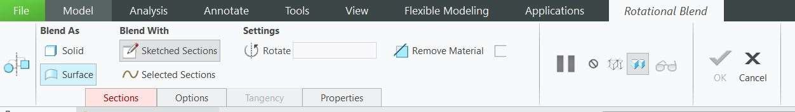

1. Open the sections tab and click on define and select front plane to draw the first section.

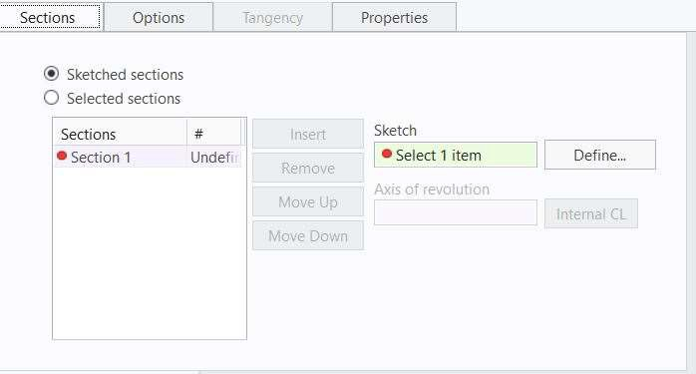

1. Draw a square of 400 X 400. Draw a datum centreline at distance of 1000 as shown below.

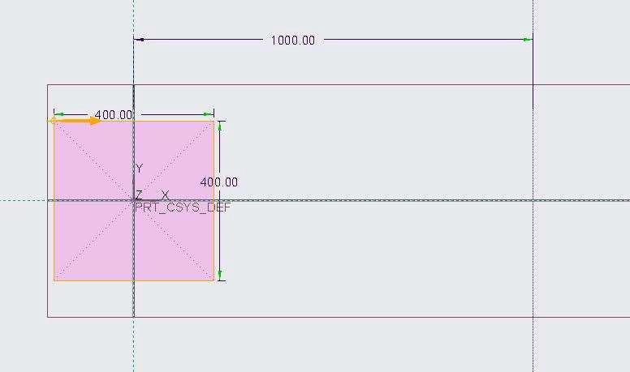

1. Click on insert option in the sections tab, ENTER offset from section 1 equal to 60 degrees.
2. Click on sketch and draw a square of 400 X 400.
3. Repeat step 6 and 7 to draw five sections taking offset from = 60 degrees from the previous section for the next section.

Section 2 = 300 X 300, Section 3 = 250 X 250, Section 4 = 500 X 500, Section 5 = 400 X 400

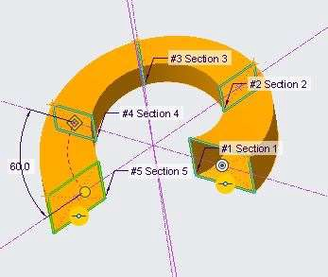 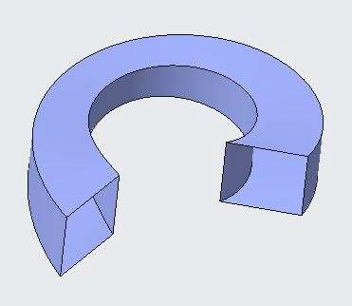

1. Surface Geometry is created. Click middle mouse button to finish the operation and observe the result.

## *ANALYZING ROTATIONAL BLEND SURFACE OPTIONS*

For Rotational Blend Geometries created can be straight or parallel. Rotational Blend command can be done with connected or unconnected start and End Sections.

1. Open Rotational_Blend_Options.prt. Disable all the datum types.



1. Select Rotational Blend 1 from the model tree and Edit Definition.

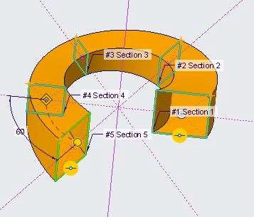 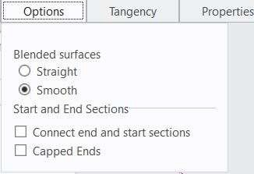

1. From the rotation blend dashboard, open options tab.
2. Select Blend surfaces as Straight. The smoothness of the geometry is lost.

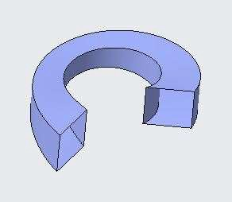 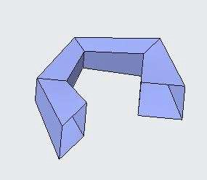

1. Check the Connect end and start sections. The start and end sections will be joined.

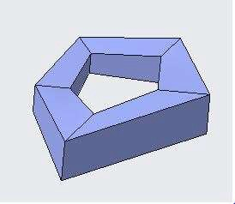 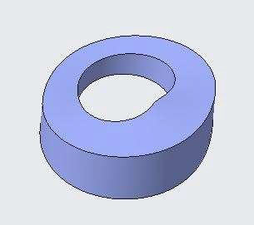

## *ANALYZING ROTATIONAL BLEND SURFACE TANGENCY*

For rotational Blend smooth option Tangency can be maintained with blend surface feature and and the adjacent surface features.

1. Open Rotational_Blend_Tangent.prt



1. Select Rotational Blend 1 from the model tree and Edit Definition.
2. From the Rotational Blend dashboard open Tangency tab.
3. Change the boundary condition of start section to Tangent.
4. Select each surface of the predefined surface geometry for each entity in the Tangency tab.

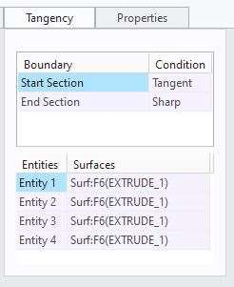

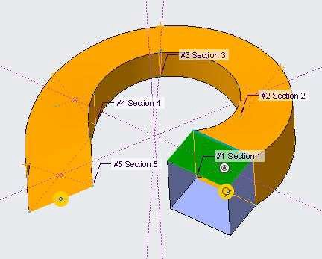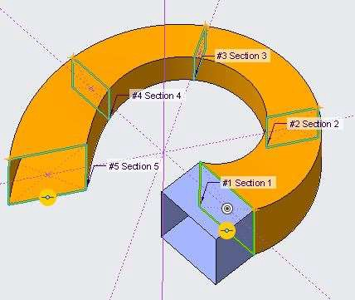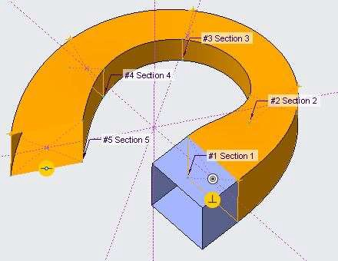

1. Change the boundary condition of End section from smooth to Sharp.

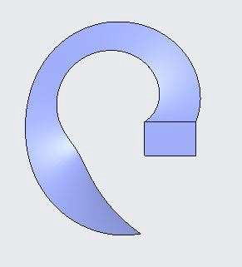 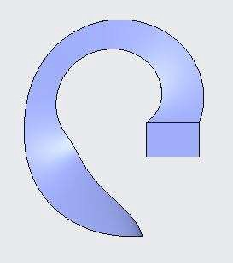

# *MODULE 4 - BOUNDARY BLEND SURFACES*

*For the activity files browse to folder Boundary Blend Surfaces.*

## *UNDERSTANDING BOUNDARY CURVE CONCEPTS*

You can create a surface by defining its boundaries.

* + You can Select combinations of:
    - Datum curves.
    - Datum points.
    - Model edges.

## *CREATING BOUNDARY BLENDS IN ONE DIRECTION*

With the Boundary Blend tool, you can create a boundary blended feature between reference entities that defines the surface in one direction.

1. Open Boundary_Blend.prt. Disable all the datum types. Select Boundary blend command from surfaces group.

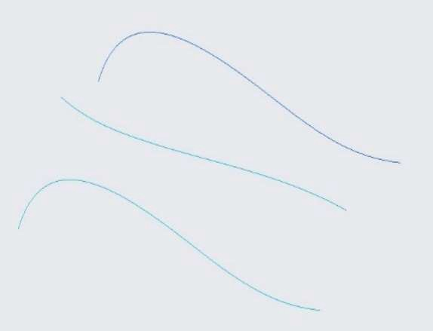

1. Click on first direction in the boundary blend dashboard.

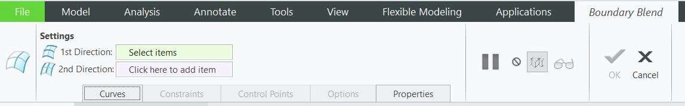

1. Press CTRL Select the three curves.

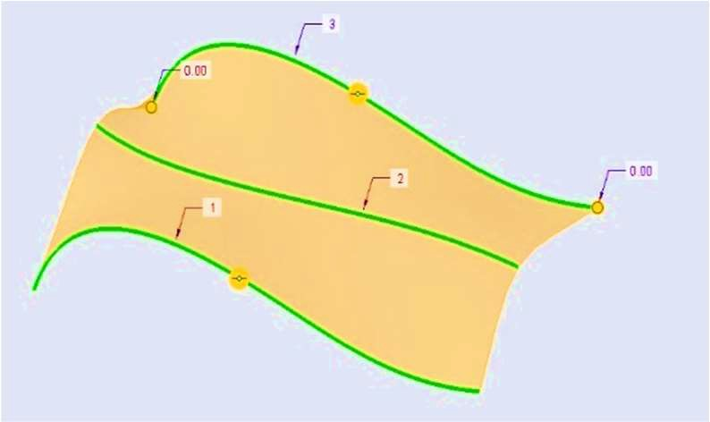 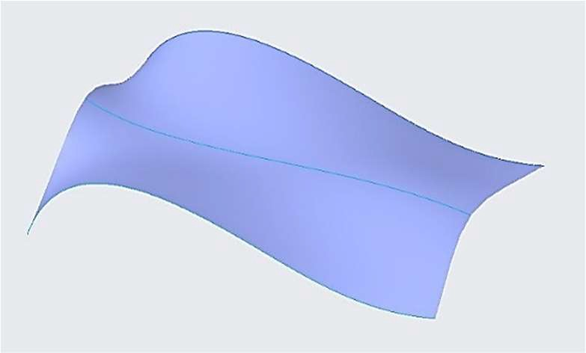

1. Click middle mouse button to finish the operation. Surface Geometry is created.

## *CREATING BOUNDARY BLENDS IN TWO DIRECTIONS*

With the Boundary Blend tool, you can create a boundary blended feature between reference entities that defines the surface in two directions.

1. Open Boundary_Blend.prt. Disable all the datum types. Select Boundary blend command from surfaces group.

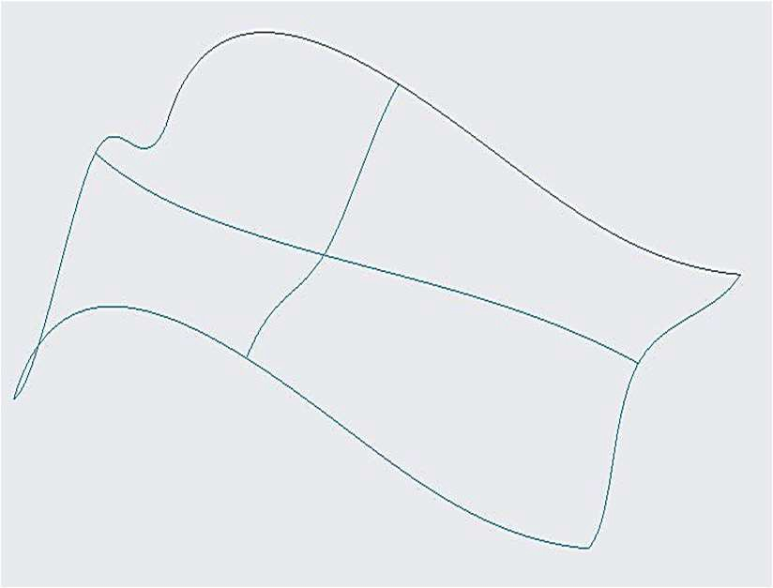 

1. Click on first direction in the boundary blend dashboard.



1. Press CTRL Select the three curves in one direction.

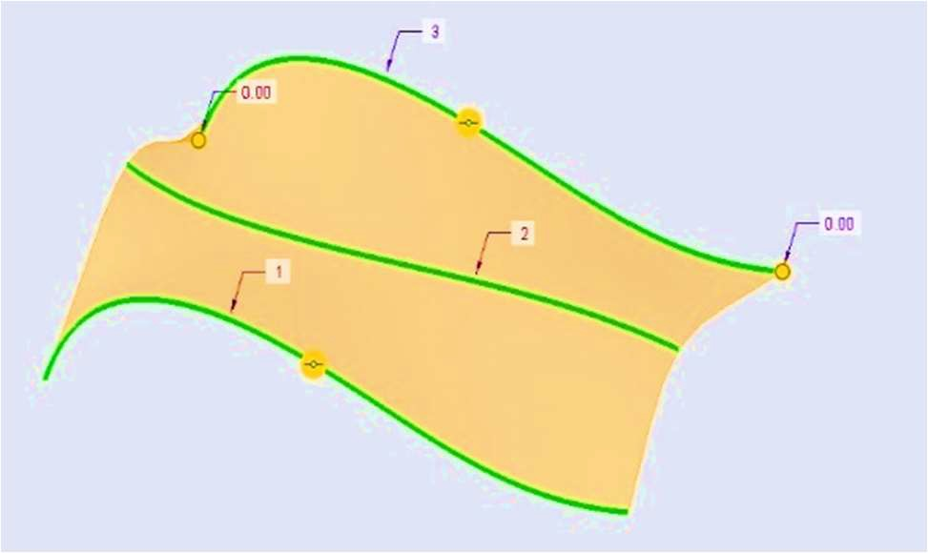

1. Click on second direction in the boundary blend dashboard.
2. Press CTRL Select the three curves in second direction.

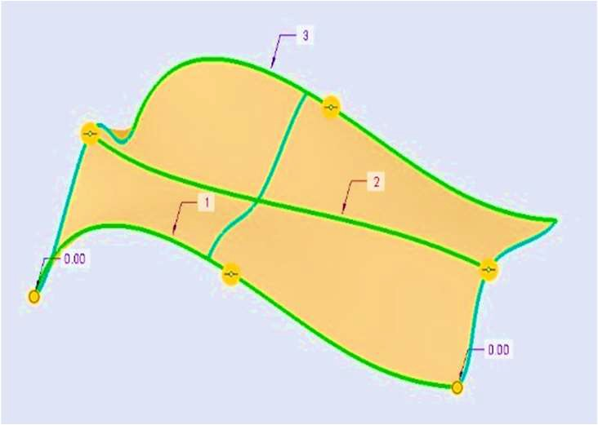 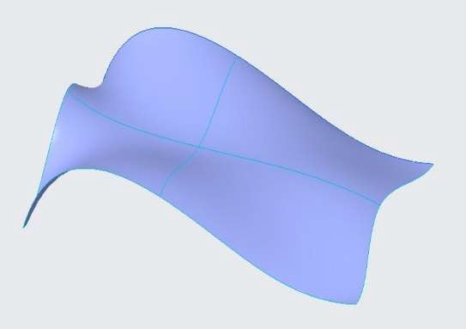

1. Click middle mouse button to finish the operation. Surface Geometry is created.

## *ANALYZING BLENDED SURFACE BOUNDARY CONDITIONS*

You can align the boundary of the surface edges with the existing geometry.

1. Open Boundary_Blend_Conditions.prt. Disable all the datum types.
2. Select Boundary Blend 2 from the model tree and Edit Definitions.
3. Open Constraints tab from the Boundary Blend dashboard.

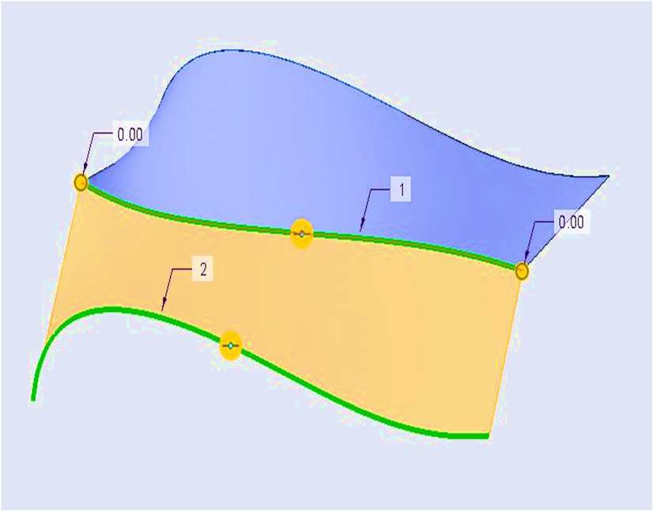 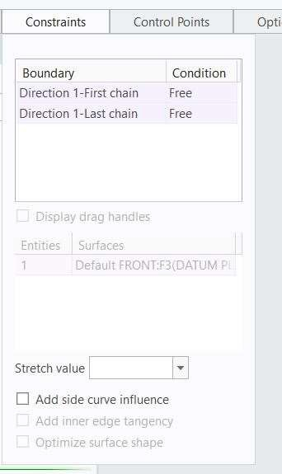

Free Boundary Condition

1. Change the boundary condition of first and second chain as Tangent and observe the result.
2. Change the boundary condition of first and second chain as Curvature and observe the result.
3. Change the boundary condition of first and second chain as Normal and observe the result.

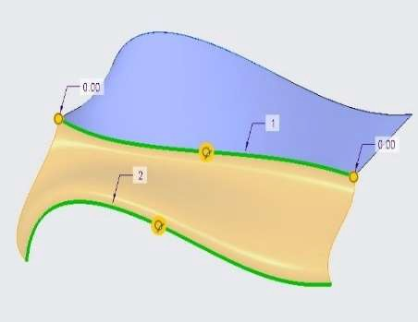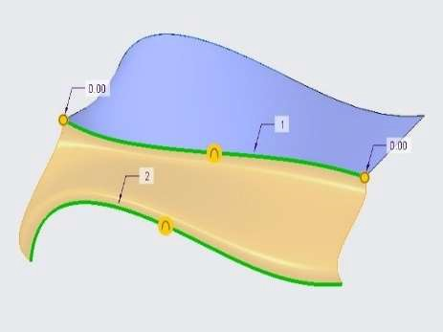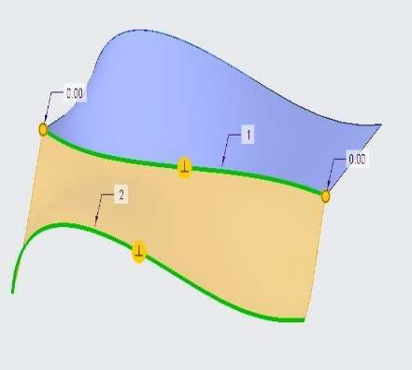

Tangent Boundary Condition Curvature Boundary Condition Normal Boundary Condition

*Note: - You can keep different boundary condition for first and second chain.*

## *ANALYZING BLENDED SURFACE CONSTRAINT OPTIONS*

You can apply multiple constraint option while creating a Boundary Blend surface feature.

1. Open Boundary_Blend_Constrain.prt. Disable all the datum types.

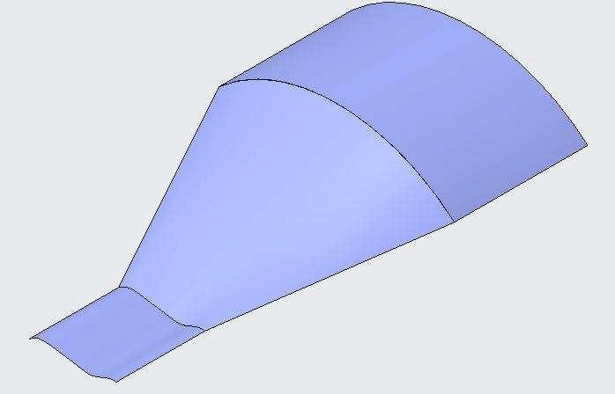 

1. Select Boundary Blend 1 from the model tree and Edit Definition.
2. Open Constraints tab from the Boundary Blend dashboard.
3. Drag each handle of the upper boundary to -100.

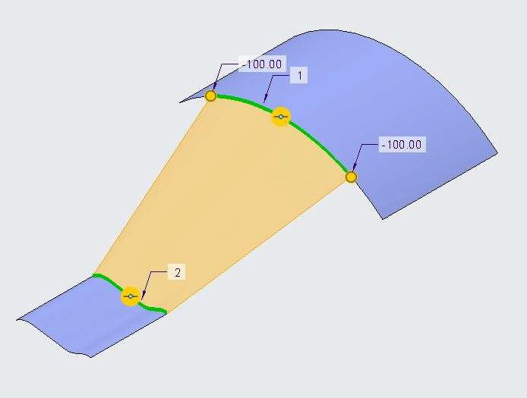

1. Double click each -100 value and make it 0
2. Change the boundary condition of first and second chain as Tangent and observe the result.
3. From the constraint bar, check Display Drag Handles check box.
4. Drag the drag handle of first and second chain to 2.

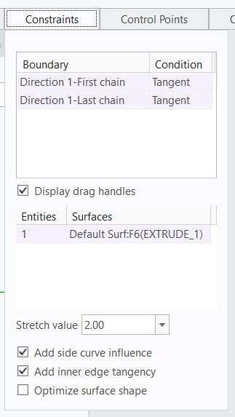 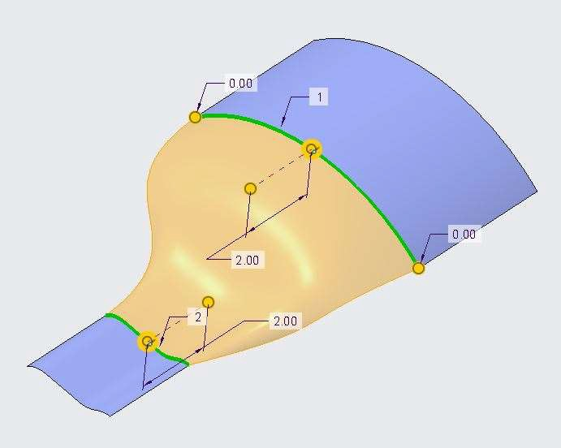

1. From the constraint bar, check Add Side Curve Influence check box.
2. Click middle mouse button to finish the operation. Surface Geometry is is modified.

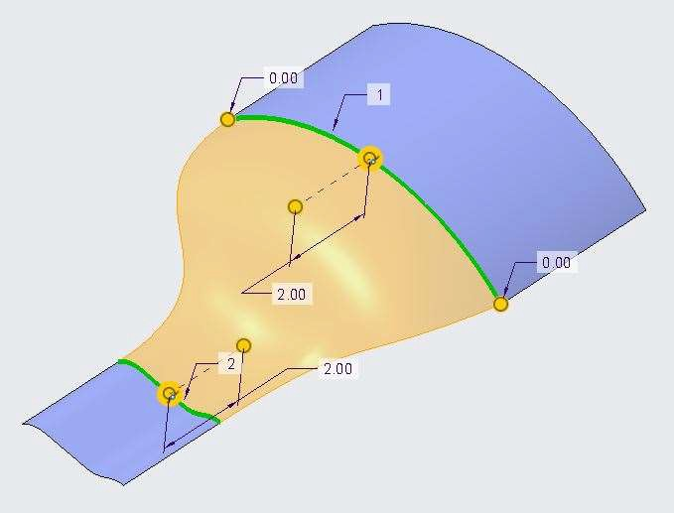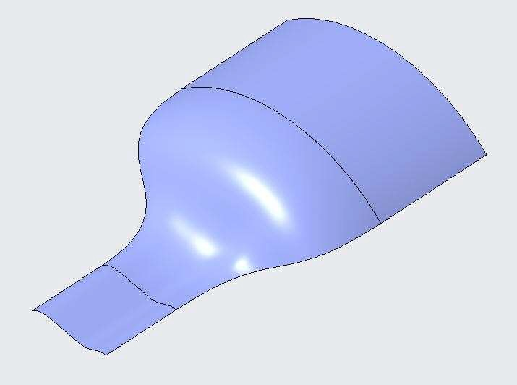

## *ANALYZING BLENDED SURFACE CONTROL POINTS*

You can add control points to help shape a surface by mapping locations on input curves.

1. Open Boundary_Blend_Control.prt. Disable all the datum types.

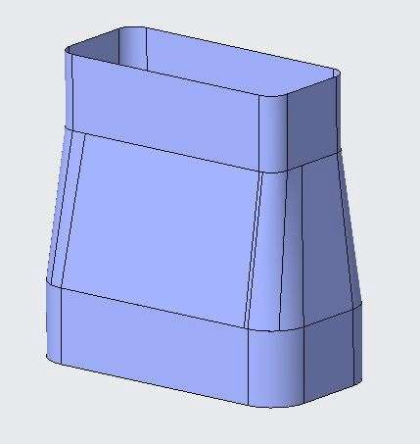

1. Select Boundary Blend 1 from the model tree and Edit Definition.
2. Open Control tab from the dashboard and select direction as first and select fit option as Natural.

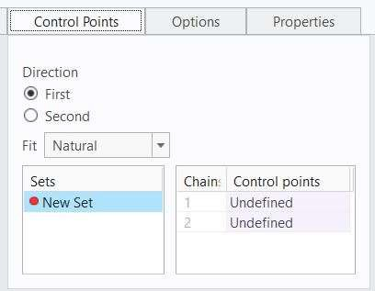

1. Click on undefined in chain 1 and select the point as shown below image.

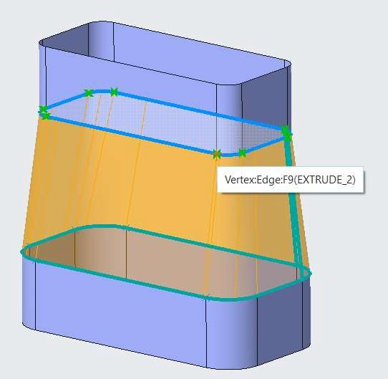

1. Now, Select the corresponding below point as shown in below image.

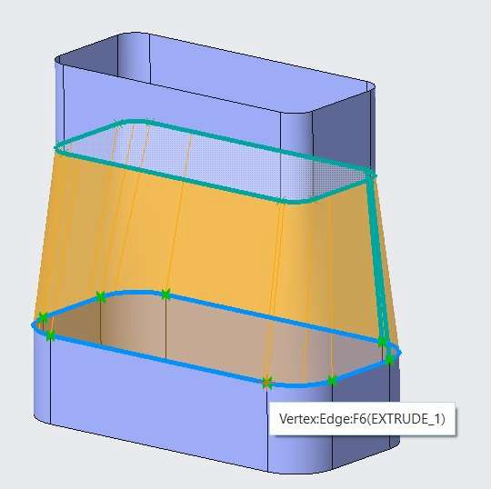

1. Notice that in controls points column undefined is changed to vertex.

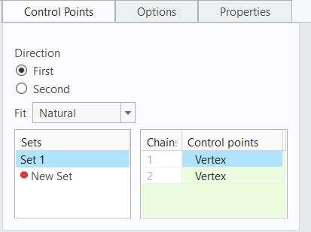

1. Select New Set in Controls Options tab, Repeat Steps 5 and 6 until all the fillet end points are aligned.
2. Click finish feature and observe the result.

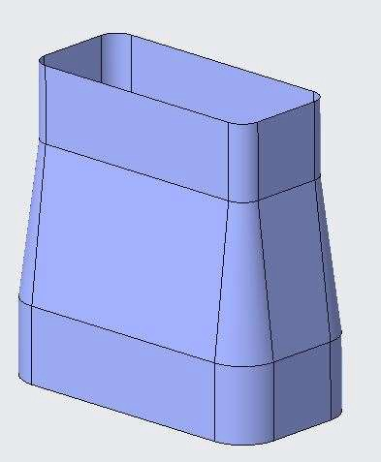

## *CREATING BOUNDARY BLENDS WITH INFLUENCING CURVES*

1. Open Boundary_Blend_Curves.prt. Disable all the datum Types.

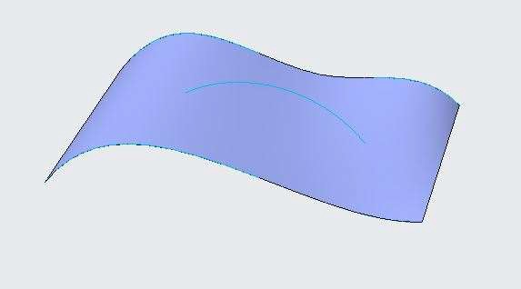 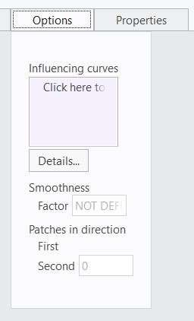

1. Select Boundary Blend 1 from the model tree and Edit Definition.
2. Open Options tab from the Boundary Blend dashboard.
3. Click on Influencing curve box to activate the option.
4. Select Sketch 3 (Arc).
5. Click Finish feature and observe the result.

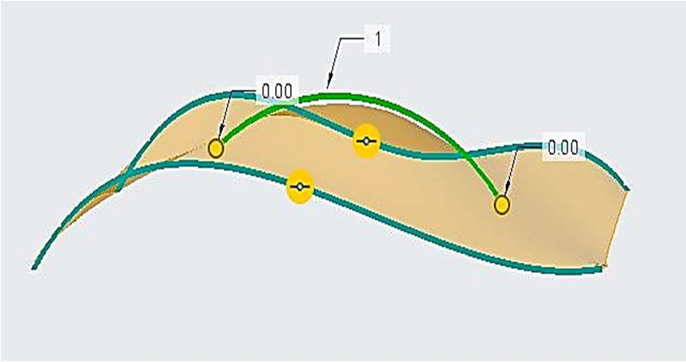 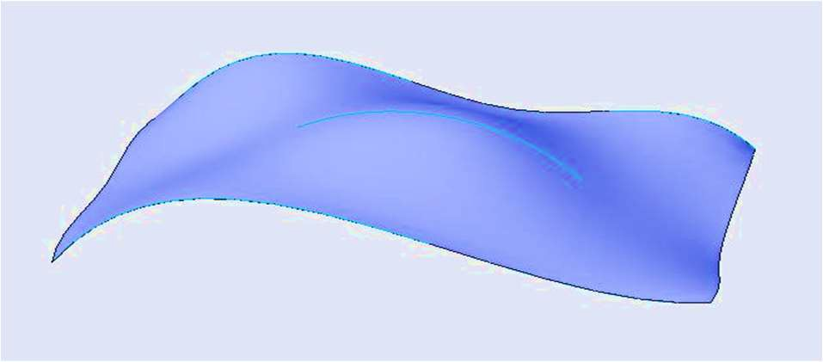

## *ANALYZING APPROXIMATE BLENDED SURFACE OPTIONS*

For a boundary blend surface using influencing curves, you can specify a smoothness parameter and the number

of surface patches.

1. Open Boundary_Blend_Curves.prt. Disable all the datum Types.

 

1. Select Boundary Blend 1 from the model tree and Edit Definition.
2. Open Options tab from the Boundary Blend dashboard.
3. Click on Influencing curve box to activate the option.
4. Select Sketch 3 (Arc).
5. Vary the smoothness factor between 0 to 1 and observe the changes.

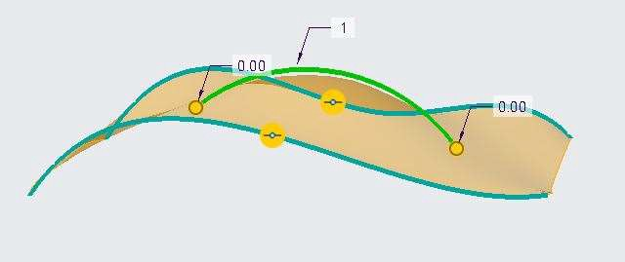 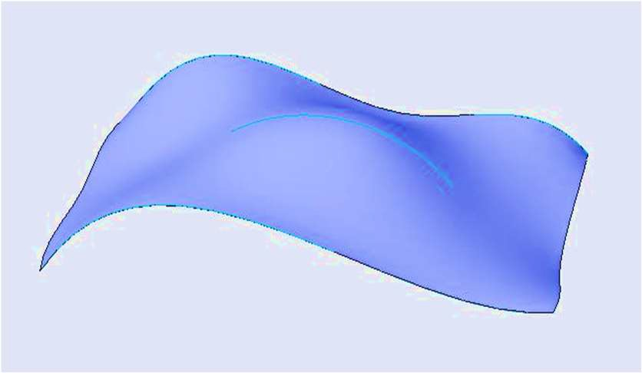

Influencing curve effect with smoothness factor 0.2

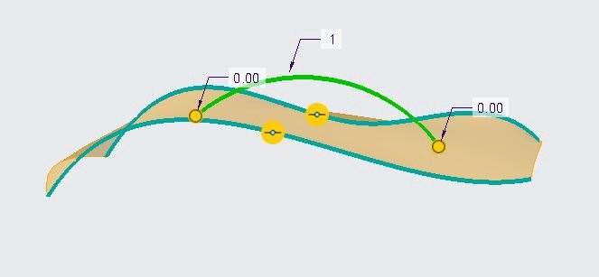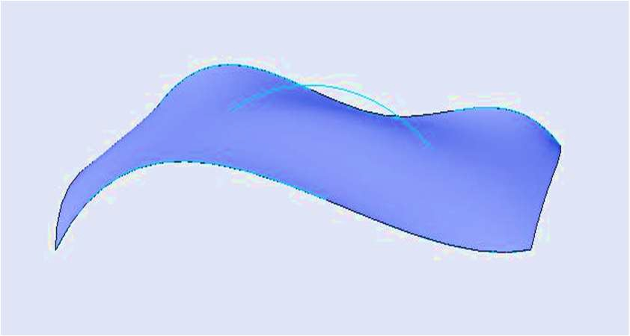

Influencing curve effect with smoothness factor 0.9

1. Click middle mouse button to finish the operation. Surface Geometry is is modified.

## *CREATING A BLEND TANGENT TO SURFACES*

The blend tangent to surfaces option enables you to create a surface blending from an edge or curve to tangent

surfaces.

1. Open Blend_Tangent_To_Surfaces.prt. Disable all the datum types.

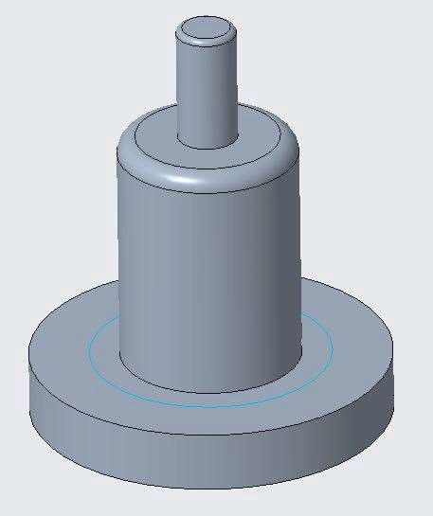 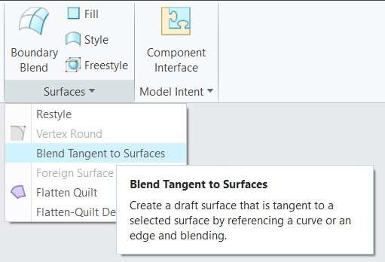

1. Select Blend Tangent to Surfaces command from Surface group drop down menu.
2. In the dialog box select Tangent Draft with Constant Draft Angle Outside of Drafted Surface option.
3. Select One Sided option in Direction option.
4. Select Top face of geometry as the direction.

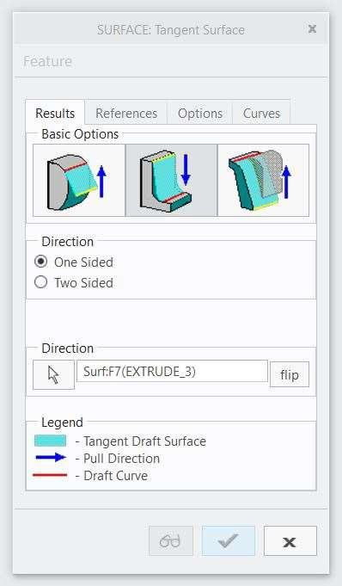 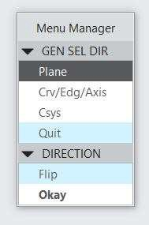

1. Flip to change the direction downwards in menu manager box and click okay.
2. Select the References tab in the dialog box.
3. In the menu manager box select Tangent Chain option.
4. Select Top face fillet edge as shown in below image and click Done in menu manager box.

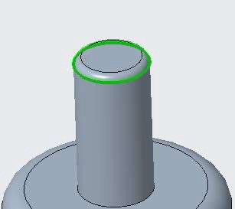 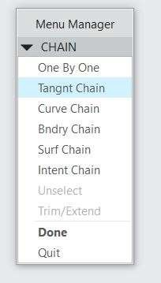

1. In dialog box, in Draft Parameters group, ENTER Angle = 10 and Radius = 10.
2. Click ok to complete the operation. Surface is created.

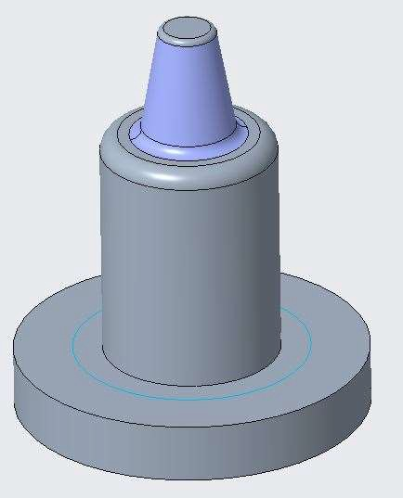

1. Select the surface created and select solidify command from the Editing group.
2. In Solidify dashboard, select Replace material and change Tool Direction.
3. Click Finish Feature. Hide Surface id from the model tree. Surface geometry is converted to solid geometry.

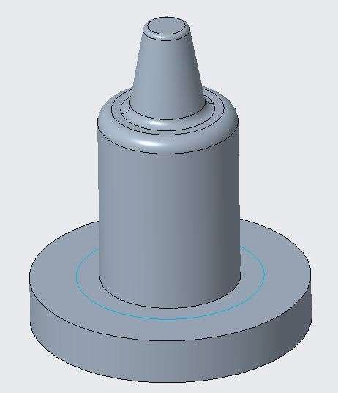

1. Select Blend Tangent to Surfaces command from Surface group drop down menu.
2. In the dialog box select Create Curve Driven Tangent Draft.
3. Select One Sided option in Direction option.
4. Select the face as shown in image below.

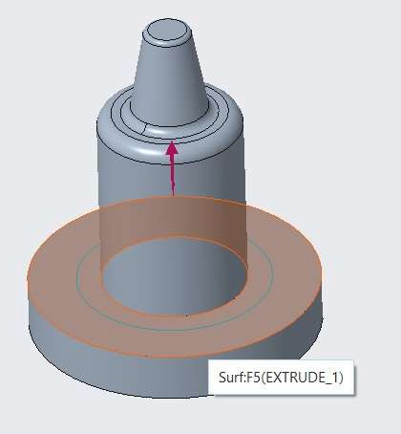 

1. Click Okay in menu manager box.
2. Select the References tab in the dialog box.
3. In dialog box, click on Draft Line selection and select the curve as shown in image below.
4. Click Done in menu manager box.

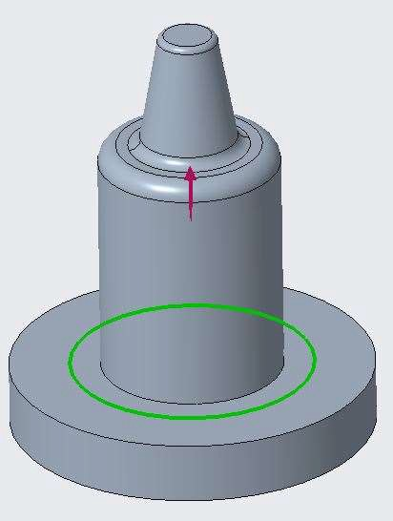 

1. In dialog box select Tangent to option and select the curve face as shown in image below.

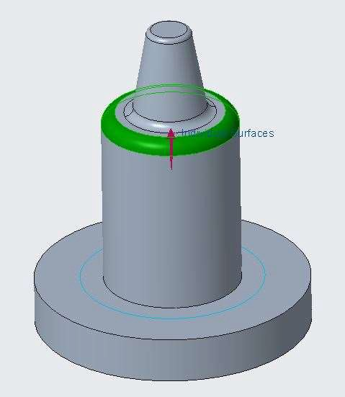 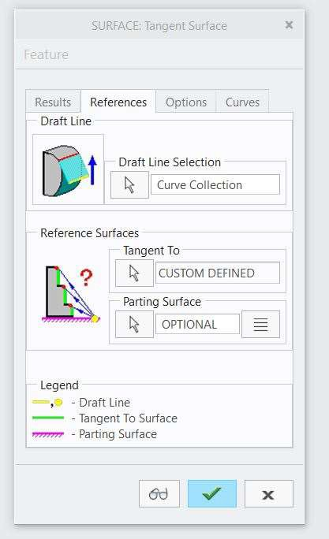

1. Click ok to complete the operation. Surface is created.
2. Select the surface created and select solidify command from the Editing group.
3. In Solidify dashboard, select Replace material.
4. Click Finish Feature. Hide Surface id from the model tree. Surface geometry is converted to solid geometry.

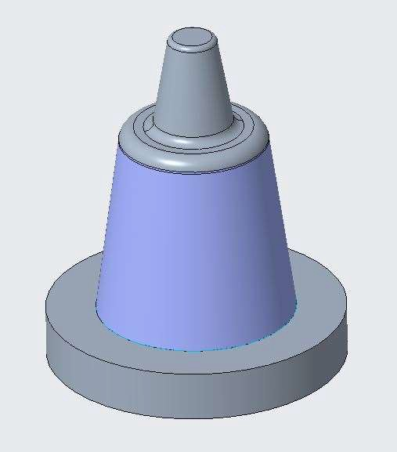 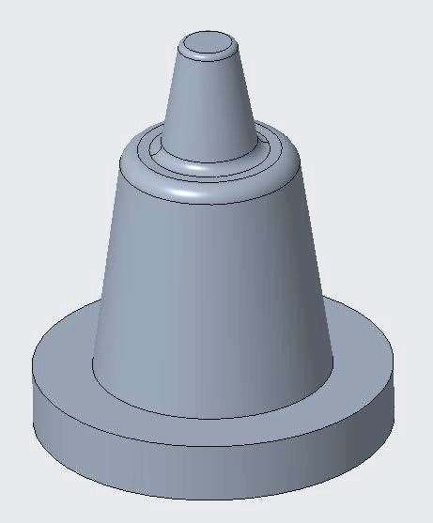

# *MODULE 5 - ANALYZING SURFACE CURVATURE*

*For the activity files browse to Analyzing Surface Curvature.*

## *ANALYZING SURFACES THEORY*

In the theory of surfaces, one examines the shape of a surface, its curvature,

the properties of various types of curves on a surface, aspects of deformation, the existence of a surface with given internal or external features, etc.

## *DEFINING CURVATURE*

The rate of change of direction of a curve with respect to distance along the curve. At every point on a circle, the curvature is the reciprocal of the radius.

That is, the curvature is K = 1/R

## *DEFINING CURVATURE CONTINUITY*

Two curves having a common point, tangent vectors lying along the same direction, and having the same curvature (which is, the same rate of change of the direction) are said to have curvature continuity.

## *ANALYZING CURVATURE OF CURVES*

The Curvature Analysis command visually evaluates surface curvature using false-color analysis. These tools can be used to gain information about the type and amount of curvature on a surface.

To Analyze the three types of curvature conditions in a part model.

1. Open Curvature_Analysis.prt. Disable all Datum Display types.

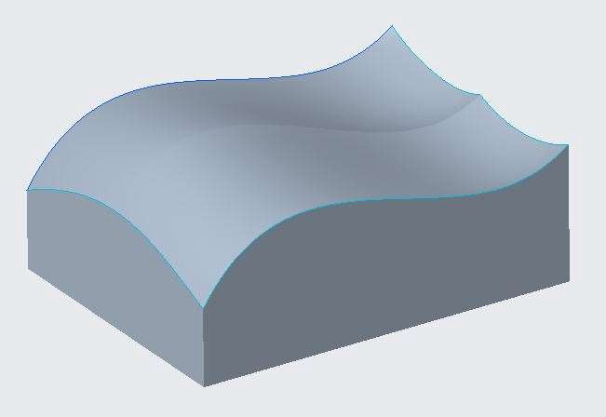

1. Select all the sketches one by one from the model tree to locate them on the model.
2. De-select all geometry.
3. Query and select the entire Sketch 3 from the model tree.
4. In the ribbon, select the Analysis tab.
5. Select Curvature from the Curvature types drop-down menu in the Inspect Geometry group.



1. In the Curvature Analysis dialog box, edit the Quality to 20, if necessary.
2. Drag the Scale upward to approximately –100.

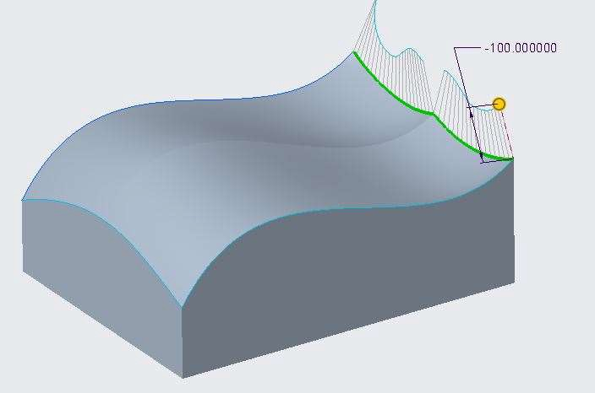

1. Notice the gap in the cENTER of the curvature plot. This curve has a free condition.
2. Select Quick as the analysis type in the Curvature Analysis dialog box, if necessary.
3. Click OK.
4. In the ribbon, click Curvature from the Inspect Geometry group.
5. Query and select the entire Sketch 2 from the model.
6. Drag the scale upward to approximately 100.

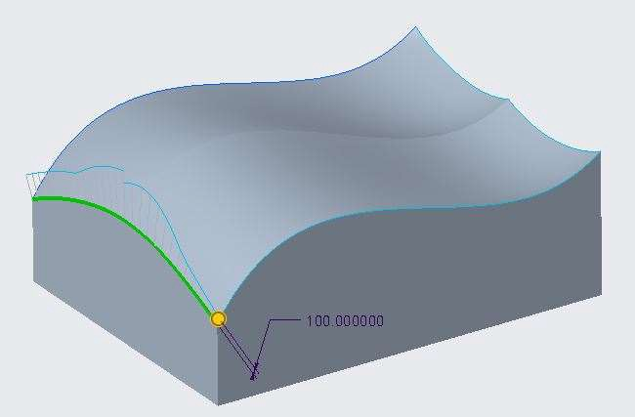

1. Notice the continuity in the curvature plot. This curve has a tangency condition.
2. Select Quick as the analysis type in the Curvature Analysis dialog box, if necessary.
3. Click OK.
4. In the ribbon, click Curvature from the Inspect Geometry group.
5. Select Sketch 1 from the model.
6. Drag the scale downward to approximately 100.

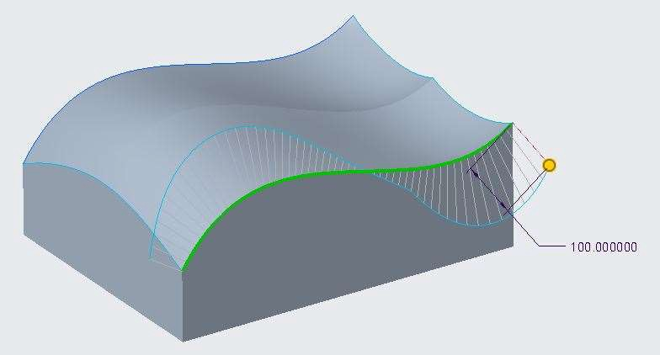

1. Notice the flow and inflection point in the CENTER of the curvature plot. This curve has a curvature continuity condition.
2. Select Quick as the analysis type in the Curvature Analysis dialog box, if necessary.
3. Click OK.

## *ANALYZING CURVATURE OF SURFACES*

Surface curvature analyses can be performed on a set of surfaces. All curves on the surface with the same tangent vector at a given point will have the same normal curvature, which is the same as the curvature of the curve obtained by intersecting the surface with the plane where R is the radius of curvature.

To Run a curvature analysis for a free condition between surfaces.

1. Open Curvature_Surface_Free.prt. Disable all Datum Display types.

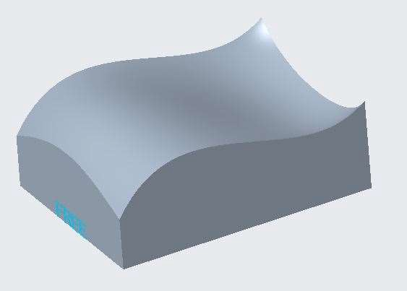

1. In the ribbon, select the Analysis tab.
2. Select Curvature from the Curvature types drop-down menu in the Inspect Geometry group.
3. Press CTRL and select both upper surfaces.
4. In the Curvature Analysis dialog box, edit the Number of plots in the first and second directions to 3 and 5, respectively.
5. Edit the Quality and 2nd Quality to 25.
6. Edit the Scale and 2nd Scale to 2 and 0, respectively.

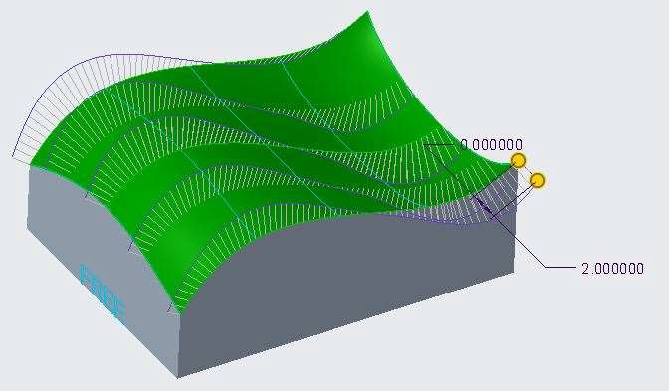

1. In the Curvature Analysis dialog box, edit the Scale and 2nd Scale to 0 and 5, respectively.

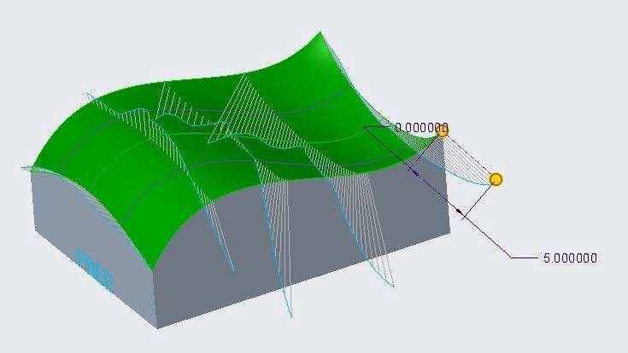

1. Select Quick as the analysis type, if necessary.
2. Click OK.
3. Click Close from the Quick Access toolbar.

To Run a curvature analysis for a tangent condition between surfaces.

1. Open Curvature_Surface_Tangent.prt. Disable all Datum Display types.

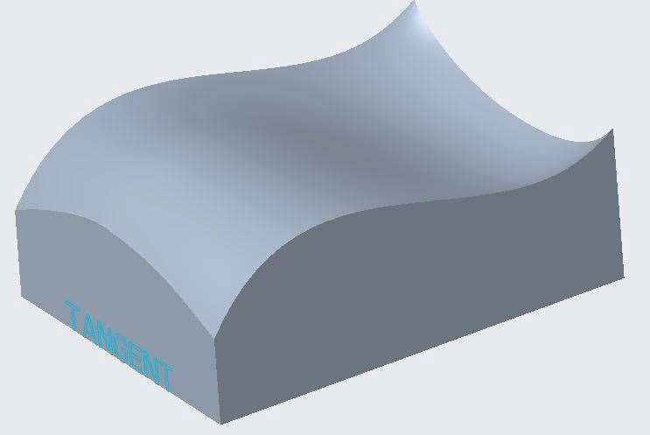

1. In the ribbon, select the Analysis tab.
2. Click Curvature from the Inspect Geometry group.
3. Press CTRL and select both upper surfaces.
4. In the Curvature Analysis dialog box, edit the Number of plots in the first and second directions to 3 and 5, respectively.
5. Edit the Quality and 2nd Quality to 25.
6. Edit the Scale and 2nd Scale to 2 and 0, respectively.

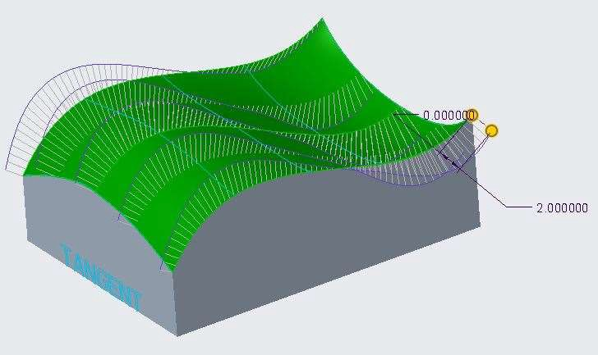

1. In the Curvature Analysis dialog box, edit the Scale and 2nd Scale to 0 and 5, respectively.

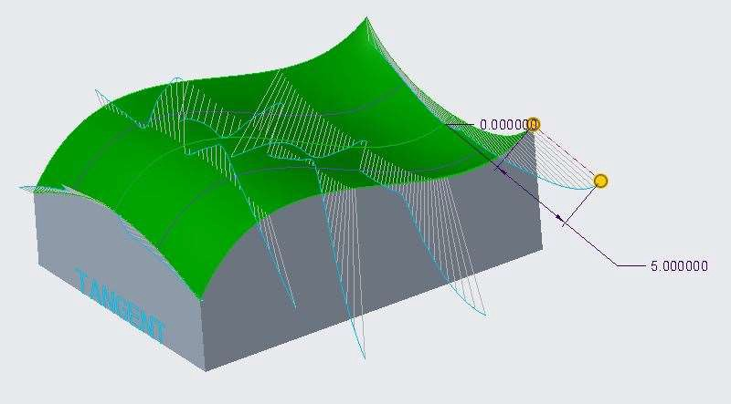

1. Select Quick as the analysis type, if necessary.
2. Click OK.
3. Click Close.

To Run a curvature analysis for a curvature condition between surfaces.

1. Click Open and double-click Curvature_Surface_Curvature.prt.

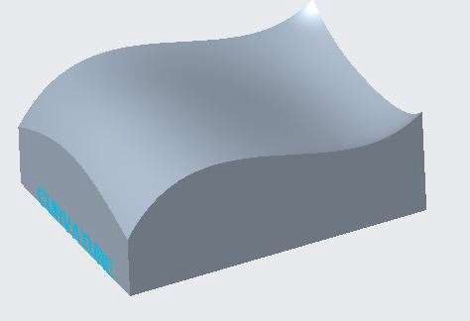

1. In the ribbon, select the Analysis tab.
2. Click Curvature from the Inspect Geometry group.
3. Press CTRL and select both upper surfaces.
4. In the Curvature Analysis dialog box, edit the Number of plots in the first and second direction to 3 and 5, respectively.
5. Edit the Quality and 2nd Quality to 25.
6. Edit the Scale and 2nd Scale to 2 and 0, respectively.

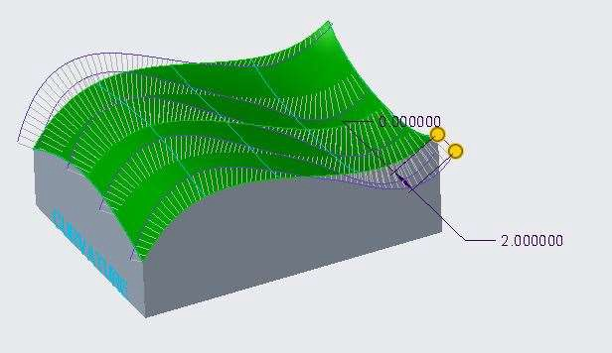

1. In the Curvature Analysis dialog box, edit the Scale and 2nd Scale to 0 and 5, respectively.

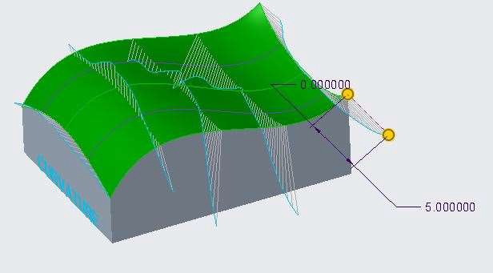

1. Select Quick as the analysis type, if necessary.
2. Click OK.

## *ANALYZING CURVATURE USING SECTIONS*

You can use the Curvature tool to display the curvature along sections for selected surfaces.

To run a curvature analysis using sections in a part model.

1. Open Curvature_Section.prt. Disable all Datum Display types.

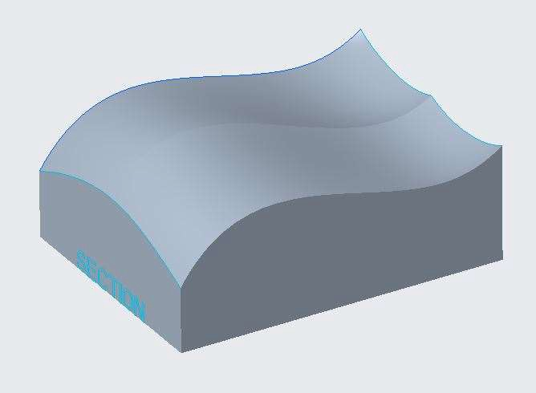

1. In the ribbon, select the Analysis tab.
2. Select Sections from the Geometry Report types drop-down menu in the Inspect Geometry group.
3. Press CTRL and select both upper surfaces.
4. Right-click and select Direction Collector.
5. Select the front surface.

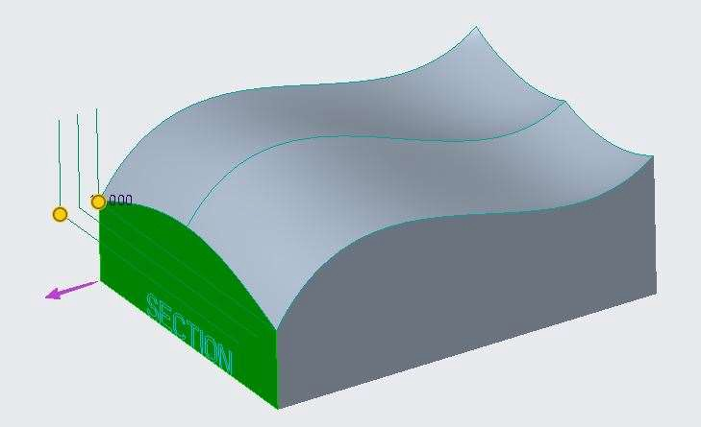

1. In the Sections Analysis dialog box, edit the Number of sections to compute to 5.
2. Edit Spacing to 24.
3. Edit Start to -98.
4. Edit Scale to 150.

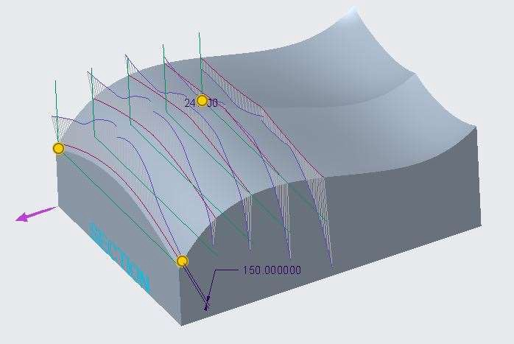

1. In the graphics window, right-click and verify that the Direction Collector is selected.
2. Select the side surface.
3. In the Sections Analysis dialog box, edit Number to 5.
4. Edit Spacing to 30.
5. Edit Start to -130.
6. Edit Scale to 20.

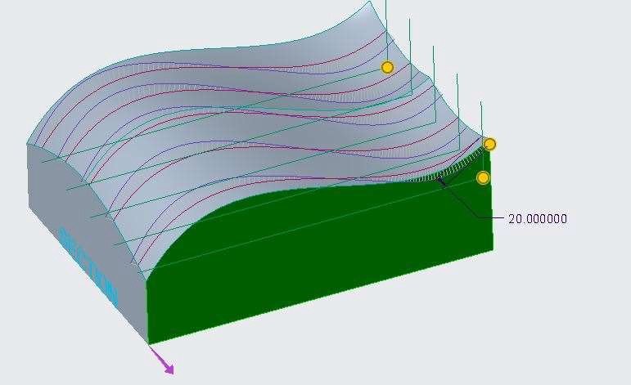

1. Select Quick as the analysis type, if necessary.
2. Click OK.

## *ANALYZING CURVATURE USING NORMALS*

You can use the Curvature tool to display the normal vectors for selected surfaces. Surface normals are displayed as arrows pointing normal to the surface at that location.

To run a normals curvature analysis on surfaces in a part model.

1. Open Surface_Normals.prt. Disable all Datum Display types.

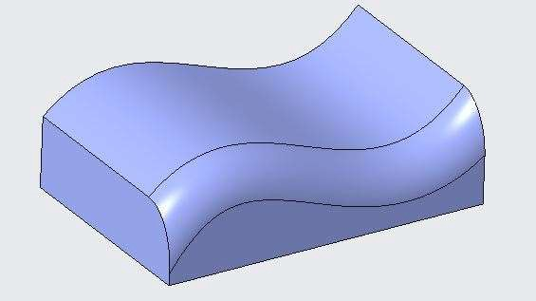

1. In the ribbon, select the Analysis tab.
2. Select Curvature from the Curvature types drop-down menu in the Inspect Geometry group.
3. Press CTRL and select the right half of the upper surface, the round surface, and the vertical right surface.
4. In the Curvature Analysis dialog box, edit the Plot type from Curvature to Normal.
5. Edit the Number of plots in the first and second direction to 5 and 6, respectively.
6. Edit Quality and 2nd Quality to 4 and 5, respectively.
7. Edit Scale and 2nd Scale to 0.5.
8. Select Saved as the analysis type, if necessary.
9. Click OK.

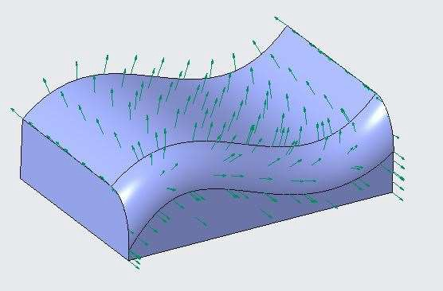

1. Edit the selection filter to Quilt.
2. Select the main upper quilt surface.
3. In the ribbon, select the Model tab.
4. Click the Editing group drop-down menu and select Flip Normal.
5. Click Repaint from the In Graphics toolbar.

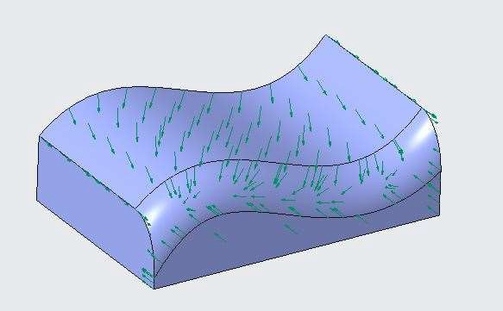

1. Notice the feature in the model tree.
2. Notice that the arrow direction updated.

## *USING SHADED CURVATURE ANALYSIS FOR SURFACES*

You can use the Curvature tool to display the shaded (or Gaussian) curvature for selected surfaces. The Gaussian curvature is defined as the product of the smallest and largest normal curvature for every point on the surface. The shaded curvature display plots the Gaussian curvature values for all points on the selected surfaces.

To run a shaded curvature analysis for a free condition between surfaces.

1. Click Open and double-click Shaded_Curvature_Free.prt. Disable all Datum Display types.

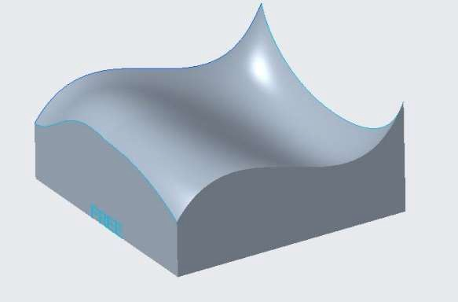

1. In the ribbon, select the Analysis tab.
2. Select Shaded Curvature from the Curvature types drop-down menu in the Inspect Geometry group.
3. Press CTRL and select both upper surfaces.
4. In the Shaded Curvature Analysis dialog box, edit the Plot type to Gaussian, if necessary.
5. Edit the Quality to 25.

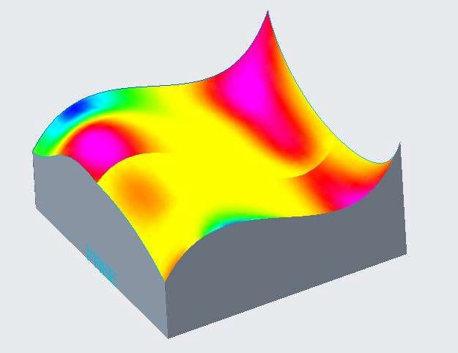

1. Notice how the colors flow, especially along the mid line of the surface.
2. Notice the color scale for the fringe plot, which indicates the degree of curvature.
3. Notice how the colors do not “flow” across the surface.
4. This surface has a free (C0) condition.
5. Select Quick as the analysis type, if necessary, and click OK.
6. Click Close from the Quick Access toolbar.

To run a shaded curvature analysis for a tangent condition between surfaces.

1. Click Open and double-click Shaded_Curvature_Tangent.prt.

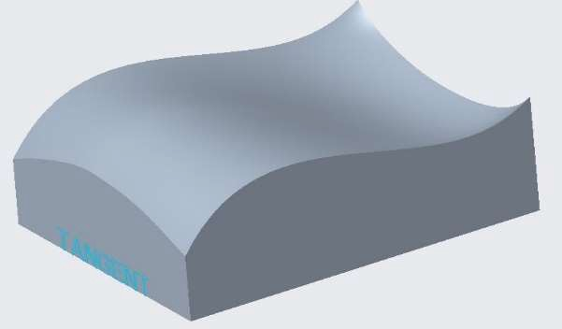

1. In the ribbon, select the Analysis tab.
2. Select Shaded Curvature from the Curvature types drop-down menu.
3. Press CTRL and select both upper surfaces.

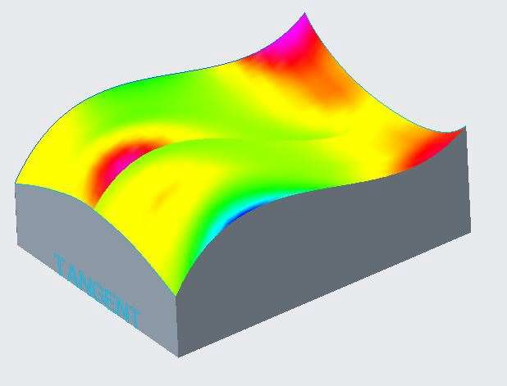

1. In the Shaded Curvature Analysis dialog box, edit the Quality to 25.
2. Notice how the colors flow, especially along the mid line of the surface.
3. Notice how the colors somewhat “flow” across the surface.
4. This surface has a tangent (C1) condition.
5. Select Quick as the analysis type, if necessary, and click OK.
6. Click Close.

To run a shaded curvature analysis for a curvature condition between surfaces.

1. Click Open and double-click Shaded_Curvature_Curvature.prt.



1. In the ribbon, select the Analysis tab.
2. Select Shaded Curvature from the Curvature types drop-down menu.
3. Press CTRL and select both upper surfaces.

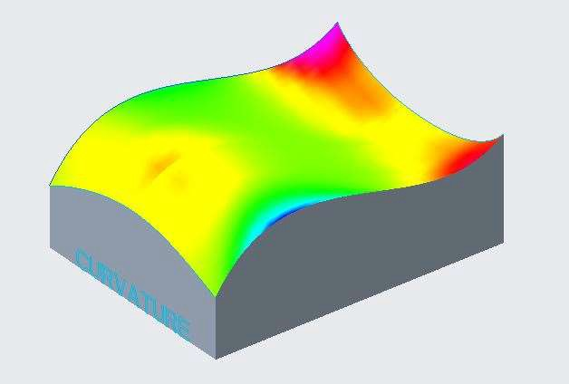

1. In the Shaded Curvature Analysis dialog box, edit the Quality to 25.
2. Notice how the colors flow, especially along the mid line of the surface.
3. Notice how the colors smoothly “flow” across the surface.
4. This surface has a curvature (C2) condition.
5. Select Quick as the analysis type, if necessary, and click ok

## *USING SHADED SECTION CURVATURE ANALYSIS*

You can use the shaded curvature tool to display the sectional curvature for selected surfaces, given a reference plane direction.

To run a shaded section curvature analysis for surfaces in a part model.

1. Open Shaded_Section_Curvature.prt. Disable all Datum Display types.



1. In the ribbon, select the Analysis tab.
2. Select Shaded Curvature from the Curvature types drop-down menu in the Inspect Geometry group.
3. In the Shaded Curvature Analysis dialog box, edit the Plot type to Section.
4. Edit the Quality to 25.
5. Press CTRL and select both upper surfaces.
6. Right-click and select Plane Collector.
7. Select the front surface.
8. Select Quick as the analysis type, if necessary, and click OK.

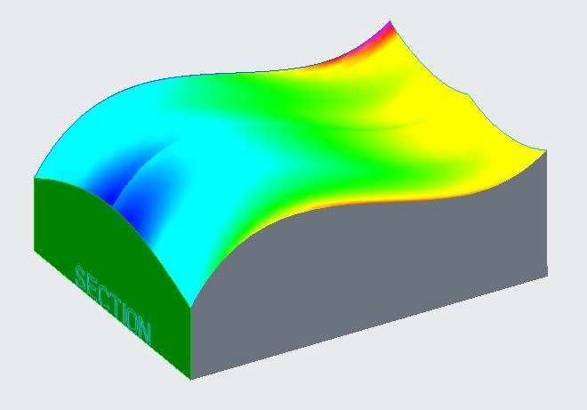

1. Select Shaded Curvature from the Curvature types drop-down menu.
2. Edit the Plot type to Section, if necessary.
3. Edit the Quality to 25, if necessary.
4. Press CTRL and select both upper surfaces.
5. Right-click and select Plane Collector.
6. Select the right-side surface.
7. Click OK.

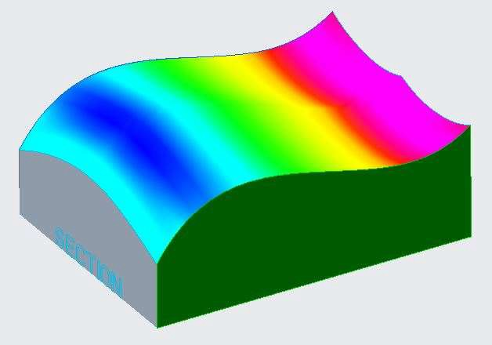

## *CREATING CURVATURE CONTINUOUS SURFACES*

To create curvature continuous surfaces, references such as curves or edges should have curvature continuity themselves. Boundary surfaces can be curvature continuous along one direction, while Style, or freeform, surfaces, can be curvature continuous in both directions.

To Create a curvature continuous surface in a part model.

1. Open Curvature_Continuous.prt. Disable all Datum Display types.

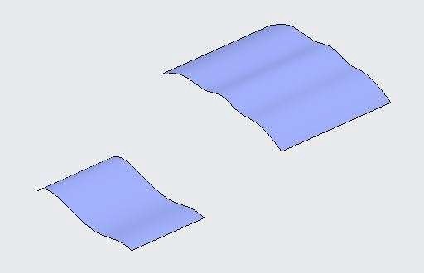

1. In the ribbon, click the Datum group drop-down menu and select Curve > Curve through Points.
2. Select the Right top vertex of left surface, then the top left vertex of right surface.

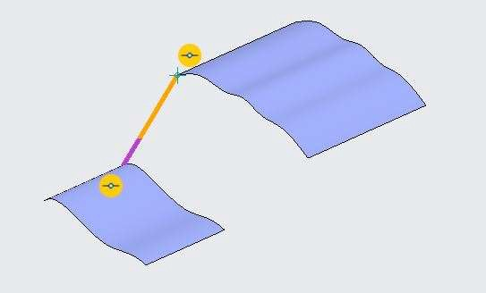

1. In the Curve Through Points dashboard, select the Ends Condition tab.
2. In the Ends Condition tab, select Start Point as the Curve side.
3. Select Tangent from the End condition drop-down menu.
4. Select the lower edge below the start point.
5. In the Ends Condition tab, select End Point as the Curve side.
6. Select Tangent from the End condition drop-down menu.
7. Select the upper edge above the end point.
8. In the Ends Condition tab, select Start Point as the Curve side.
9. Select Curvature continuous from the End condition drop-down menu.
10. In the Ends Condition tab, select End Point as the Curve side.
11. Select Curvature continuous from the End condition drop-down menu.

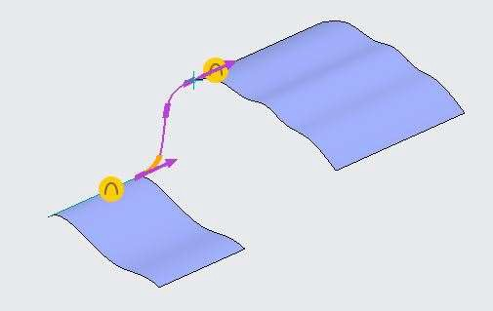

1. Click Complete Feature from the dashboard.

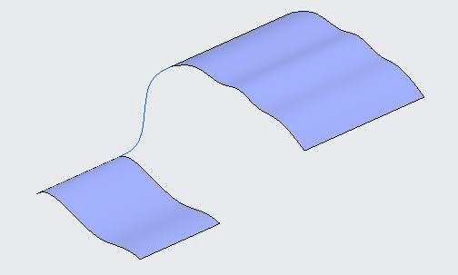

1. Repeat the procedure to create another curve through points that spans the gap on the bottom side of the model.

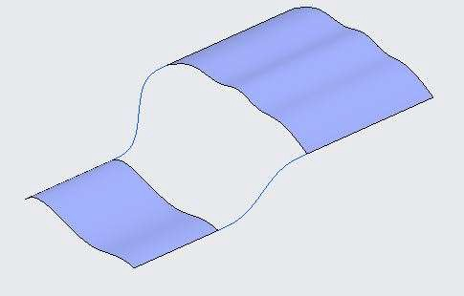

1. Click in the background to de-select all geometry.
2. Click Boundary Blend from the Surfaces Group.
3. Press CTRL and select the two horizontal surface edges.
4. Right-click and select Second Direction Curves.
5. Press CTRL and select the two curves you created.

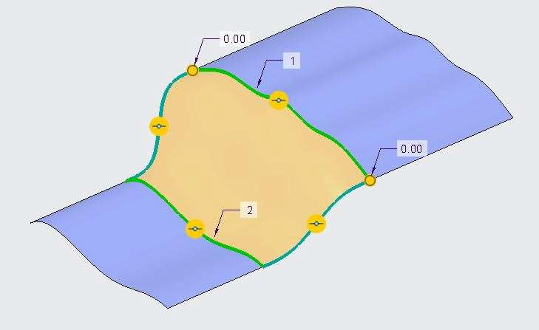

1. Set both horizontal boundaries tangent to their adjacent surfaces.

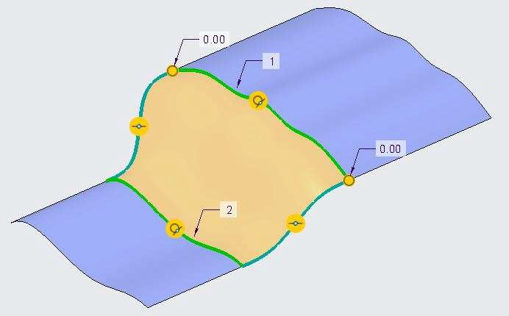

1. Click Complete Feature from the Boundary Blend dashboard.

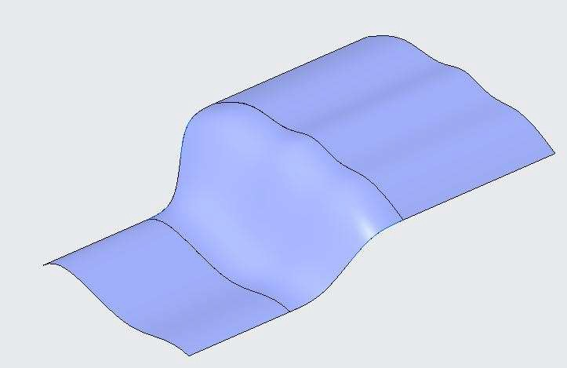

1. In the ribbon, select the Analysis tab.
2. Select Shaded Curvature from the Curvature types drop-down menu in the Inspect Geometry group.
3. In the Shaded Curvature Analysis dialog box, edit the Plot type to Gaussian, if necessary.
4. Press CTRL and select the central boundary surface you just created, followed by the outer main surfaces.

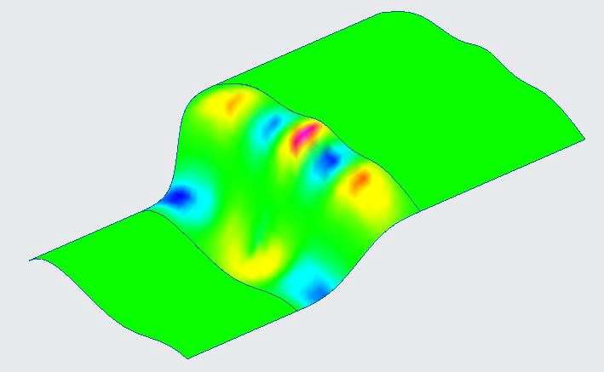

*Notice how the color flow stops abruptly along the blended surface.*

1. Select Saved as the analysis type and click OK.
2. Edit the definition of Boundary Blend 1.
3. Right-click both tangent horizontal boundaries and select Curvature.
4. Click Complete Feature from the Boundary Blend dashboard.

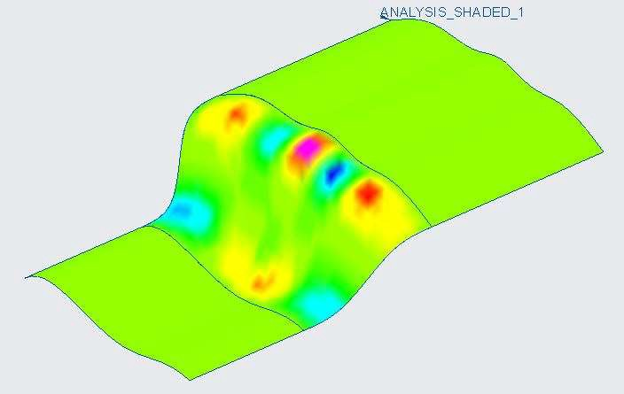

1. Click No Hidden and notice that the analysis has updated.

## *ANALYZING CONNECTIONS*

You can select individual surfaces, quilts, or surface edges to analyze surface connections. The Connection Analysis dialog box is available in the following two locations:

* From the Analysis tab, click the Inspect Geometry group drop-down menu and select Connection.
* Within the Style dashboard, click Connection from the Analysis group.

To analyze connections between two selected quilts.

1. Open Analyze_Connections.prt. Disable all the datum types.

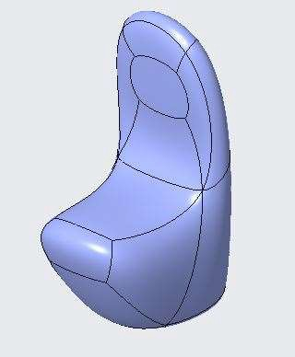

1. Select Quilts from the Selection Filter in the status bar.
2. Press CTRL and select Top sitting base face and vertical right face of chair.

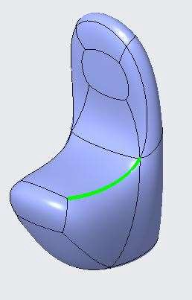

1. In the ribbon, select the Analysis tab.
2. Click the Inspect Geometry group drop-down menu and select Connection.
3. Select Position (G0) as the Connection type.
4. Verify the Intersection only check box is selected.
5. Set Tolerance to 0.01 mm.
6. Click OK from the Connection Analysis dialog box.
7. Again, Press CTRL and select Vertical Oval shaped face and right adjacent face.

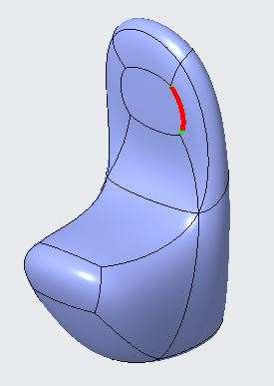

1. In the ribbon, select the Analysis tab.
2. Click the Inspect Geometry group drop-down menu and select Connection.
3. Select Tangency (G1) as the Connection type.
4. Verify the Intersection only check box is selected.
5. Set Tolerance to 2 degrees.
6. Click OK from the Connection Analysis dialog box.
7. Again, Press CTRL and select Horizontal sitting base face and adjacent vertical face.

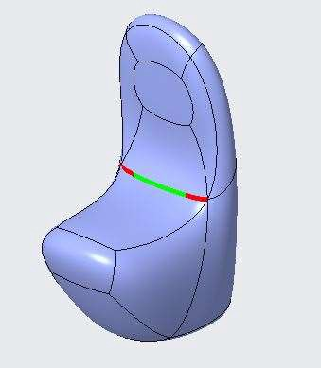

1. In the ribbon, select the Analysis tab.
2. Click the Inspect Geometry group drop-down menu and select Connection.
3. Select Curvature (G2) as the Connection type.
4. Verify the Intersection only check box is selected.
5. Set Tolerance to 1%.
6. Click OK from the Connection Analysis dialog box.
7. Close the part without saving it.

To analyze connections on a whole surface Quilt.

1. Open Analyze_Connections.prt. Disable all the datum types.
2. Select complete surface geometry.
3. In the ribbon, select the Analysis tab.
4. Click the Inspect Geometry group drop-down menu and select Connection.
5. Select Position (G0) as the Connection type.
6. Verify the Intersection only check box is cleared.
7. Set Tolerance to 0.01 mm.

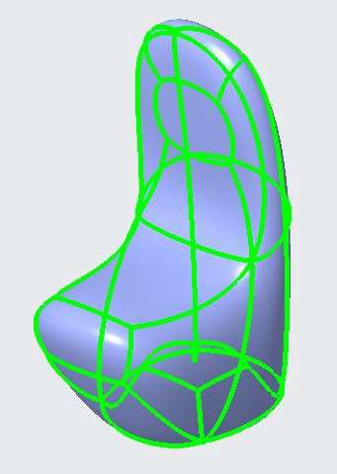

1. Notice the Position Check Passes.
2. Select Tangency (G1) as the Connection type.
3. Verify the Intersection only check box is Cleared.
4. Set Tolerance to 1 degree.

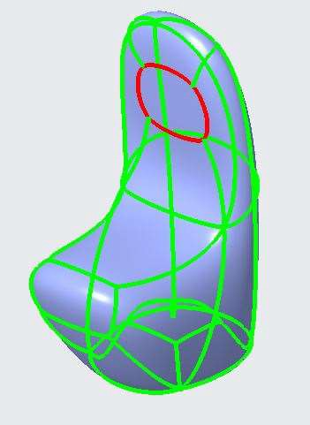

1. Notice the Tangency check fails at vertical face as there is some sharp edges.
2. Select Curvature (G2) as the Connection type.
3. Verify the Intersection only check box is Cleared.
4. Set Tolerance to 1%.

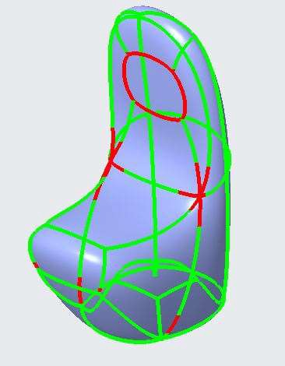

1. Notice the Curvature check has failed.
2. Expand the Display options.
3. Select the Show only connections that fail check box.
4. Notice the Curvature check has failed and notice the new edges that display.
5. Select Show spikes as the Style option.
6. Set the Scale to –2.0.

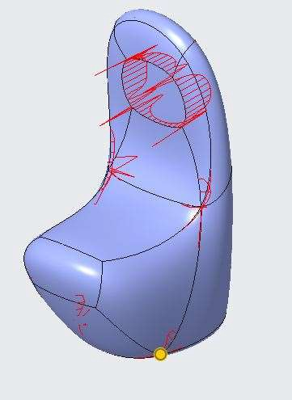

1. Select Enable tooltips and cursor over the tall spike.
2. Click OK from the Connection Analysis dialog box.

# *MODULE 6 - EXTENDING AND TRIMMING SURFACES*

*For the activity files browse to folder Extending and Trimming Surfaces.*

## *EXTENDING SURFACES*

You can extend a surface by selecting an edge, multiple edges, or a face.

1. Open Extend.prt. Select an edge at right side of the surface geometry.

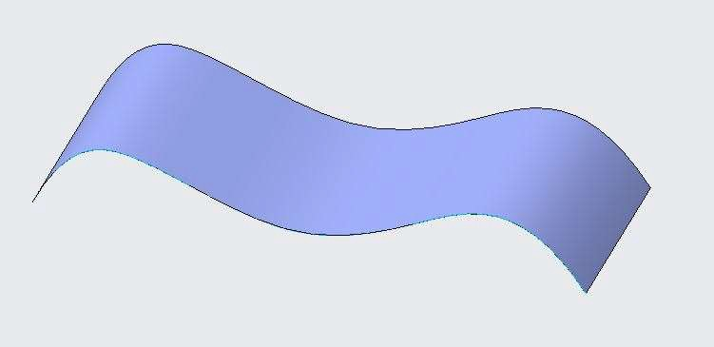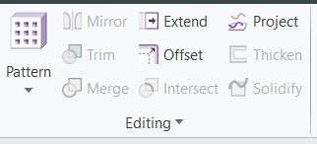

1. Open Extend command from the Editing Group.
2. From the Extend command dashboard, ENTER extend value to -150.

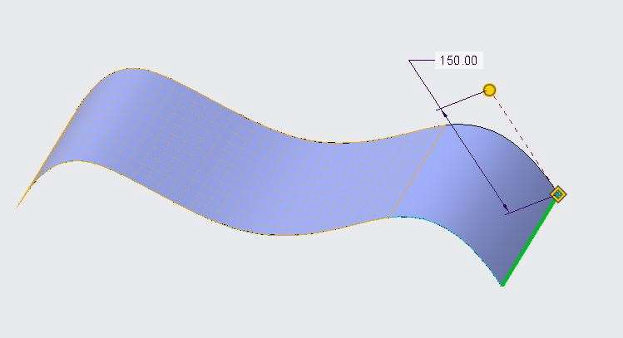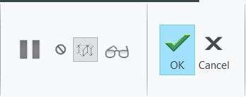

1. Click on preview feature from the dashboard and observe that the surface geometry is trimmed.
2. Click on Resume feature from the dashboard.
3. Drag the value to 150 away from the surface geometry.
4. Click on preview feature from the dashboard and observe that the surface geometry is Extended.

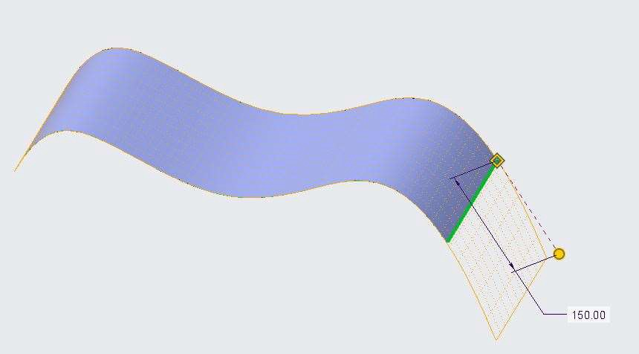

1. Click on Resume feature from the dashboard.
2. Open Options tab from the Extend dashboard and change method type to Tangent.

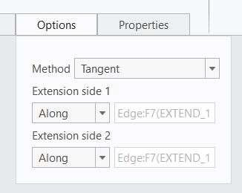 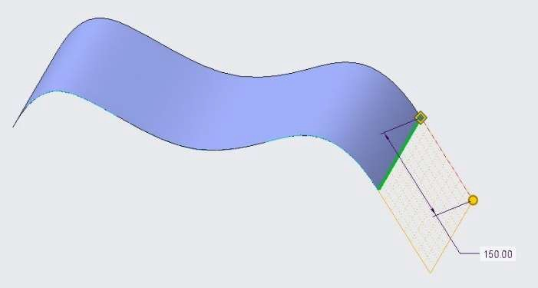

1. Click on preview feature from the dashboard and observe that the surface geometry is Extended.
2. Click on Resume feature from the dashboard.
3. Display the datum planes from the display group.
4. From the Extend dashboard select Extend the surface to the reference plane option. 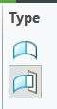
5. Select the top plane. Obseve the surface geometry is extended to the selected plane.

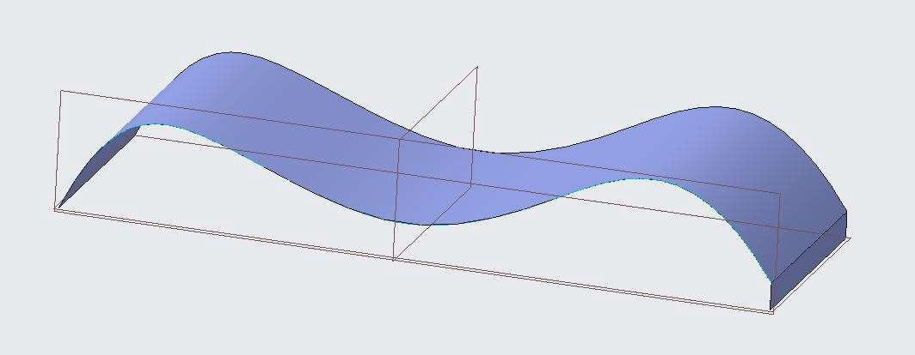

1. Click finish feature from the dashboard.

## *EXTENDING SURFACES USING MEASUREMENTS*

You can extend a surface by selecting an edge, with variable values of extension at different locations.

1. Open Extend.prt. Select an edge at right side of the surface geometry.

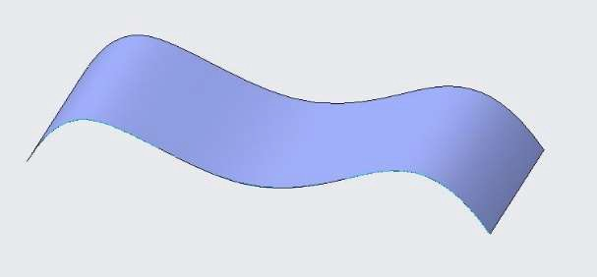 

1. Open Extend command from the Editing Group.
2. Open Measurements tab in the Extend dashboard command.
3. ENTER the value 50 in distance option.
4. Right click the in the Measurements tab and click add and ENTER the distance value as 35 and in location column ENTER value as 0.35.
5. Repeat Step 5 with following values as shown in below.

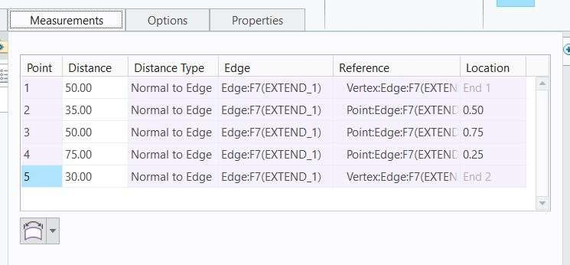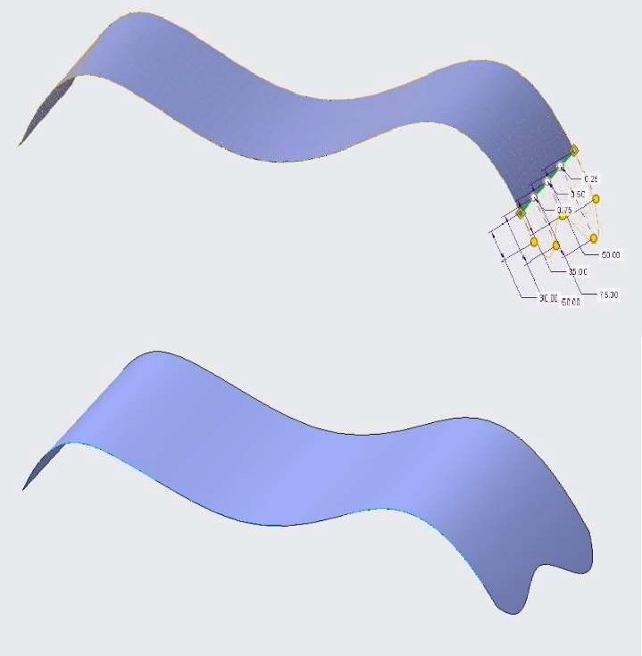

1. Click finish feature from the dashboard. Observe the result.

## *ANALYZING EXTEND SURFACE OPTIONS*

You can extend and measure sides of a surface geometry by various options.

1. Open Extend.prt. Select an edge at right side of the surface geometry.
2. Open Extend command from the Editing Group.
3. ENTER the Extend value to 100.

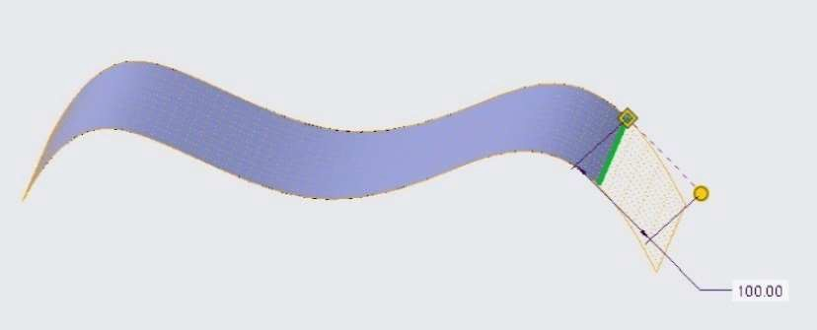

1. Open measurements tab and Select Measure the extension distance in the selected plane.
2. Select the top plane. Observe the result.
3. Click the finish feature to finish the operation.

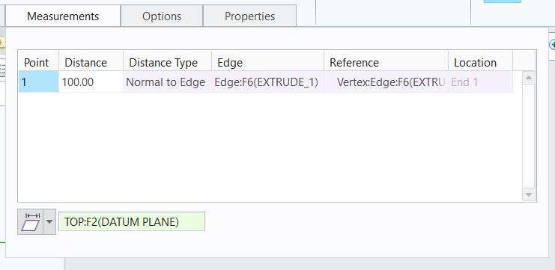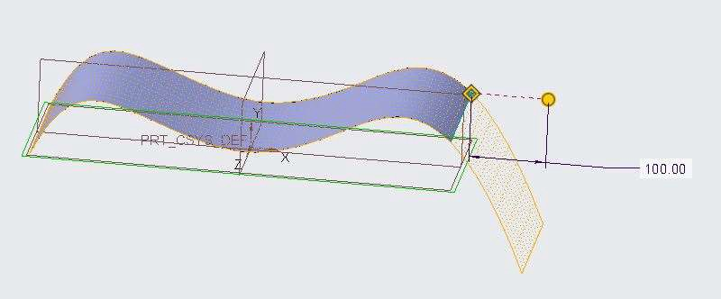

## *CREATING A SURFACE TRIM*

You a trim a portion of the surface with the help of another surface. It is similar to remove material of Extrude command.

1. Open Surface_trim.prt. Disable all the datum types.
2. Change the display style to Hidden line. Observe the geometry.

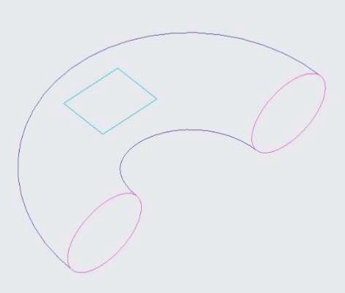

1. Select Extrude command from the surface group.
2. In the Extrude command dashboard select Extrude as Surface.

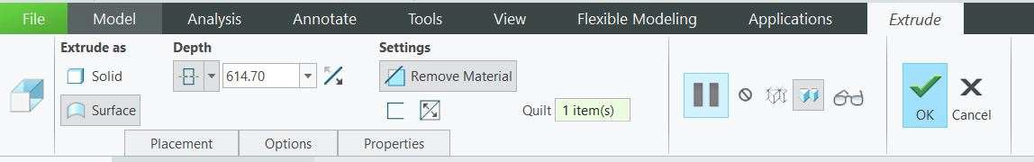

1. Select Sketch 1 from the model tree.
2. Drag the drag handle so that it crosses the first surface geometry.
3. In the Extrude command dashboard select Remove Material and select displayed surface in the quilt box.
4. Change the display style to Shaded with Edges.

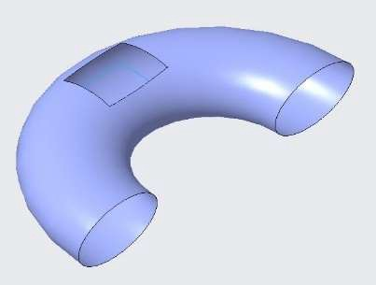

1. Click preview feature from the Extrude dashboard. The surface is trimmed.
2. Click resume feature from the Extrude dashboard.
3. In the Extrude command dashboard select depth option as symmetric.
4. Drag the drag handle so that it crosses the first surface geometry on both sides.
5. The surface is trimmed on both sides. Click finish feature to finish the operation.

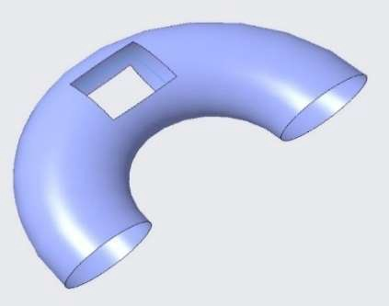

## *TRIMMING SURFACES WITH GEOMETRY*

You a trim a Surface Geometry with reference to another surface geometry as an trim tool.

1. Open trim.prt. Disable all the datum types.
2. Select the Extrude 1 as the trim sheet and Select Trim command from the Editing group.

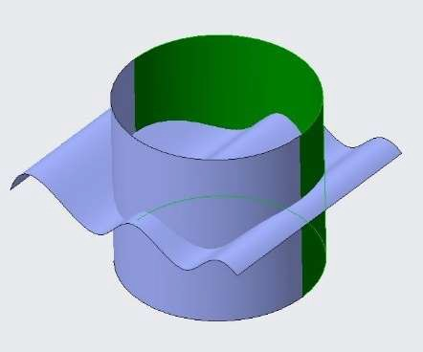 

1. Select the Extrude 2 as trim tool.

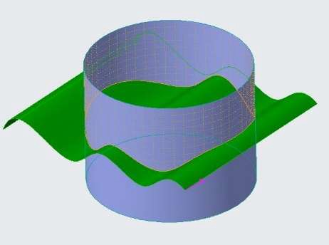 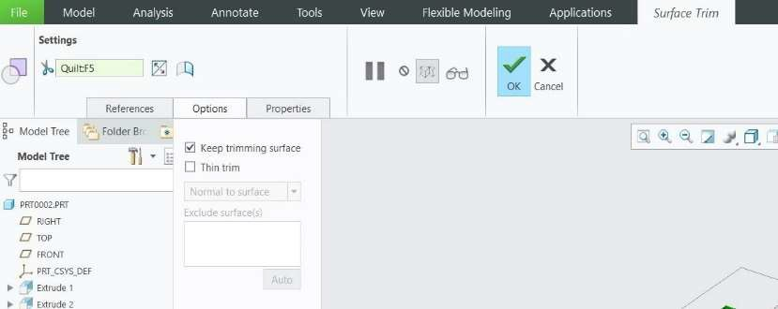

1. Click preview feature, the cylindrical surface is trimmed.
2. Click resume feature and click on Flip options in the Trim command dashboard to switch from one side, other side and both sides of trimmed surface to keep.
3. Observe the result by using filp options one by one.

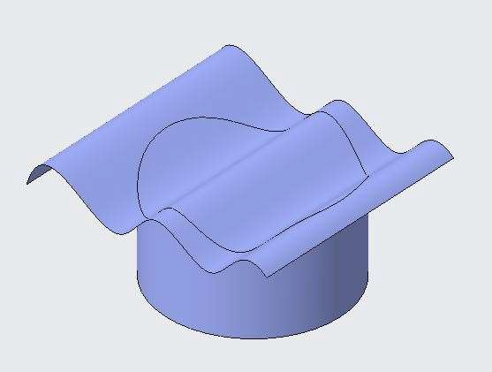 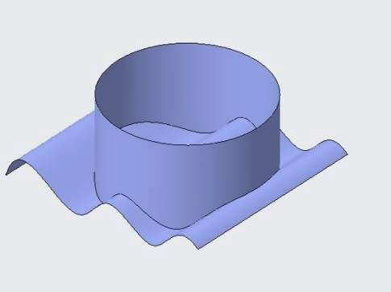

1. You can repeat the steps by using curve Extrude 2 as the trim sheet and Extrude 1 as the Trim tool.

## *TRIMMING SURFACES WITH QUILTS OPTIONS*

You can trim a sheet with quits with various available options.

1. Open trim.prt. Disable all the datum types.
2. Select Extrude 2 as the trim sheet and Select Extend command from the Editing group.



1. Select the Extrude 1 sheet as trim tool.
2. In the options tab check Keep trimming surface check box. Trimming surface is visible.

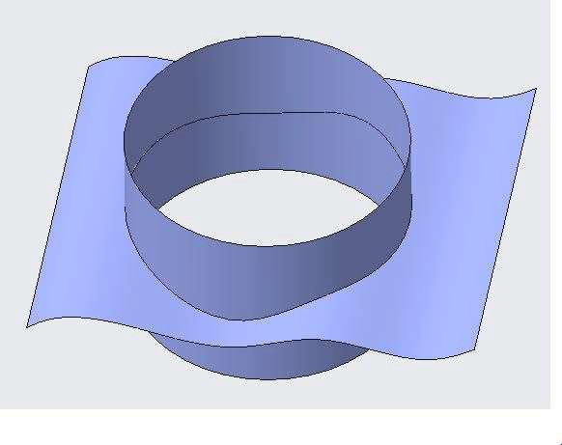 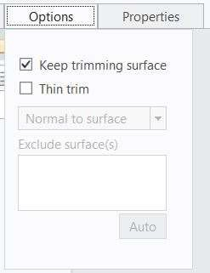

1. In the options tab Select the clear Keep trimming surface check box. Trimming surface is invisible.

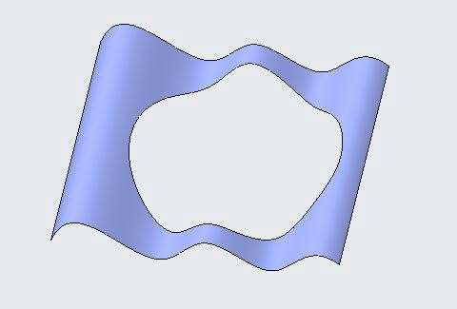

1. Again, Select the check Keep trimming surface check box. Trimming surface is visible.
2. In the options tab check Thin trim check box. ENTER the Thin trim value 20.
3. Surface is trimmed with a gap of 20.

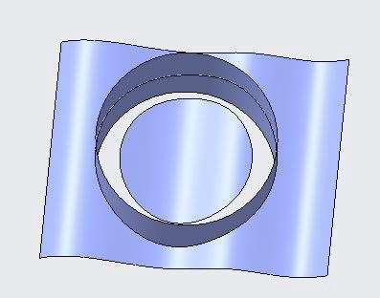 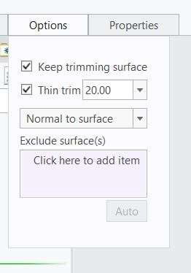

## *TRIMMING SURFACES WITH THE SILHOUETTE TRIM OPTION*

The Silhouette Trim option enables you to trim a surface quilt based on the outline of the quilt shape as viewed

from a view direction reference.

1. Open Trim_Silhouette.prt. Disable only the datum planes. Hide top and front plane from model tree.
2. Select the surface geometry and Select the Trim command from the Editing group.

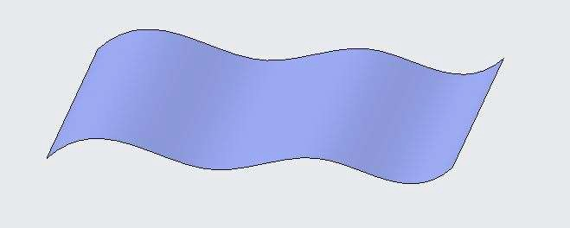 

1. Select the Right plane displayed on the screen.
2. Select the Silhouette option from the Trim dashboard.
3. Click preview feature from the dashboard. Observe the result.
4. Click Resume feature from the dashboard.
5. Use flip option from the dashboard and observe the trim by switching between one side, other side and both sides of trimmed surface to keep.

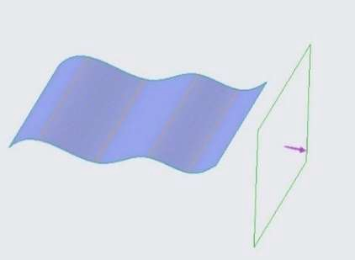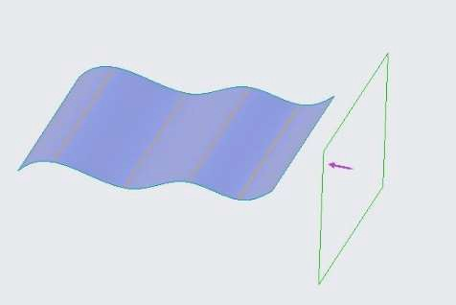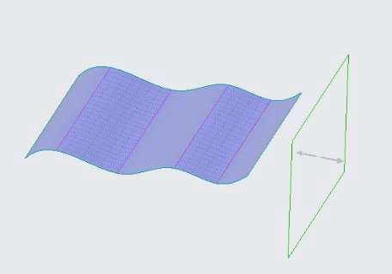

One side of trimmed surface other side of trimmed surface Both side of trimmed surface

## *TRIMMING SURFACES WITH THE VERTEX ROUND OPTION*

You can trim the corners of a surface geometry using the Vertex Round Option.

1. Open Vertex_Round.prt. Display all the datum types.
2. Select Vertex command from the Surfaces group drop down.

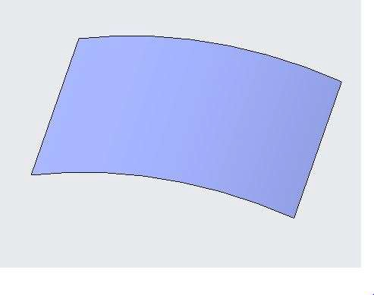 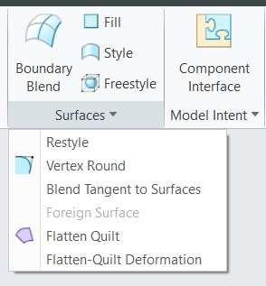

1. Press CTRL and select all the corners of the surface geometry.
2. ENTER the round value 50 in the dashboard.

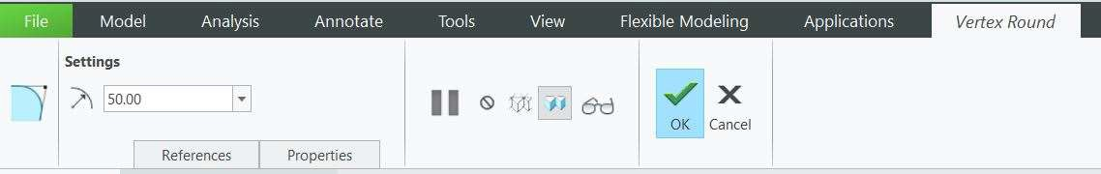

1. Click finish feature. All the corners are trimmed as fillet.

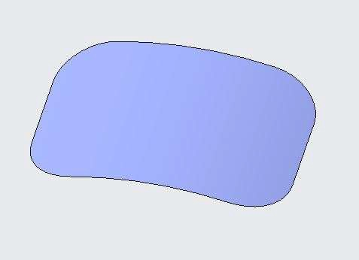

# *MODULE 7 - MANIPULATING SURFACES*

*For the activity files browse to folder Manipulating Surfaces.*

## *COPYING AND PASTING SURFACES*

Copying and Pasting a surface creates an overlay copy of the surface. You can then manipulate the copied surface.

To Copy and paste surfaces in a part model.

1. Open Copy_Paste.prt. Disable all Datum Display types.

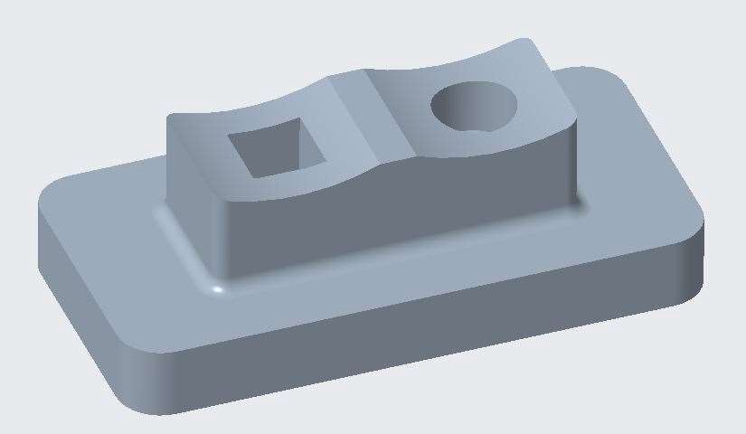

1. Select the entire top surface as shown below.

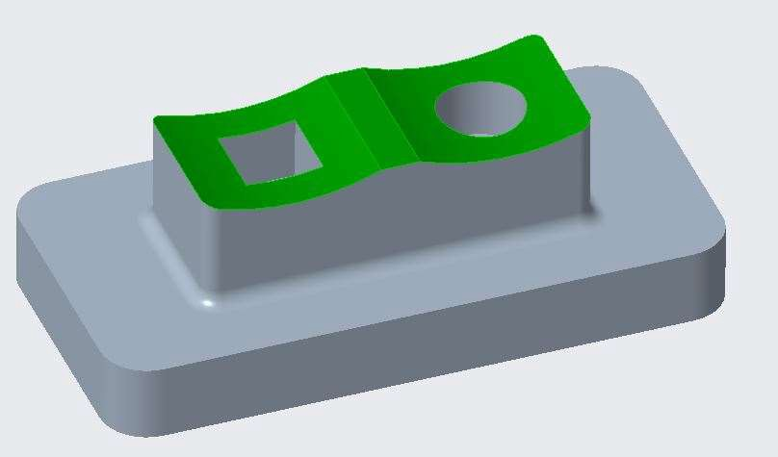

1. In the ribbon, click Copy from the Operations group.



1. In the ribbon, select Paste from the Paste types drop-down menu in the Operations group.
2. In the Surface Copy dashboard, select the Options tab.
3. Select the Copy all surfaces as is option, if necessary.

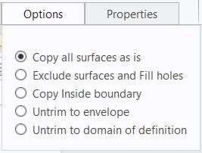

1. Click Complete Feature.

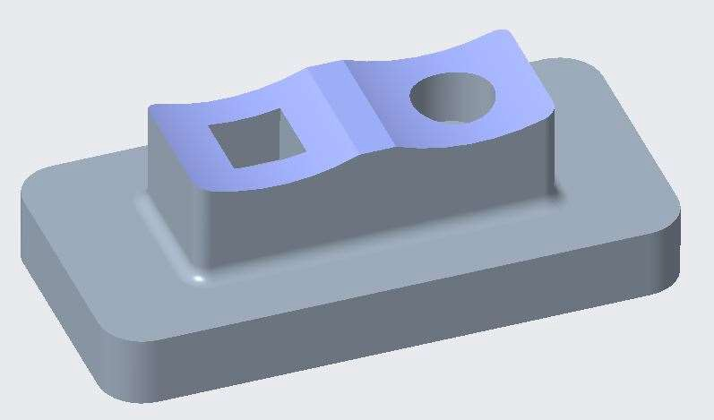

1. Select Copy 1 and click Hide from the mini toolbar.
2. Select the entire top surface again.
3. Click Copy from the Operations group.
4. Click Paste. From the Operations group.
5. Press CTRL and select the cENTER rectangle to exclude it.

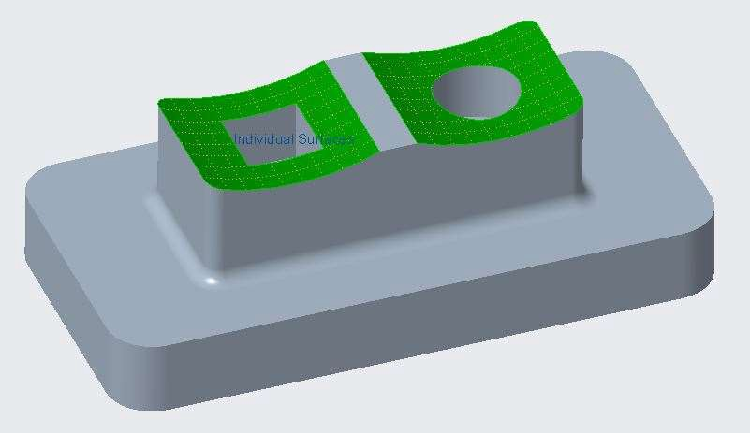

1. Click Complete Feature.

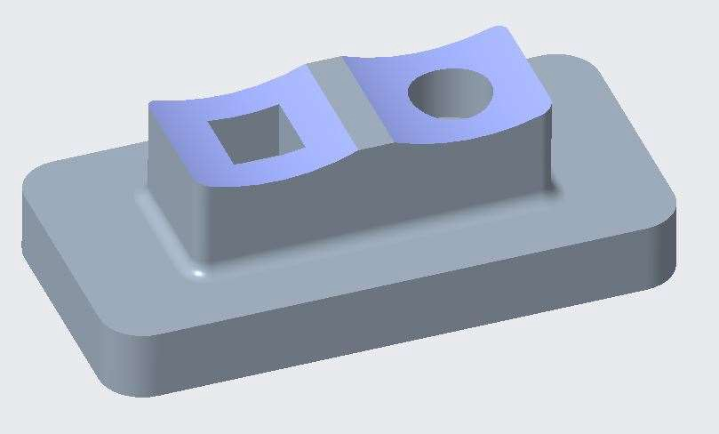

1. Select Copy 2 and click Hide from the mini toolbar.
2. Select the entire top surface again.
3. Click Copy from the Operations group.
4. Click Paste. From the Operations group.
5. Select the Options tab.
6. Select Exclude surfaces and Fill holes.

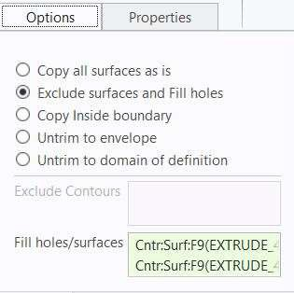

1. Press CTRL and select the edges of the square cut and round hole.

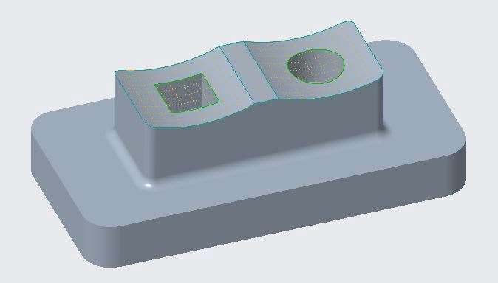

1. Click Complete Feature.

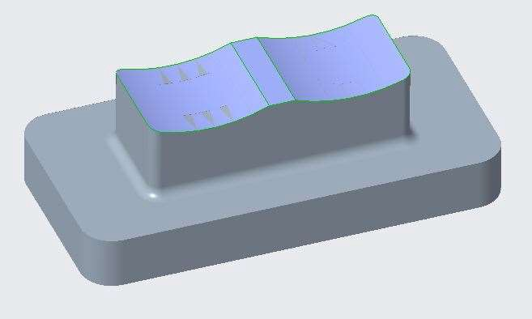

1. Select Copy 3 and click Hide from the mini toolbar.
2. In the model tree, select Project 1 and click Unhide from the mini toolbar.

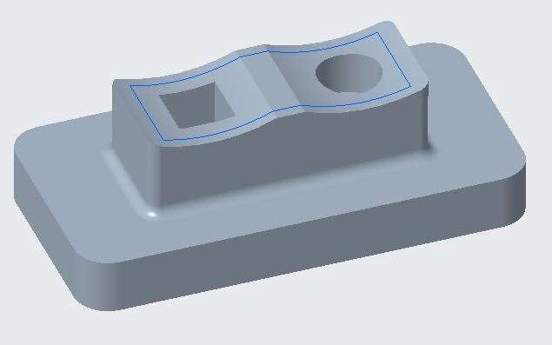

1. Select the entire top surface again.
2. Click Copy from the Operations group.
3. Click Paste from the Operations group.
4. Select the Options tab.
5. Select Copy Inside boundary.

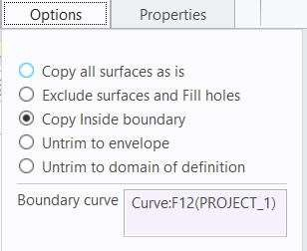

1. Query select the entire projected curve.

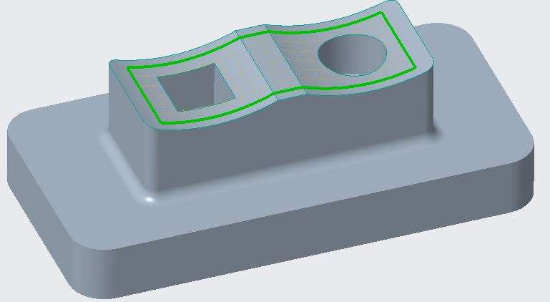

1. Click Complete Feature.

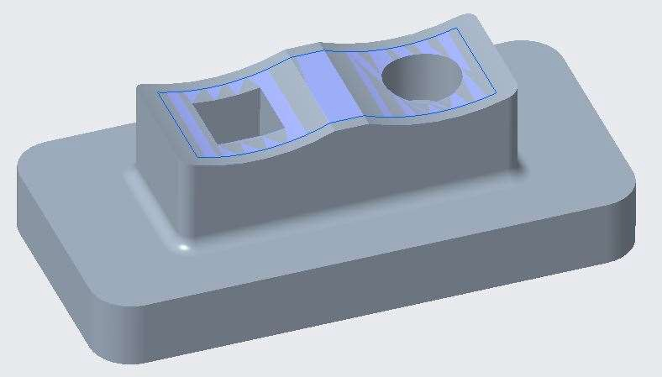

## *OFFSETTING SURFACES*

You can create a surface quilt by offsetting a surface or a solid surface at certain value.

1. Open Offset_Surface.prt. Disable all the datum types.
2. Select the surface geometry and select Offset Command from the Editing group.

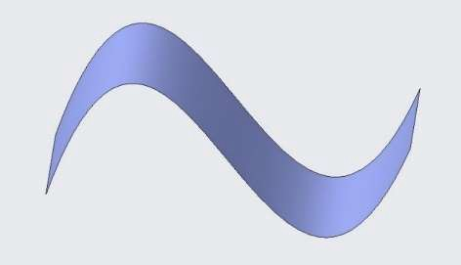

1. In Offset dashboard, ENTER offset value as 30.
2. Click preview feature and observe the result.
3. Click resume feature.

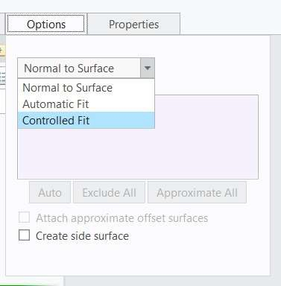

1. From the options tab, select offset type Automatic fit.
2. Click preview feature and observe the result.
3. Click resume feature.
4. From the options tab, select offset type Controlled fit.
5. Click preview feature and observe the result.

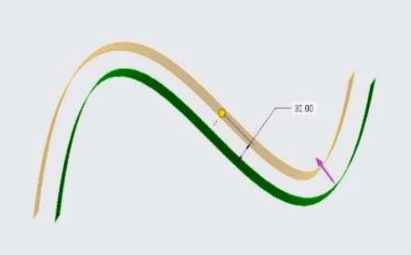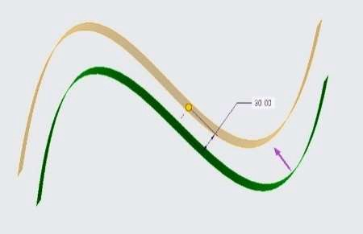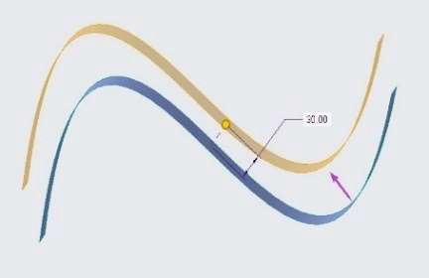

Normal to Surface Automatic Fit Controlled Fit

1. Click resume feature.
2. From the options tab, check Create Side Surface check box.

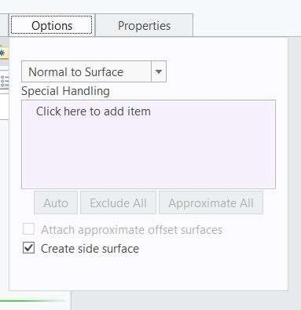

1. Click finish feature. Side surface is created.

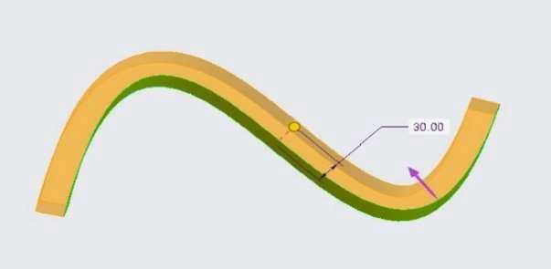 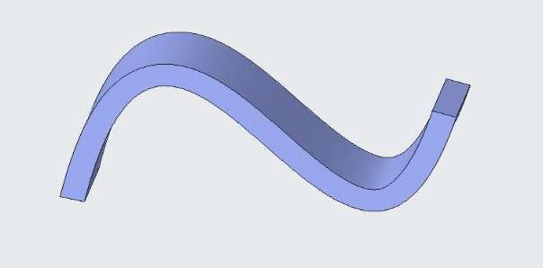

## *OFFSETTING SURFACES WITH THE EXPAND OPTION*

You can offset a surface with reference to a sketch by creating an embossed surface.

1. Open Offset_Expand.prt. Disable all the datum types.
2. Select the surface geometry and select Offset Command from the Editing group.

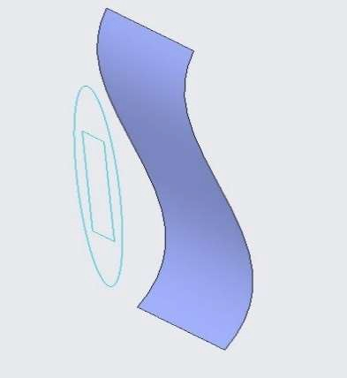 

1. In offset dashboard from the settings drop down menu, select Expand Feature.
2. Select Sketch 2.
3. Surface geometry is offset with reference to the sketch. Observe the result.

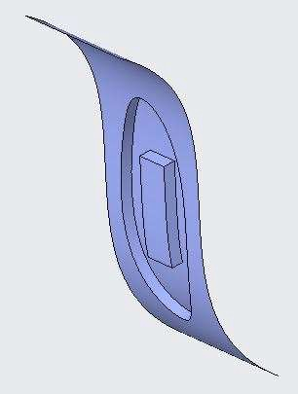 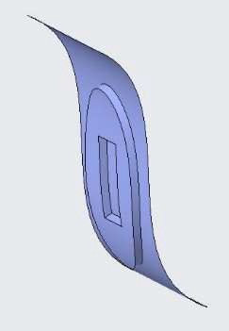

1. From the offset dashboard, use Flip material side and observe the changes.
2. From the offset dashboard, use Offset direction flip and observe the changes.

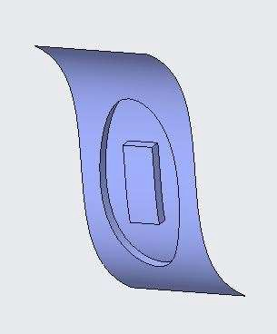 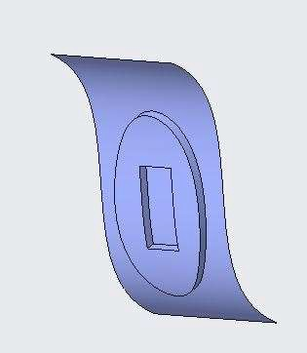

1. From the options tab, change the offset direction from Normal to surface to translate and observe the result.

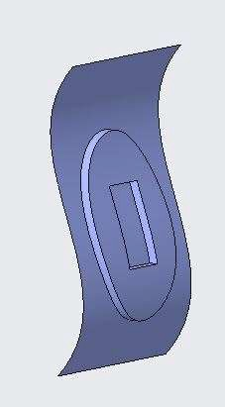 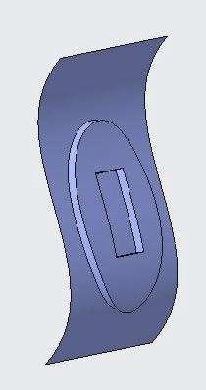

## *OFFSETTING SURFACES WITH DRAFT*

You can offset a surface and create draft angles with reference to a sketch by creating a embossed surface.

1. Open Offset_Expand.prt. Disable all the datum types.
2. Select the surface geometry and select Offset Command from the Editing group.

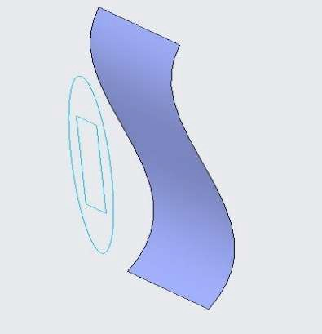 

1. In offset dashboard from the settings drop down menu, select With Draft Feature option.
2. Select Sketch 2.
3. Surface geometry is offset with draft with reference to the sketch. Observe the result.
4. In option tab, Switch Side surface normal to between Surface and sketch and observe the result.
5. In option tab, Switch Side surface Profile between Straight and tangent and observe the result.

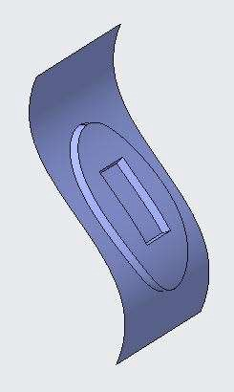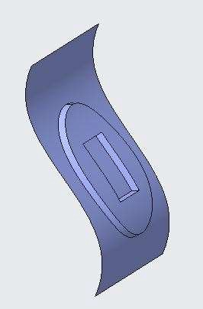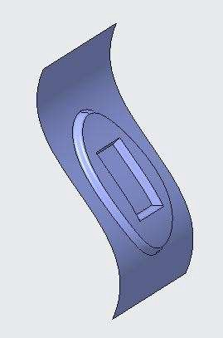

Normal to Sketch Normal to Sketch Tangent

## *MOVING AND ROTATING QUILTS*

You can reposition a quilt using by translating and rotating it.

To Transform a surface by moving and rotating it.

1. Open Quilt.prt. Enable only the following Datum Display types.

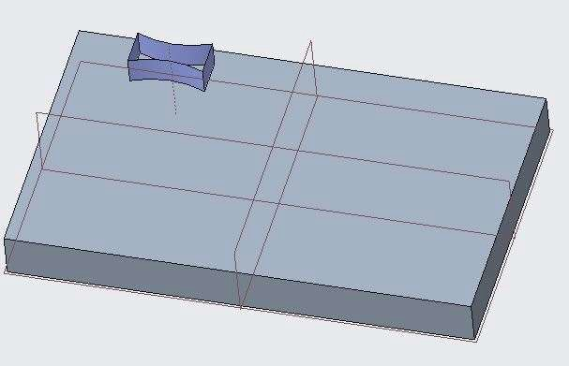

1. 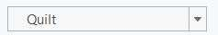Set selection filter to Quilt.
2. In the model tree, select Extrude 2.
3. In the graphics window, select Extrude 2 again to select the quilt.

Note: You must select the quilt rather than the feature; otherwise, you will actually create a feature copy, not a surface transform.

1. In the Operations group, click Copy and select Paste Special from the Paste types drop-down menu.
2. In the dashboard, click Rotate, prehighlight datum axis A_1, and then select it.
3. Edit the angle to 90.

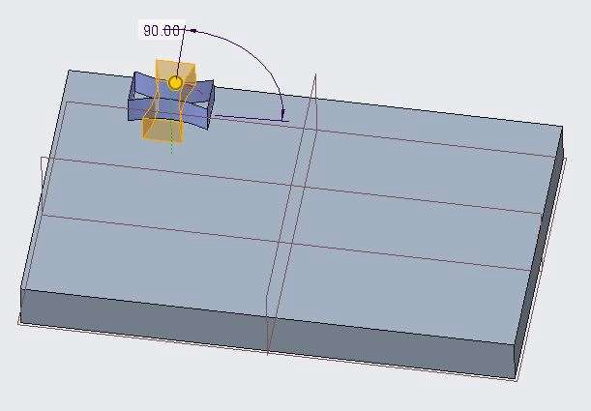

1. In the dashboard, select the Transformations tab.
2. Click New Move and select datum plane FRONT as the Direction Reference.
3. Drag the translation handle down to 150.

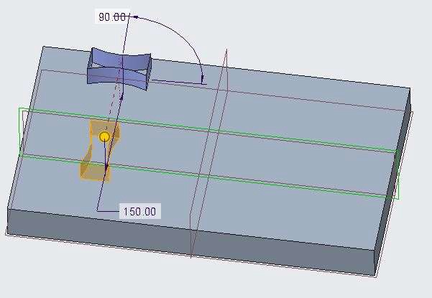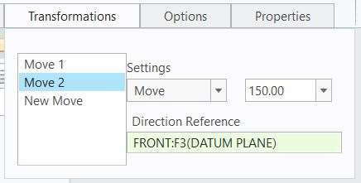

1. In the dashboard, select the Options tab.
2. Clear the Hide original geometry check box.
3. Click Complete Feature.

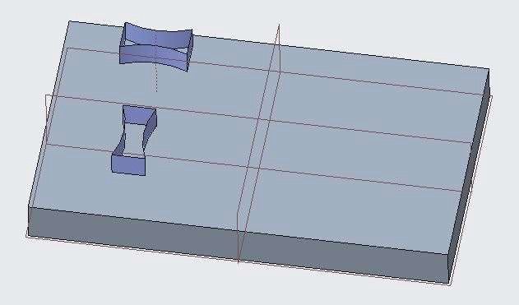

1. Select Extrude 2.
2. Select Extrude 2 again to select the quilt.

Note: You must select the quilt rather than the feature; otherwise, you will actually create a feature copy, not a surface transform.

1. Click Copy and select Paste Special from the Paste types drop-down menu.
2. In the dashboard, click Translate, if necessary, and select the front, horizontal edge of the base feature.
3. Drag the translation handle to the right to 250.

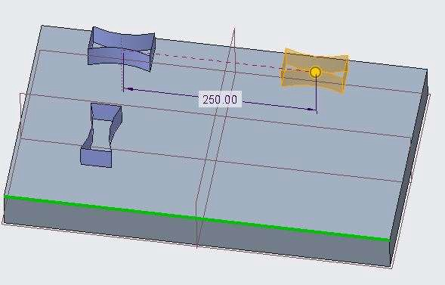

1. Right-click and select New Move.
2. Right-click and select Rotate.
3. Enable the CSYS display from the display group and select Y-axis of CSYS.
4. Edit the angle to 300.

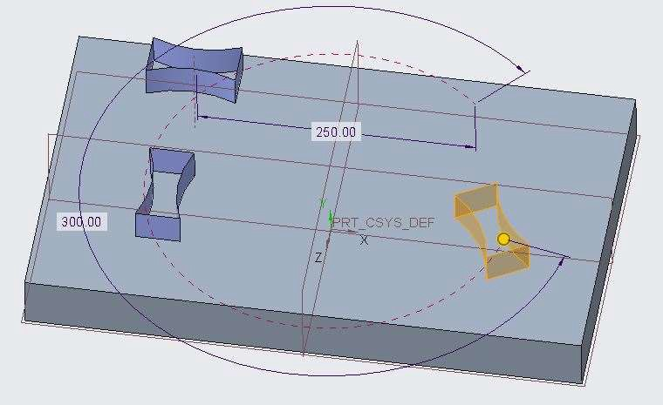

1. Click Complete Feature.

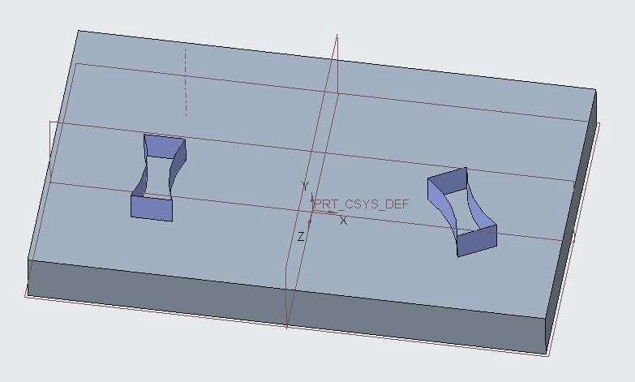

1. Select Extrude 2 and click Edit from the mini toolbar.
2. Zoom in, edit the height from 30 to 100, and click twice in the background.

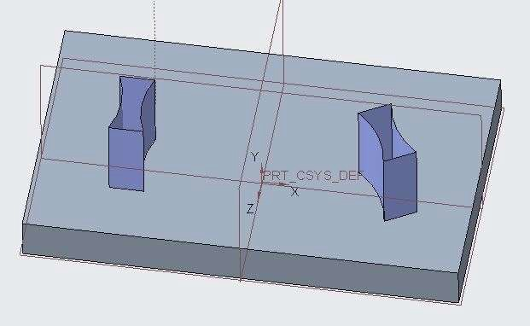

## *MIRRORING QUILTS*

You can transform a quilt by duplicating it by mirror tool.

1. Open Mirror.prt. Display only datum plane types.
2. Select the surface geometry. Select the Mirror tool from the Editing group.

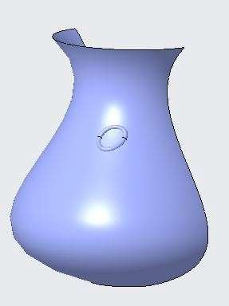 

1. Select the Right plane and click finish feature.

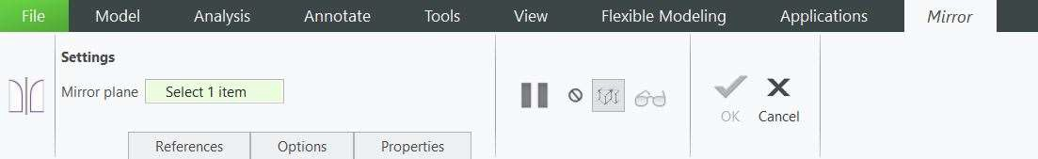

1. Mirror of surface geometry is created.

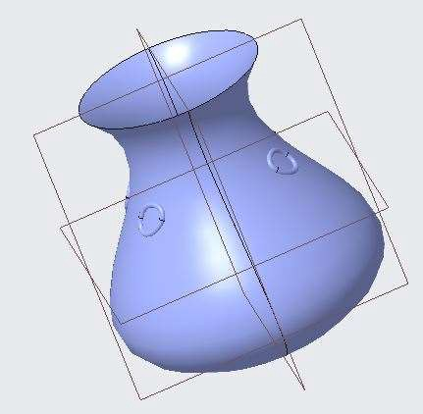

## *MERGING SURFACES*

You can merge two or more quilts into a single closed quilts used for creating solids.

1. Open Merge.prt. Disable all the datum types.
2. Select both the surface geometry displayed on the screen.
3. Select Merge command from the Editing group.

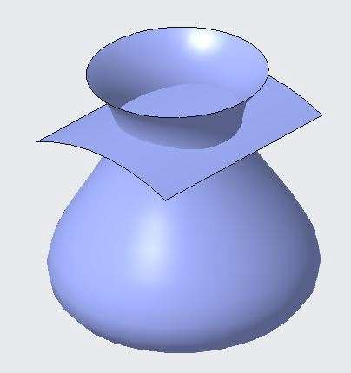 

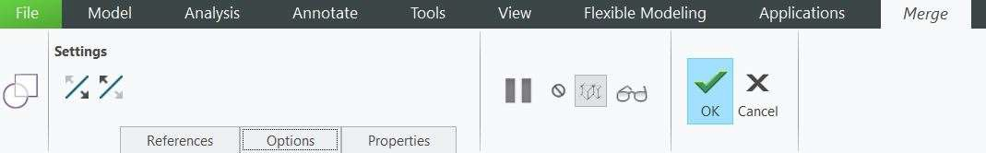

1. Click finish feature and observe the result.
2. Click resume feature and use flip options to get different results.

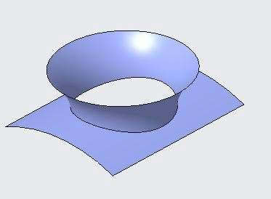 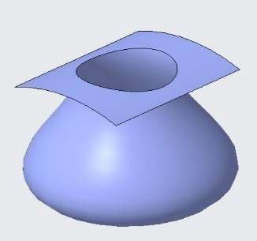

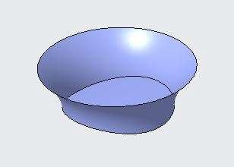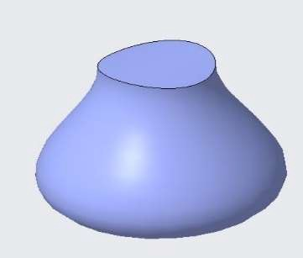

## *UNTRIMMING SURFACE COPIES*

You can Untrim surfaces by using Copy and paste.

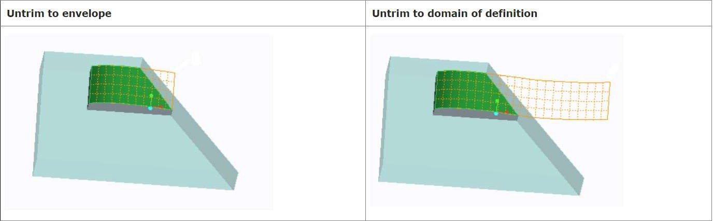

## *FLATTENING QUILTS*

You can flatten and deform a variety of surface features and geometry types.

1. Open Flatten.prt. Display only CSYS datum types.
2. Select the Flatten Quilt command from Surfaces group drop down.

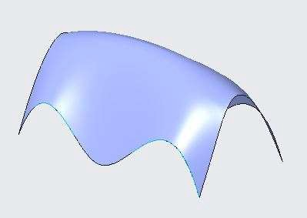 

1. Select the displayed surface geometry.
2. Click on origin box in flatten quilt dashboard and select CSO (CSYS) from the model tree.

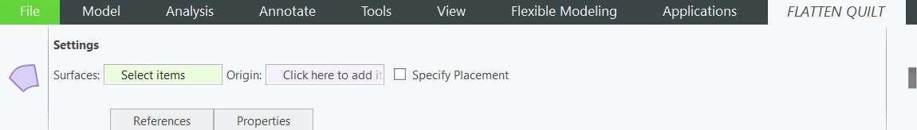

1. Click Finish feature. The surface Geometry is flattened.

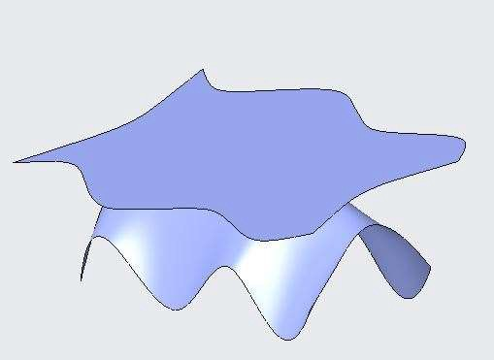

1. Select the flattened suraface and click on sketch.
2. Draw elliptical cross-section as shown below and Finish the sketch.

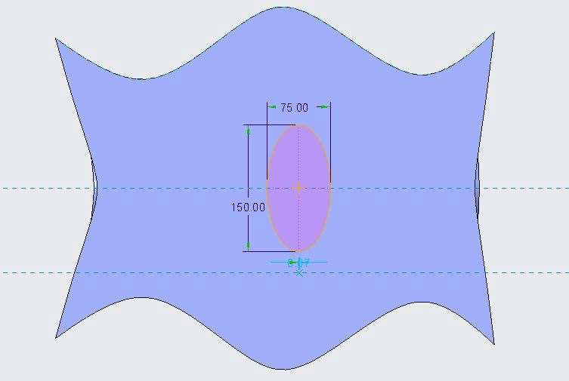

1. Extrude the elliptical sketch as a surface by depth value 50.
2. Hide the Flatten Quilt 1 from the model tree.

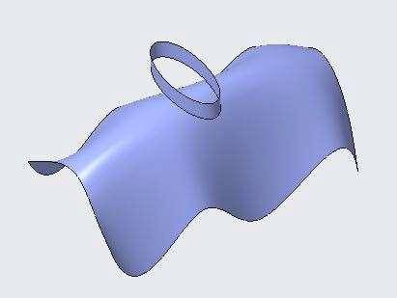

1. Select the Flatten Quilt Deformation command from Surfaces group drop down.
2. Select Flatten Quilt 1 from the model tree.
3. In the references tab, in quilt collector dashboard, select elliptical surface geometry.
4. Click finish feature. Elliptical surface geometry is deformed.

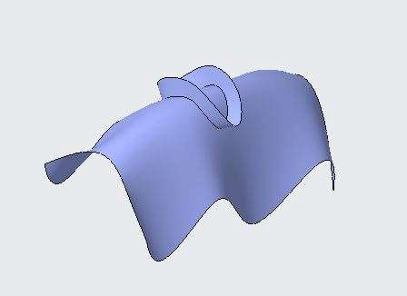

# *MODULE 8: CREATING AND EDITING SOLIDS USING QUILTS*

*For the activity files browse to folder Creating and Editing Solid Quilts.*

## *THICKENING SURFACE QUILTS*

You can create or remove material by offsetting a selected quilt with the Thicken command.

1. Open Thicken.prt. Disable all the datum types.
2. Select the Boundary Blend 1 from the model tree.
3. Select Thicken command from the Editing group.

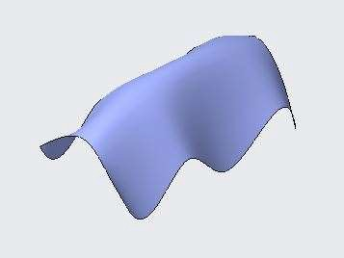 

1. In the dashboard ENTER the offset value 20. The surface geometry is thickened as solid.
2. Click finish feature and close the part.

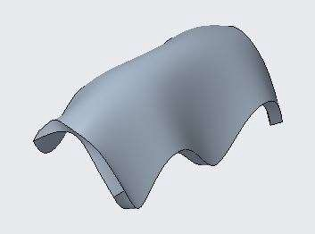

1. Open Thicken_2.prt. Disable all the datum types.

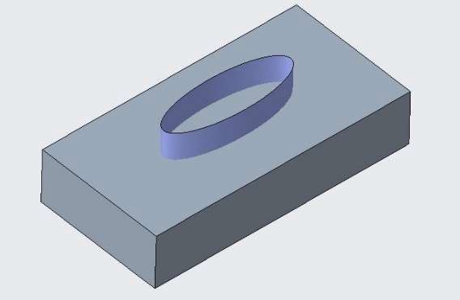

1. Select the Elliptical surface body and select Thicken command from the Editing group.
2. In the dashboard ENTER the offset value 20. The surface geometry is thickened as solid.
3. In the dashboard select Remove material. Material is removed from the solid geometry.

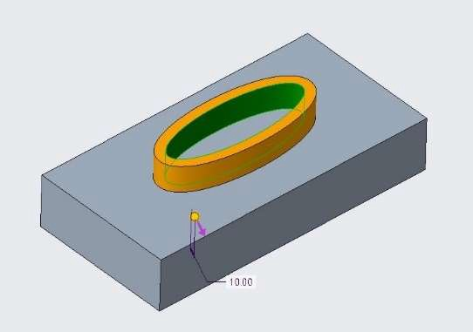 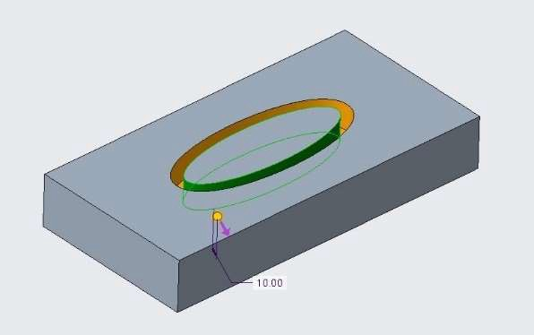

Thicken filled with solid material Thicken with Remove Material

1. Click finish feature and complete the operation.

## *SOLIDIFYING QUILTS TO ADD MATERIAL*

You can use Solidify command to add material in a surface geometry.

1. Open Solidify.prt. Disable all the datum types.
2. Select the surface geometry and select Solidify command from the editing group.

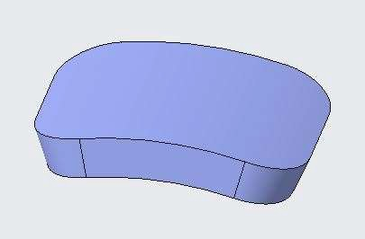 

1. Click finish feature. The surface geometry is filled with solid.

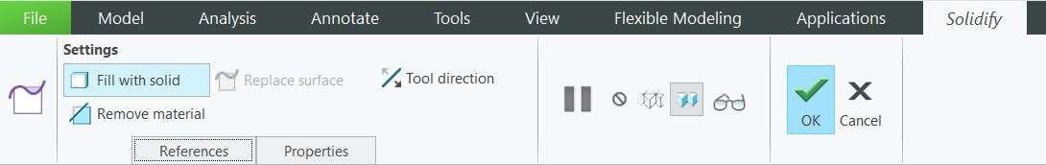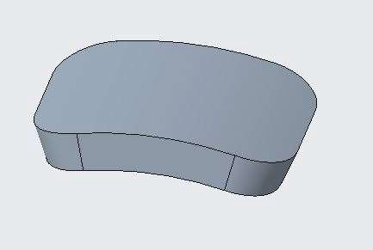

## *SOLIDIFYING QUILTS TO REMOVE MATERIAL*

You can use solidify command to remove material from a solid geometry based on surface quilt.

1. Open Solidify_1.prt. Disable all the datum types.
2. Select Revolve 1 from the model tree and select Solidify command from the Editing group.

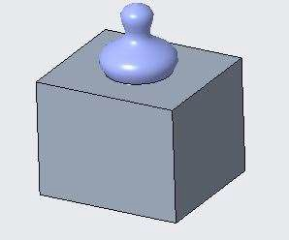 

1. Click finish feature. Surface Quilt is filled with solid material.
2. Select solidify 1 from model tree and Edit Definition.
3. Select remove material from the dashboard and click finish feature. Material is removed.

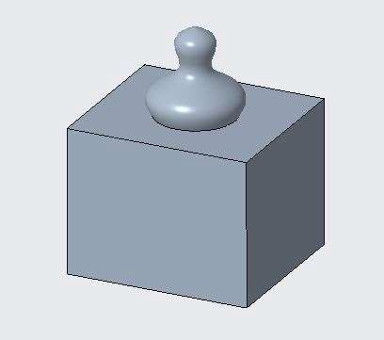 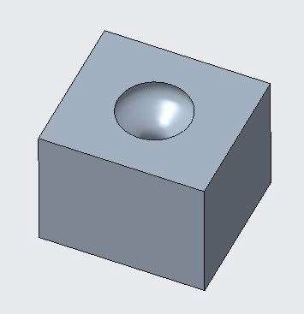

Filled with Solid Material Remove material

## *SOLIDIFYING QUILTS TO REPLACE MATERIAL*

You can add or remove material simultaneously with solidify command based on surface quilt.

1. Open Solidify_2.prt. Disable all the datum types.
2. Select Merge 1 from the model tree and select Solidify command from the Editing Group.
3. With Replace surface selected in the dashboard click finish feature.
4. Hide Fill 1 and Fill 2 from the model tree.
5. Material is Added and removed together from the solid geometry.

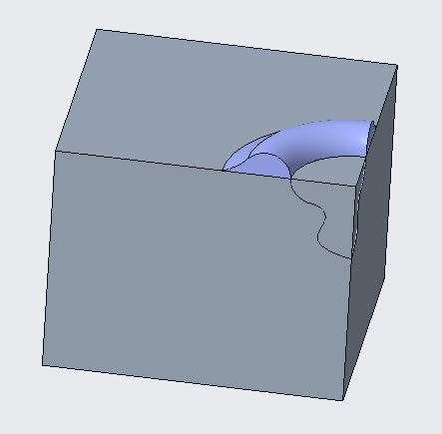 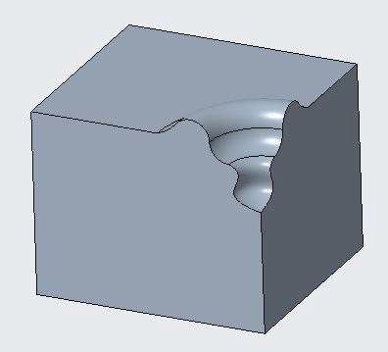

Original Geometry Replaced Material

## *OFFSETTING SURFACES USING THE REPLACE OPTION*

You can replace a single solid surface with a quilt by using the replace option in the offset command.

* 1. Open Offsetting_Surfaces.prt. Disable all the datum types.
  2. Select the top surface of the solid geometry and select offset command from the Editing group.

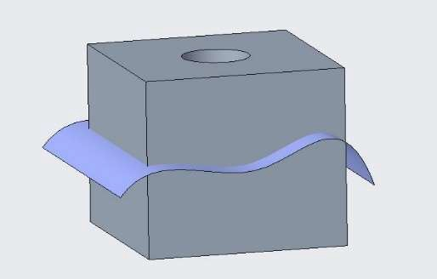 

* 1. In the Offset dashboard, Select Replace Surface Feature from the settings drop down option.
  2. Activate the Replacement quilt option, and select the surface quilt.
  3. Click finish feature.

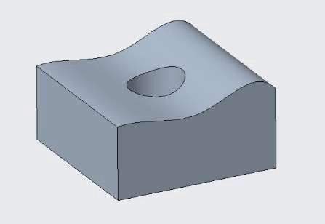

* 1. The selected face is offsetted to the surface quilt by trimming the solid geometry.
  2. Delete Offset 1 from the model tree.
  3. Hide Extrude 2 and unhide Extrude 4 from the model tree.
  4. Repeat above steps from step 2 to step 6.
  5. Click finish feature.

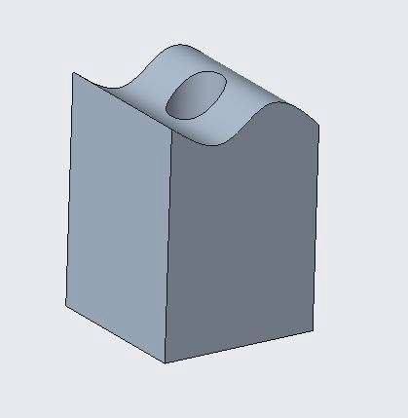

* 1. The selected face is offsetted to the surface quilt by Extending the solid geometry.
  2. Delete Offset 1 from the model tree.
  3. Hide Extrude 4 and unhide Extrude 5 from the model tree.
  4. Repeat above steps from step 2 to step 6.
  5. Click finish feature.
  6. The selected face is offsetted to the surface quilt by Trimming and Extending the solid geometry as per surface quilt.

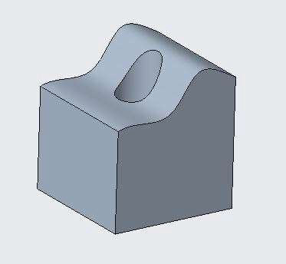

## *CREATING ROUNDS ON SURFACES*

Rounds can be created directly on the surface quilts.

1. Open Surface_Round.prt. Disable all datum types.
2. Select Round command from the Engineering Group.

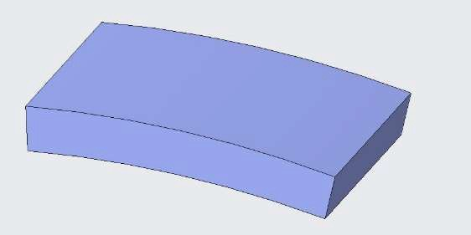 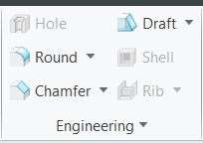

1. Press CTRL Select all the edges and ENTER round value as 5.
2. Click finish feature. The edges of the surface geometry are rounded.

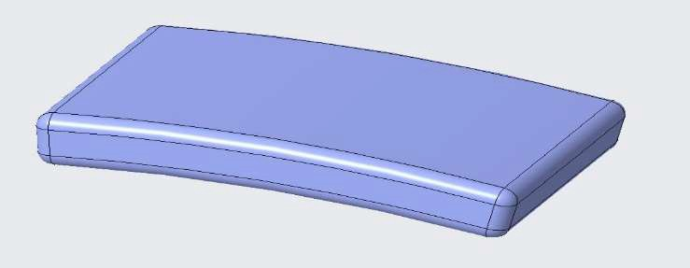

## *CONVERTING SOLID ROUNDS TO SURFACES*

You can convert solid rounds to surfaces to aid in difficult modeling situations. You can then manipulate

the surfaces manually to create a custom round shape or resolve a failing round. Within the Round tool's Options tab, you have the ability to modify the round Attachment type.

To convert solid rounds to surfaces in a part model.

1. Open Convert_Rounds.prt. Disable all the datum types.

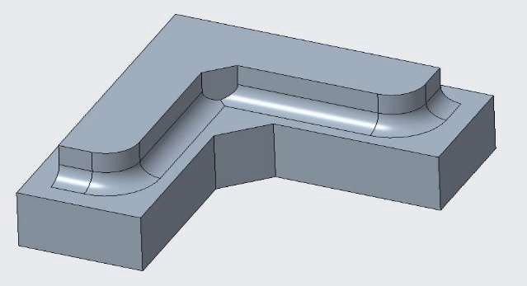

1. Select Round 1 from the model tree and Edit Definition.
2. From the Round dashboard select the Options tab.
3. Select Surface as the Attachment.
4. Select the Create end surfaces check box.

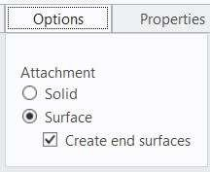

1. Click Complete Feature from the Round dashboard.

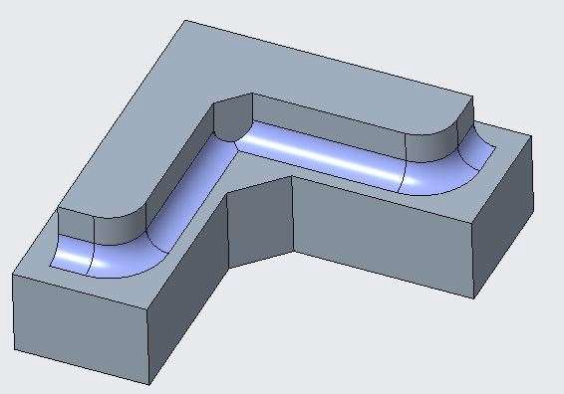

1. With the round still selected, select it again to select the round quilt.
2. Display only the Datum Plane Display types.
3. In the ribbon, click Trim command from the Editing group and select datum plane DTM1.
4. Click Flip Trim Sides two times to keep both sides.

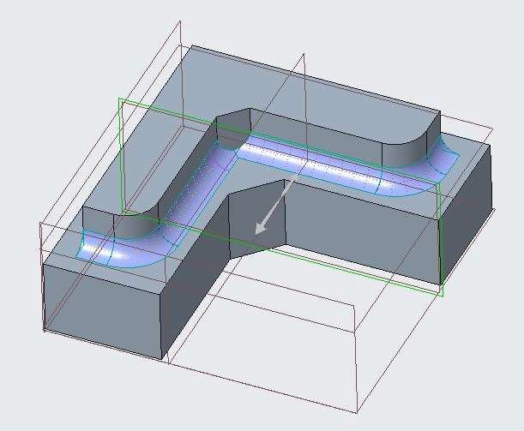

1. Click Complete Feature.
2. Select the right front round quilt and click Trim.
3. Select datum plane DTM2.

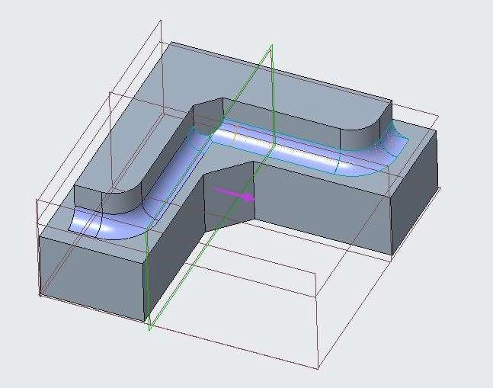

1. Verify that only the front is kept and click Complete Feature.

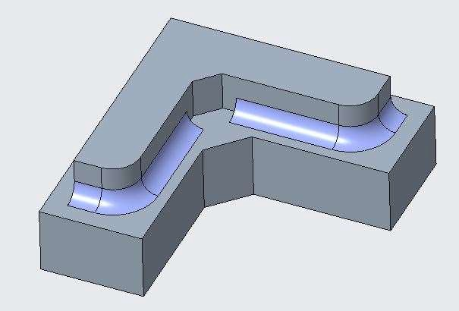

1. Disable Datum Plane Display.
2. De-select all geometry.
3. Select No Hidden from the Display Style types drop-down menu and notice the two open round quilts with magenta edges.

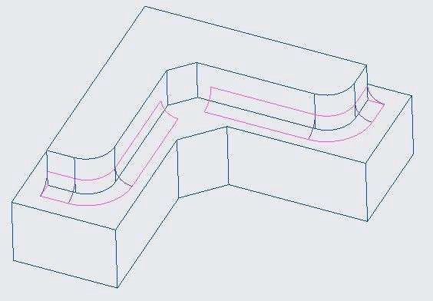

1. Select Shading from the Display Style types drop-down menu.
2. In the model tree, select Sketch 3, press CTRL, and select Sketch 4.
3. Click Unhide from the mini toolbar.

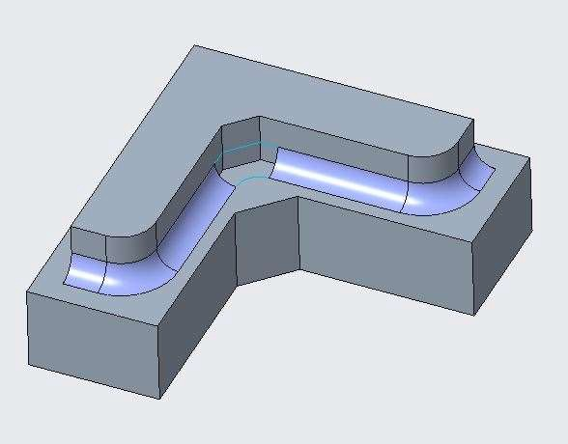

1. De-select all geometry.
2. Click Boundary Blend from the Surfaces group.
3. Press CTRL and select the edges of the two round quilts.
4. In the dashboard Click in Second Direction box to activate Second Direction Curves.
5. Press CTRL and select the two unhidden curves.
6. Right-click each of the constraints and select Tangent.

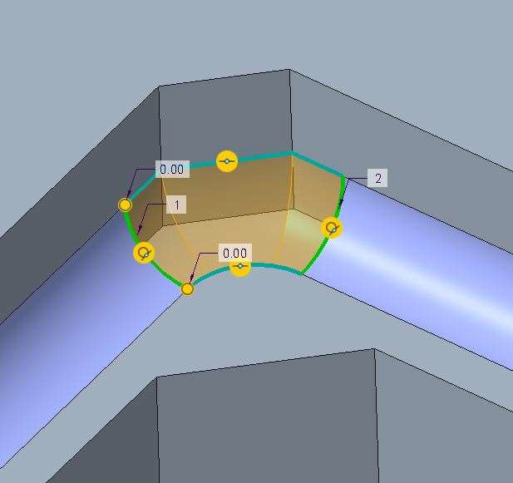

1. Click Complete Feature.

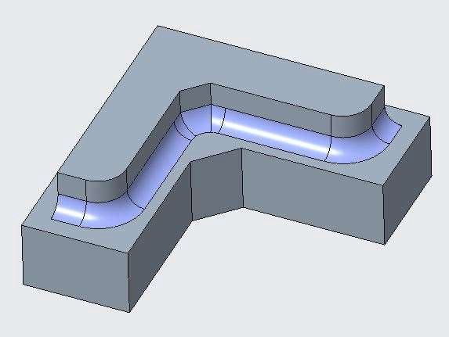

1. Hide Sketch 3 and Sketch 4.
2. Select Trim 1 and select it again from the graphic window to select the quilt.
3. Press CTRL and select the newly created quilt.
4. Click Merge command from the Editing group.
5. Press CTRL and select the other quilt.

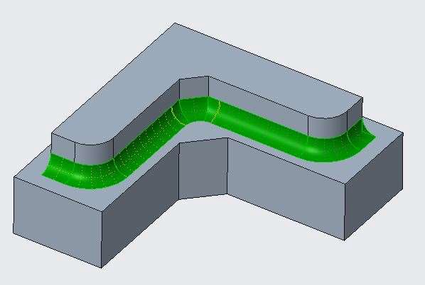

1. Click Complete Feature.
2. With the merge feature still selected, click Solidify from the Editing group.
3. In the dashboard, click Filled with Solid.
4. Click Complete Feature and de-select all geometry.

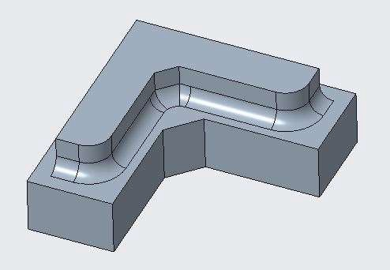

# *MODULE 9 - INTRODUCTION TO THE STYLE SURFACE MODELING* PROCESS

*For the activity files browse to folder Introduction to the Style Surface Modeling Process.*

## *INTRODUCTION TO FREEFORM SURFACE MODELING*

Freeform surface, or freeform surfacing, is used in CAD and other computer graphics software to describe the skin of a 3D geometric element. Freeform surfaces do not have rigid radial dimensions, unlike regular surfaces such as planes, cylinders and conic surfaces.

 

## *UNDERSTANDING SURFACE MODELING PARADIGMS*

Surface Modeling also uses various technical approaches to complete function like parametric surface modelling driven by Dimension and Geometric Constraints, Mathematical Expressions. Surface modelling is also based on Design Input and Output.

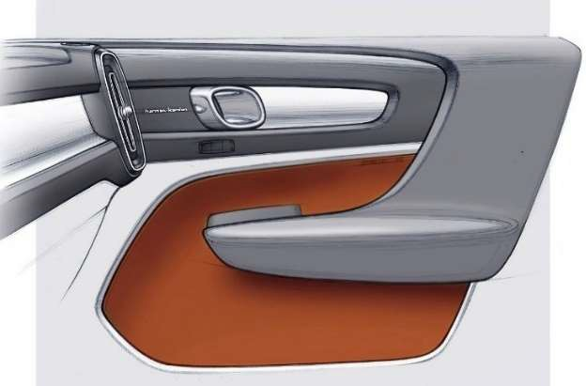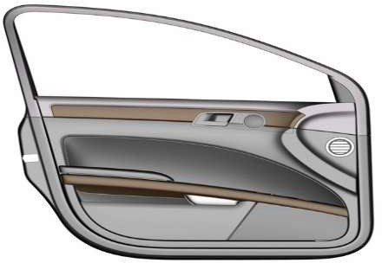

## *COMBINING STYLE AND PARAMETRIC MODELING*

In Surface Modeling many complex shapes are created with the combination of parametric surface modelling and freeform surface features. Parametric models comprising of freeform curves and shapes.

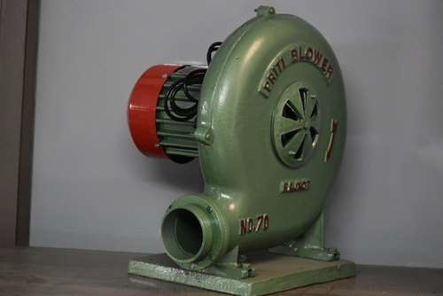 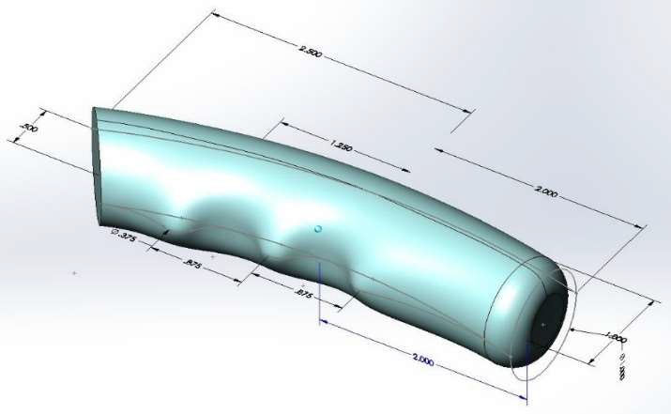

## *TYPICAL STYLE MODELING PROCESS*

The typical style modeling process can be summarized in four steps:

1. Creating a Design Framework
2. Creating Style Features
3. Blending Parametric and Style Features
4. Refining the Design
5. Open Style_Cover.prt. Enable only the Plane Datum Display types

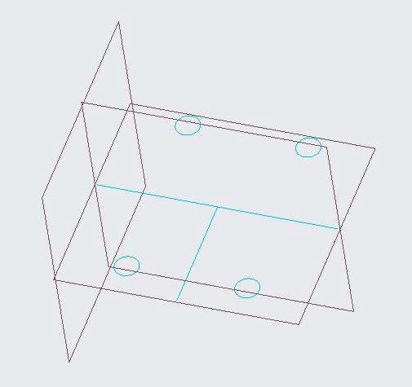

1. To create a datum plane at the cENTER of the existing framework, click Plane from the Datum group.
2. In the model tree, select datum plane RIGHT.
3. Press SHIFT, click and drag the drag handle of the datum plane onto the curve.

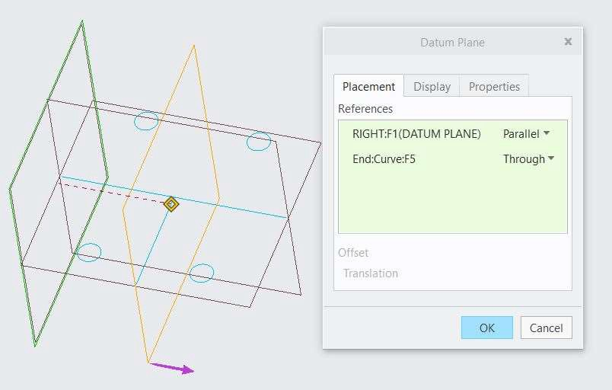

1. In the Datum Plane dialog box, select the Properties tab and edit the name to CENTER and click OK.
2. Disable Plane Display.
3. In the model tree, right-click the Insert Indicator and select Exit Insert Mode.
4. Click Yes in the Confirmation dialog box.
5. In the model tree, right-click Style 1 and select Edit Definition.
6. In the style tree, located below the model tree, select each of the four style curves and notice each as they are highlighted in the graphics window.
7. Click in the background of the graphics window to de-select all geometry.

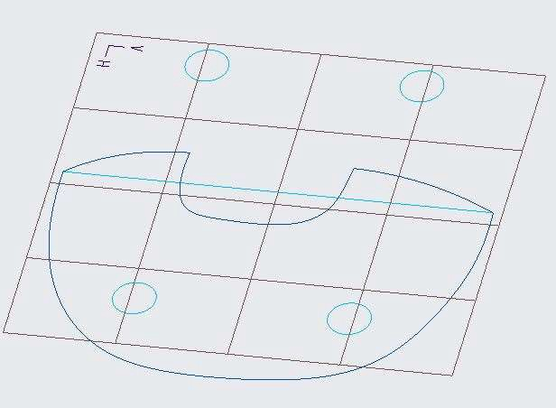

1. To create a style surface using the four style curves as boundaries, Click Surface from the Surface group.

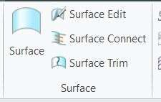

1. Press CTRL and select the four curves, as shown.
2. Click Complete Feature from the dashboard to complete creation of the style surface.
3. Click OK from the Close group.

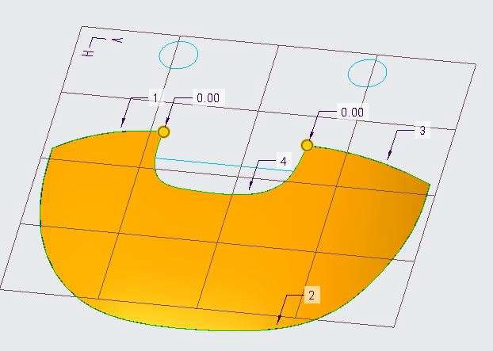 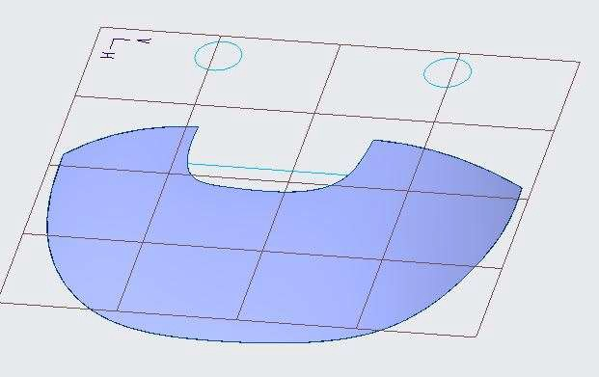

1. Select the Quilt and click Mirror from the Editing group.
2. In the model tree, select datum plane FRONT as the mirror plane.
3. Click Complete Feature.

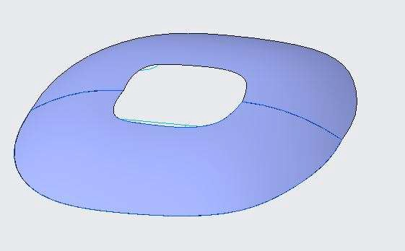

1. Select Style 1 and Mirror 1 from the model tree and click Merge from the Editing group.
2. 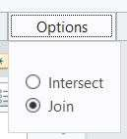In Merge dashboard, under options tab, Select Join.
3. Click Complete Feature.

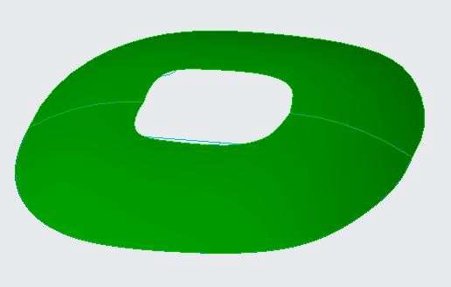

1. To add solid thickness to the model, select the surface quilt, click Thicken from the Editing group.
2. Edit the thickness to 3 and press ENTER.
3. Click Complete Feature.

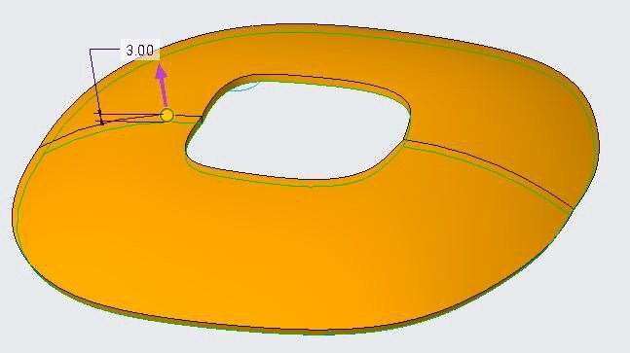

1. To remove material to form four access holes, in the model tree, select Sketch 2.
2. Click Extrude from the Shapes group.
3. In the dashboard, edit the depth to Through All.
4. Click Remove Material from the dashboard.
5. Click Complete feature.

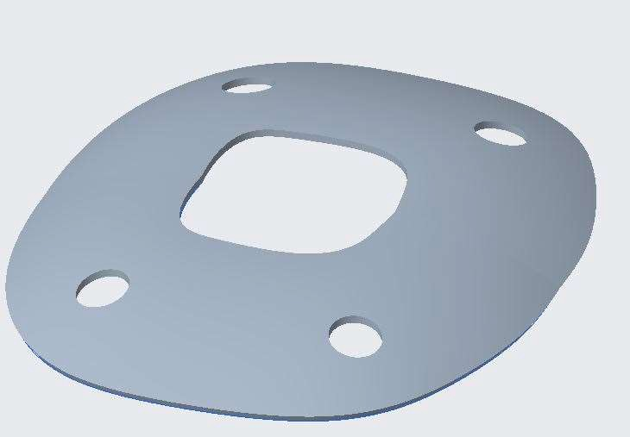

1. Right-click Style 1 and select Edit Definition.
2. Right-click in the graphics window and select Set Active Plane.
3. In the model tree, select datum plane CENTER.
4. Create an internal control curve of the surface to be referenced.
5. Right-click in the graphics window and select Curve and click Planar Curve from the dashboard.
6. Press SHIFT and click to place the start point of the curve on the lower boundary of the surface, as shown.
7. Press SHIFT and click to place the end point of the curve on the upper boundary of the surface, as shown.
8. Click Complete Feature.

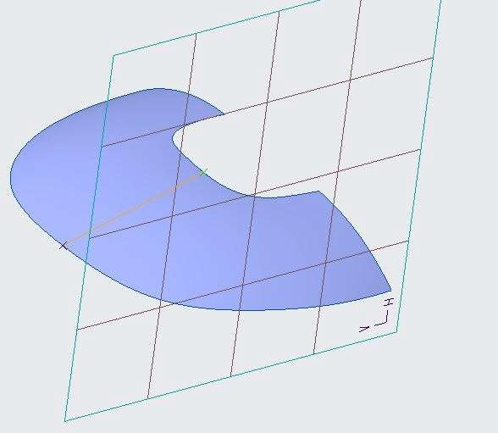

1. Edit the style surface and add the new curve to its definition.
2. In the style tree, right-click the surface feature and select Edit Definition.
3. Right-click in the graphics window and select Internal Collector.
4. Select the previously created curve.
5. Click Complete Feature. Click OK.
6. Click in the background of the graphics window to de-select all geometry.
7. To add additional points to control the internal curve's shape, Right-click Style 1 and select Edit Definition.
8. Select the curve you just created and Right-click and select Edit Definition.
9. Right-click in the graphics window and select Active Plane Orientation.
10. Right-click the curve and select Add Midpoint.
11. Right-click the curve just above the first midpoint and select Add Midpoint.
12. Right-click the curve just below the first midpoint and select Add Midpoint.

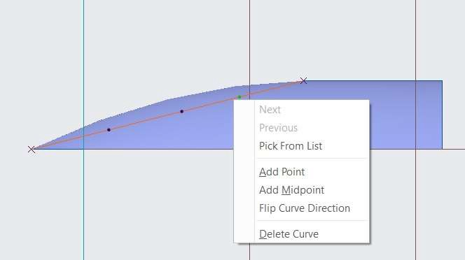

1. To Edit the end conditions of the curve, select the upper end point of the curve.
2. Right-click the tangent handle and select Normal.

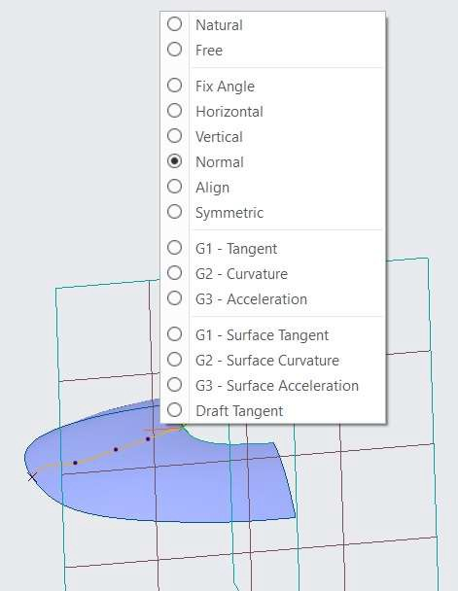

1. In the model tree, select datum plane FRONT.
2. Select the lower end point of the curve, Right-click the tangent handle and select Draft Tangent.
3. Select datum plane TOP.
4. Edit the draft tangent angle value to -20 and press ENTER.

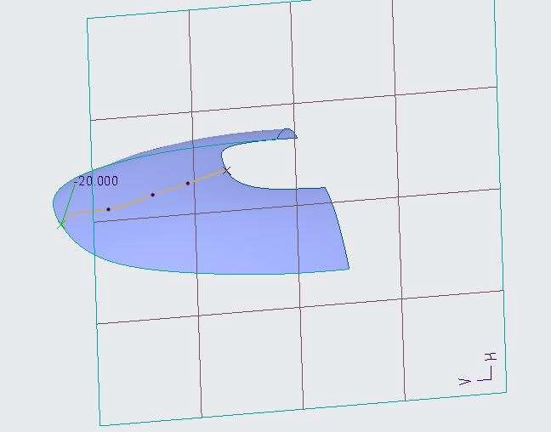

1. Add a curvature analysis to the curve.
2. In the ribbon, select the Analysis tab, click Curvature from the Inspect Geometry group.

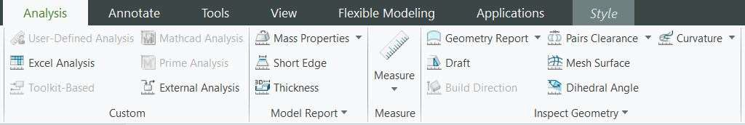

1. In the Curvature Analysis dialog box, edit the Quality to 40 and Edit the Scale to 5.
2. Select Saved from the drop-down list. Click OK.

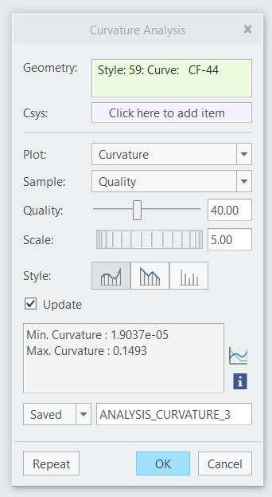

1. Click the Manage group drop-down menu and select Hide All.
2. Click Finish feature. Click ok. Geometry is modified.

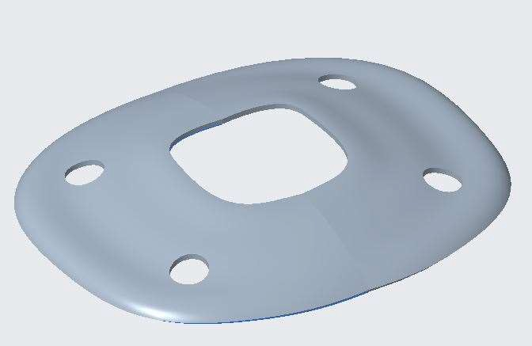

# *MODULE 10 - UNDERSTANDING STYLE SURFACE MODELING* CONCEPTS

*For the activity files browse to folder Understanding Style Surface Modeling Concepts.*

## *UNDERSTANDING THE STYLE TOOL*

Style is a design environment within Creo Parametric that allows you to create free-form curves and surfaces quickly and easily, and to combine multiple elements into super features. Style features are called super features because they can contain limitless numbers of curves and surfaces.

The Style user interface offers the best of both worlds—it is a self-contained, intuitive modelling environment and is also a Creo feature. The user can create truly free Style features and take advantage of the parametric and associative Creo capabilities.

## *UNDERSTANDING STYLE FEATURES*

Style features are flexible; they have their own internal parent/child relationships, and can also have relationships with other Creo features.

Create Style Curve Features

* Shape visually.
* Manipulate interactively.
* Boundaries, sections, and trajectories.
* Use for style or parametric features. Create Style Surface Features
* Use style curves or other curves/edges.

## *UNDERSTANDING DATUM FEATURES WITHIN STYLE*

You can create datum planes internal or external to the style feature.

* Datum Features
  + Axes
  + Points
  + Curves
  + Planes
* Internal Datum Planes
  + Internal to the style feature
  + Visible only in the style feature

## *UNDERSTANDING THE STYLE MODELING ENVIRONMENT*

Creo Parametric provides a special modeling environment for creating style features.

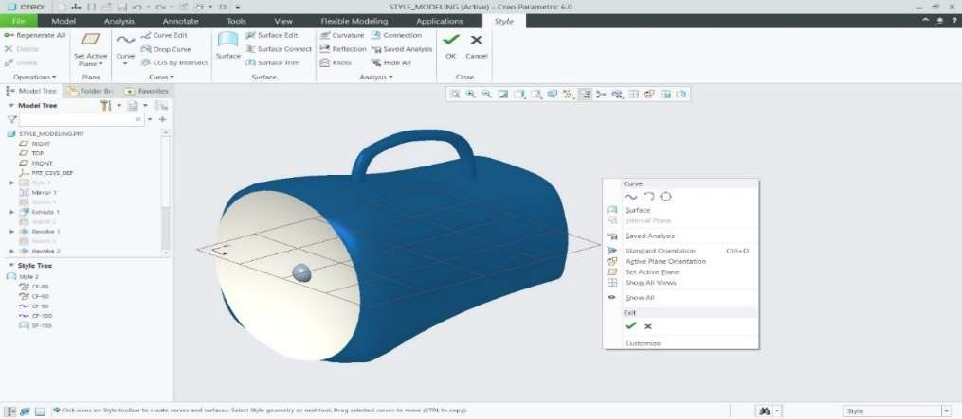

## *USING STYLE TOOL SHORTCUT MENUS*

There are several context-sensitive shortcut menus available within the Style tool.

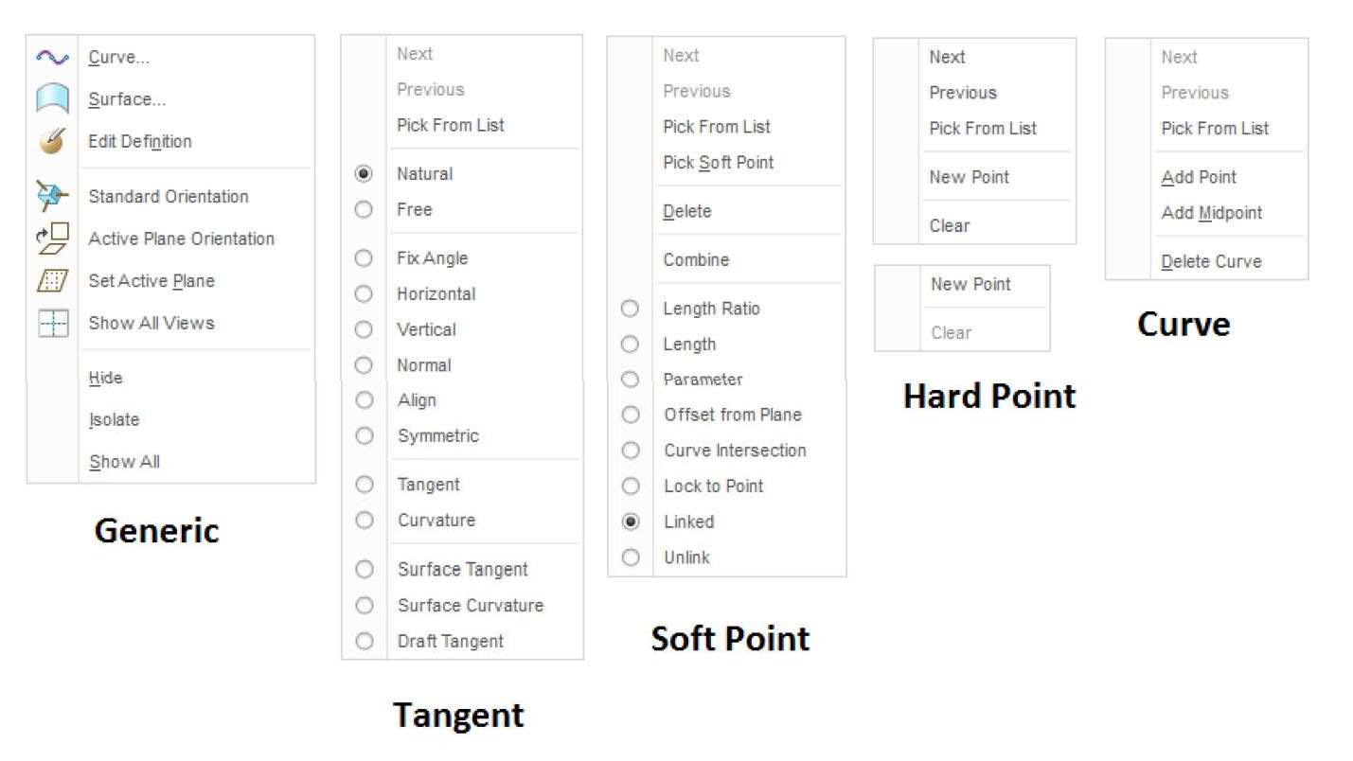

## *USING STYLE TOOL KEY COMBINATIONS*

There are several keyboard-mouse combinations available within the Style tool.

### Selections

* + Double-click: Edit Definition
  + CTRL+ALT: Lock horizontal or vertical drag.
  + CTRL: Copy and move by dragging.
  + CTRL+SHIFT: Move by dragging.

### Surface Create/Edit

* + CTRL: Add curves to selection.
  + SHIFT: Add curve to chain.

### Curve Create/Edit

* + SHIFT: Snap to geometry.
  + ALT: Move normal.
  + SHIFT+ALT: Extend point.
  + CTRL+ALT: Lock horizontal and vertical drag.
  + ALT: Drag tangent length.
  + CTRL+ALT: Drag tangent angle.

## *UNDERSTANDING ACTIVE PLANES*

### Points on a style curve are projected onto the active plane.

The Active Style Plane

* Default active plane
* Setting active plane
* Internal active plane

To Set a View to the Active Plane Orientation

* You can display the model with the active datum plane parallel to the screen.
* Click  Active Plane Orientation on the Graphics toolbar, or click  Style > Active Plane Orientation. Alternatively, right-click the graphics window and choose Active Plane Orientation on the shortcut menu.



## *UNDERSTANDING THE STYLE TOOL 4-VIEW LAYOUT*

In the Style tool, you can display a model in a single-view or a 4-view layout.

* 4-view layout
* Resize
* Switching
* Style orientations
* Active plane
* Zooming

1. Open Style_4_View.prt. Disable all Datum Display types.

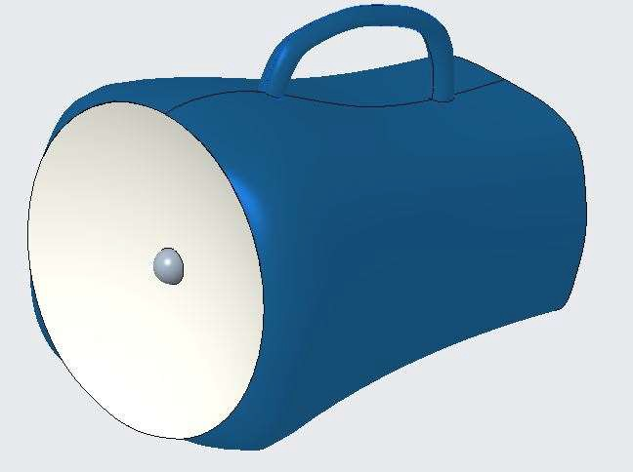

1. In the model tree, right-click Style 2 and select Edit Definition.
2. From the In Graphics toolbar, enable Show All Views to start the 4-view layout. 
3. Click the horizontal and vertical sashes and drag to resize the windows.
4. Click the intersection of the sashes and drag to resize all four windows.
5. Double-click the intersection of the sashes to reset the 4-view window sizes.

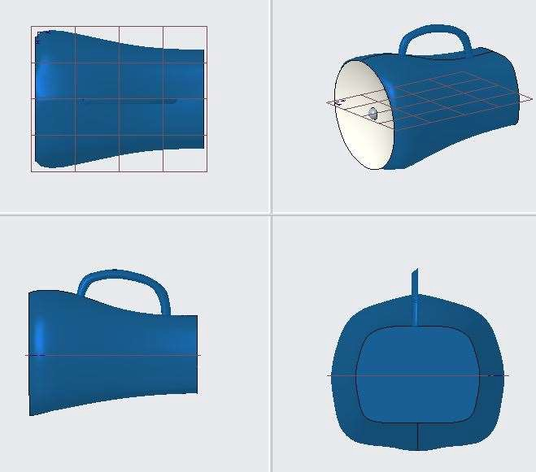

1. Disable Show All Views to toggle to the single-view layout.
2. From the In Graphics toolbar, click Show Next View to show the right-side view. 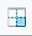
3. Click Show Next View three more times to toggle through the front and top views before returning to the default view.
4. Enable Show All Views
5. Right-click in the lower-left window and select show All Views.

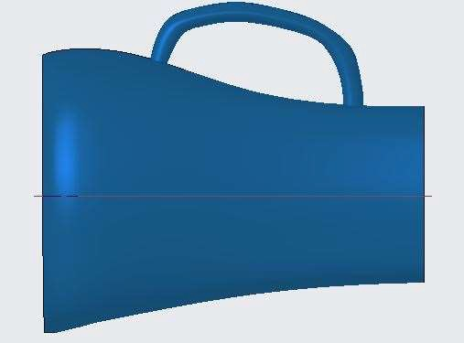

*Note: The front view is now displayed in the single window.*

1. Right-click and select Show All Views.
2. Middle-click in the upper-left window and drag to spin the model.
3. Right-click in the upper-left window and select Standard Orientation.
4. Click in the upper-right window.
5. From the In Graphics toolbar, click Saved Orientations and select BACK.

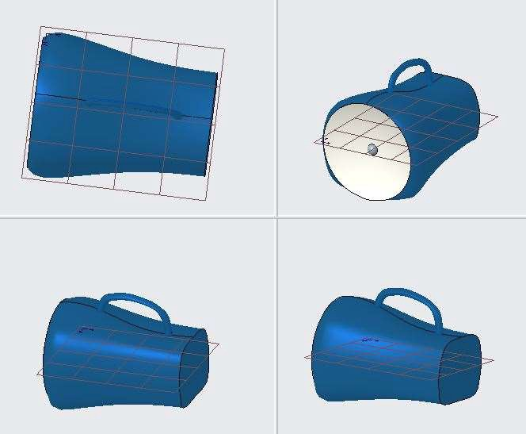

1. Press CTRL+D to orient all 4 views to the Standard Orientation.
2. Click OK from the Close group.

*Note: The window returns to a single view because you have left the Style tool.*

1. To use the Active Plane Orientation, in the model tree, right-click Style 1 and select Edit Definition.

Note: The window returns to a 4-view layout because that is the layout you were in when you were last in the Style tool.

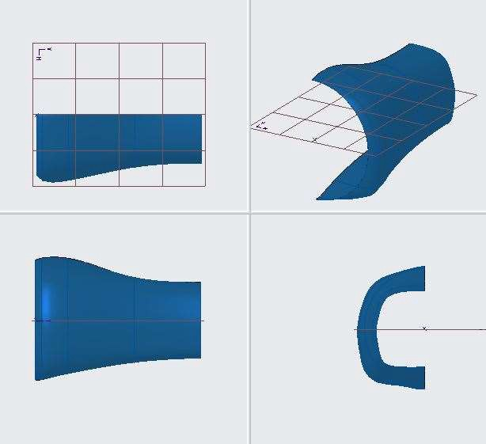

1. Disable Show All Views.
2. In the style tree, right-click CF-84 and select Edit Definition.
3. Right-click in the graphics window and select Active Plane Orientation.

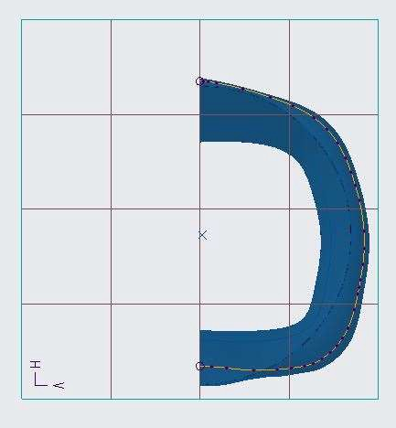

1. Click Complete Feature from the dashboard.
2. Click OK.

## *UNDERSTANDING STYLE PREFERENCES*

You can define preferences for display, curvature plots, and surface mesh within the Style tool. To open the Style Preferences dialog box, click the Operations group drop-down menu and select Preferences.

1. Open Style_Preferences.prt. Disable all Datum Display Types.

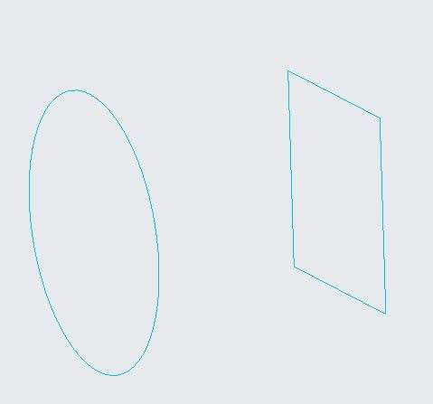

1. Click Style from the Surfaces group.
2. Click the Operations group drop-down menu and select Preferences.
3. In the Style Preferences dialog box, notice the default option, Check Merge surfaces on exit and click OK.

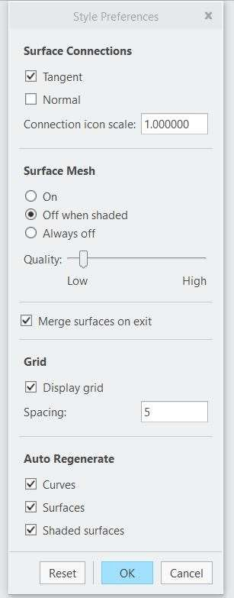

1. Right-click in the graphics window and select Surface.
2. Press CTRL and select Top line from square and Top portion of Circle as shown below.

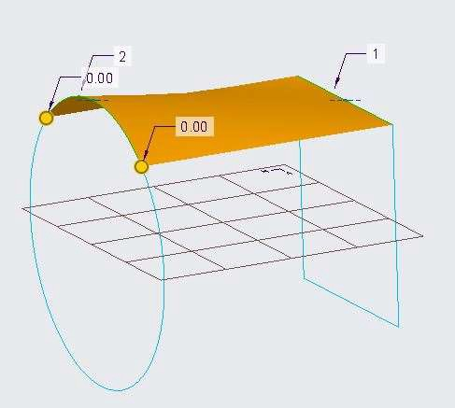

1. Click Complete Feature from the dashboard.
2. Right-click in the graphics window and select Surface.
3. Press CTRL and select Back side line and Back portion of Circle as shown below.

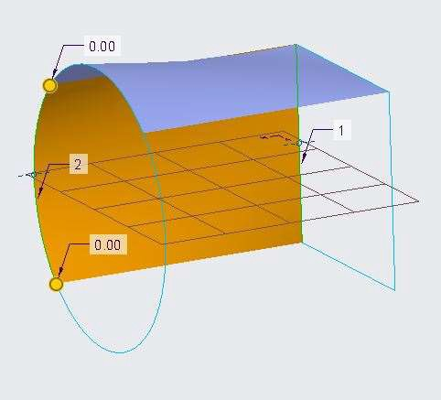

1. Click Complete Feature.
2. Click OK from the Close group.
3. Select the surfaces created.

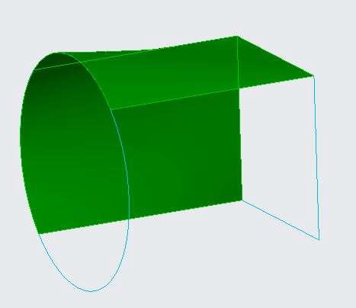

*Note: The two surfaces created have been merged into one, due to the default option, Merge surfaces on exit. Merge option from the Editing group is not highlighted.*

1. Click Style.
2. Click the Operations group drop-down menu and select Preferences.
3. Clear the Merge surfaces on exit check box and click OK.
4. Right-click in the graphics window and select Surface.
5. Press CTRL and select bottom side line and bottom portion of Circle as shown below.

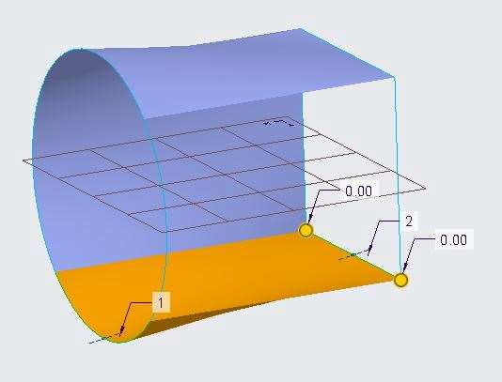

1. Click Complete Feature.
2. Right-click in the graphics window and select Surface.
3. Press CTRL and select front side line and front portion of Circle as shown below.

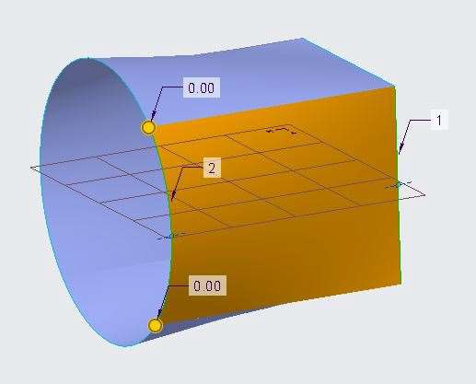

1. Click Complete Feature.
2. Click OK.
3. Select the last surface created.

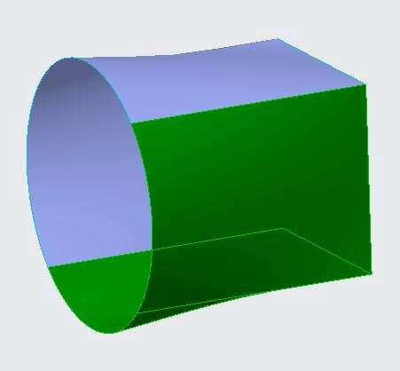

*Note: By disabling, Merge surfaces on exit, the surfaces are not merged together. Merge option from the Editing group is highlighted.*

# *MODULE 11 - CREATING INITIAL STYLE CURVES*

*For the activity files browse to folder Creating Initial Style Curves.*

## *UNDERSTANDING STYLE CURVES*

A curve is any path drawn through two or more defining points. A set of internal points and tangency at the endpoints defines the curve.

In Style, creating good curves is the key to creating a feature with high-quality surfaces, because all surfaces are defined directly from curves.

1. Tangent for selected endpoint
2. Internal points
3. Endpoint

## *CREATING BASIC STYLE CURVES*

Creating high-quality curves is essential for creating high-quality surfaces, because all surfaces are defined directly from these curves.

* + Basic style curve types
    - Free Curve
    - Planar Curve
    - Curve on Surface

For Free Curve

1. Open Creo Parametric. Create a New File.
2. Enable only the Datum Plane Display types.
3. Click Style from the Surfaces group.

Note: The active plane is now visible on the TOP datum plane, identified by the grid.

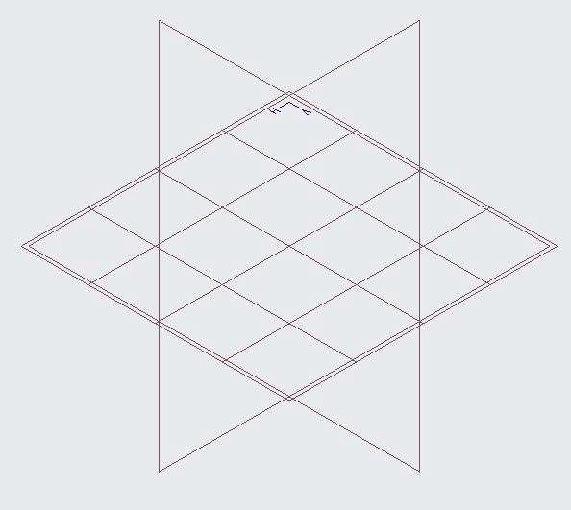

1. Right-click in the graphics window and select Active Plane Orientation.
2. Right-click in the graphics window and select Curve or select curve from the curve group.

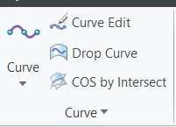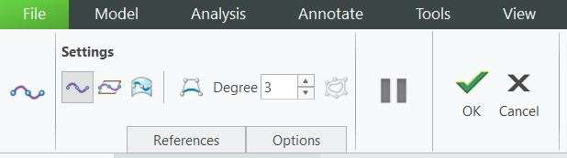

1. Click Free Curve from the dashboard.
2. Working left to right, from the cENTER of the model, select locations for four points, as shown.
3. Click Ok to complete.

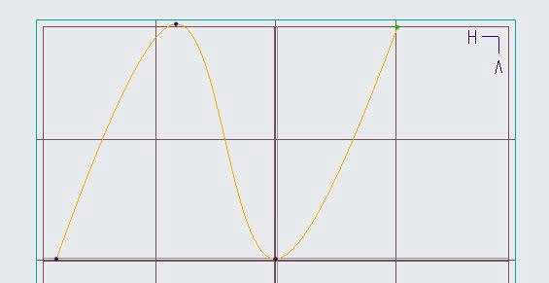

1. Select the Curve and Edit Definition.
2. Spin the model and notice that the four points and the resulting curve were placed on the active plane.
3. From the In Graphics toolbar, click Saved Orientations and select FRONT.
4. Select the point shown and drag it upward, off of the active plane.

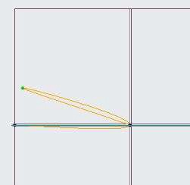

1. Spin the model and notice that the free curve you initially created as a 2-D curve is now a 3-D curve.

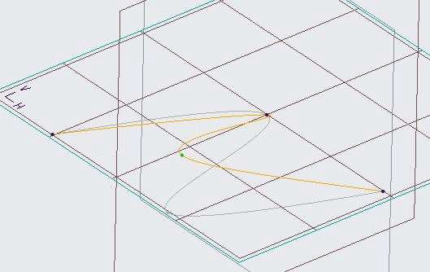

Note: The gray “ghost” curve that is visible when you spin the model is the shape of the original curve before your edits. This ghost display can be toggled on and off using Display Curves Before Edits from the dashboard.

For Planar Curve

1. Select curve from the curve group.
2. Click Planar Curve from the dashboard.
3. In the model tree, select datum plane TOP.
4. Click Active Plane Orientations from the graphics toolbar.
5. Working left to right, from the cENTER of the model, select locations for four points, as shown.



1. Click Ok to complete
2. Select the Curve and Edit Definition.
3. Spin the model and notice that the four points and the resulting curve were placed on the active plane.
4. From the In Graphics toolbar, click Saved Orientations and select FRONT.
5. Select the same point and try to drag it upward, off of the active plane.

*Note: Because the curve is now a planar curve, the points cannot be moved off of the TOP datum plane, Curve will lie only on the sketch plane as a 2D Curve.*

1. Orient to the Standard Orientation.
2. Right-click and select Active Plane Orientation.
3. Disable Plane Display.
4. Select and move the points, as shown.

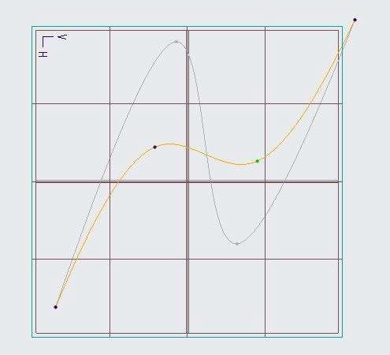

1. Select the right endpoint, then drag the length and angle of the tangent handle.

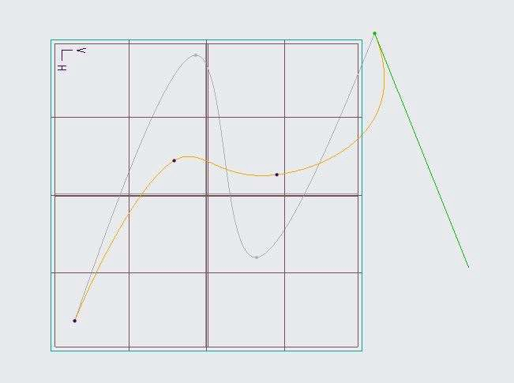

1. Click Complete Feature from the dashboard.
2. Click OK from the Close group.

## *CREATING STYLE CURVES AS CIRCLES OR ARCS*

Besides using the versatile spline shape for style curves, it is often desirable to create exact arc or circle

geometry without having to close the Style.

Add a Circle to the style feature.

1. Open Creo Parametric. Create a New File.
2. Disable all Datum Display types.
3. Click Style from the Surfaces group.

Note: The active plane is now visible on the TOP datum plane, identified by the grid.



1. Select Circle from the Curve types drop-down menu in the Curve group.
2. Right-click in the graphics window and select Active Plane Orientation.
3. Click Planar Curve from the dashboard.
4. Select the References tab from the dashboard.
5. Ensure the Offset value is 0.

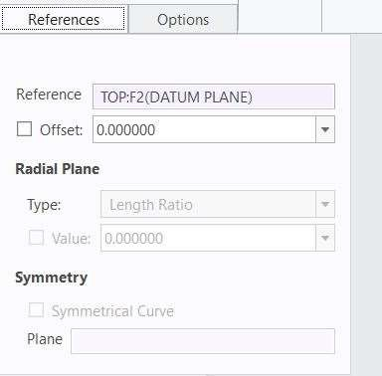

1. Click to place the circle at the cENTER of the active plane.
2. In the dashboard, edit the radius to 200 and press ENTER.

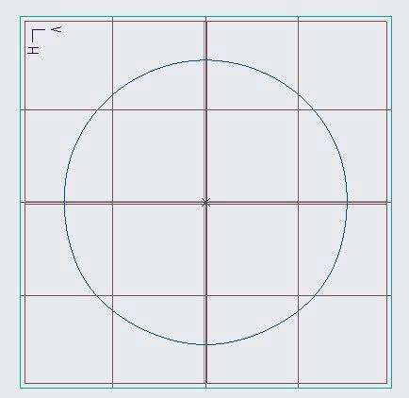 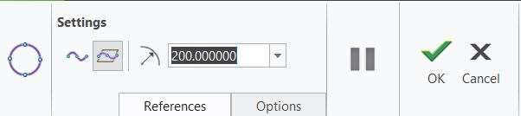

1. Click Complete Feature from the dashboard.
2. Select Circle from the Curve types drop-down menu.
3. Select the References tab.
4. Edit the Offset value to 160 and press ENTER.
5. Click to place the circle at the cENTER of the active plane.
6. Edit the radius to 120 and press ENTER.
7. Orient to the Standard Orientation.

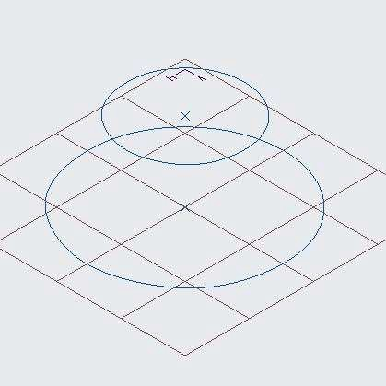

1. Click Complete Feature.

Add an arc to the style feature.

1. Right-click in the graphics window and select Set Active Plane.
2. In the model tree, select datum plane FRONT.
3. Select Arc from the Curve types drop-down menu in the Curve group.
4. Click Planar Curve.
5. Select the References tab.
6. Ensure the Offset value is 0.

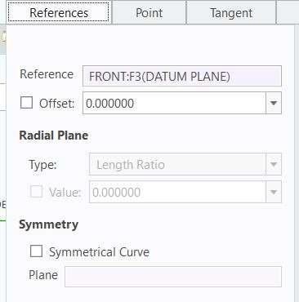

1. Place the arc, as shown.
2. Edit the radius to 200 and press ENTER.
3. Edit the Start angle to 126 and press ENTER.
4. Edit the End angle to 180 and press ENTER.
5. Click Complete Feature.
6. Right-click in the graphics window and select Edit Definition.
7. Press SHIFT, select the bottom endpoint, and drag to snap to the lower circle curve.
8. Press SHIFT, select the top endpoint, and drag to snap to the upper circle curve.
9. Click Complete Feature.

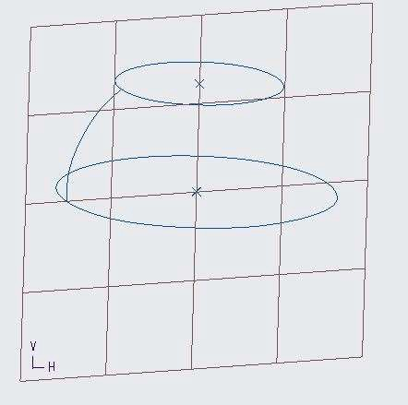

1. Click OK from the Close group.

## *MANIPULATING STYLE POINT LOCATIONS*

To modify the shape of a curve, you can manipulate the location of the style points that define it.

1. Open Style_Points.prt. Disable all Datum Display types.

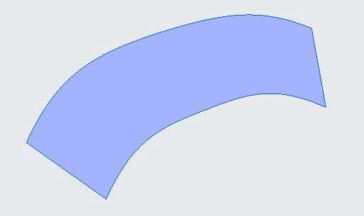

1. In the model tree, right-click Style 1 and select Edit Definition.
2. In the style tree, right-click CF-132 and select Edit Definition.
3. Right-click the curve and select Add Point.
4. Select the Point tab from the dashboard.
5. Edit the Y coordinate value to 100 and press ENTER.
6. Edit the Z coordinate value to 200 and press ENTER.

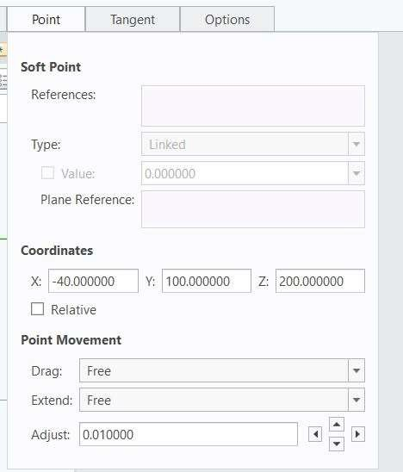 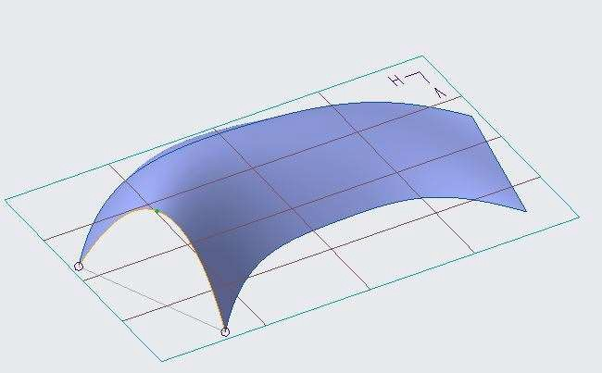

1. Select the top endpoint of the curve.
2. In the Point tab, select soft point type as Length Ratio.
3. Edit the Soft Point Value to 0.1 and press ENTER.
4. Select the bottom endpoint of the curve.
5. Edit the Soft Point Value to 0.2 and press ENTER.

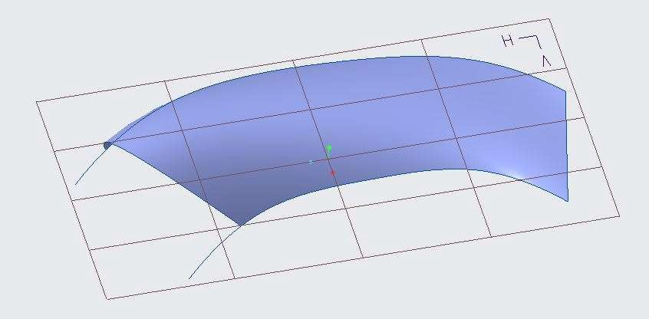

1. Click Complete Feature from the dashboard.

To Drag multiple points, then control points.

1. In the style tree, right-click CF-134 and select Edit Definition.
2. Right-click in the graphics window and select Active Plane Orientation.
3. From the saved orientation select back view.
4. Press CTRL and select the three points in the middle of the curve.
5. Drag the three points to upside, as shown.

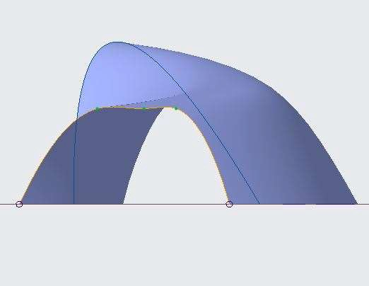

1. Enable Control Points from the dashboard. 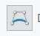
2. Drag the control points to shape the top and bottom of the curve, as shown.

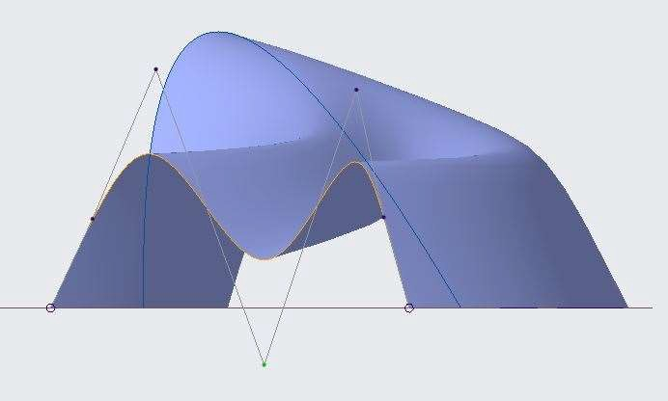

Note: In the Point tab, you can also numerically control the location of control points.

1. Right-click in the graphics window and select Standard Orientation.
2. Click Complete Feature.

To add midpoints and incrementally adjust their locations.

21. In the style tree, right-click CF-130 and select Edit Definition.

1. Right-click the curve and select Add Midpoint.
2. Select the Point tab.
3. Edit the Adjust value to 10 and press ENTER.

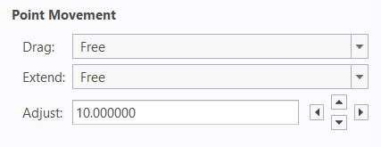

1. Click the adjustment arrows to incrementally move the point horizontally and vertically around the active plane.

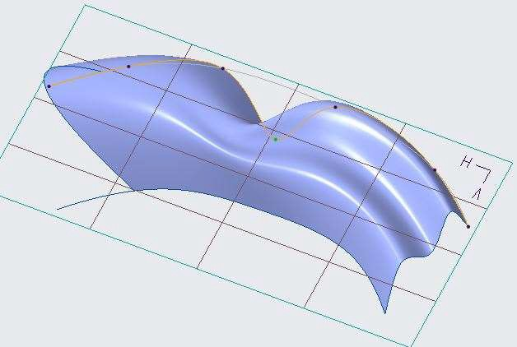

1. Click Complete Feature.
2. Click OK from the Close group.

## *CONNECTING CURVES USING SOFT POINTS*

You can attach a style curve to any curve, edge, quilt or solid surface, scan curve, facet, datum plane, or datum axis by snapping any of the curve's points to these entities as soft or fixed points. If the referenced geometry changes, all attached curves will then update accordingly.

To create a free curve by attaching soft endpoints to existing curves.

1. Open Style_Snap_Points.prt. Disable all Datum Display types.

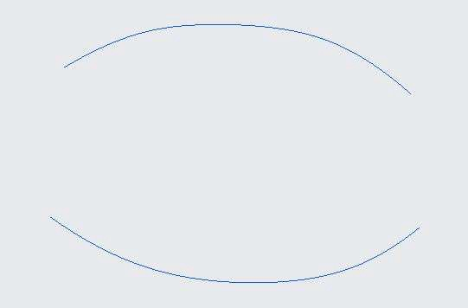

1. In the model tree, right-click Style 1 and select Edit Definition.
2. Right-click in the graphics window and select Set Active Plane.
3. In the model tree, select datum plane RIGHT.
4. Right-click in the graphics window and select Curve.
5. Click Free Curve from the dashboard.
6. Press SHIFT to snap the start point to the lower curve.
7. Select a point location approximately in the cENTER of the model.
8. Press SHIFT to snap the end point to the upper curve.

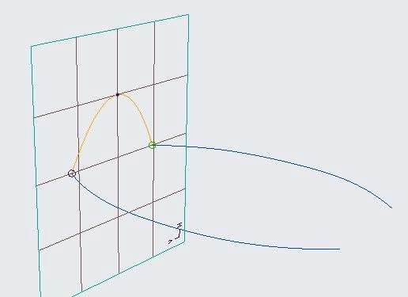

Note: The circles at each end of the new curve signify the soft point attachments to the existing

curves.

1. Right-click in the graphics window and select Edit Definition.
2. Select each endpoint and drag it along the curve to which it is attached.
3. Enable Show All Views from the In Graphics toolbar.

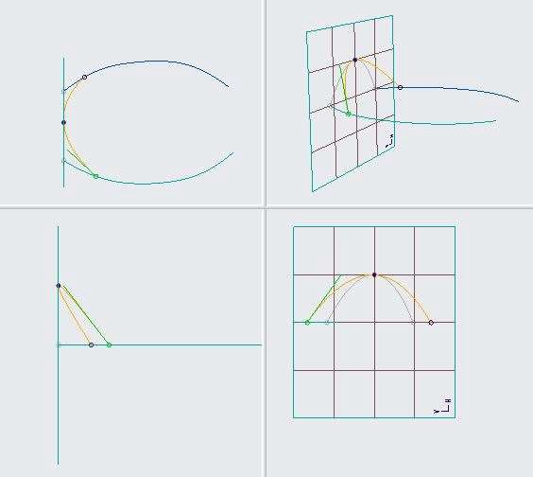

1. Notice that the curve is now a 3-D curve.

To Edit the curve to be planar and connect the internal point to PNT0.

1. Click Planar Curve from the dashboard.
2. In the model tree, select datum plane RIGHT.
3. Disable Show All Views.
4. Click Active Plane Orientation from the In Graphics toolbar.
5. Click Refit from the In Graphics toolbar.
6. Enable Point Display.
7. Press SHIFT and drag the internal point until it snaps to datum point PNT0.

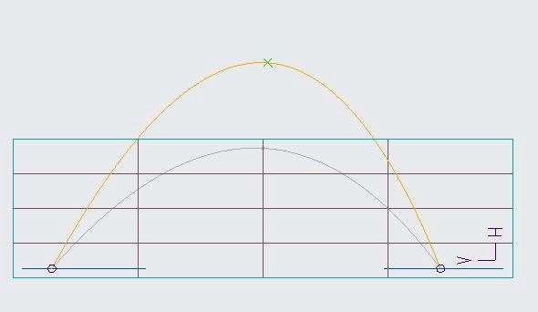

1. Note: The “x” symbol, now at each point of the curve, signifies that the points are now fixed points. They are located at the intersection of datum plane RIGHT and the curve or point reference.
2. Click Complete Feature from the dashboard.

To create a curve with fixed and soft endpoints, then add a mid-point.

1. Right-click and select Curve orient to the Standard Orientation.
2. Press SHIFT to snap the start point to the end of the lower curve.
3. Press SHIFT to snap the end point to the middle of the upper curve.

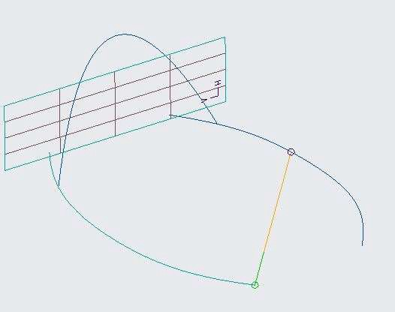

1. Right-click and select Edit Definition.
2. Select the lower endpoint, right-click, and select Lock to Point.
3. Right-click the curve and select Add Midpoint.
4. Select the upper endpoint and drag it along the curve.

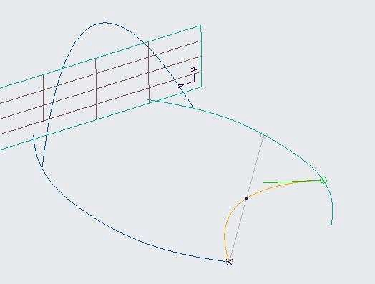

1. Click Complete Feature.
2. Click OK from the Close group.

## *MANIPULATING SOFT POINTS*

When you move a soft point, it moves along the entity to which it is attached. You can slide a soft point

along its reference geometry during curve edits.

To Edit the location of endpoints using the Length Ratio option.

1. Open Style.prt. Disable all Datum Display types.

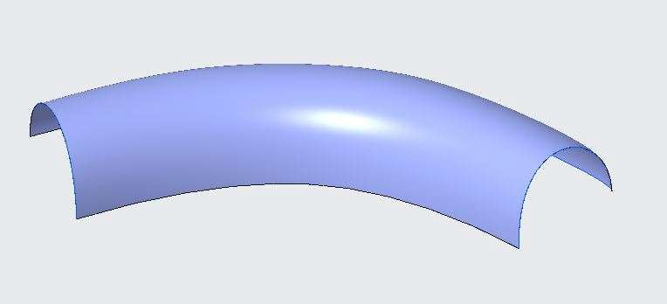

1. In the model tree, right-click Style 1 and select Edit Definition.
2. In the style tree, right-click CF-54 and select Edit Definition.
3. Select the lower right endpoint.
4. Select the Point tab from the dashboard.
5. Select the Soft Point type as Length Ratio.
6. Edit the Soft Point Value to 1 and press ENTER.
7. Select the top right endpoint.
8. Edit the Soft Point Value to .6 and press ENTER.

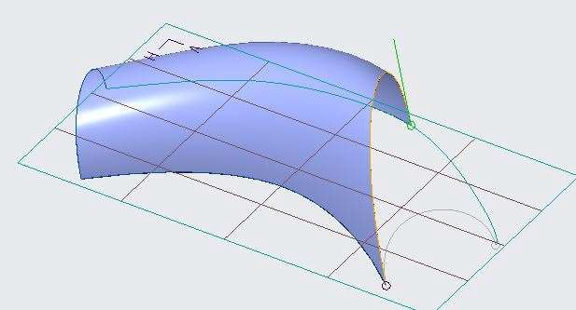

*Note: The circle symbol denotes that this is a soft endpoint.*

To Edit the location of an endpoint using the Length option.

1. Select Length from the Soft Point Type drop-down list.
2. Edit the Soft Point Value to 300 and press ENTER.
3. Edit the Soft Point Value to 400 and press ENTER.

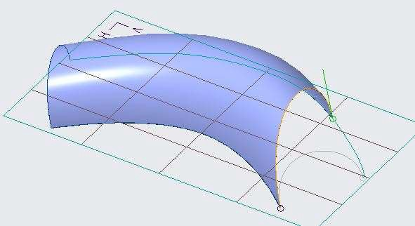

*Note: A value of 80.530185 is placed in the value field; this is the full length of the curve. A length of 100 is not possible because the curve is only 398.496628 long.*

To Edit the location of an endpoint using the Offset from Plane option.

1. Select the top endpoint.
2. Select Offset from Plane from the Soft Point Type drop-down list.
3. In the model tree, select datum plane RIGHT as the offset reference.
4. Edit the Soft Point Value to 120 and press ENTER.

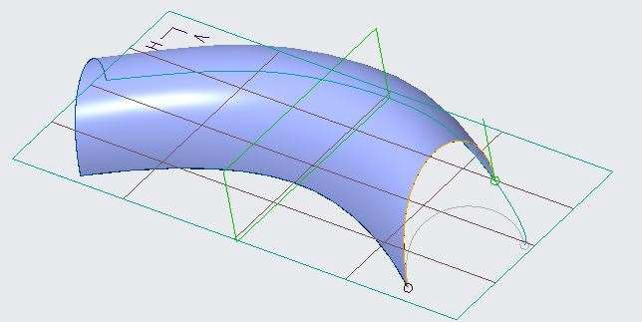

To Edit the location of an endpoint using the Lock to Point option.

1. Select the top soft endpoint.
2. Edit the Soft Point Value to 75 and press ENTER.
3. Right-click the top soft endpoint and select Lock to Point.



*Note: The soft endpoint snaps to the nearest vertex.*

1. Click Complete Feature from the dashboard.

To Edit a curve to planar and observe soft endpoints change to fixed.

1. In the style tree, right-click CF-54 and select Edit Definition.
2. Click Planar Curve from the dashboard.
3. In the model tree, select datum plane RIGHT.

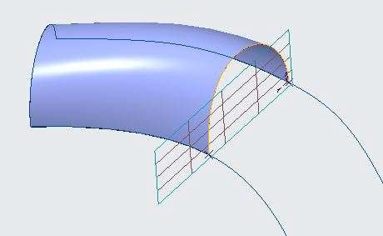

Note: The endpoints change from soft to fixed points.

1. Click Complete Feature.
2. Click OK from the Close group.

## *DEFINING ENDPOINT TANGENCY*

The length and angle of an endpoint's tangent vector influences the shape of the curve it belongs to. After selecting an endpoint, a green tangent handle is displayed at that endpoint in the graphics window. You can drag the tangent handle to define the length and direction of tangency at the endpoint. You can also edit the tangent of a selected endpoint numerically on the Tangent tab.

To Edit the shape of a curve using Fix Length tangency

1. Open End_Point_Tangency.prt. Disable all Datum Display types.

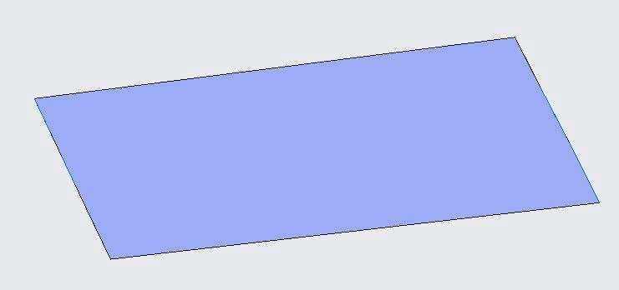

1. In the model tree, right-click Style 1 and select Edit Definition.
2. In the style tree, right-click CF-162 and select Edit Definition.
3. Select each endpoint and drag the tangent handles, as shown.

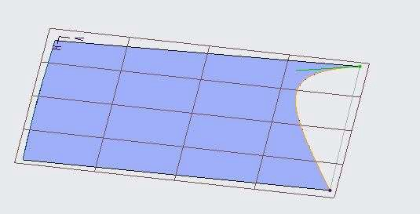

1. Right-click in the graphics window and select Active Plane Orientation.
2. Select the lower endpoint.
3. Right-click the tangent handle and select Normal.
4. In the model tree, select datum plane TOP.
5. Select the Tangent tab from the dashboard.
6. Select the Fix Length option.
7. Edit the Length to 200 and press ENTER.

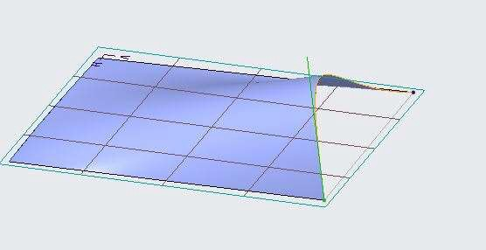

1. Select the upper endpoint.
2. Right-click the tangent handle and select Normal.
3. Select datum plane Right.
4. Select the Fix Length option.
5. Edit the Length to 50 and press ENTER.

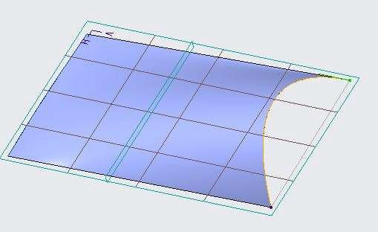

1. Click Complete Feature from the dashboard.

To Edit the shape of a curve using Relax Length tangency.

1. In the style tree, right-click CF-160 and select Edit Definition.
2. Orient to the Standard Orientation.
3. Select each endpoint and drag the tangent handles, as shown.

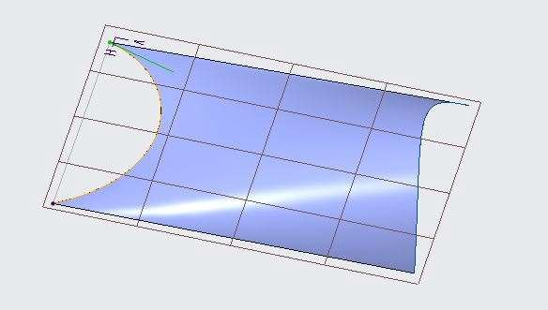

1. Select the lower endpoint.
2. Right-click the tangent handle and select Normal.
3. Select datum plane TOP.
4. Select the Tangent tab. Notice that Relax Length is the default option.
5. Edit the Length to 150 and press ENTER.

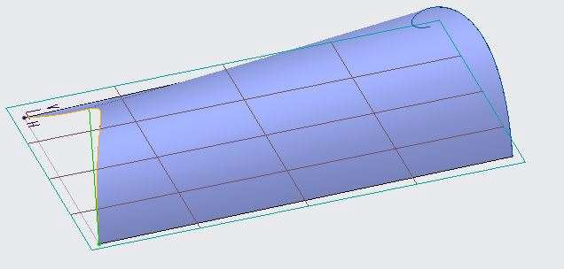

1. Select the upper endpoint.
2. Right-click the tangent handle and select Normal.
3. Select datum plane FRONT.
4. Edit the Length to 30 and press ENTER.

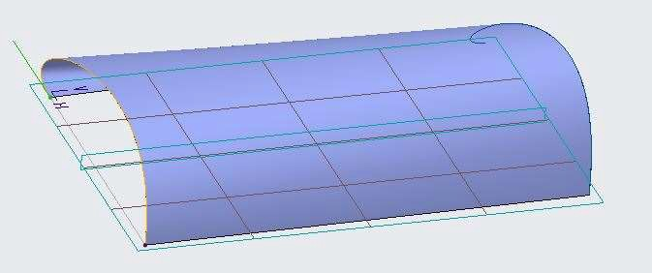

1. Click Complete Feature.

## *DEFINING SOFT ENDPOINT TANGENCY*

In addition to the standard tangent constraints available for any endpoint, there are additional constraint types that you can use only where two curves are connected with a soft point.

To Manipulate the tangent constraint between curves.

1. Open Soft_Endpoints_Tangency.prt Disable all Datum Display types.

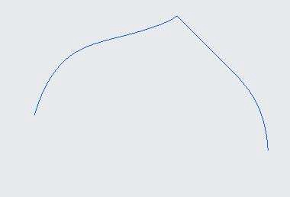

1. In the model tree, right-click Style 1 and select Edit Definition.
2. In the style tree, right-click CF-2 and select Edit Definition.
3. Click Active Plane Orientation from the In Graphics toolbar.
4. Select the Right endpoint of the curve.
5. Right-click the tangent handle and select G1 Tangent.

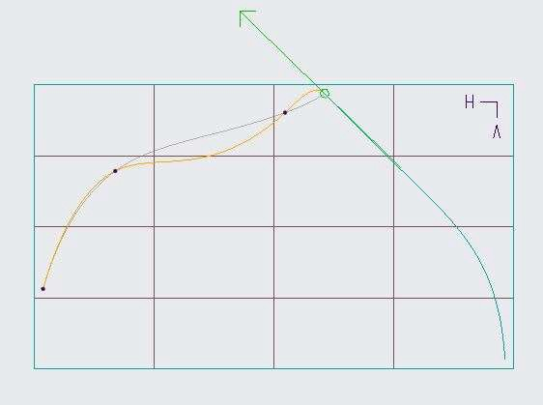

1. Drag the arrow end of the tangent handle to edit the length of the tangent vector.

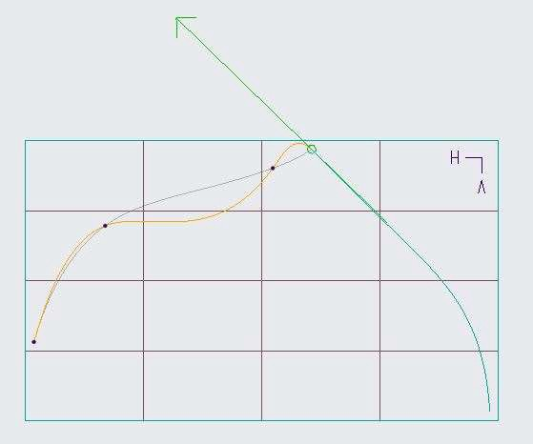

*Note: The leader curve on the right remains unchanged as you drag the tangent arrow. You can modify only the tangent length because the tangent angle is controlled by the leader curve*.

1. Drag the tail end of the tangent handle, located just to the right of the constraint point.

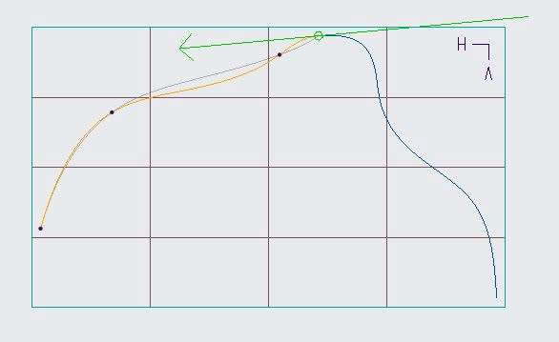

*Note: Dragging the tail edits both the tangent angle and tangent length of the leader curve.*

1. Click the tail end of the tangent handle (left side) to reverse the tangency.
2. Drag the arrow end of the tangent handle to adjust the curve shape.

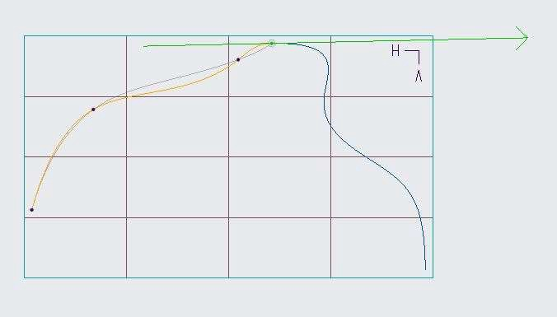

*Note: The leader curve is now the curve on the Left, CF-2.*

To Observe how the symmetric constraint behaves.

1. Right-click either the arrow or the tail of the tangent arrow and select Symmetric.

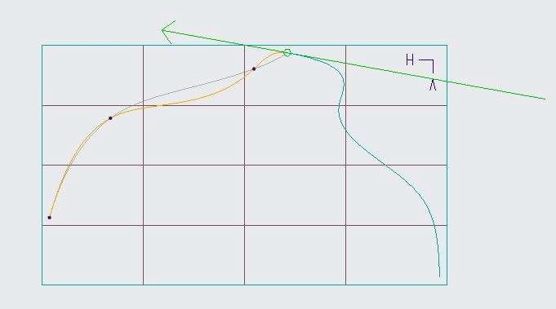

*Note: The shape does not change. This is because Symmetric changes the tangent angle and this can only be done to the follower curve.*

1. Double-click the follower curve (on the right) and then select the constraint point.
2. Right-click either the arrow or tail of the tangent arrow and select Symmetric.
3. Select the Tangent tab from the dashboard.
4. Notice that the constraint listed is Tangent.

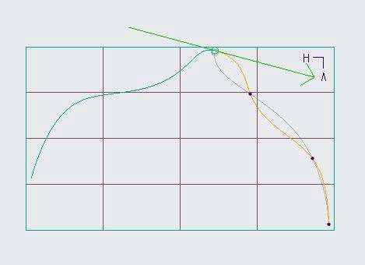

*Note: When you select Symmetric, you are not really applying a symmetric constraint. You are applying a tangent constraint, with the initial tangent angles of the two adjoining curves set to the*

*average of the tangents at the endpoints. After the constraint is applied, it behaves as any other tangent constraint.*

1. Right-click the tangent arrow and select G2 Curvature.
2. Drag the curvature arrow and tail to change the shape.

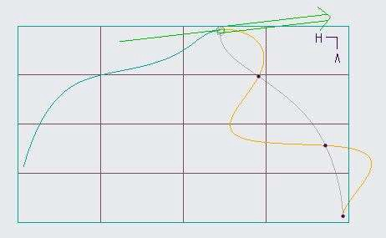

*Note: You can manipulate the curvature connection in the same way with the same limitations as the tangent connection.*

To Add a Draft Tangent to a soft endpoint.

1. Right-click the Curvature handle and select Draft Tangent.
2. In the model tree, select datum plane TOP.
3. Orient to the Standard Orientation.

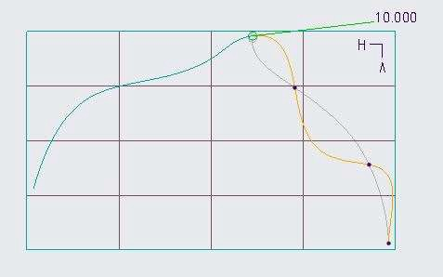

1. Click Complete Feature from the dashboard.
2. Click OK from the Close group.

## *EDITING CURVES*

One method for editing a curve is to edit the style points that define that curve. You can move, add, or

remove style points to change the curve's definition. You can also edit the curve itself by splitting it, combining it with another curve, or extending its length at the ends.

To Combine two curves and delete a point.

1. Open Style_Curve_Edit.prt. Disable all Datum Display types.

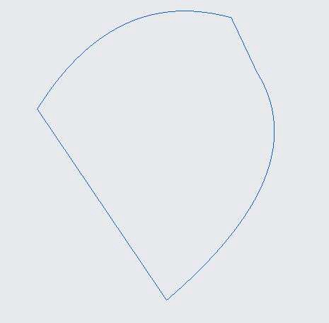

1. In the model tree, right-click Style 1 and select Edit Definition.
2. In the style tree, right-click CF-174 and select Edit Definition.
3. Right-click the point shown and select Combine.

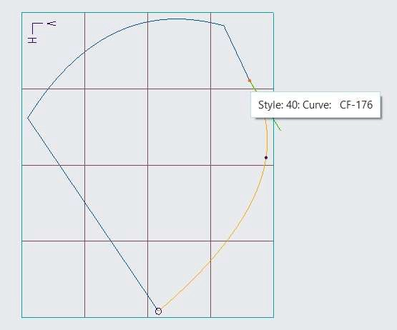

1. Notice the combined curve contains four points and has been renamed.

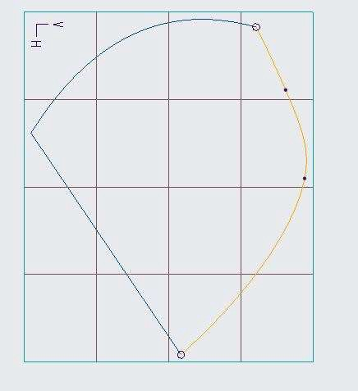

1. Right-click the same second point and select Delete.

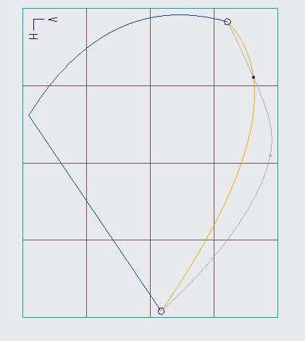

1. Click Complete Feature from the dashboard.

To Add a midpoint to a curve, split it, and drag the intersection.

1. In the style tree, right-click CF-173 and select Edit Definition.
2. Right-click the curve and select Add Midpoint.
3. Right-click the new point and select Split.

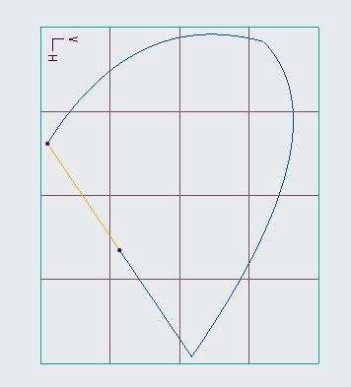

Notice that curve CF-173 has been replaced with two new curve features.

1. Select the midpoint.
2. Select the Point tab from the dashboard.
3. Edit the X coordinate value to –150 and press ENTER.
4. Edit the Z coordinate value to –100 and press ENTER.
5. Select the Tangent tab.
6. Edit the Angle value to 150 and press ENTER.

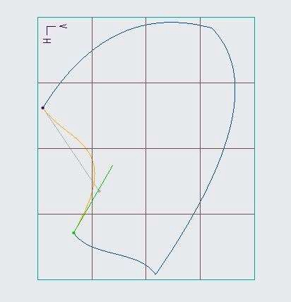

1. Click Complete Feature.

To Extend a curve using the free and tangent options.

1. Double-click the Left curve.
2. Select the Top endpoint of the curve.
3. Press SHIFT+ALT and click just to the right of the endpoint, as shown.

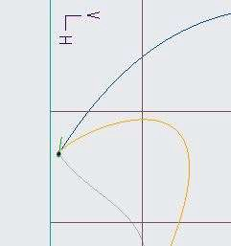

Note: The old endpoint changes to an internal point and a new endpoint is created. This is a Free extension.

1. Select the bottom endpoint of the curve.
2. Press SHIFT+ALT and drag the endpoint as shown.

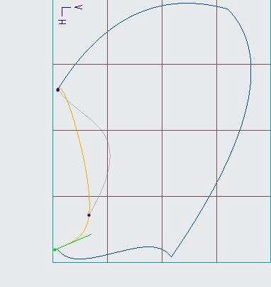

1. Click Complete Feature.
2. Click OK from the Close group.

Note: The endpoint moves along with the curve that is attached to it, leaving an internal point at the old endpoint location. This is a Tangent extension.

## *CREATING RADIAL PATH PLANAR CURVES*

You can create a radial path planar curve by creating points on a soft plane. The soft plane is normal to

the parent curve at a selected point on the parent curve and normal to the parent curve's active plane.

The soft plane can slide along its parent curve while remaining normal to the parent curve. When the parent curve is updated, the planes and the planar curves are regenerated.

1. Open Surface_Radial_Path.prt. Disable all the datum types.

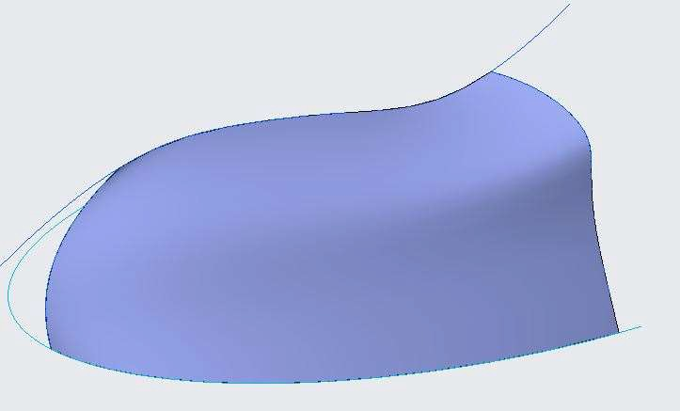

1. In the model tree, right-click Style 1 and select Edit Definition.
2. Select the curve command from the curve group.
3. Click Planar Curve from the dashboard.
4. Right-click in the graphics window and select Reference Collector.
5. Place the soft plane by clicking on the lower curve of the surface.
6. From the In Graphics toolbar, click Saved Orientations and select TOP.
7. Select the References tab from the dashboard and edit the Radial Plane Value to .2 and press ENTER.

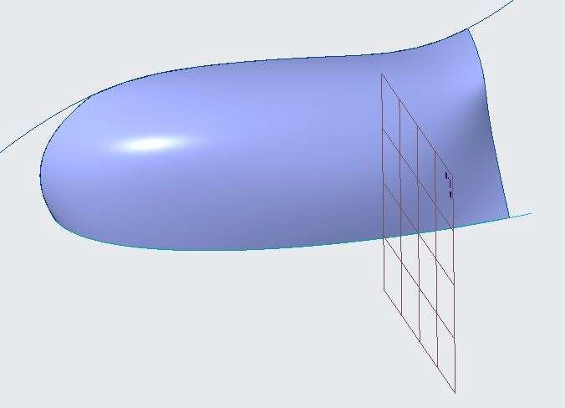

1. Notice how the soft plane's location Changes.
2. Create the curve by clicking another four points by placing the last points on the upper curve as shown.

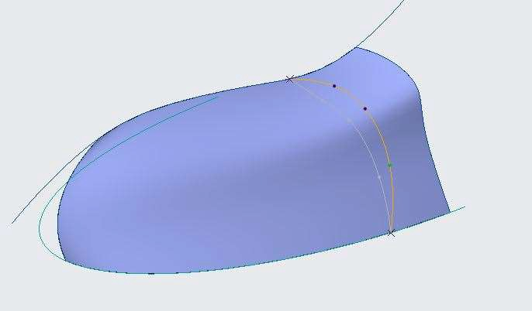

1. Click Complete Feature.
2. Similarly draw another curve as shown below by Editing the Plane Value to 0.7.

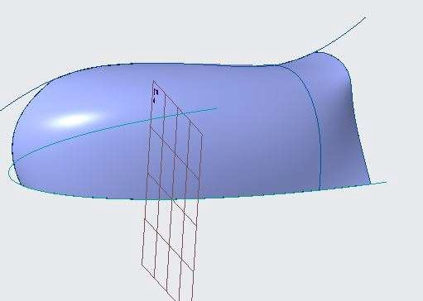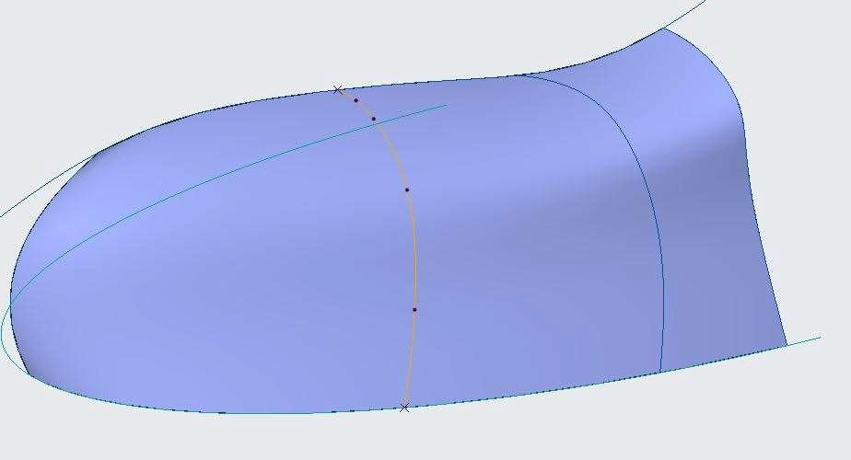

1. Click Complete Feature.
2. Select and right click surface SF-456 and Edit Definition.
3. Right click in the graphics Window and select Internal Collector.
4. Select the two created curves.

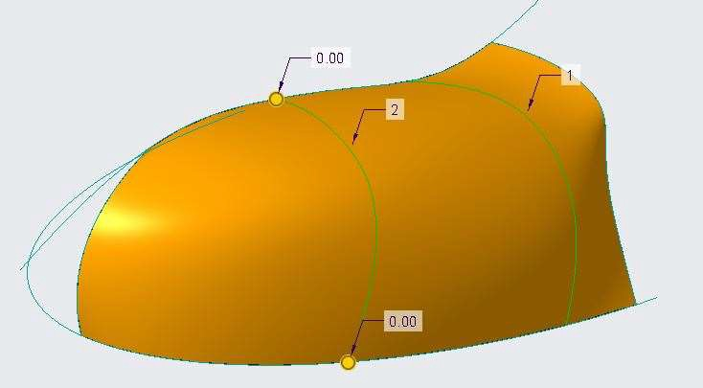

1. Click Complete Feature.
2. Click OK from the Close group

## *USING THE 4-VIEW LAYOUT TO MODIFY CURVES*

You can use the 4-view layout option within the Style tool to create and manipulate style curves and surfaces. When activated, the system creates front, top, right, and 3-D views of the model. You can resize each window and then independently spin/pan/zoom in each window.

1. Open Modify_Curves.prt. Disable all the datum types.

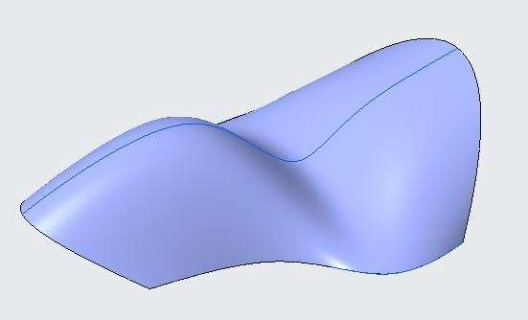

1. In the model tree, right-click Style 1 and select Edit Definition.
2. Select CF-442 and Edit Definition.
3. From Graphics toolbar, enable Show All Views.

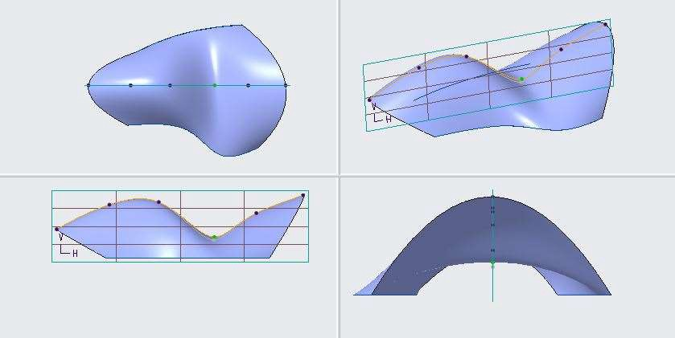

1. From the lower left view select and drag the point upwards as shown below.

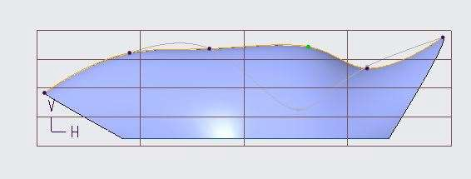

1. From the upper left view select and drag the point downwards as shown below.

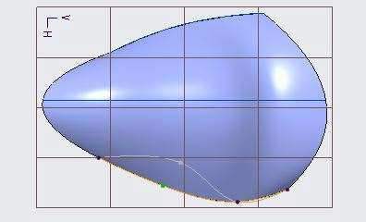

1. From Graphics toolbar, disable Show All Views.
2. Orient the model to observe the shape.

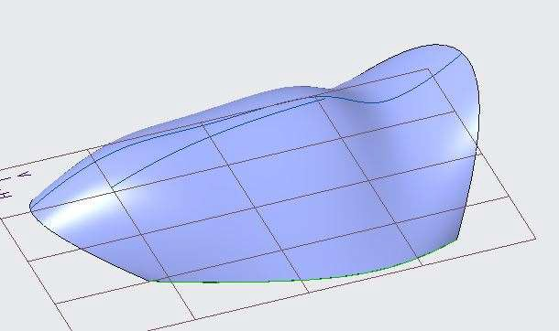

1. Click OK from the Close group

## *ANALYZING CURVES*

You should analyze curves during the modeling process to ensure that the tangency and curvature requirements of your design are maintained.

1. Open Analyzing_Curves.prt. Disable all the datum types.

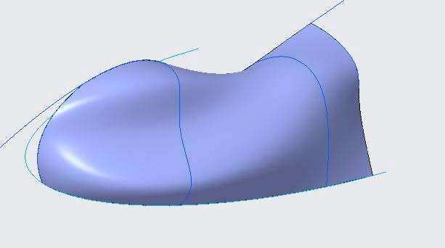

1. Select Style 1 from the model tree and Edit Definition.
2. Select CF-474 and Edit Definition.
3. Click Pause Feature from Style: Curve Edit tab. 
4. Select Curvature command from the under Inspect Geometry group from Analysis tab.
5. ENTER the Scale value as 50.

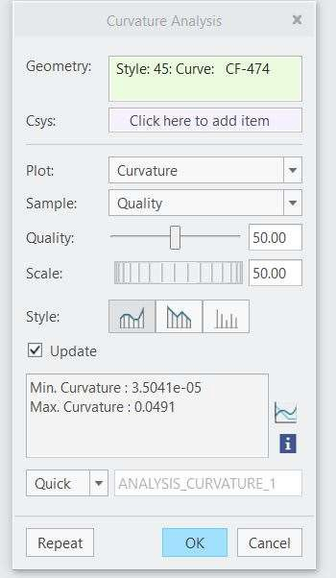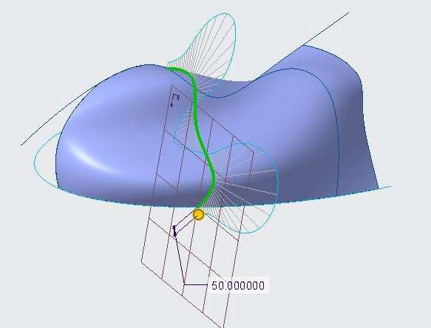

1. Select the Style: Curve Edit tab.
2. Select the centre point and move it as shown below.

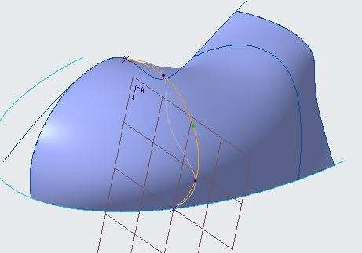

1. Click Pause Feature from Style: Curve Edit tab.
2. Select Curvature command from the under Inspect Geometry group from Analysis tab.

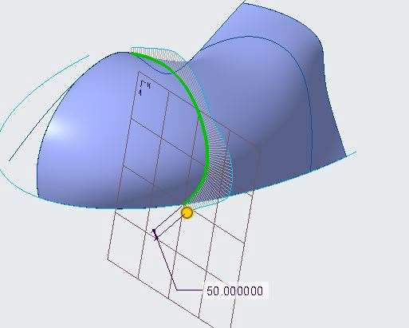

1. Observe the changes.
2. Select the Analysis tab.
3. Click Saved Analysis from the Manage group.
4. In the Saved Analysis dialog box, click Hide Analysis for ANALYSIS _CURVATURE _1.
5. Click Delete Analysis.
6. Close the Saved Analysis dialog box.
7. Select the Style tab.
8. Click OK from the Close group.

# *MODULE 12 - DEVELOPING STYLE SURFACE MODELS*

*For the activity files browse to folder Developing Style Surface Models.*

## *UNDERSTANDING STYLE SURFACES*

Surface Design learning guide focuses on the creation of complex geometry that cannot be created easily using solid features. It provides students with a basic understanding of surface modeling styles and extensive practices to practice the new functionality used to create complex geometry.

## *CREATING BOUNDARY SURFACES*

You can create style surfaces using boundaries. You can add internal curves to modify the shape. You can work interactively with style surfaces by manipulating the boundary and the internal curves. Boundary surfaces are particularly useful when you create conceptual models in which you interactively and intuitively design the shapes.

To Create a four-boundary surface.

1. Open Surface_Boundary.prt. Disable all Datum Display types.

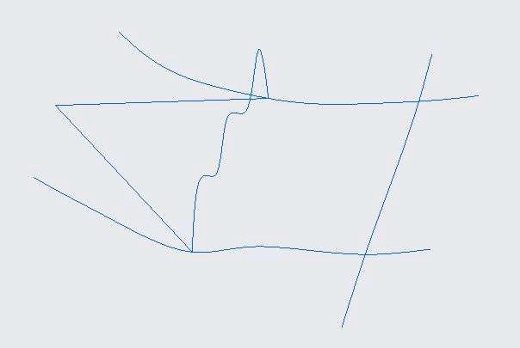

1. In the model tree, right-click Style 1 and select Edit Definition.
2. Click Surface from the Surface group.
3. Press CTRL and select the four boundaries in the right side as shown.

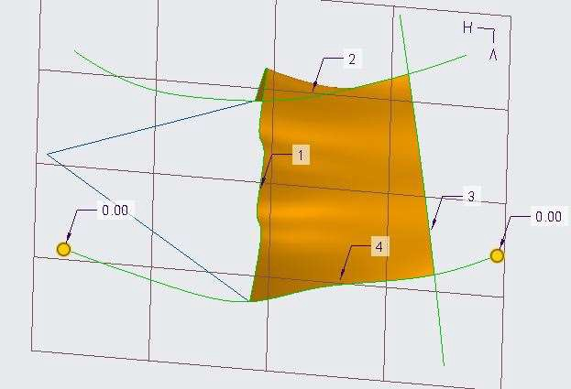

*Note: The four boundaries can be selected in any order. The selected boundaries include a solid edge, two sketched curves, and a single style curve.*

1. Click Complete Feature from the dashboard.
2. Click OK from the Close group.

To Create a three-boundary surface.

1. In the model tree, right-click Style 1 and select Edit Definition.
2. Click Surface from the Surface group.
3. Press CTRL and Select the three curves on the left side as shown.

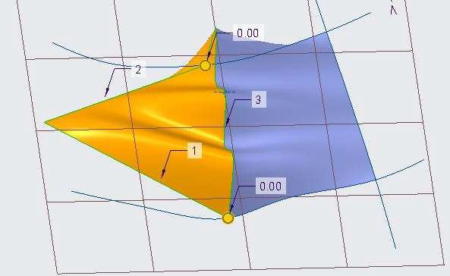

*Note: When you create a triangular surface, the first boundary curve you select becomes the natural boundary. This is the boundary that is opposite the degenerate vertex. Experimenting with different natural boundaries for the same triangular surface can produce smoother surface curvature results.*

1. Click Complete Feature.
2. Click OK.
3. Click File > Manage Session > Erase Current.
4. Click Yes in the Erase Confirm dialog box.

To Create an N-Sided surface.

1. Click Open from the Quick Access toolbar.
2. Double-click N-sided_surface.prt. Disable all the datum types.

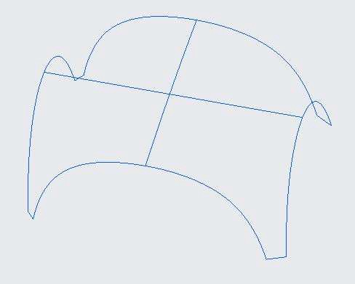

1. In the model tree, right-click Style 1 and select Edit Definition.
2. Click Surface to define the six curves that define the boundaries for the N-sided surface, press CTRL and select the curves in a clockwise order.

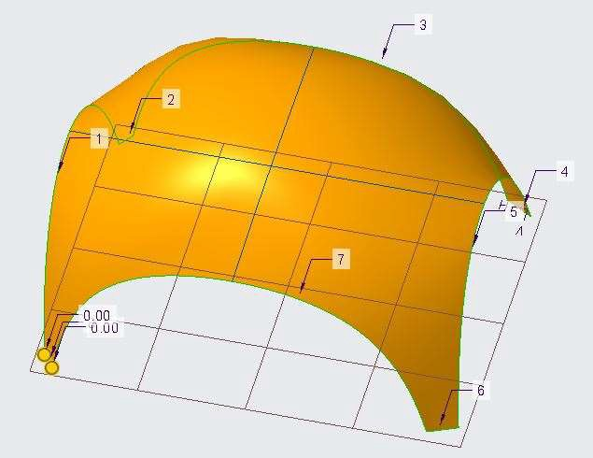

1. Click Complete Feature.
2. Click OK.
3. Spin the model and review the newly created surface.

Note: Notice that the surface is not a very smooth transition between the adjacent surfaces. To use internal curves to create a smooth transition between the adjacent boundaries.

1. Right-click Style 1 and select Edit Definition.
2. In the style tree, right-click SF-348 and select Edit Definition.
3. Select the References tab from the dashboard and click in the Internal collector to activate it.
4. Press CTRL and select the two straight curves.

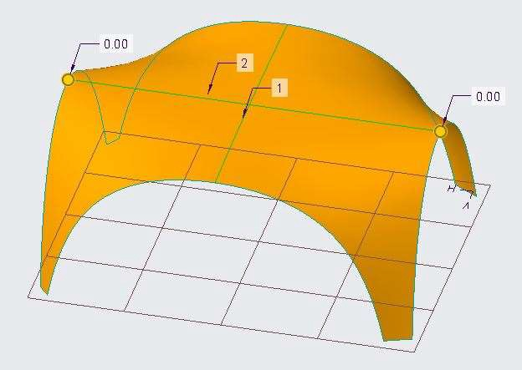

1. Click Complete Feature.
2. Click OK.
3. Spin the model and review the modified geometry.

Note: Notice how the internal curves have influenced the surface.

## *CREATING LOFT SURFACES*

You can create loft surfaces by selecting a set of non-intersecting curves that flow in the same direction as boundaries.

To Create a loft surface.

1. Open Style_Loft.prt. Disable all Datum Display types.

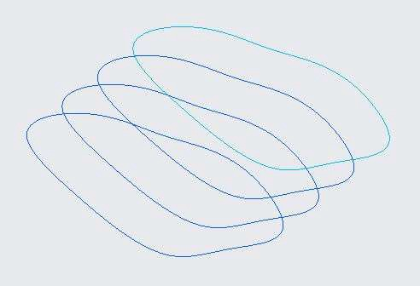

1. Select Sketch 1 and unhide.
2. Click Style from the Surfaces group.
3. Click Surface from the Surface group.
4. Select the first curve from bottom. (Half curve is selected). Press SHIFT and select the remaining portion to select the complete curve.
5. Press CTRL, repeat the step 4, working from bottom to top, select the four loft sections, as shown.

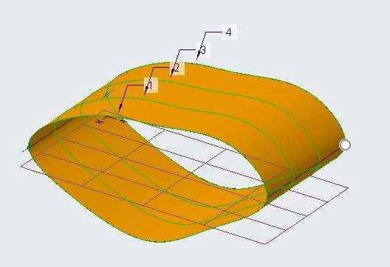

1. Click Complete Feature from the dashboard.
2. Click OK from the Close group.

Note: You create a loft surface by selecting boundary curves that flow in the same direction across a model. You cannot select curves randomly; they must be selected in a single direction across the model.

## *USING MULTIPLE CURVES AS A SINGLE BOUNDARY*

You can use more than one curve to create a single boundary of a surface; however, the resulting surface is a composite surface.

To create a boundary surface with a multi-segment boundary.

1. Open Style_Multiple_Curves.prt. Disable all Datum Display types.

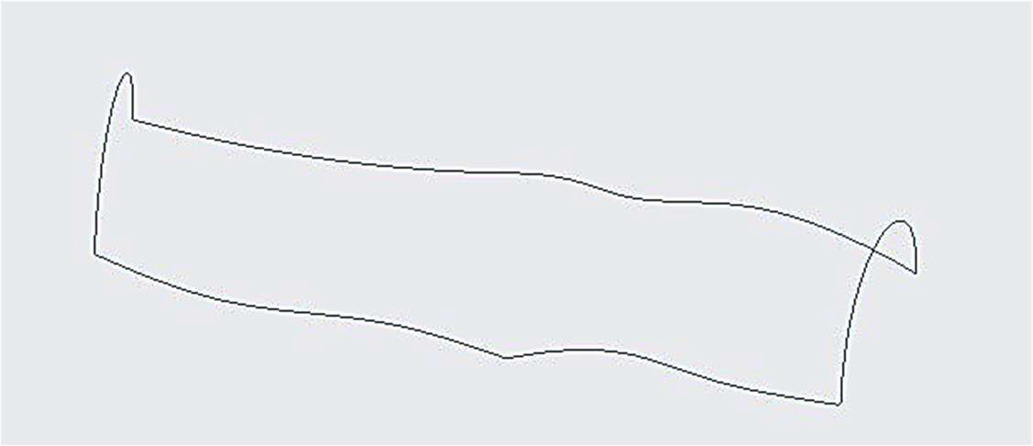

1. In the model tree, right-click Style 1 and select Edit Definition.
2. Click Surface from the Surface group.
3. Select the lower arc-shaped curve, CF-209, as the first boundary.
4. Press CTRL and select the upper arc-shaped curve, CF-208, as the second boundary.
5. With CTRL still pressed, select the lower-left curve, CF-207, as the third boundary.
6. Release CTRL and press SHIFT, then try to select the upper-left curve, CF-206, as the continuation for the third boundary segment.

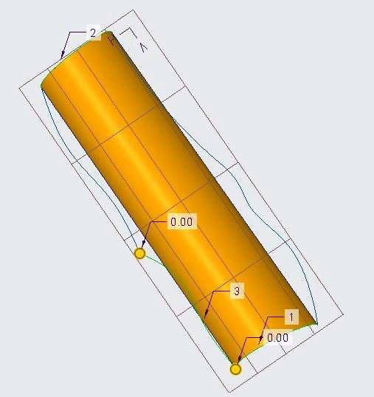

*Note: You cannot select the second curve as a segment of the boundary because the curves are not connected with a tangent or curvature constraint.*

To edit the endpoint tangency so that you can use it as a boundary.

1. Click Cancel Feature from the dashboard.
2. In the style tree, right-click CF-207 and select Edit Definition.
3. Select the endpoint of the curve shown.

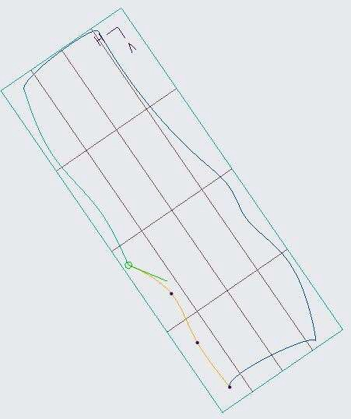

1. Right-click the tangent handle, and select Tangent.
2. Click Complete Feature from the dashboard.
3. Click in the background of the graphics window to de-select all geometry.

To Create a boundary surface using multi-segment boundaries.

1. Click Surface from the Surface group.
2. Select the lower arc-shaped curve, CF-209, as the first boundary.
3. Press CTRL and select the upper arc-shaped curve, CF-208, as the second boundary.
4. With CTRL still pressed, select the lower-left curve, CF-207, as the third boundary.
5. Release CTRL and press SHIFT, then select the upper-left curve, CF-206, as the continuation for the third boundary segment.
6. Release SHIFT, press CTRL and select the lower-right curve, CF-205, as the fourth boundary.
7. Release CTRL and press SHIFT, then select the upper-right curve, CF-203, as the continuation for the fourth boundary segment.

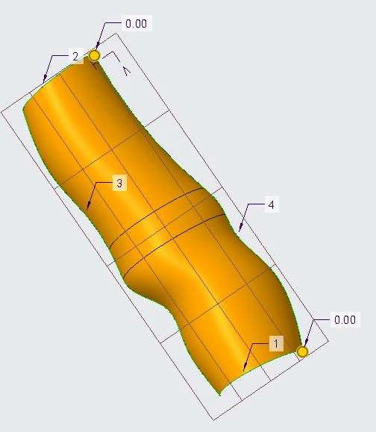

1. Click Complete Feature.
2. Click OK from the Close group.

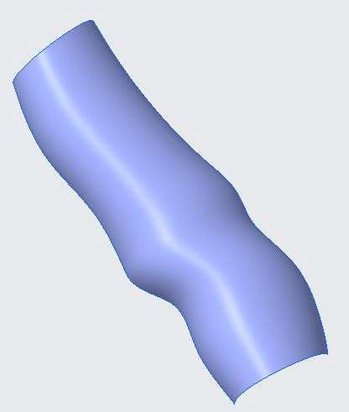

Note: The completed surface is a single-quilt composite surface, containing three surface patches. It is a composite surface because it was created from boundaries containing multiple curve segments.

## *CREATING A BLEND SURFACE USING THE RADIAL OPTION*

A blended surface is created by selecting one primary curve and one cross curve as a boundary. Drag handles at the ends of the primary and cross curves enable you to further control the shape and size of the surface.

To Create a surface using the Radial option.

1. Open Radial_Surface.prt. Disable all Datum Display types.

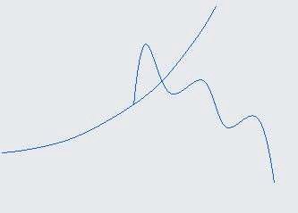

1. In the model tree, right-click Style 1 and select Edit Definition.
2. Click Surface from the Surface group.
3. Select the large primary curve, CF-273.
4. Right-click in the graphics window and select Cross Collector.
5. Select the small cross curve, CF-270.

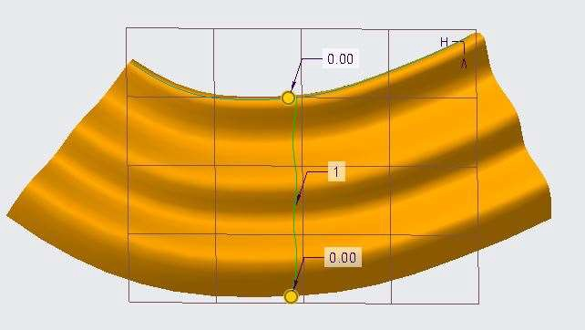

1. Right-click in the graphics window and select Active Plane Orientation.
2. Select the Options tab from the dashboard. Notice the Radial option is selected by default.
3. Note: The Radial option creates a surface by sweeping the cross curve normal to each point on the primary curve.
4. Clear the Radial check box.

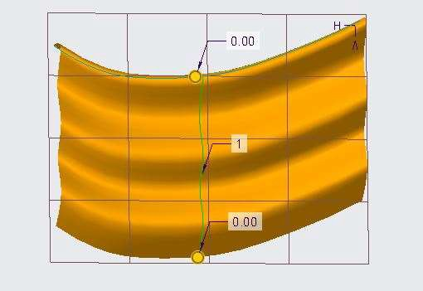

*Note: Without the Radial option selected, the surface is created by sweeping the cross curve parallel to primary curve.*

1. Click Close feature.

## *CREATING A BLEND SURFACE USING THE UNIFORM OPTION*

A blended surface is created by selecting two primary curves and one cross curve as boundaries. Drag handles at the ends of the primary and cross curves enable you to further control the shape and size of the surface.

To Create a surface using the Uniform option.

1. Open Style_Uniform.prt. Disable all Datum Display types.

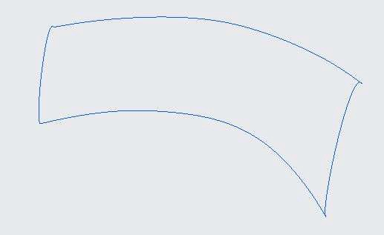

1. In the model tree, right-click Style 1 and select Edit Definition.
2. Click Surface from the Surface group.
3. Press CTRL and select the two longer curves as primary curves.
4. Right-click in the graphics window and select Cross Collector.
5. Select the small cross curve.

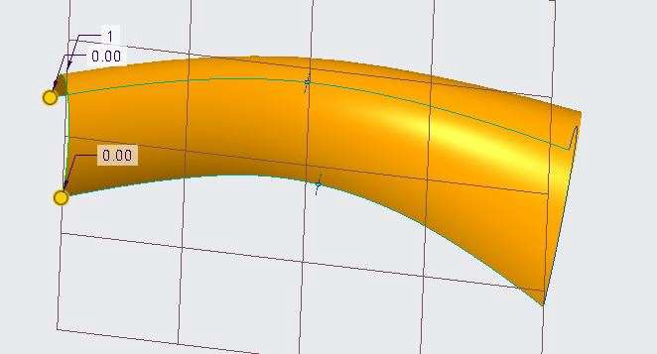

1. Right-click in the graphics window and select Active Plane Orientation.
2. From the In Graphics toolbar, click Saved Orientations and select FRONT.
3. Select the Options tab from the dashboard. Notice that Uniform is selected by default.

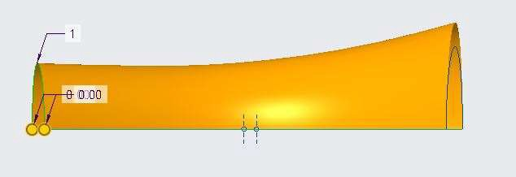 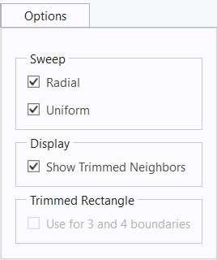

1. Note: The Uniform option creates a surface by sweeping the cross curve along the primary curves, which
2. scales the cross curve uniformly along the primary curves.
3. Clear the Uniform check box.

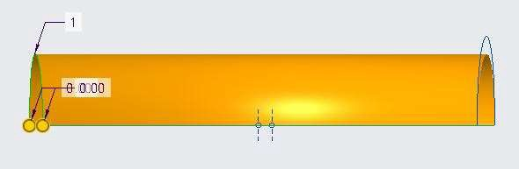

Note: Without the Uniform option selected, the cross curve is scaled non-uniformly to preserve the consistent loft over the blend.

To drag to adjust the primary curve lengths.

1. Orient to the Standard Orientation.
2. In the ribbon, select the Style tab.
3. Select Internal Plane from the Set Active
4. Plane types drop-down menu in the Plane group.
5. In the model tree, select datum plane RIGHT.
6. Drag the datum plane offset handle to the right to approximately 100.

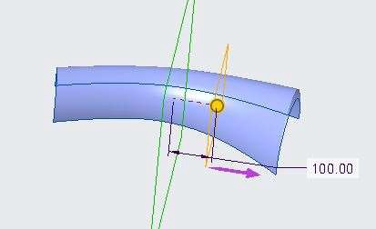

1. Click OK in the Datum Plane dialog box.
2. Enable Plane Display.
3. Select the Style: Surface tab.
4. Click Saved Orientations and select TOP.
5. Right-click in the graphics window and select Primary Collector.
6. Press SHIFT and drag the selected primary curve's drag handle until it snaps to the new datum plane.
7. Select the second primary curve, press SHIFT, and drag its handle until it snaps to the new datum plane.

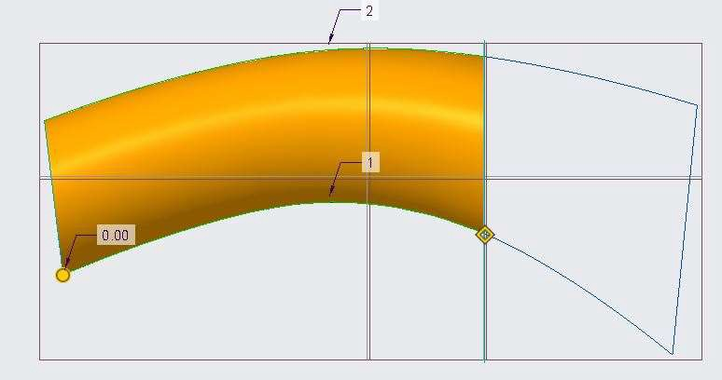

1. Click Complete Feature from the dashboard.
2. Click OK from the Close group.

## *USING SURFACES TO DEFINE CURVES*

You can create several types of curves that use surfaces as references. These curves are referred to as curve on surface type curves and are often abbreviated as COS type curves. Methods for creating these curves are as follows:

* + Curve on Surface option
  + Drop Curve
  + COS By Intersect
  + Curve from Surface
    - Free Curve
    - Curve on Surface

## *CREATING A CURVE ON SURFACE TYPE CURVE*

You can create a curve on a surface using the following methods:

* Curve on Surface option
* Dropping a curve

To Create a curve on surface using the Curve on Surface option.

1. 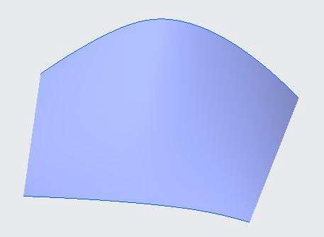Open Curve_on_Surface.prt. Disable all Datum Display types.
2. In the model tree, right-click Style 1 and select Edit Definition.
3. Select Curve from the Curve types drop-down menu in the Curve group.
4. Click Curve on Surface from the dashboard.

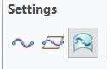

1. Right-click in the graphics window and select Surface Collector.
2. Select the surface.
3. Press SHIFT and place a soft point on the upper boundary of the surface.
4. Click the surface twice to place two additional points, as shown.
5. Press SHIFT and place a soft point on the lower boundary of the surface.

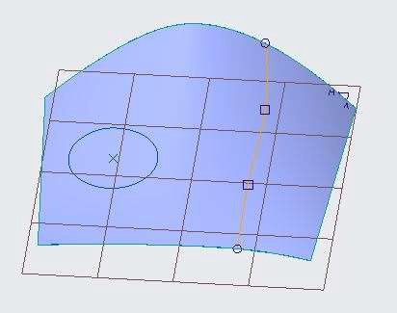

Note: The hollow circle symbols represent soft points attached to curves. The hollow square symbols represent soft points attached to the surface. If the top point is attached to the surface, you can drag it to the curve in the next step.

1. Right-click in the graphics window and select Edit Definition.
2. Drag the points to adjust the shape.

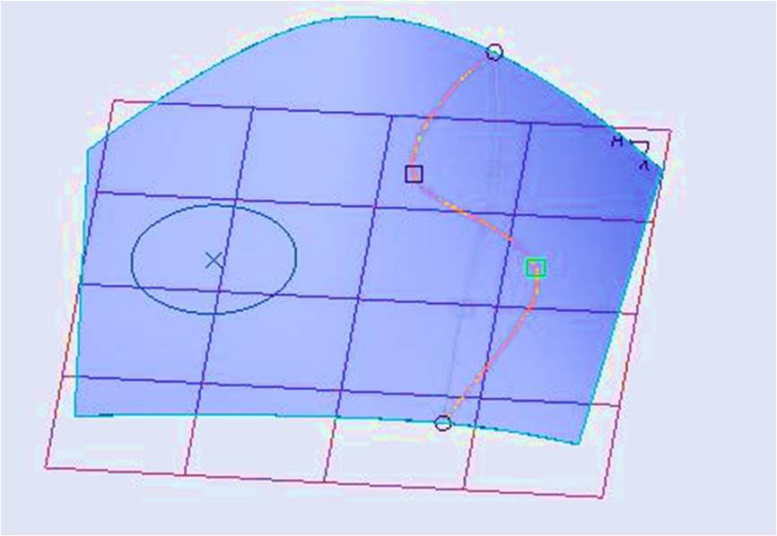

1. Spin the model and notice that the curve has been placed on the surface.
2. Click Complete Feature from the dashboard.

To Create a curve by dropping an existing curve onto the surface.

1. Click in the background of the graphics window to de-select all geometry.
2. From the In Graphics toolbar, click Saved Orientations and select Default Orientation.
3. Click Drop Curve from the Curve group.

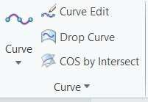

1. Select the circular curve.
2. Right-click and select Surface Collector.
3. Click the surface.

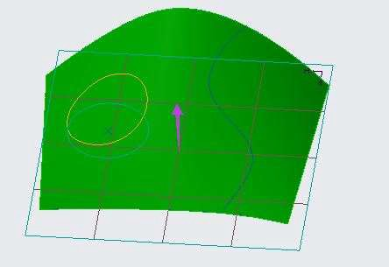

1. Note: In the dashboard, you can see that the TOP datum plane is selected as the direction reference.
2. You can edit this at any time.
3. Click Complete Feature.
4. Click OK from the Close group.
5. Spin the model and notice that the curves have been placed on the surface.

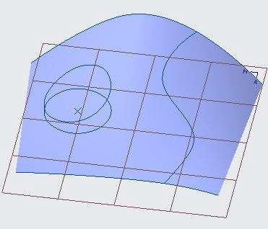

## *INTERSECTING TO CREATE A CURVE ON SURFACE*

You can create curve on surface type curves by intersecting two surfaces or a surface with a datum plane. You can reference surface geometry from solid models, imported geometry, or style features.

To Create a curve by intersecting two surfaces.

1. Open Curve_Intersection.prt. Disable all Datum Display types.

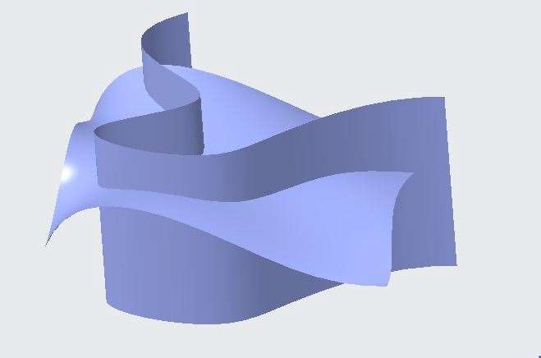 

1. Click Style from the Surfaces group.
2. Click COS by Intersect from the Curve group.
3. Select the upper blend surface.
4. Right-click in the graphics window and select Second Collector.
5. Select the side spline surface.
6. Click Complete Feature from the dashboard.

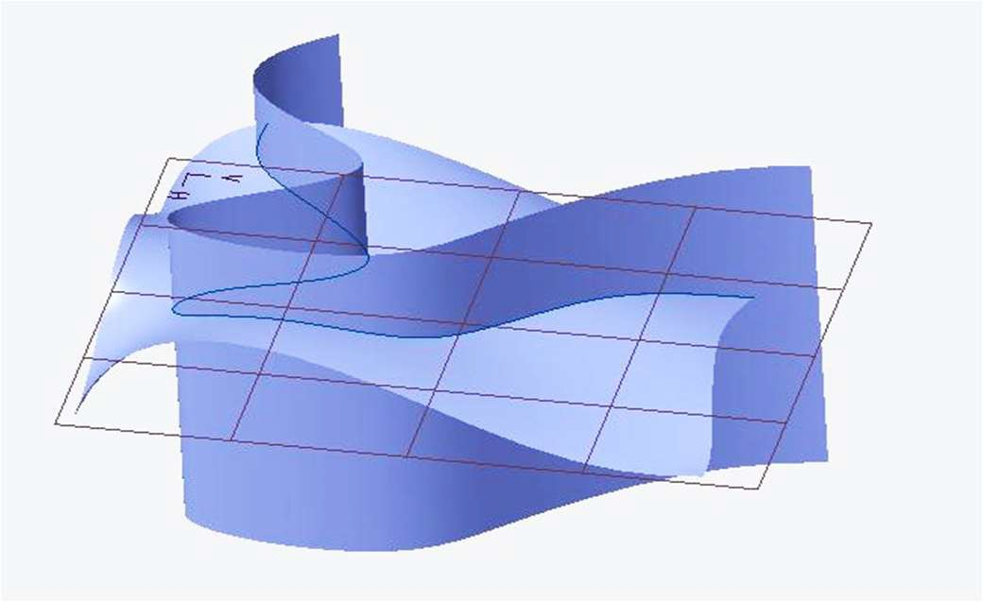

*Note: You can reference surface geometry from solid models, imported geometry or style features to create Curve on Surface type curves.*

To Create three curves by intersecting datum planes with surfaces.

1. Enable Plane Display.
2. Click COS by Intersect from curve group.
3. Select the side surface.
4. Right-click and select Second Collector.
5. Select datum plane TOP.
6. Click Complete Feature.

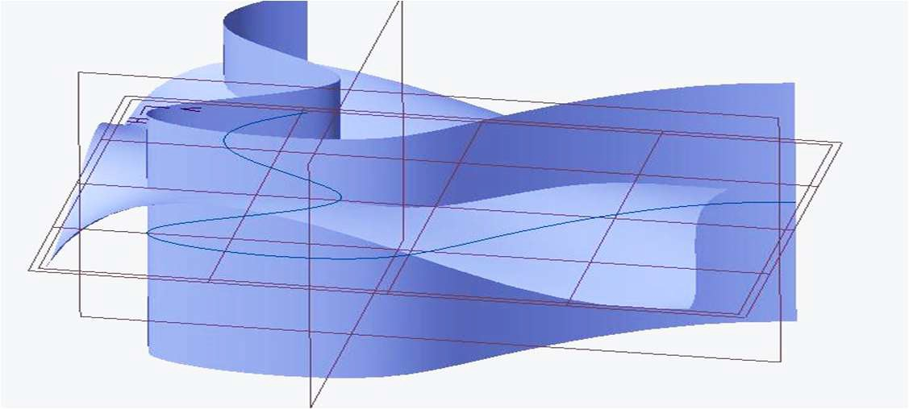

1. Click COS by Intersect from curve group.
2. Select the side surface.
3. Right-click and select Second Collector.
4. Select datum plane FRONT.
5. Click Complete Feature.

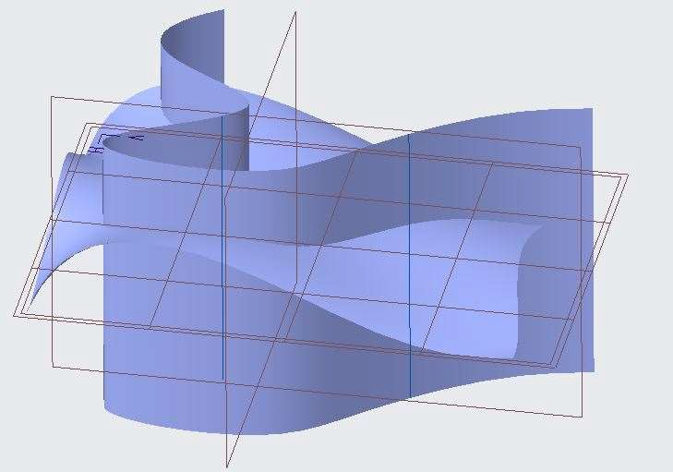

1. Click COS by Intersect from curve group.
2. Select the side surface.
3. Right-click and select Second Collector.
4. Select datum plane RIGHT.
5. Click Complete Feature.

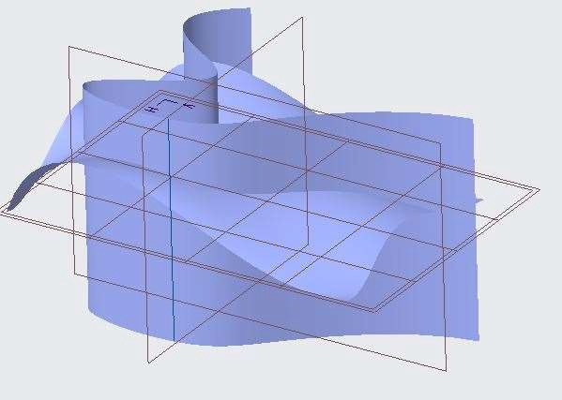

## *CREATING A CURVE USING CURVE FROM SURFACE*

You can create a free curve or curve on surface type curve from a parallel isoline (isoparametric) of a surface.

To Create a curve from surface.

1. Open Curve_from_Surface.prt. Disable all Datum Display types.

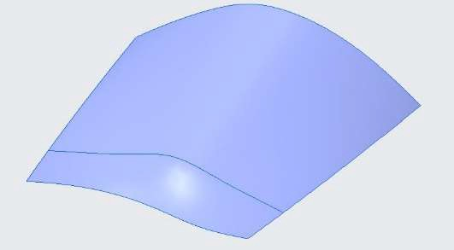

1. In the model tree, right-click Style 1 and select Edit Definition.
2. Click the Curve group drop-down menu and select Curve from Surface.
3. Select the surface.

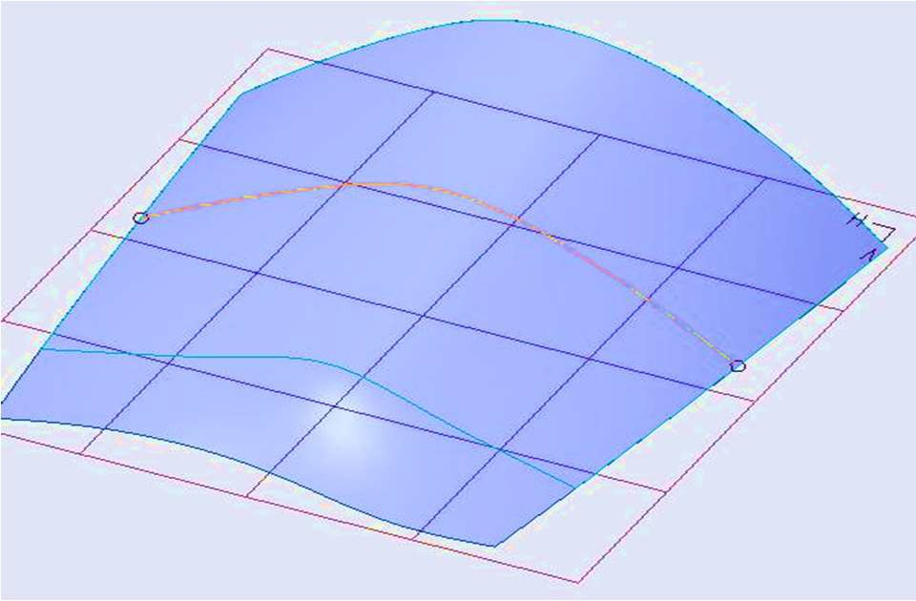

1. Click Free Curve from the dashboard.
2. Press CTRL and click the surface again to change the curve's direction.

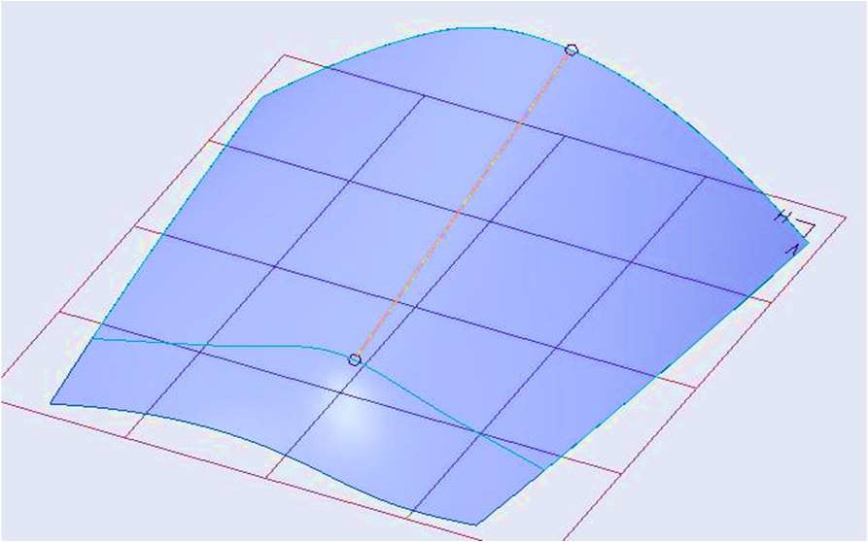

*Note: The curve does not span the entire surface. This surface is a composite surface, and you can only create curves from a single surface patch.*

1. In the style tree, click CF-430 to view the isoline dividing the surface feature.
2. Click Repaint from the In Graphics toolbar.
3. Press CTRL and click the surface to change the curve's direction back to a horizontal orientation.
4. In the dashboard, edit the Value to .1 and press ENTER.
5. Click the curve and drag it until the Value is approximately .5.

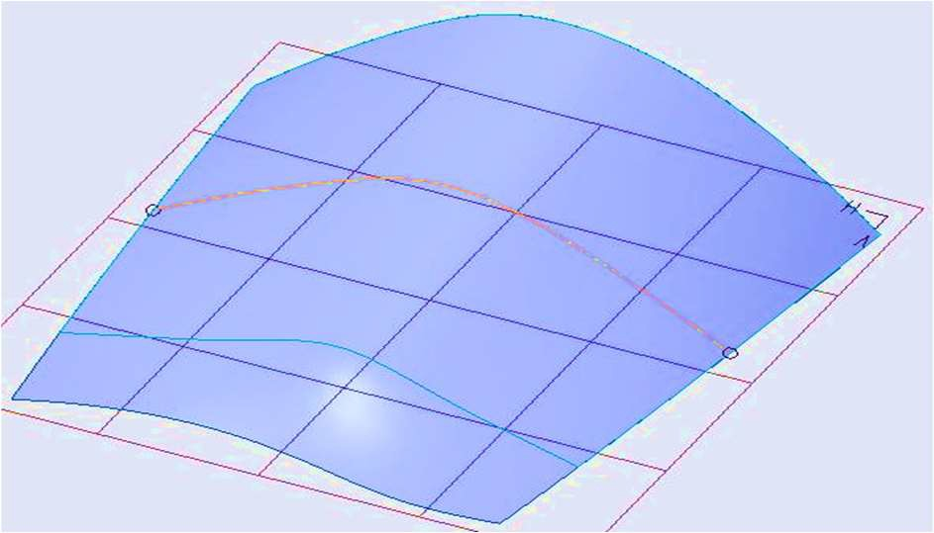

1. Click Complete Feature from the dashboard.

To Edit the surface from which the new curve was created.

1. In the style tree, right-click CF-227 and select Edit Definition.
2. Click the midpoint of this curve and drag it as shown.

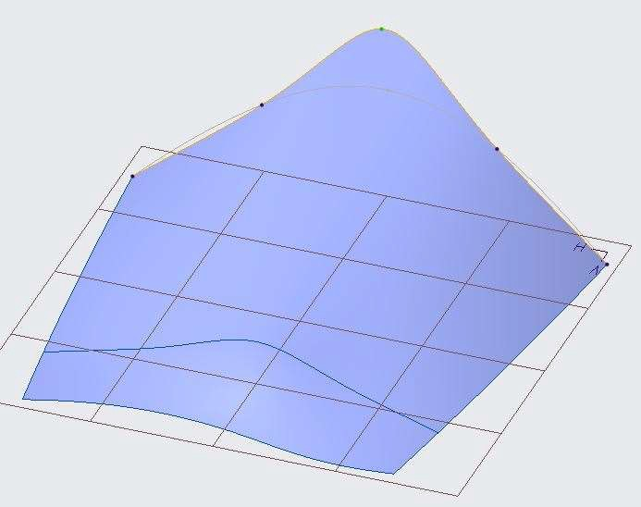

1. Click Complete Feature.
2. Spin the model and notice that the curve you created using Curve from Surface does not follow the modified surface.

*Note: Free type curves from surface do not maintain a parent/child relationship with the surface from which they were created.*

1. Select the surface.
2. Right-click in the graphics window and select Edit Definition.
3. Right-click in the graphics window and select Internal Collector.
4. Select the curve that was created using the Curve from Surface feature.

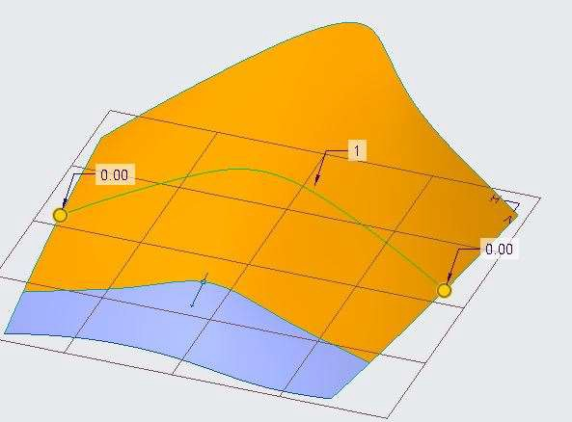

1. Click Complete Feature.
2. Click OK from the Close group.
3. From the In Graphics toolbar, click Saved Orientations and select Default Orientation.

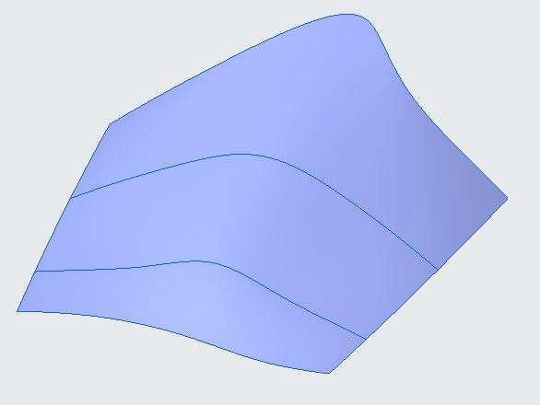

To Create an isoline curve on surface.

1. Right-click Style 1 and select Edit Definition.
2. Click the Curve group drop-down menu and select Curve from Surface.
3. Click Isoline from the dashboard.
4. Select the surface.
5. Click and drag the newly created isoline.
6. Press CTRL and select the surface.
7. Click and drag the isoline curve in the second direction.
8. Edit the Value to .7 and press ENTER.

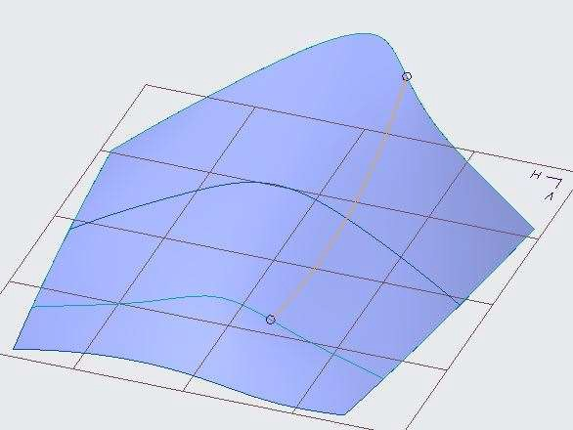

*Note: The isoline will always be created in the U or V direction of the surface. Alternatively, the Change Isoline Orientation can be used to change the U or V direction of the isoline.*

1. Click Complete Feature.
2. Right-click CF-227 and select Edit Definition.
3. Click the midpoint and move the curve up and down.

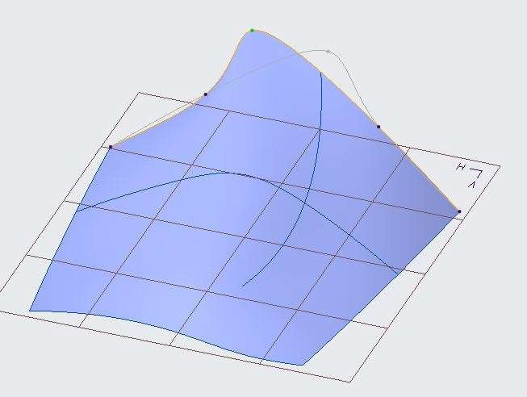

1. Note: Notice that the isoline follows the surfaces contour.
2. Click Complete Feature.
3. Click OK.

## *MANIPULATING CURVE ON SURFACE TYPE CURVES*

A curve on surface type curve consists of point locations lying on a surface, with the curve through the points also lying on the surface. To manipulate a curve on surface type curve, you can manipulate either the points or the parent surface.

To Manipulate a curve so that it crosses the surface patches.

1. Open Manipulating_Curves.prt. Disable all Datum Display types.

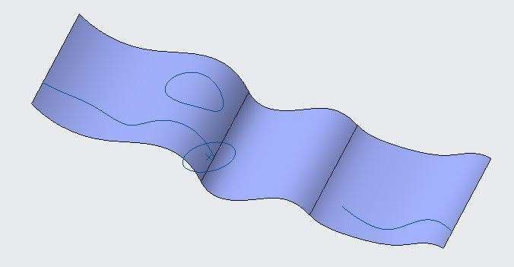

1. In the model tree, right-click Style 1 and select Edit Definition.
2. Click the Operations group drop-down menu and select Preferences.
3. In the Style Preferences dialog box, clear the Display grid check box and click OK.
4. From the In Graphics toolbar, click No Hidden from the Display Style types drop-down menu.
5. In the style tree, right-click CF-12 and select Edit Definition.
6. Drag the curve endpoint and attempt to connect it to the end of curve CF-11.

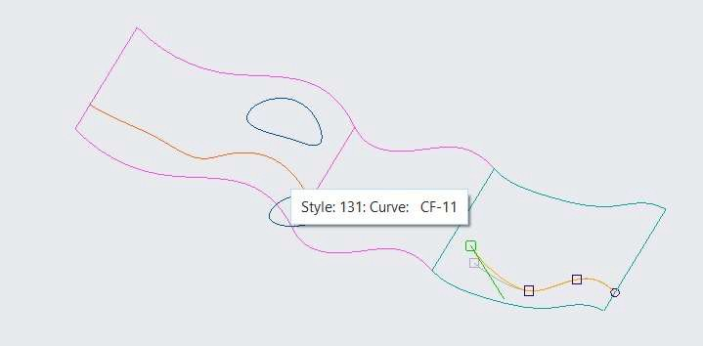

*Note: The step cannot be completed because a single curve on surface type curve cannot span surface patches*.

1. Click Undo from the Quick Access toolbar.
2. Press SHIFT and drag the endpoint, attaching it to the surface boundary as a soft point.
3. Click Complete Feature from the dashboard.

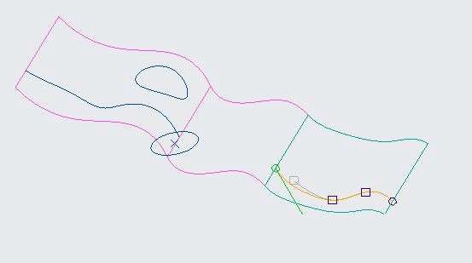

1. Select Curve command from the Curve group.
2. Click Curve on Surface from the dashboard.
3. Right Click and select Surface Collector.
4. Select the middle surface.
5. Click to place two endpoints on the middle surface patch, near the endpoints of the existing curves, as shown.

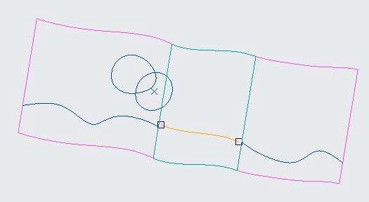

*Note: It is important not to click beyond the middle surface patch when placing the two points*.

1. Right-click in the graphics window and select Edit Definition.
2. Press SHIFT, then drag each endpoint and attach it as a soft point to the existing curves.

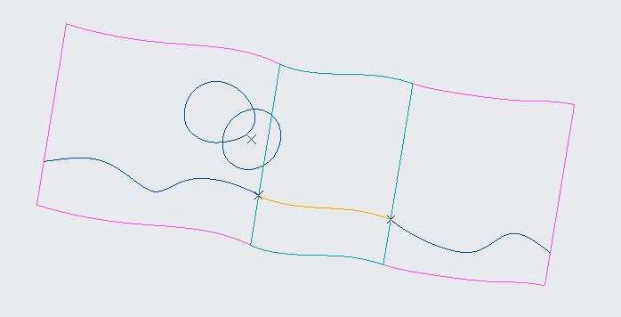

1. Select the right endpoint.
2. Right-click the tangent handle and select G1 Tangent.
3. Click the right endpoint again and notice the tangency arrow.
4. Select the left endpoint.
5. Right-click the tangent handle and select G1 Tangent.
6. Click Complete Feature.

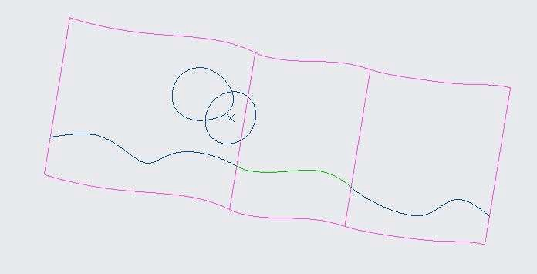

1. Right-click curve CF-11 and select Edit Definition.
2. Drag the endpoint and notice how the curves stay connected and remain on their reference surfaces.

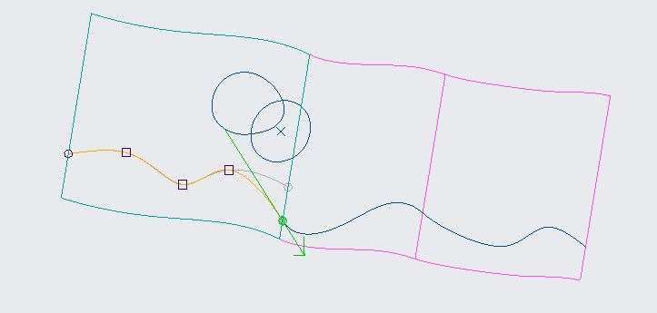

1. Click Complete Feature.

To Edit the drop curve by editing the reference surface and curve.

1. In the style tree, right-click DF-17 and select Edit Definition.
2. Right-click in the graphics window and select Surface Collector.
3. Press CTRL and select the middle surface patch.

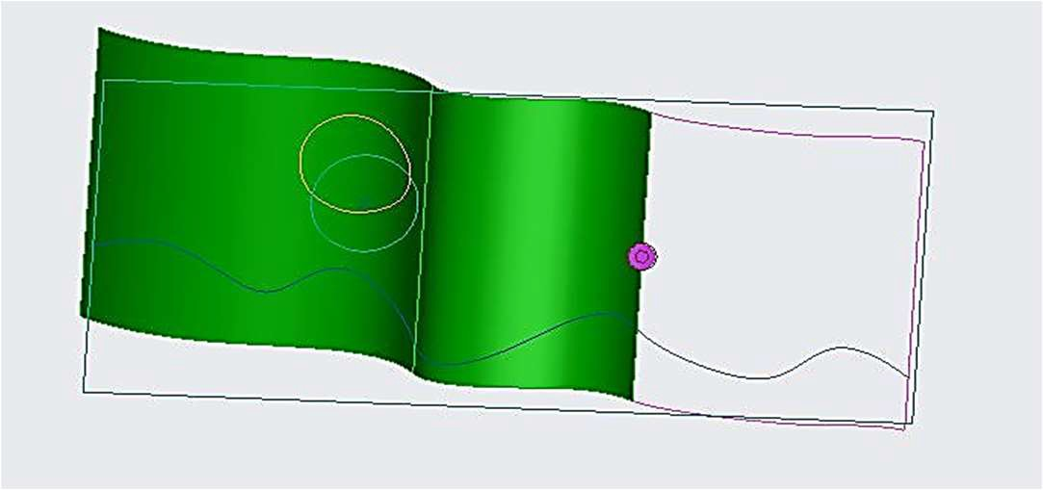

1. Click Complete Feature.

*Note: You can also use Drop Curve and COS By Intersect to create curve on surface type curves across surface patches.*

1. In the style tree, right-click CF-16 and select Edit Definition.
2. Drag two points on the curve, as shown below.

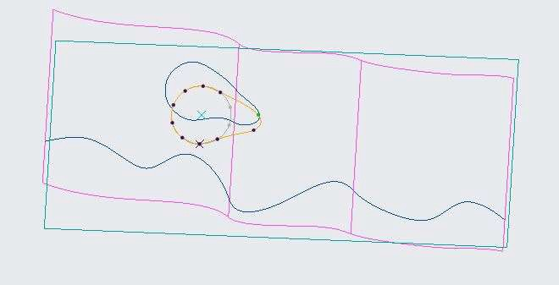

1. Click Complete Feature.

To Edit a COS type curve to a free type curve.

1. From the In Graphics toolbar, select Shading from the Display Style types drop-down menu.
2. In the style tree, right-click CF-19 and select Edit Definition.
3. Click Free Curve from the dashboard.
4. Click Yes in the Confirmation dialog box.
5. From the In Graphics toolbar, click Saved Orientations and select FRONT.
6. Right-click the curve and select Add Midpoint.
7. Drag the midpoint, as shown.

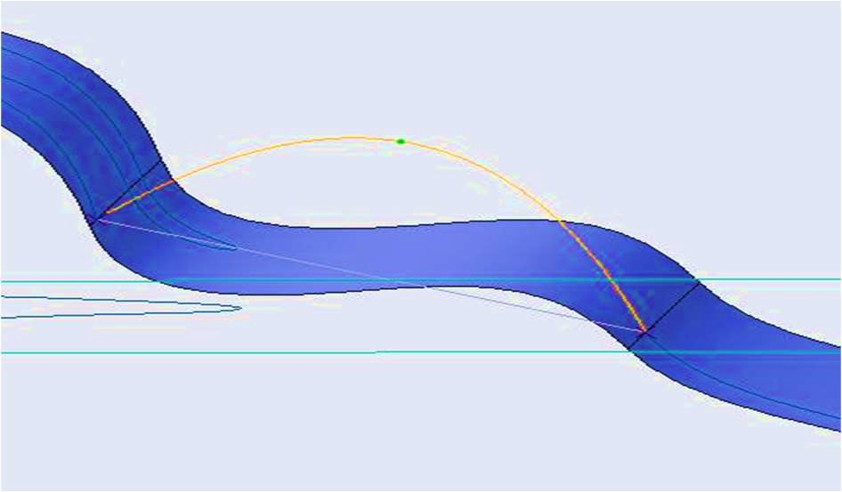

1. Click Complete Feature.
2. Click the Operations group drop-down menu and select Preferences.
3. Select the Display grid check box and click OK.
4. Click OK from the Close group.
5. Spin the model and notice that the curve is no longer lying on the surface.

## *TRIMMING SURFACES IN THE STYLE TOOL*

You can use the Surface Trim feature to trim surfaces while creating or editing a style feature. This eliminates the need to trim or cut surfaces outside of the Style tool, after the style feature has been completed.

To Trim the surface by referencing a curve dropped on the surface.

1. Open Trim_surface.prt. Disable all Datum Display types.

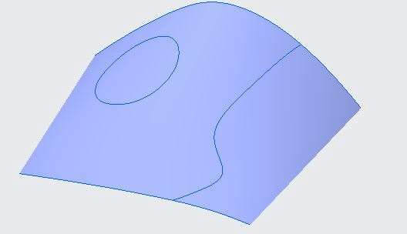

1. In the model tree, right-click Style 1 and select Edit Definition.
2. Click Surface Trim from the Surface group.
3. Select the surface quilt.
4. Right-click in the graphics window and select Curve Collector.
5. Press CTRL and select the two segments of circular curve.
6. Right-click in the graphics window and select Delete Collector.
7. Inside circular curve, select the surface area to remove.

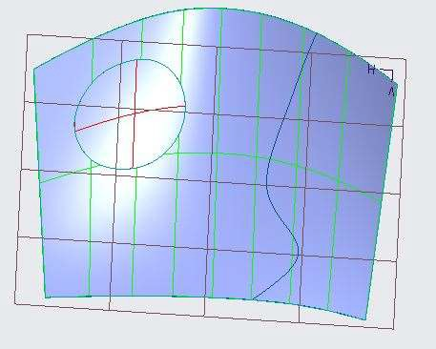 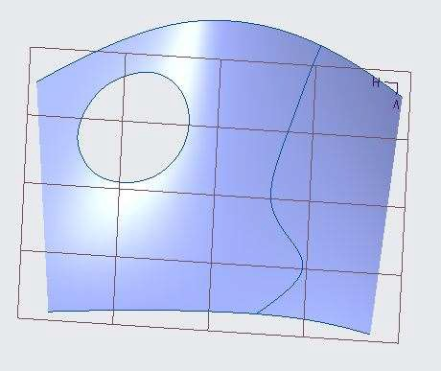

1. Click Complete Feature from the dashboard.

To Trim the surface again, referencing a curve created on the surface.

1. Click Surface Trim.
2. Right-click and select Curve Collector.
3. Select free curve as the trimming curve.
4. Right-click and select Delete Collector.
5. Select the surface area to the right of free curve.
6. Click Complete Feature.

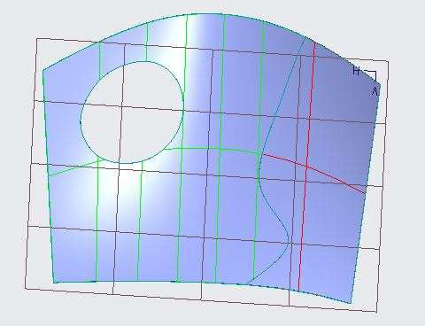 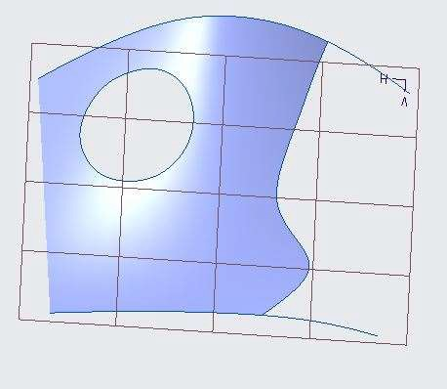

1. Click OK from the Close group.

# *MODULE 13 - INTRODUCTION TO CREO DIRECT*

*For the activity files browse to folder Introduction to Creo Direct.*

## *UNDERSTANDING DIRECT MODELING*

Direct Modeling gives you authority to manipulate and modify on geometries with no history. You can use parametric and feature modelling on the dump model and redefine its shape and size.

1. 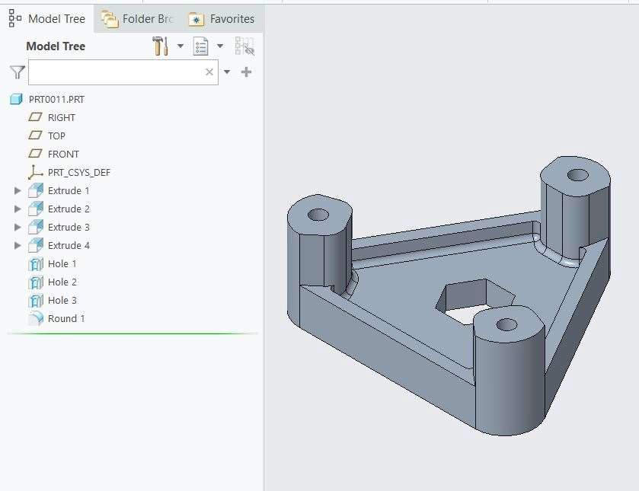Open Creo_Direct_Intro.prt. Disable all the datum types.
2. Select Extrude 2 from model tree and Edit Definition.
3. ENTER the depth value as 50. Observe that entire height of the model is increased.

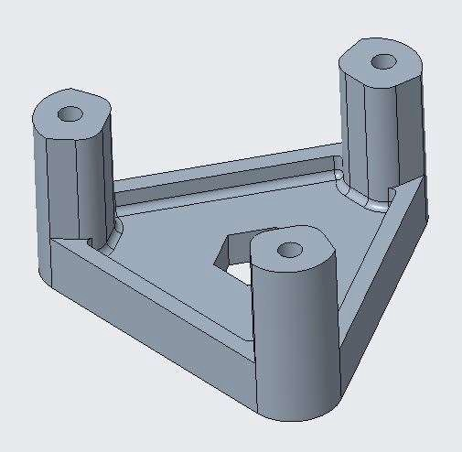

1. Click Undo from the Quick Access toolbar.
2. Click Close from the Quick Access toolbar.
3. Click Erase Not Displayed from the Data group and click OK.
4. Minimize Creo Parametric.
5. Start Creo Direct.
6. Click Open from the Data group, and open Creo_Direct_Intro.prt. Disable all the datum types.
7. In the model tree, expand the Planes node and the Coordinate systems node.
8. Notice that the model tree displays only datums, and no geometry.
9. In the ribbon, ensure that Select (with default) is specified in the Selection group.
10. Select a surface as shown in image below.

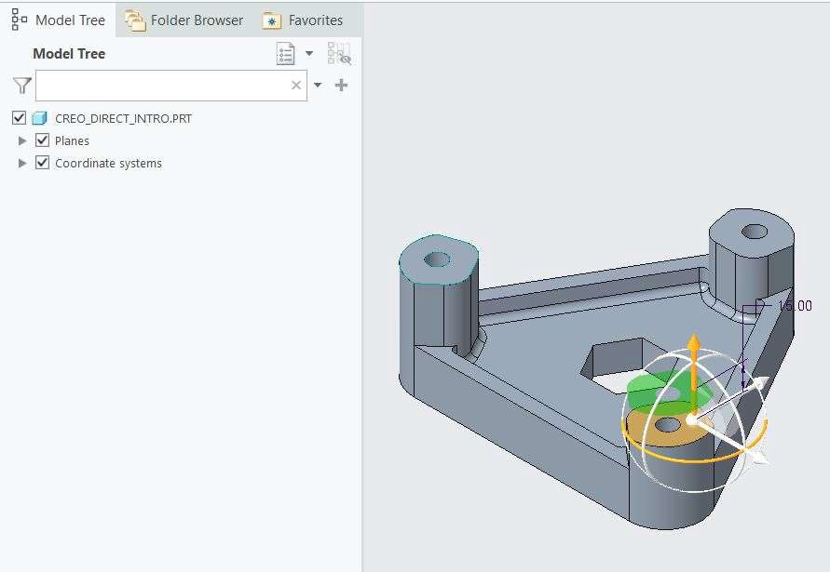

1. Drag its height down a depth of approximately 15.
2. Select a surface as shown in image below.

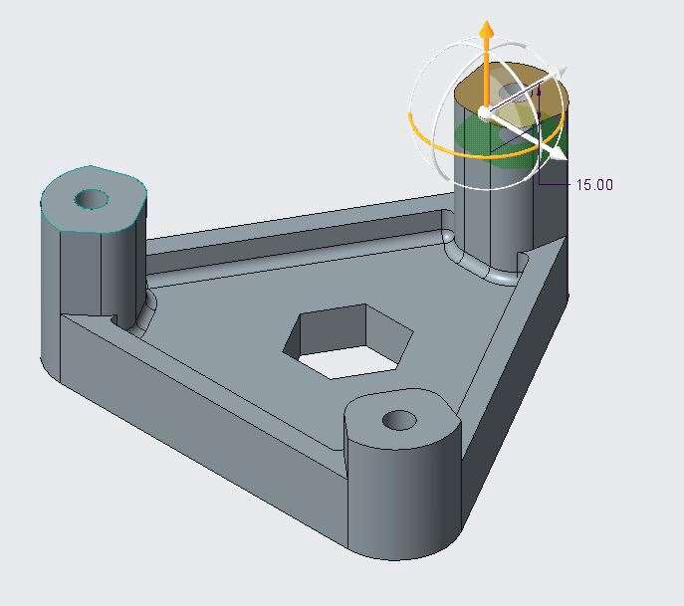

1. Drag its height up a depth of approximately 15.
2. Middle-click to complete the move.
3. Under file tab, select Save as Copy from save as and ENTER the name Creo_Direct_Intro_1 and click ok.
4. Click Close.
5. Click Erase Not Displayed from the Data group and click OK.
6. Minimize Creo Direct.
7. Maximize Creo Parametric and open saved file Creo_Direct_Intro_1.prt.

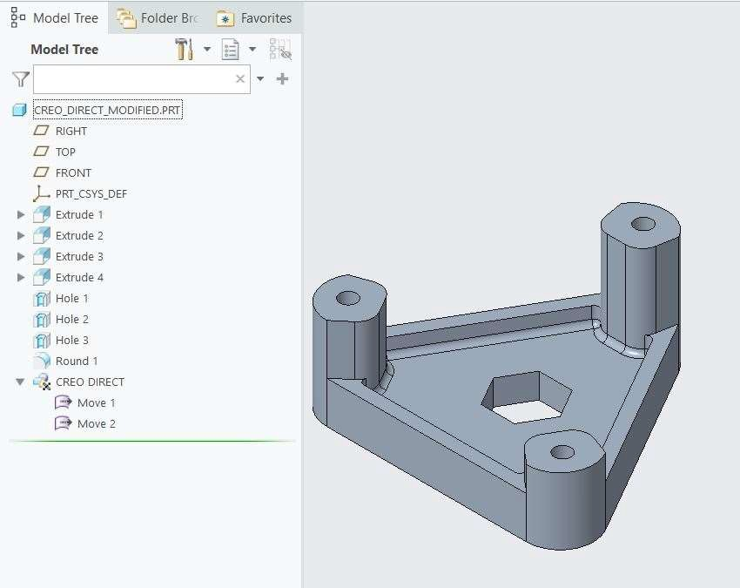

1. Notice the changes in the model and two move commands used in Creo Direct appears in Model Tree.

## *UNDERSTANDING THE USER INTERFACE*

Creo Direct contains several standard user interface elements, many of which are also available in other Creo

applications.

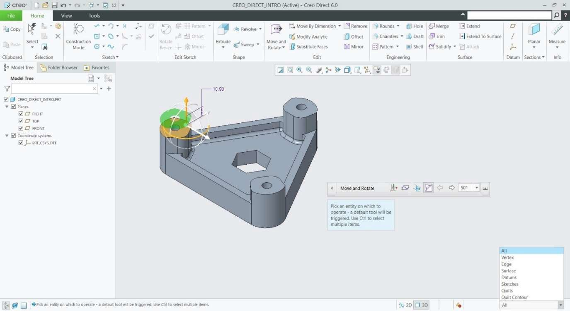

PTC Creo Direct Help

Quick Access Toolbar

Ribbon Bar

Command

In Graphics Toolbar

Navigator Panel

Status Bar

Graphics Window

## *UNDERSTANDING THE LIVE TOOLBAR*

The Live toolbar displays in the graphics window when you select geometry.

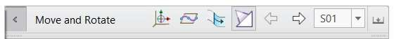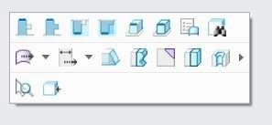

Options Toolbar Live Toolbar

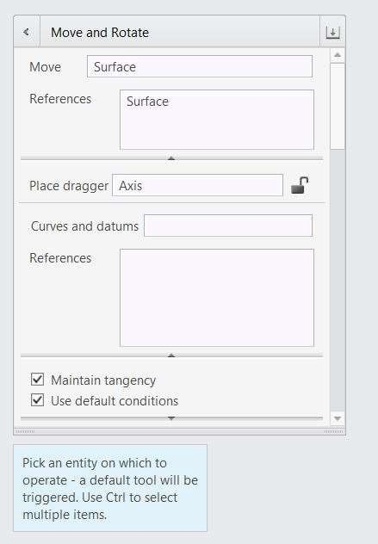

Floating Dashboard

## *OPENING AND CREATING A CREO DIRECT MODEL*

You can open a Creo Parametric model in Creo Direct and Vice-Versa.

To create a new Creo Direct part model

1. Click New command from either the Data group in the ribbon or the Quick Access toolbar.
2. Select Part in the New dialog box and type a name for the new part model.
3. Specify whether to use the default template. If you clear the Use default template check box, you can select the template as per your requirement.

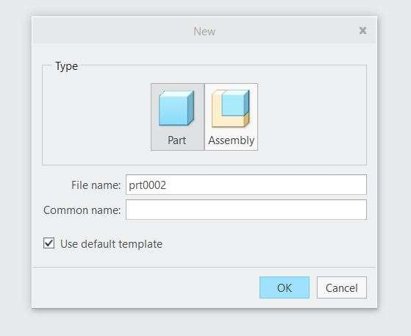 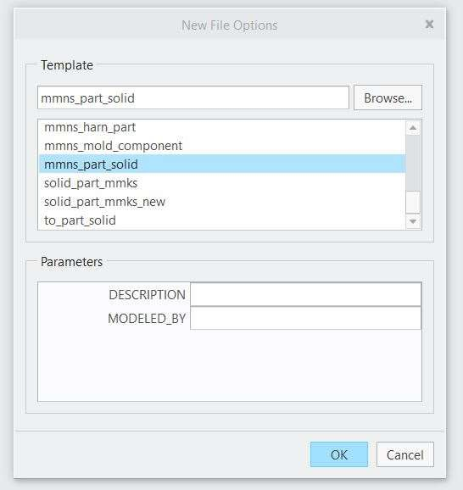

To open a Creo Direct part model

1. Click Open command from either the Data group in the ribbon or the Quick Access toolbar.
2. Select Creo_Direct_Open.prt and click open.
3. The Part is opened on the screen.

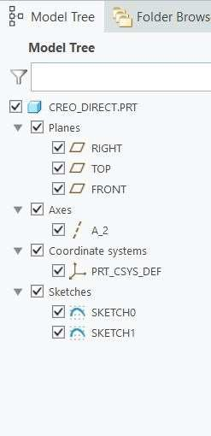 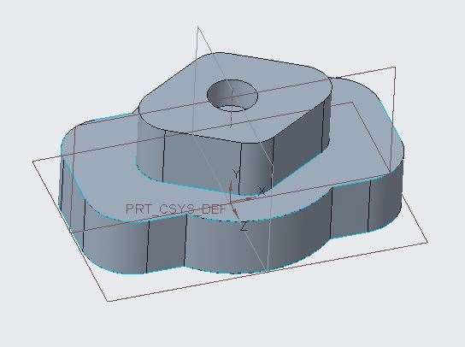

## *ORIENTING AND POSITIONING THE MODEL*

You can reorient and reposition any geometry in creo direct with the help view group.

1. Open model Creo_Direct_Intro.prt

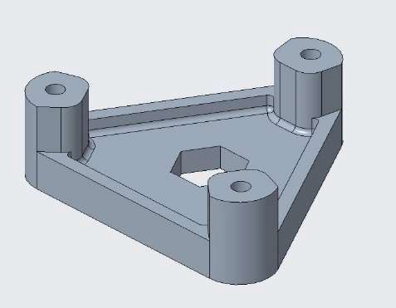

1. Use Display Style, Saved Orientations, Refit, Zoom in, Zoom Out, Spin Centre to Observe Various Orientations and positions of the geometry.

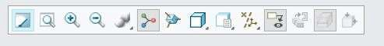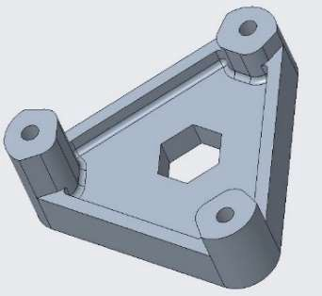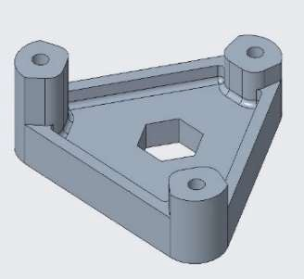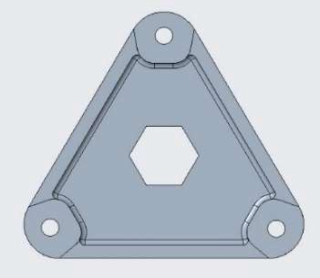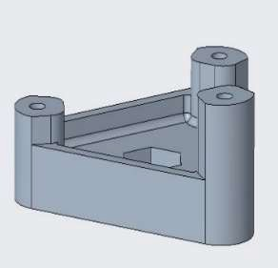

Different Orientation of Model

## *UNDERSTANDING SELECTION BEHAVIOR*

You can select your geometry in various ways to perform any operations. Open model Creo_Direct_Intro.prt

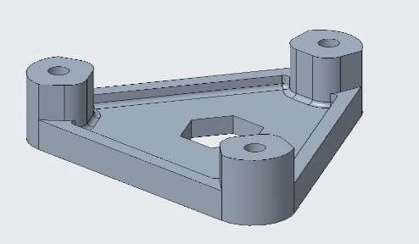

1. When you move your cursor over an entity, it’s a Preselection with Red color.
2. 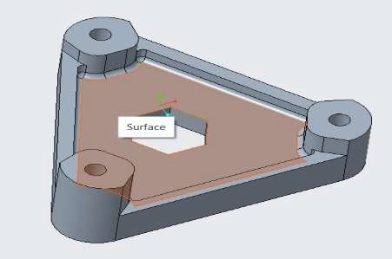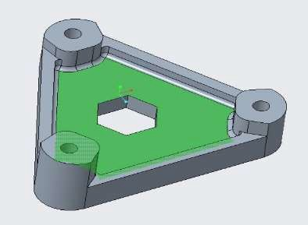When you select any entity, It’s a selected entity with Green Color.
3. When You have Multiple entities at a single place to select you can use pick from list option.
4. Highlight the Edge of the hole by placing the pointer on the edge and right click, (You don’t have to select the entity)

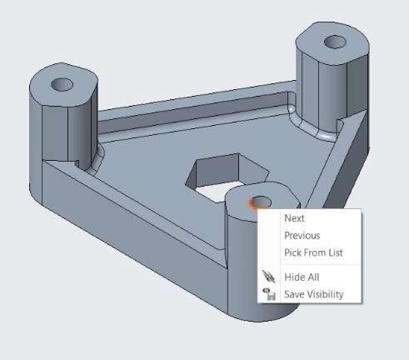 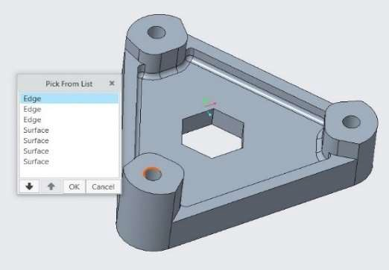

1. Select Pick from list from the displayed option.
2. From the pick from list option Select the Surface Until the surface is highlighted as shown and click OK.
3. You can also use Selection filters to select a specific entity type in the geometry.
4. In the Right Bottom Corner of the Screen in the software, Select the Entity types you want to use.
5. Select the entity on the geometry as per the selected entity types from the selection filter.

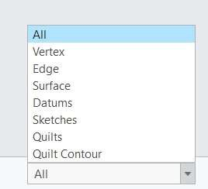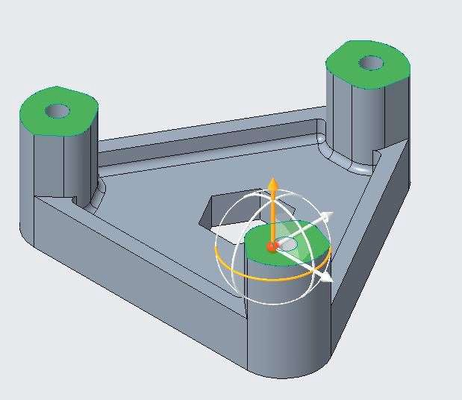

## *USING MARQUEE SELECTION*

Using the Marquee selection, you can select multiple objects at once. There are two types of Marquee Selection: - Inside and Crossing.

Open model Creo_Direct_Intro.prt

1. For Inside Option, Press and hold left click and drag the mouse from left top to bottom right making a box over some parts of the geometry, you will observe that only those entities are selected which comes under the box.

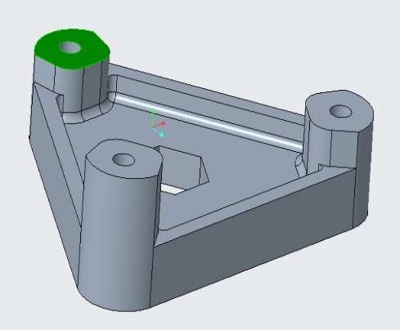 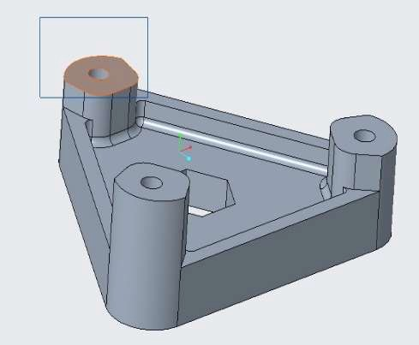

1. For Crossing Option, Press and hold left click and drag the mouse from Right top to bottom left making a box over some parts of the geometry, you will observe that all the entities are selected if only some portion of the entity comes under the box.

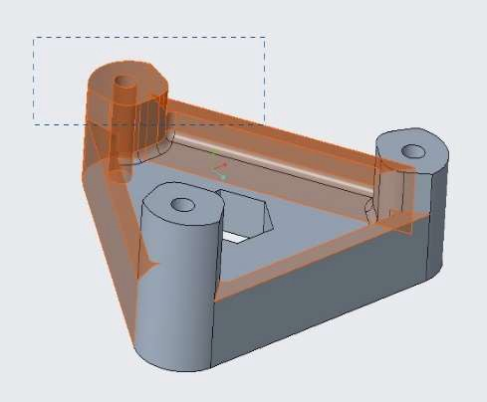

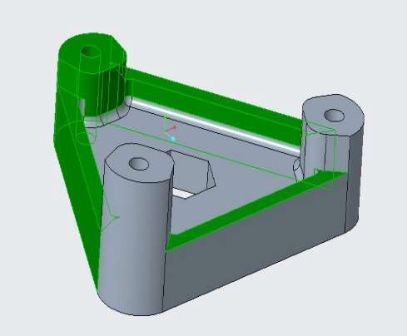

## *UNDERSTANDING DATUM AND SKETCH DISPLAY*

You can Hide and unhide the datums from the view group, also you can do hide and unhide from the model tree by selecting ang right click and select the hide and unhide option.

1. Open Creo_Direct_Model.prt.
2. Disable and enable display of datum types from view toolbar and observe the result.
3. You can use model tree to hide and unhide individual and specific datums.

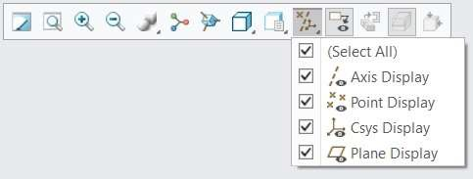

# *MODULE 14 - CREATING SKETCHES IN 2-D MODE*

*For the activity files browse to folder Creating Sketches In 2-D Mode.*

## *UNDERSTANDING 2-D MODE*

* 1. mode is used to Sketch Curves and Sections to use in creating the 3-D geometries.
     1. Click 2D from the status bar. 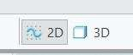
     2. Select any datum plane or planar surface as the sketching plane.
     3. This ENTERs you into 2-D mode in the current 3-D mode orientation. If desired, you can click Sketch Plan View to reorient the sketch plane parallel to the screen.
     4. Use the tools from the Sketch and Edit Sketch groups in the ribbon to create 2-D sketch geometry.
     5. Complete the sketch either by clicking Complete Sketch from the Sketch group or 3D from the status bar.
     6. If you wish to immediately create a different sketch on a different plane, click Select New Sketch Plane from the Sketch group, and the system remains in 2-D mode but switches the sketch plane to the newly selected reference.

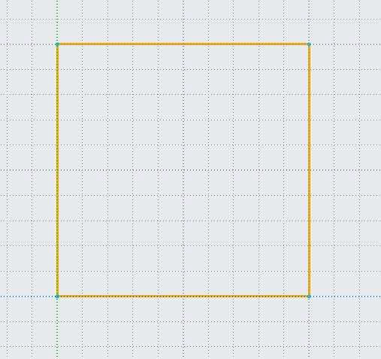 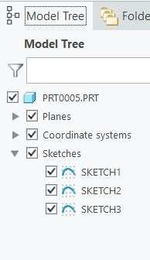

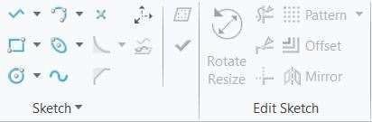

## *CONFIGURING THE 2-D GRID*

* 1. Grid is very useful in creating the Sketches node. It can be Cartesian Grid and Polar Grid. To change the Grid settings, go to View tab in ribbon bar, and select Grid settings in grid group. In Grid settings dialog box apply the settings as per your need.

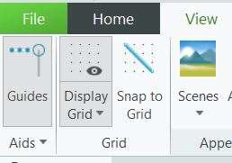 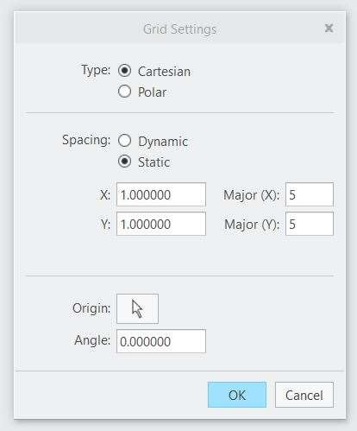

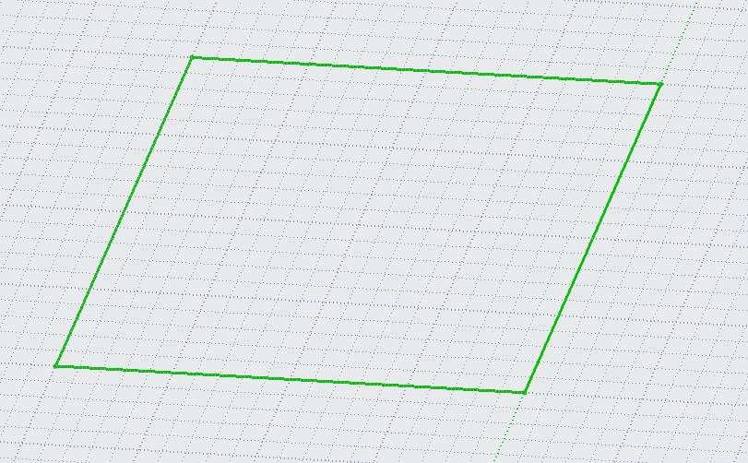 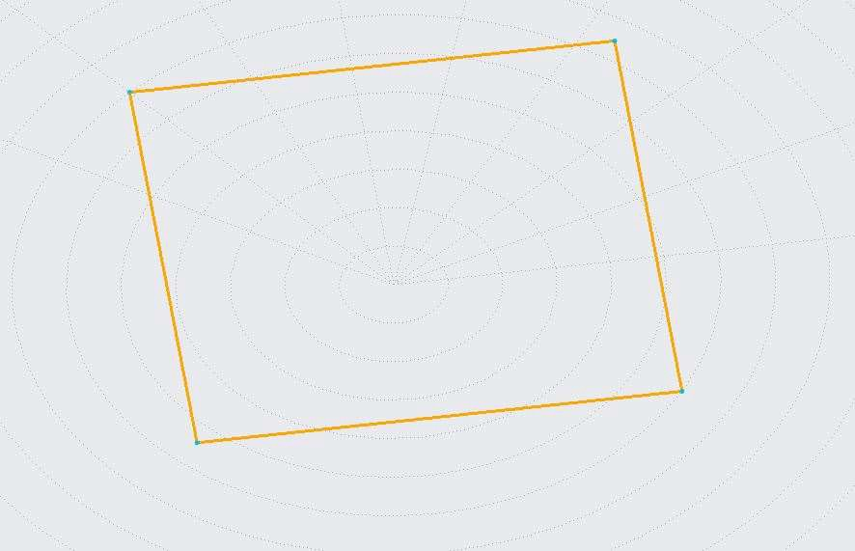

Cartesian Grid Polar Grid

## *SKETCHING USING PRECISION PANELS*

The Precision Panel is an alternate option in Creo Direct to specify the position of any point.

* + 1. 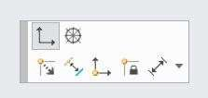Open a New file in Creo Direct.
    2. Select the 2-D mode at the Bottom Right corner.
    3. Select Front plane to activate the plane for sketch.
    4. Select Line command from the Sketch Group.
    5. Select the cartesian Coordinate option from displayed options.
    6. Specify the value 0 in 1st input box and press ENTER
    7. Specify the value 0 in the 2nd input box and ENTER and left click to specify the first point.
    8. 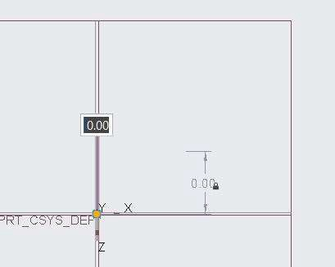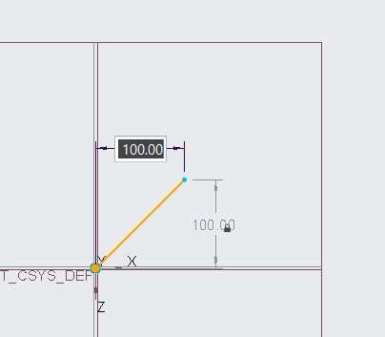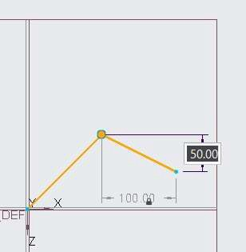Similarly specify the values 100 and 100 & 50 and 100 to complete the lines.

## *SKETCHING USING GUIDES*

You can create entities by constraining to other entities while drawing the sketch. Dotted lines or Constraint symbols will appear while referencing the nearby entity.

1. Open a New file in Creo Direct.
2. Select the 2-D mode at the Bottom Right corner.
3. Select Front plane to activate the plane for sketch.
4. Select Line command from the Sketch Group.
5. Select the Polar Dimension option from displayed options.
6. Left click on the screen to specify the first point of the line.
7. ENTER the value 100 in the on-screen input box and press ENTER, ENTER the angle value 45 and left click to create a line.
8. Move the cursor over the created line and move away from the line to track the dotted lines from the previous line and left click to create the line with constraint to previous one.
9. 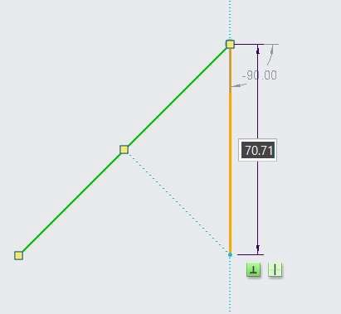Repeat above step to create more lines.

## *SKETCHING LINES*

You can create a line or a set of lines or a line chain from the Line command.

1. Select the 2-D mode at the Bottom Right corner.
2. Select Front plane to activate the plane for sketch.
3. Select Line command from the Sketch Group.
4. Select the Polar Dimension option from displayed options.
5. Left click on the screen to specify the first point of the line.
6. Specify the other point by left clicking at some distance from the first point.
7. Repeat the steps to create a line chain or a closed sketch.

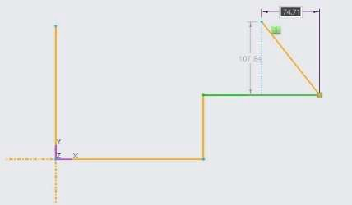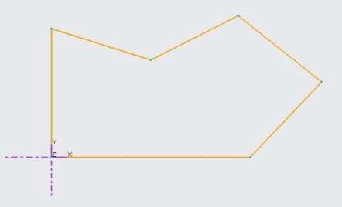

## *SKETCHING ARCS*

You can create an many types of Arcs with help of Arc Command in Creo Direct.

For 3-point/Tangent End Arc

1. Select the 2-D mode at the Bottom Right corner.
2. Select Front plane to activate the plane for sketch.
3. Select 3-point/Tangent End command from ARC drop down list from the Sketch Group.
4. Left click on the screen to specify the start point of the Arc.
5. Again, left click on the screen to specify the end point of the Arc.
6. Again, left click on the circumference of the arc to specify the third point and complete the arc.

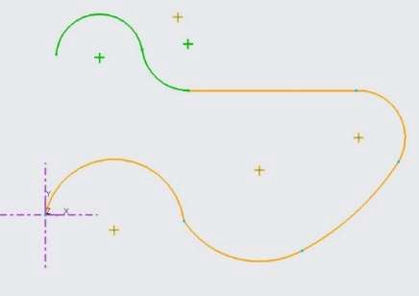

For Centre and Ends Arc

1. Select Centre and Ends Arc option from the ARC drop down list from the Sketch Group.
2. Left click on the screen to specify the Centre point of the Arc.
3. Left click on the screen to specify the start point of the Arc.
4. 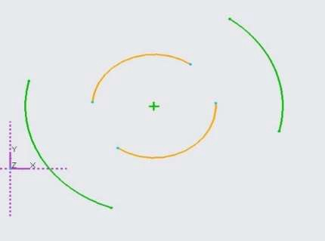Left click on the screen to specify the end point of the Arc and complete the arc.

For Tangent Arc

1. Create any 2/3 entities like Line/Arc/Circle
2. Select Tangent Arc option from the ARC drop down list from the Sketch Group.
3. 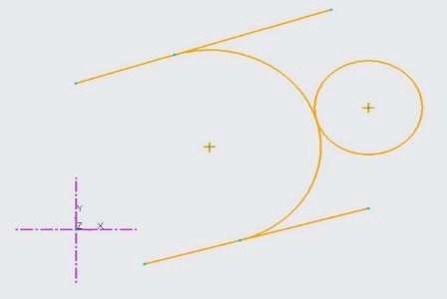Click on one entity, then on other, and click on the third entity to create the tangent arc.

For Concentric Arc

1. Create an arc or circle.
2. Select Concentric Arc option from the ARC drop down list from the Sketch Group.
3. Select arc/circle entity.
4. Click on screen to specify the start point of arc. This also specifies the radius of the arc.
5. 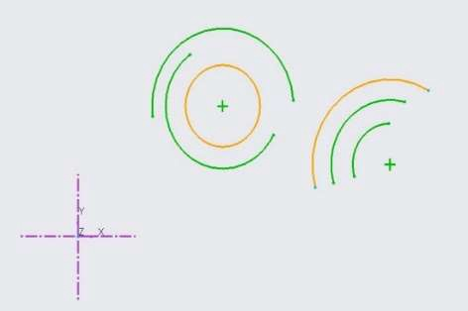Click on screen to specify the end point of arc. This also complete the arc.

For Conic Arc

1. Select Conic Arc option from the ARC drop down list from the Sketch Group.
2. Click on screen to specify the start point of arc.
3. Click on screen at some distance to specify the end point of arc.
4. 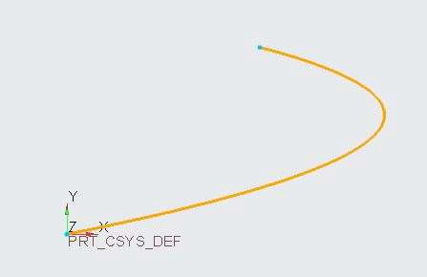Click on the circumference to specify the third point of arc. This also complete the arc.

## *SKETCHING RECTANGLES AND PARALLELOGRAMS*

You can create 4 types of Rectangles with help of Rectangle Command in Creo Direct.

For Corner Rectangle

1. Select Corner Rectangle option from the Rectangle drop down list from the Sketch Group.
2. Click on screen to specify the first corner of rectangle.
3. 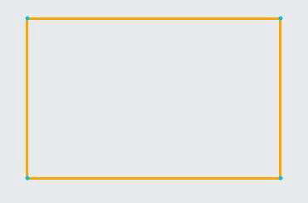Click on screen to specify the opposite corner of rectangle. This completes the Rectangle.

For Slant Rectangle

1. Select Slant Rectangle option from the Rectangle drop down list from the Sketch Group.
2. Click on screen to specify the first corner of rectangle.
3. Click on screen to specify the adjacent corner of rectangle. This creates the edge of Rectangle.
4. 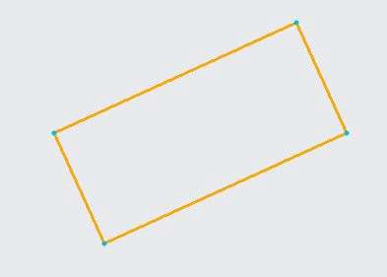Click on opposite edge to specify third point. This completes the Rectangle.

For Centre Rectangle

1. Select Corner Rectangle option from the Rectangle drop down list from the Sketch Group.
2. Click on screen to specify the Centre of rectangle.
3. Click on screen to specify a corner of rectangle. All the corners are at equidistant from the centre.
4. This completes the Rectangle.

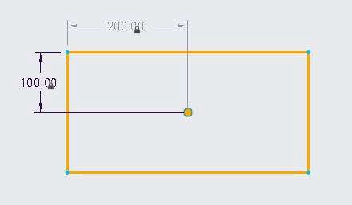

For Parallelogram

1. Select Parallelogram option from the Rectangle drop down list from the Sketch Group.
2. Click on screen to specify the first corner of rectangle.
3. Click on screen to specify the adjacent corner of rectangle. This creates the edge of Rectangle.
4. 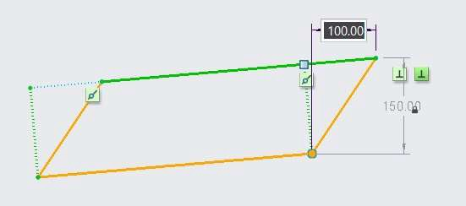Click on opposite edge to specify third point at an angle. This completes the Rectangle.

## *SKETCHING CIRCLES*

You can create 5 types of circles in Creo Direct.

For Centre and Point Circle

1. Select Centre and point option from the Circle drop down list from the Sketch Group.
2. Click on the screen to specify the centre point of the circle.
3. Specify a point on the circumference of the circle. This Specifies the radius and creates the circle.

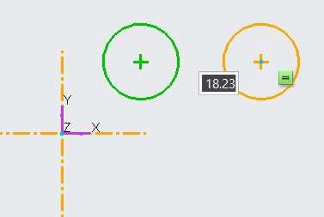

For 2-point Circle

1. Select 2-point option from the Circle drop down list from the Sketch Group.
2. Click on the screen to specify the first point on circumference of the circle.
3. Specify another point on the circumference of the circle. This Specifies the diameter and creates the circle.

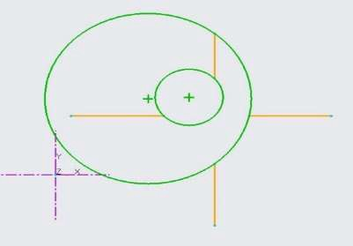Note: - You can snap any points on the screen to create your circle.

For 3-point Circle

1. Select 2-point option from the Circle drop down list from the Sketch Group.
2. Click on the screen to specify the first point on circumference of the circle.
3. Specify second point on the circumference of the circle.
4. Specify third point on the circumference of the circle. This Specifies the diameter and creates the circle.

Note: - You can snap any points on the screen to create your circle.

For Tangent Circle

1. Create any 2/3 entities like Line/Arc/Circle
2. Select Tangent Circle option from the Circle drop down list from the Sketch Group.
3. Click on one entity, then on other, and click on the third entity to create the tangent Circle. Note: - Your circle will not be created if you any one of the tangencies.

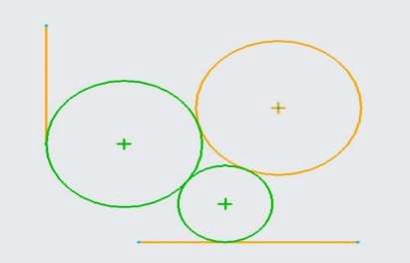

For Concentric Circle

1. Create an arc or circle.
2. Select Concentric Circle option from the Circle drop down list from the Sketch Group.
3. Select arc/circle entity.
4. Click on screen to specify the start point of arc. This also complete the Circle by defining the radius of the Circle.

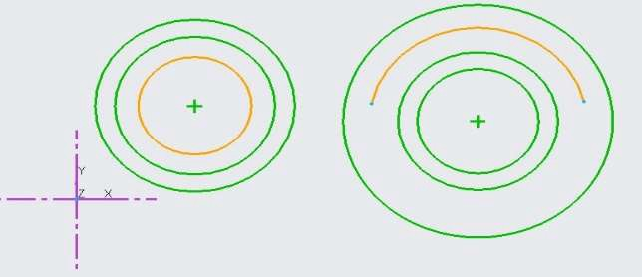

## *SKETCHING FILLETS*

Fillet command allows you smooth the corners points of by making it in round shape.

1. Open Creo Direct.
2. Draw a rectangle of 100 X 100.
3. Select Circular fillet from fillet drop down list from the sketch group.
4. Select the adjacent edges.
5. ENTER the radius value 20. Fillet is created.
6. Select Elliptical fillet from fillet drop down list from the sketch group.
7. Select the opposite adjacent edges.
8. 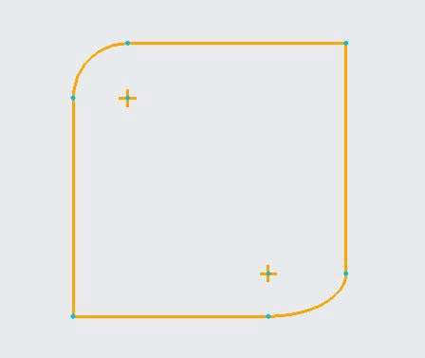Elliptical fillet is created.

## *SKETCHING CHAMFERS*

Chamfer command allows you trim the corner points of any shape.

1. Open Creo Direct.
2. Draw a rectangle of 100 X 100.
3. Select Chamfer command from the sketch group.
4. Select the two adjacent edges.
5. ENTER the distance value as 100 and 50. Chamfer is created.
6. 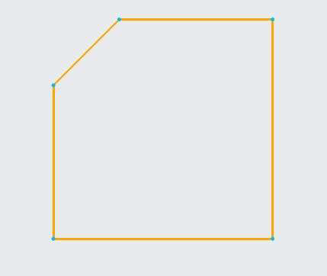You can use DXD, Angle X D or D X Angle method to create a chamfer.

## *SKETCHING CONSTRUCTION GEOMETRY*

Construction entities are used as reference for creating any geometry.

1. Activate the Construction Mode from the Sketch Group.
2. Draw the section as shown in figure.
3. Deactivate the Construction Mode from the Sketch Group.
4. 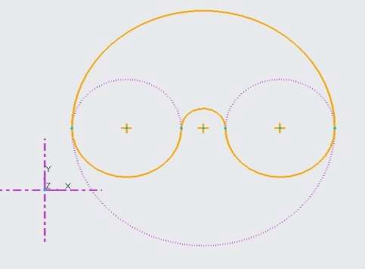Now draw the following entities but snapping down the construction entities.

## *SKETCHING TEXT*

You can sketch Text in Creo Direct.

1. Select Text Command from the Sketch group.
2. Draw a vertical line from Bottom to top with the help of Text command. This defines the height of the text.
3. Text command dialog box will appear. Write Horizontal in the Text Group.
4. Observe the text written on the screen.
5. Change the font to Win_font from the font group. Observe the changes.
6. Change the Horizontal alignment to centre and Vertical alignment to middle.
7. Change the Aspect ratio = 1.5, Slant Angle = 30, Spacing = 1.5. Observe the changes.
8. Draw a spline as shown in figure.
9. Draw a vertical line from Bottom to top with the help of Text command. This defines the height of the text.
10. Text command dialog box will appear. Write Creo Direct in the Text Group.
11. Select Place on curve option in the Text Command dialog box.
12. Select the Curve as Shown. The text is placed on the curve.
13. Observe the result.

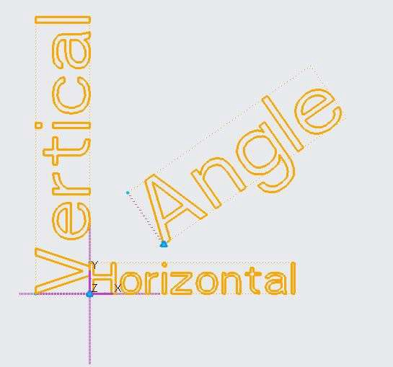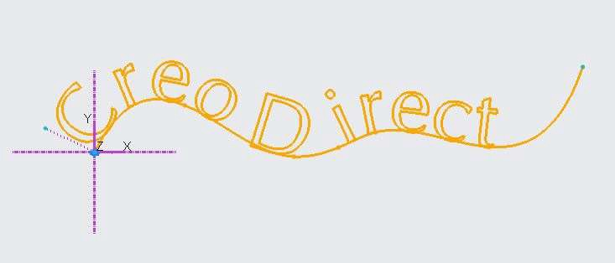

## *SKETCHING ELLIPSES*

Elliptical Sections can be sketched in Creo direct by Ellipse Command.

For Centre and Axis Ellipse

1. Select Centre and Axis from Ellipse drop down from the sketch group.
2. Click on screen to specify the centre point of ellipse.
3. Specify end point of one axis.
4. Specify end point of another axis.
5. Ellipse is created.

For 2-Point Ellipse

1. Select 2-Point Ellipse from Ellipse drop down from the sketch group.
2. Click on screen to specify the end point of one axis of ellipse.
3. Specify other end point of same axis.
4. Specify third point on circumference of curve to define second axis of ellipse. This creates the ellipse.

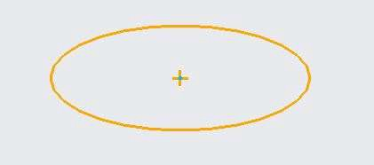

## *SKETCHING SPLINES*

Splines are freeform curves that pass smoothly through two or more points.

1. Select Spline command from the sketch group.
2. Click on screen to specify first point of spline.
3. Click on screen to specify second point of spline.
4. 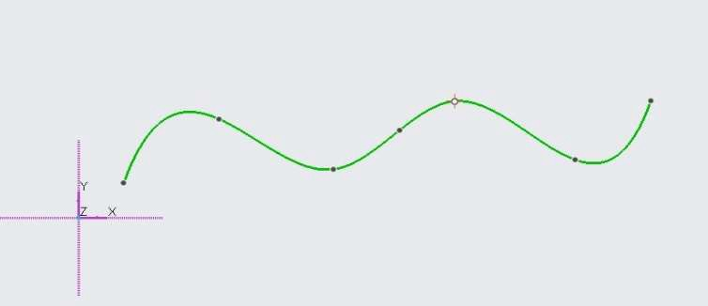Specify 3-4 more points to create the spline. Observe the curve created.

## *USING SKETCHED GEOMETRY TOOLS*

Various geometry tools are available in Creo Direct to modify the existing entities.

Trim Segment – Delete the entity at the point of intersection.

1. Open Creo Direct.
2. Draw the left side curves as shown.
3. Select Trim Segment command from the edit sketch group.
4. Drag the mouse through the vertical and horizontal lines (you can select the lines by clicking also) as shown in figure.
5. 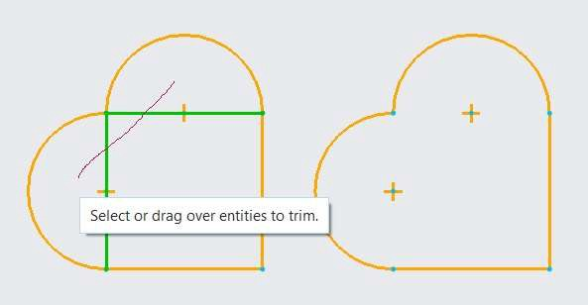Observe the resultant entities on the right side of image.

Divide – It divides the entities into a more number of parts.

1. Open Creo Direct.
2. Draw a circle of 100mm diameter. Observe that you can select the entire circle.
3. Select Divide command from the edit sketch group.
4. Click at four quadrant locations on the circle as shown.
5. Observe the resultant entities by selecting each portion of circumference of circle.

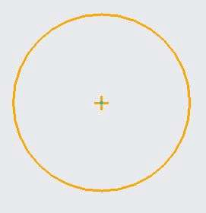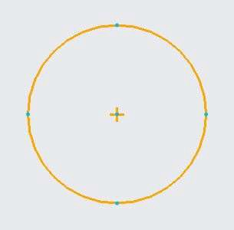

Corner – It joins two entities by trimming or extending the entities.

1. Open Creo Direct.
2. Draw two lines as shown in left side of the below image.
3. Select Corner command from the edit sketch group.
4. Select the two lines as shown in image below. Selected lines form a corner by trimming the lines.

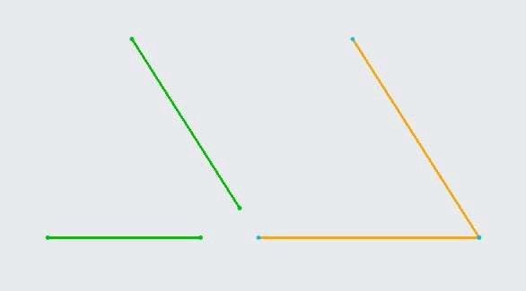

Mirror – It mirror any geometry along the plane.

1. Open Creo Direct.
2. Draw the left side of image below. Also draw a vertical line passing through the end points of image.
3. Select the curves to be mirrored.
4. Select the mirror command from the Edit Sketch Group.
5. Select the vertical line. The curves are mirrored as shown in right side of the image below.

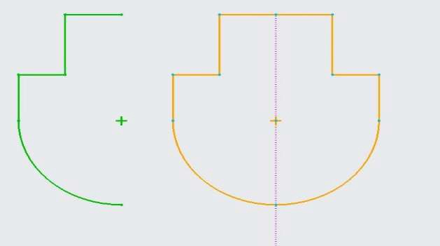

# *MODULE 15 - CREATING GEOMETRY SHAPES*

*For the activity files browse to folder Creating Geometry Shapes.*

## *UNDERSTANDING SKETCHES AND SKETCH REGIONS*

Sketches and sketch regions in 2-D planes are used for 3-D operations in Creo Direct. 3-D shapes are created by using 2-D sketches and sketch regions. 3-D operation such as Extrude, Revolve, Sweep features are used to create 3-Shapes. These sketches are selected to use in the operations either from the model tree or from the graphics window.

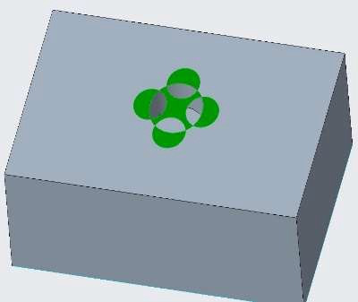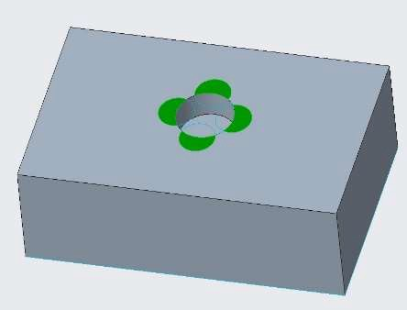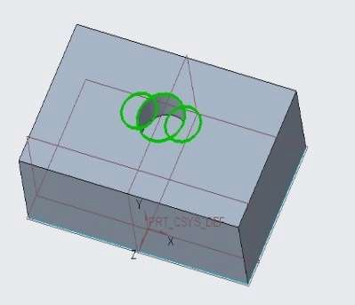

## *CREATING EXTRUDE GEOMETRY*

Extrude create a 3-D geometry by selecting a 2-D sketch and projects the sketch linearly to a specified distance or to a specified limit.

1. 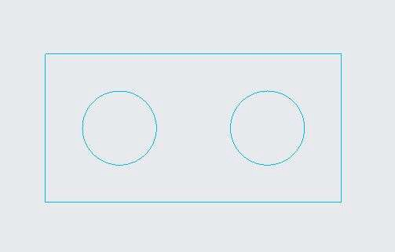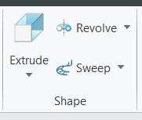Open Extrude.prt. Select the Extrude Command from the shape group.
2. 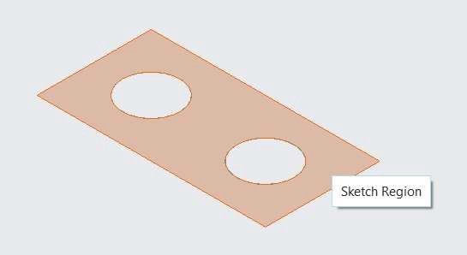Select the closed region as shown.
3. Specify the depth 100 and click ENTER. Click middle mouse button to complete the operation.

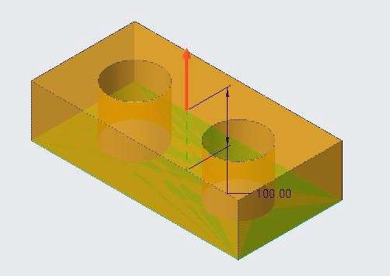 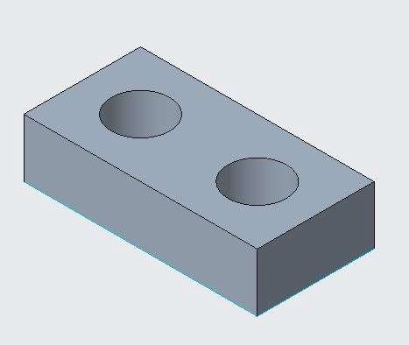

1. Observe the result as closed region was selected so circular section results in the holes in the block.
2. Press Ctrl+Z until you come back to the sketch.
3. 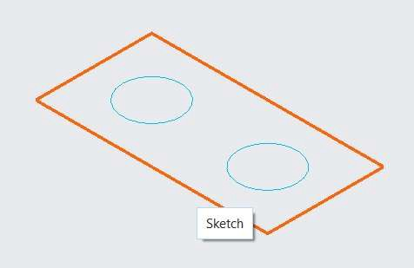Select the rectangle by selecting one of its edges as shown in figure.
4. 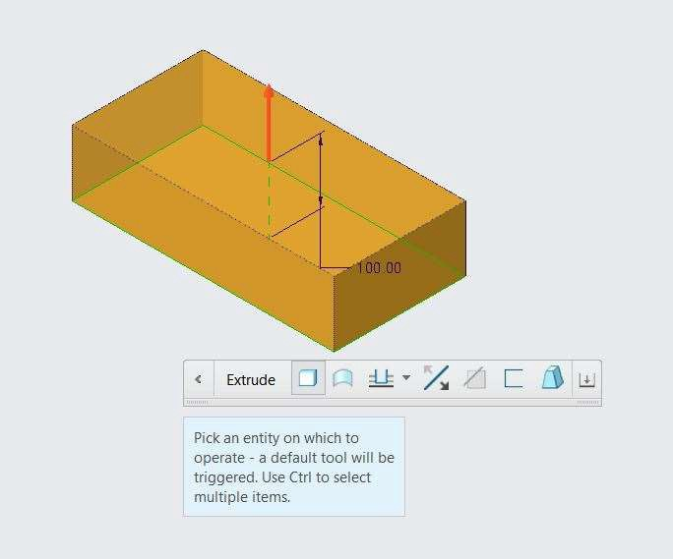Specify the depth 100 and click ENTER.
5. Observe the result as the rectangle was selected so the circular section was ignored.
6. Select the taper option from the option tool bar.
7. 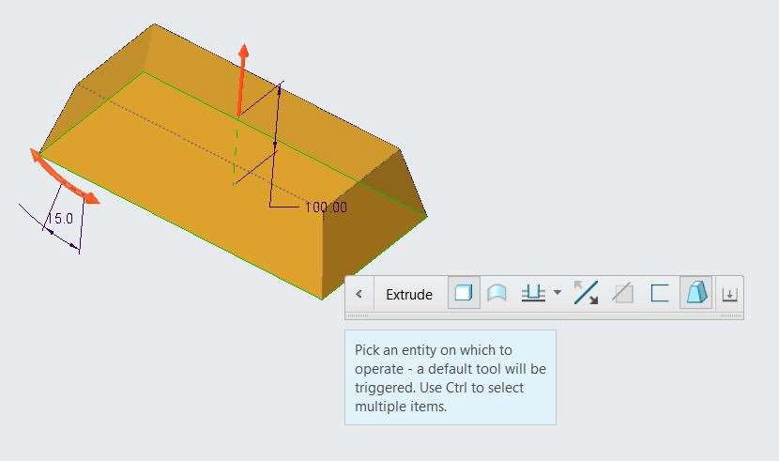Specify the taper angle as 15 degrees.
8. Click middle mouse button to complete the operation. Observe the result.

## *CREATING REVOLVE GEOMETRY*

Revolve create a 3-D geometry by selecting a 2-D sketch and projects the sketch axially along an axis.

1. Open Revolve.prt. Select the Revolve Command from the shape group.

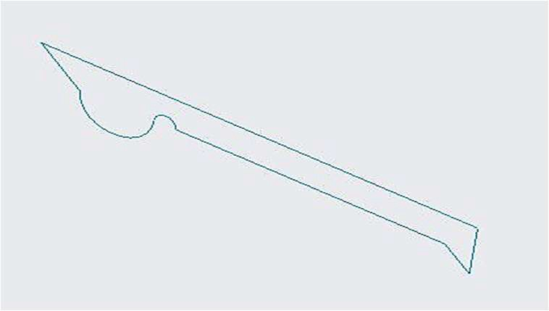

1. 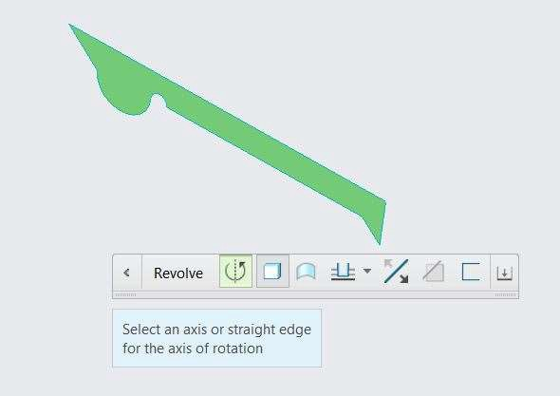Select the closed region as shown.
2. 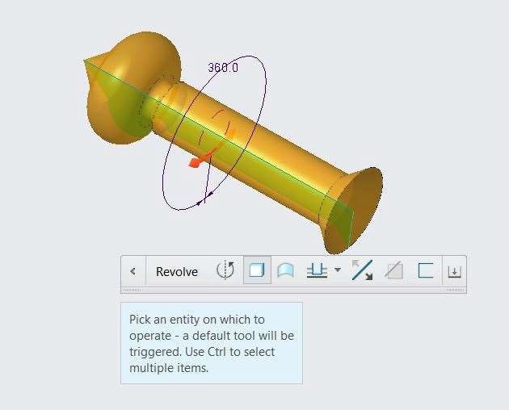Select the edge of section as an axis for revolve.
3. Click middle mouse button to complete the operation and observe the result as cross-section is revolved around the axis to create the geometry.

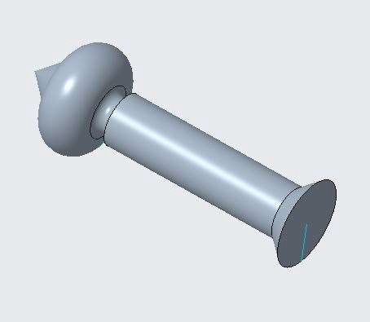

1. Press Ctrl+Z until you come back to the sketch.
2. Select the closed region again.
3. 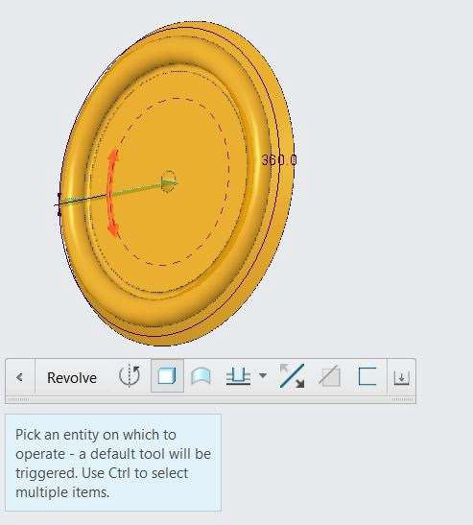Select the smaller edge of section as an axis for revolve.
4. Click middle mouse button to complete the operation and observe the result as cross-section is revolved around the axis to create the different shape of geometry.

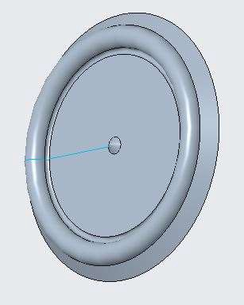

## *CREATING SNAPPED GEOMETRY DEPTH*

Depth of Extrude, Revolve and hole can be snapped to the selected geometry and reference.

1. 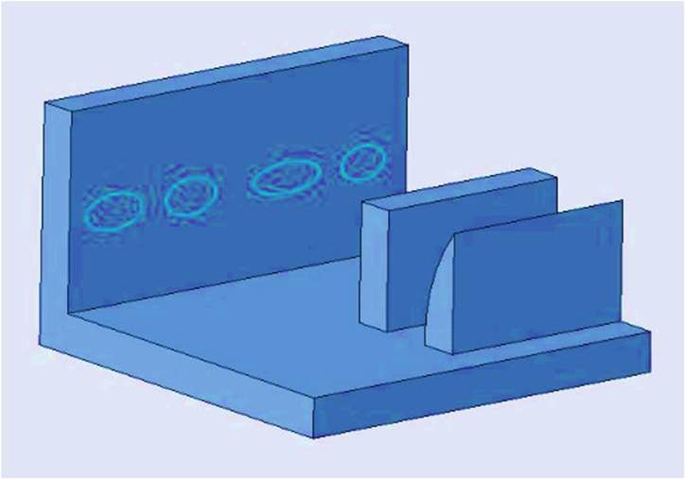Open Snapped_Extrude.prt
2. Select the Extrude Command from the shape group.
3. Select the section as shown and press SHIFT and drag the drag handle to vertical face.

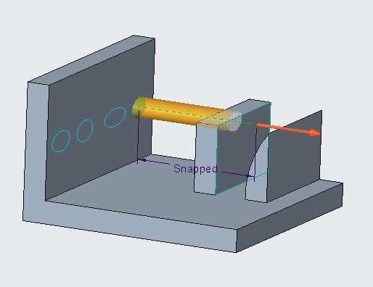

1. Click middle button to execute the function.
2. Select the section as shown and press SHIFT and drag the drag handle snapping to Curve face.

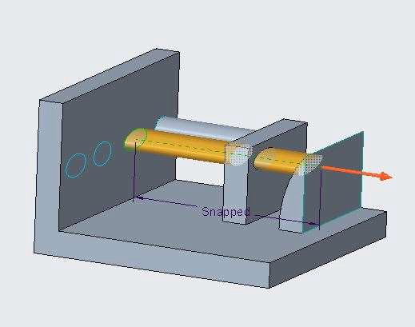

1. Click middle button to execute the function.
2. Select the section as shown and press SHIFT and drag the drag handle snapping to Curve face.

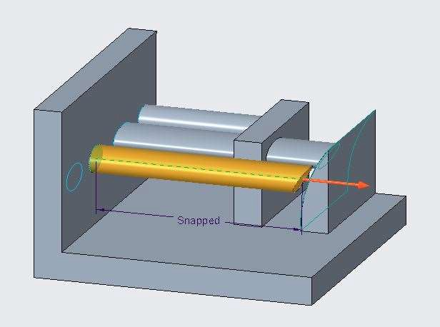

1. Click middle button to execute the function.
2. Observe the cross-section of the solid created.
3. Select the section as shown and press SHIFT and drag the drag handle snapping to vertical face.

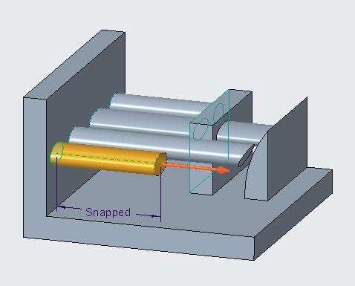

1. Click middle button to execute the function.
2. Observe the geometry.

## *REMOVING MATERIAL AND SPECIFYING THE SIDE*

You can remove the material from the geometry by using the 3-D operations.

1. Open remove_material.prt
2. Select the two circles on the geometry.

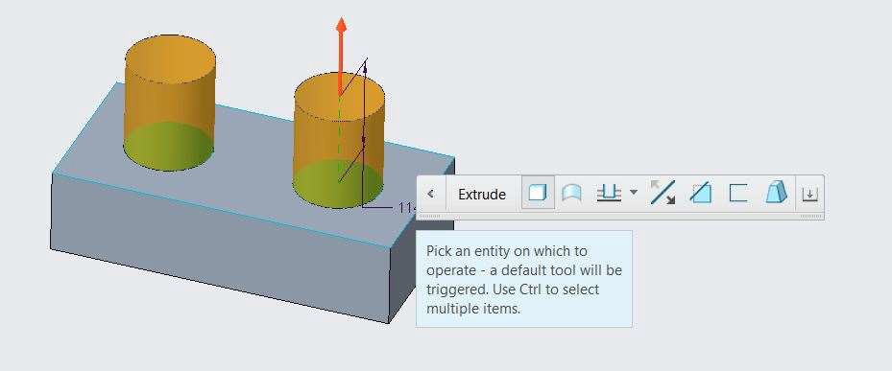

1. Specify the depth value 50 and click on Extrude Direction from the option toolbar.

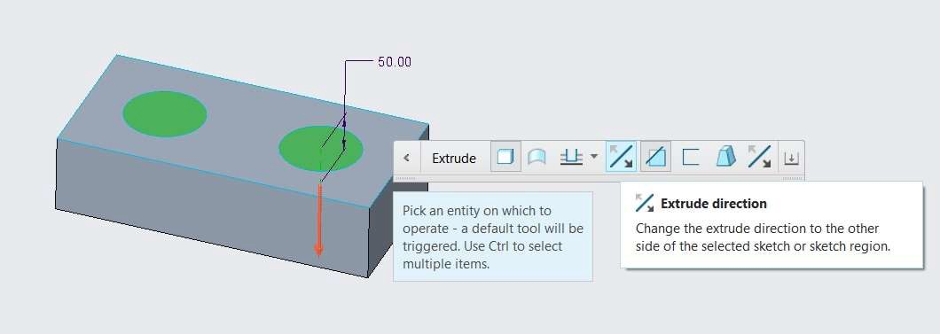

1. In the extrude option toolbar click on Remove Material.

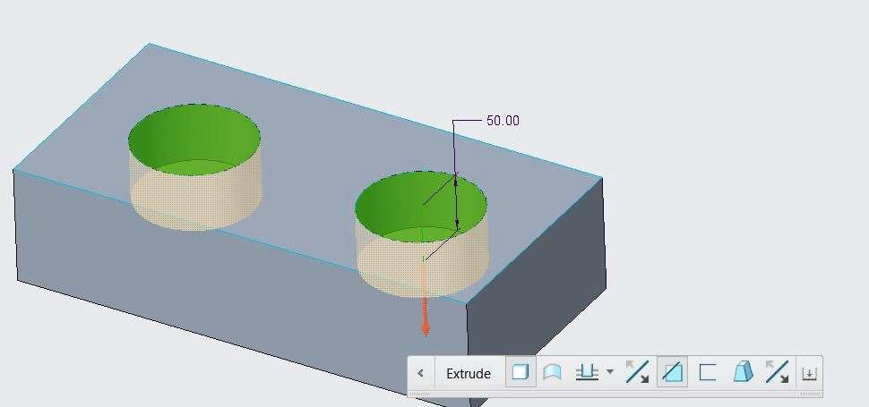

1. Click middle mouse button to complete the operation.
2. Observe the geometry.

## *PROJECTING 3-D GEOMETRY INTO A SKETCH*

You can project any entity to any plane to position into a new place.

1. Open Creo_Direct_Project.prt

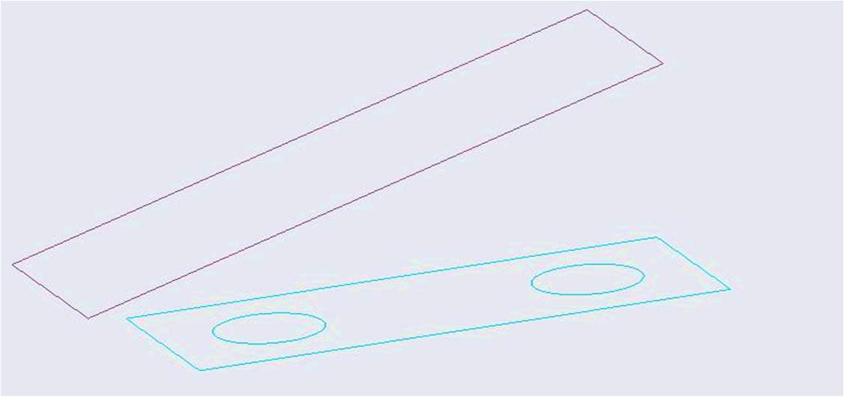

1. 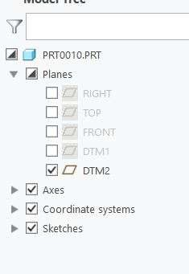Hide all the planes except DTM2
2. Activate the 2-D mode from the status bar.
3. Select the DTM2 displayed on the screen.
4. Select Project command from the sketch group.
5. 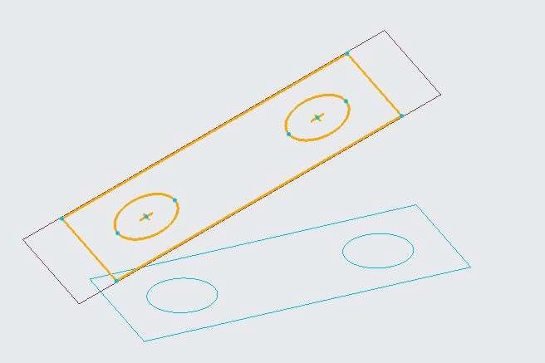Select all the entities displayed on the screen. The entities are projected to the sketch plane.
6. Select complete sketch from the Sketch group.
7. Now you can use your 3-D operations on the projected sketch.

## *CREATING SWEEP GEOMETRY*

You project any sketch along a trajectory to create 3-D shape.

1. Open Sweep_Closed.prt. Hide all the datum planes.

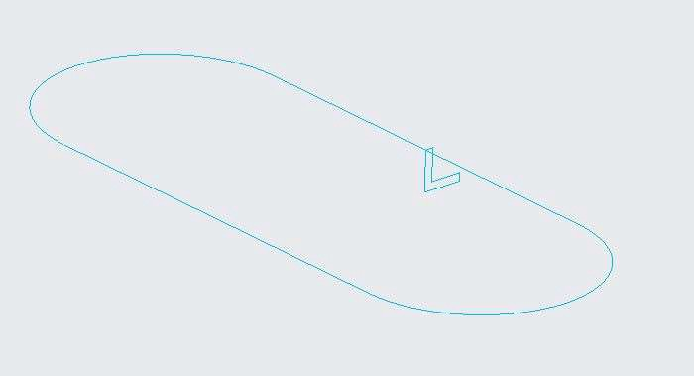

1. Select the sweep command from the shape group.



1. 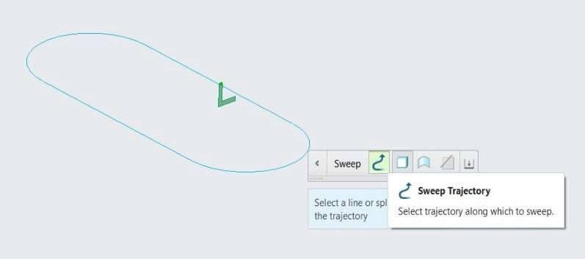Select the small cross-section the as sweep section.
2. 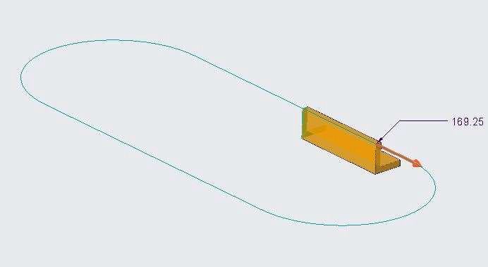Select the entity of the oval shape section.
3. 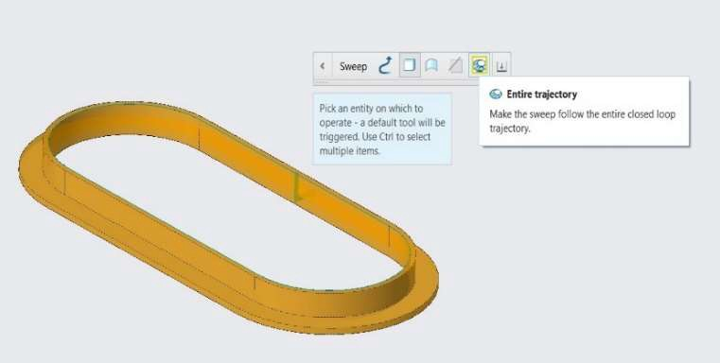Select the Entire Geometry option from the toolbar option.
4. Click middle mouse button to complete the operations. Sweep geometry is created.

# *MODULE 16 - EDITING 3-D GEOMETRY*

*For the activity files browse to folder Editing 3-D Geometry.*

## *USING SHAPE SELECTION*

To use the edit operations, Shape selection helps you to select surface geometry in more specific way.

It gives you options to select all the faces of a specific features like boss or cuts.

1. 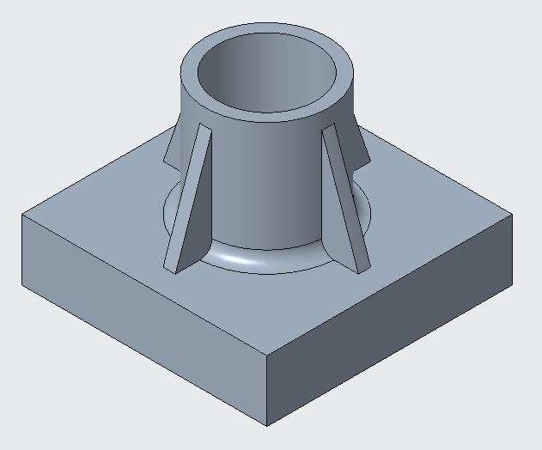Open Shape_Selection.prt. Hide all the datum features.
2. Move the cursor over the top surface. Do not select it.
3. Use Tab button from the keyboard to toggle between the shapes.
4. 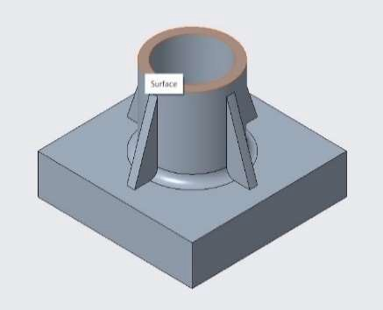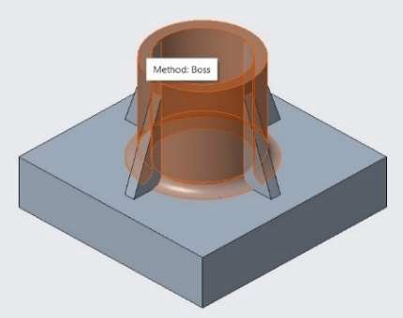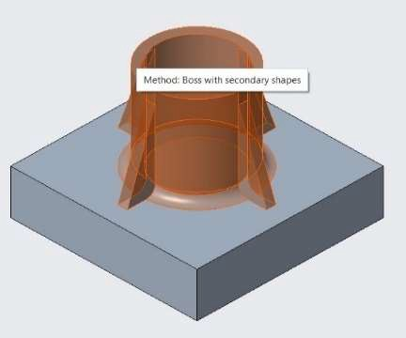Observe how the selection works.

Toggling through the Shape Selection Types

## *UNDERSTANDING SHAPE SELECTION TYPES*

Examples to use shape selection on various types of shapes.

1. Open Shape_Selection.prt. Hide all the datum features.
2. Move the cursor over the face as shown in figure 1. Do not select it.
3. Use Tab button from the keyboard to toggle between the shapes.
4. Observe how the selection works.

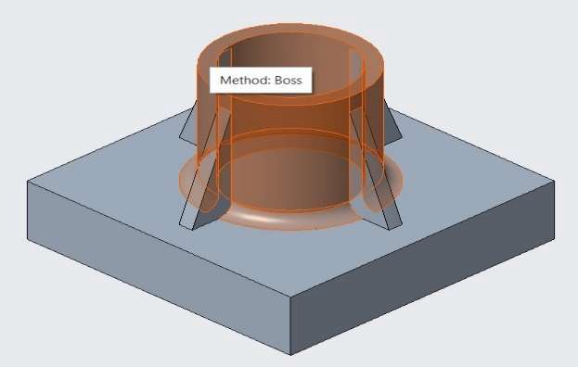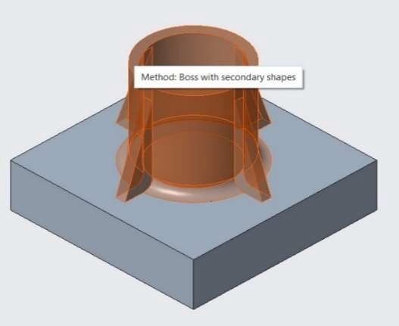

Figure 1 Boss Shape Selection Figure 2 Boss with Secondary Selection

1. Open Shape_Selection_types.prt. Hide all the datum features.
2. Move the cursor over the vertical face as shown in figure 1. Do not select it.
3. Use Tab button from the keyboard to toggle between the shapes.
4. Observe how the selection works.

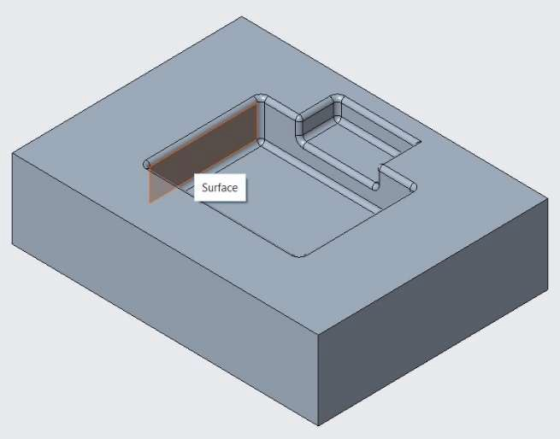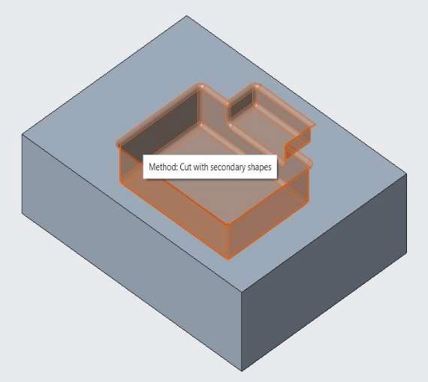

Figure 1 Cut Shape Selection Figure 2 Cut with Secondary

Selection

1. Open Shape_Selection_types.prt. Hide all the datum features.
2. Move the cursor over the round surface as shown in figure 1. Do not select it.
3. Use Tab button from the keyboard to toggle between the shapes.
4. Observe how the selection works

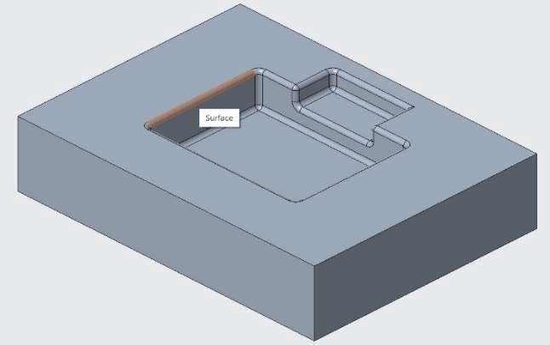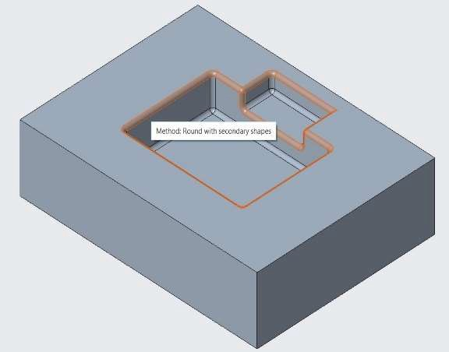

Figure 1 Round Shape Selection Figure 2 Round with Secondary Selection

## *LEVERAGING GEOMETRY SELECTION RULES*

To select all the surfaces with same criteria as the seed surface is selected, Geometry selection can be leveraged. This selection is useful when you have to perform operation in many surfaces.

1. Open Leverage_Selection.prt. Hide all the datum features.
2. Select the internal face of cylinder as shown in figure below.

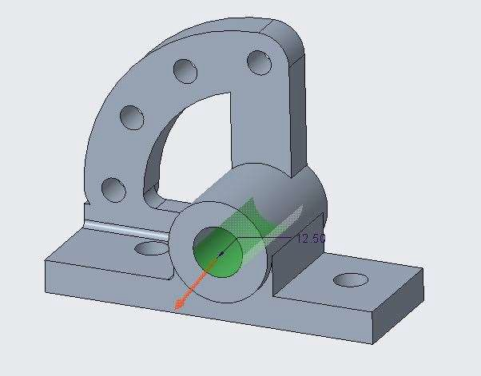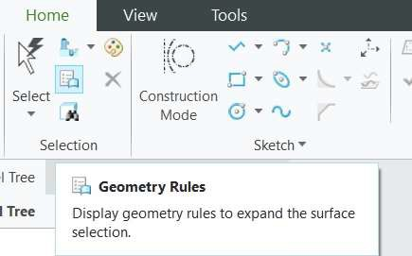

1. Select Geometry Rules option from the selection group.
2. 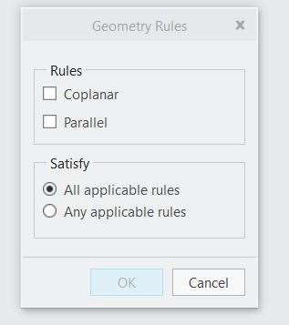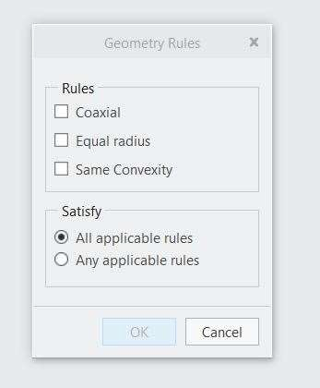Following dashboard will open as shown below per the selection parameters.
3. From the geometry rules dashboard, select coaxial/Equal Radius/same convexity and observe the result.

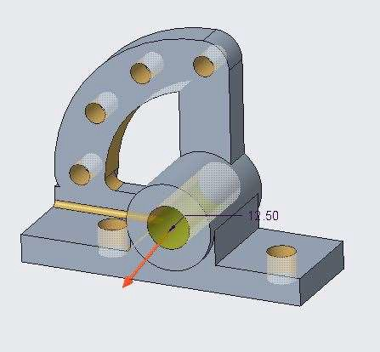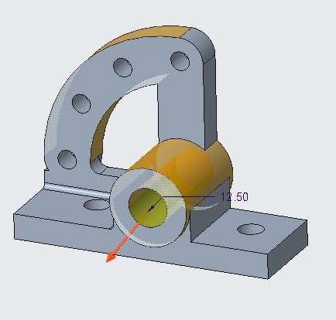

Figure 1 Same Convexity Figure 1 Same Convexity

## *UNDERSTANDING THE DRAGGER*

The Dragger is a tool you can use to move and rotate geometry in a specific direction as per available degrees of freedom. For using the Dragger tool, you have to just select the drag handles drag it to the requires position.

1. Open Dragger.prt
2. Select the top face as shown and work with dragger tool and observe the result.

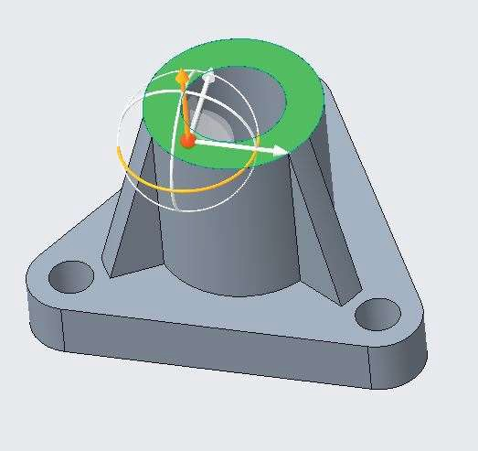

## *MOVING AND ROTATING GEOMETRY*

The Move and Rotate tool are used to move and rotate the selected geometry to a new specified position. You can either extend or trim the surface as per requirement.

1. Open Move_rotate.prt. Select the Boss Face as shown in figure.

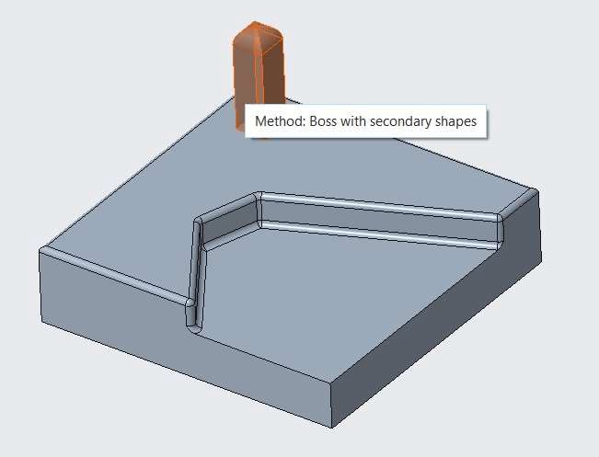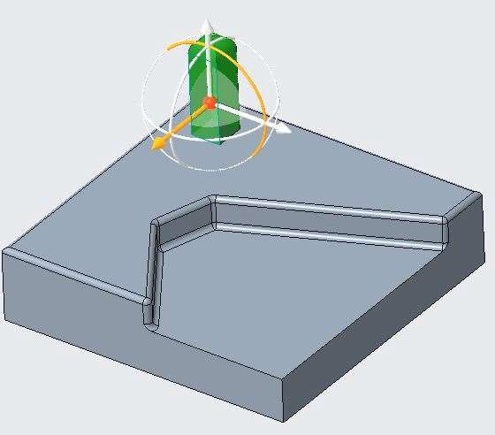

1. Drag the translation handle as shown and ENTER value 100.

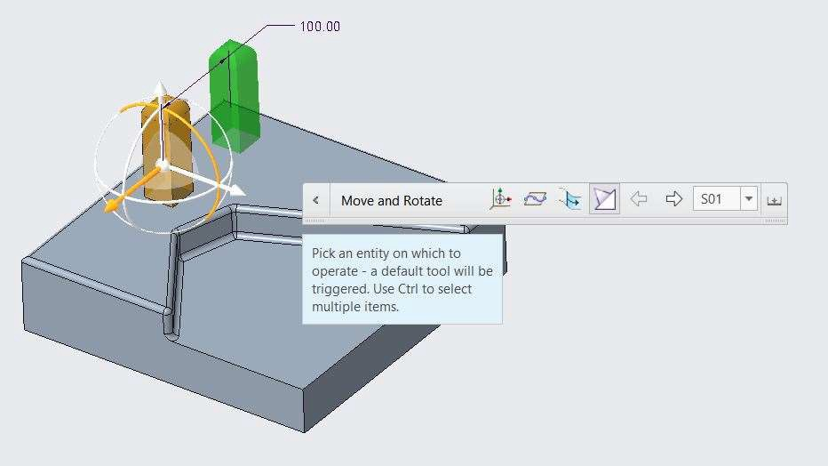

1. Middle click mouse button to complete the operation. Observe the result.
2. Undo the operation till you reach to the original position.
3. 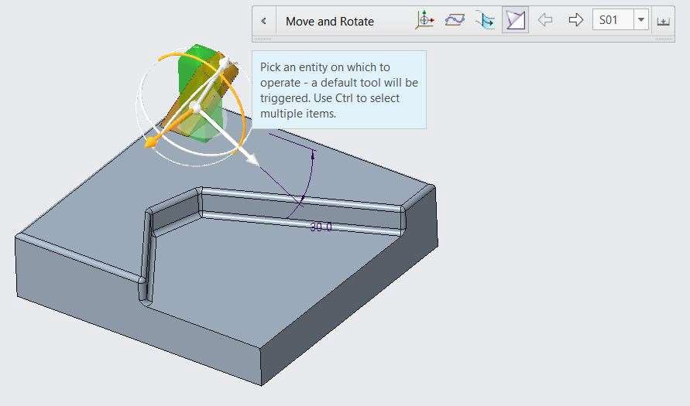Again, select the Boss as shown in above figure.
4. Drag the rotation handle and ENTER the value 60 degress.
5. Middle click mouse button to complete the operation. Observe the result.

## *MOVING GEOMETRY BY DIMENSION*

Dimension references can be used to move the selected geometry.

1. Open Dimension.prt. Select the Boss Face as shown in figure.
2. 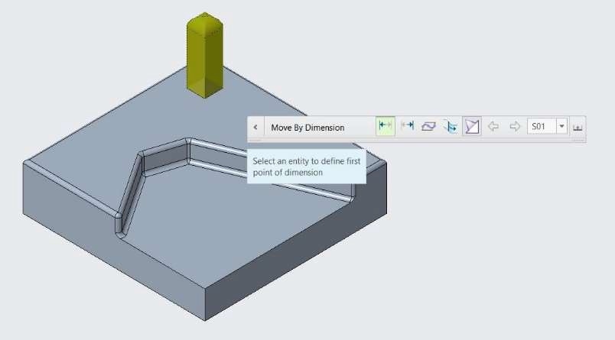Select Move by Dimension option from the edit group.
3. Select the side face of the rectangular face as shown for From option in option toolbar, and boss face as shown for To option in live tool bar.

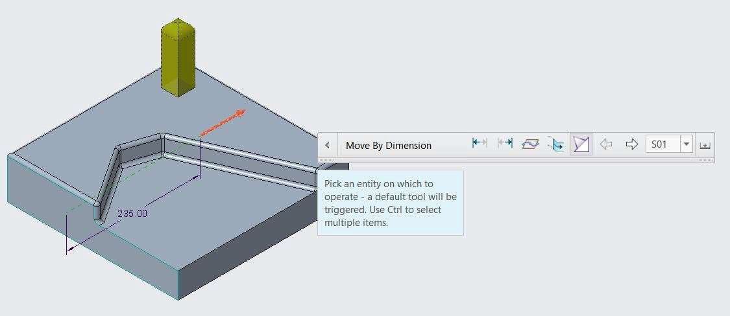

1. ENTER the distance value as 150 and observe the result.

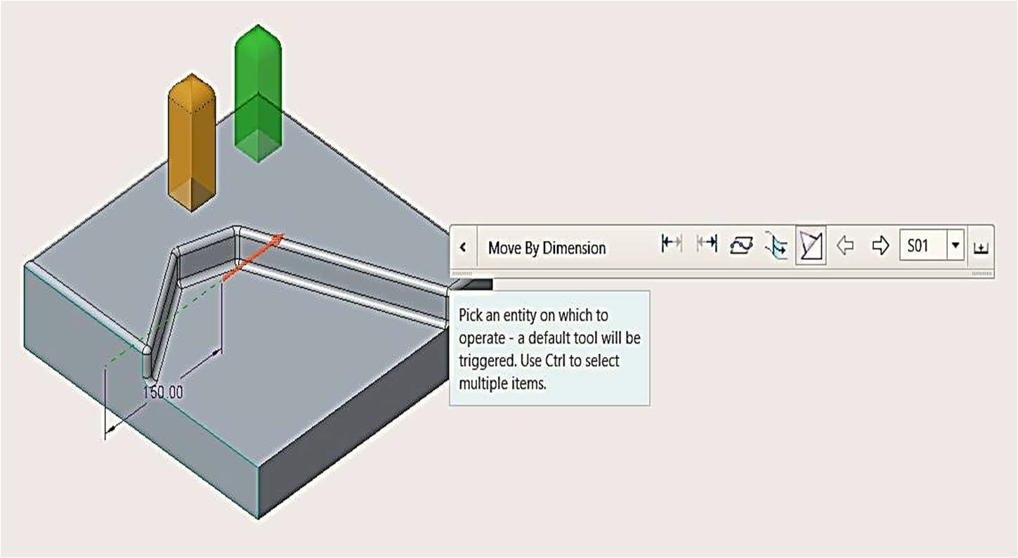

1. Click middle mouse button to observe the result.
2. 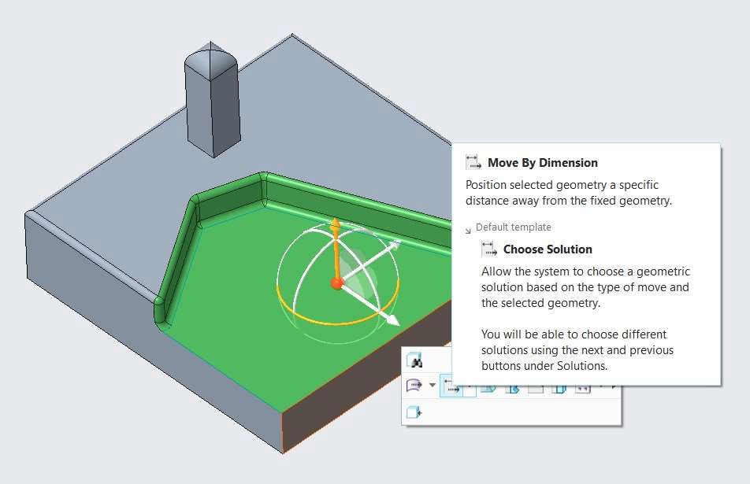Select the Cut Shape as shown in figure.
3. Select the two non-parallel sides.
4. Specify the rotation angle to 75 degrees.

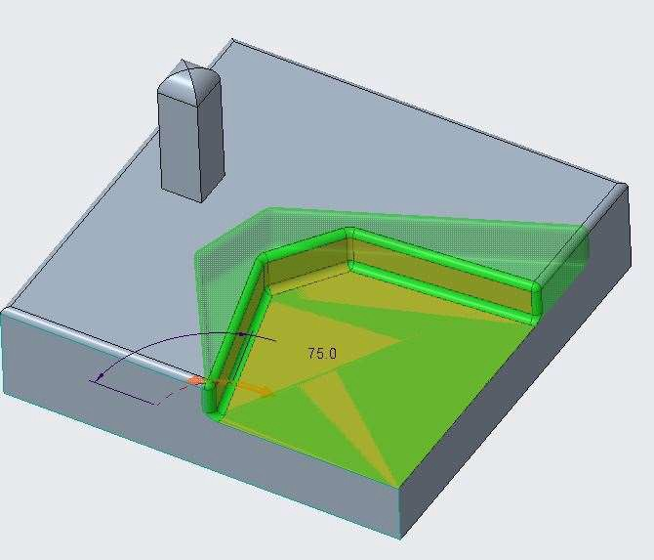

1. Click middle mouse button to complete the operation and observe the result.

## *ANALYZING SIDE SURFACE OPTIONS*

Behaviour of neighbouring surfaces of geometry can be seen while using side surface options. When you use move option, neighbouring surfaces also gets affected.

1. 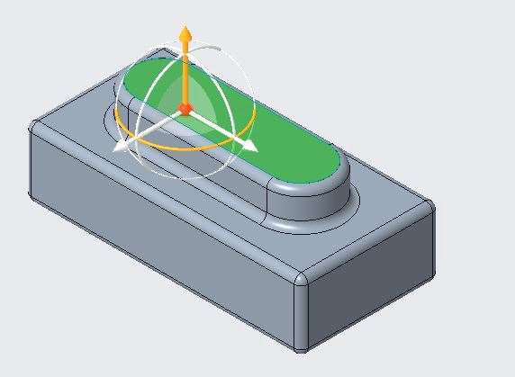Open Side_Surface.prt. Select the top face as shown in figure below.
2. 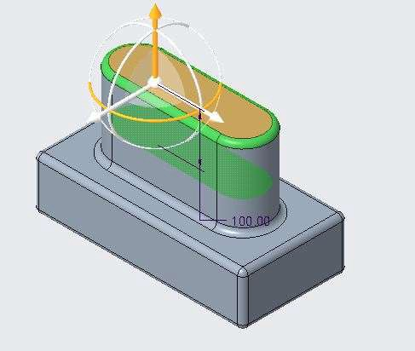Drag the drag handle upside to move the selected face. ENTER the vale as 100.
3. Click the middle mouse button to complete the operation and observe the result.
4. Undo the result to the original geometry.
5. Again, select the top face as shown in figure above.
6. Drag the drag handle upside to move the selected face. ENTER the vale as 100.
7. 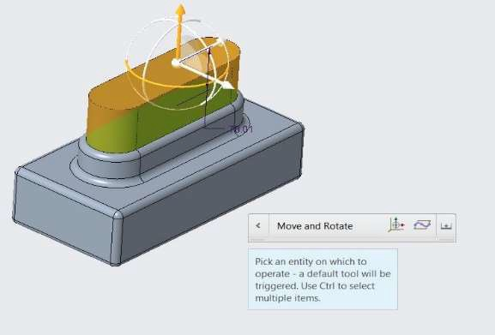From the live option tool bar, select Create Side Surfaces Options.
8. Click the middle mouse button to complete the operation and observe the result.

## *OFFSETTING GEOMETRY*

With the offset tool you can offset any geometry to attach them to another geometry or to a specified distance.

1. Open Offsetting.prt. Select the Offset command from the Edit Group.

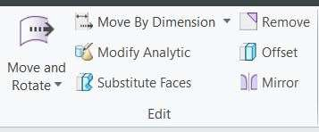

1. 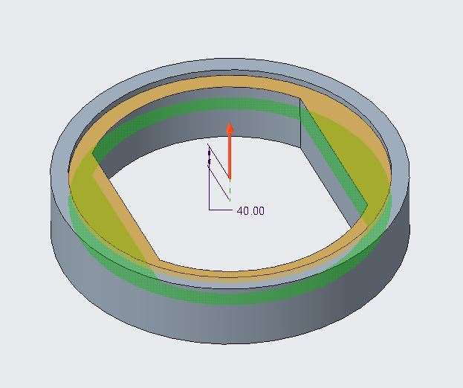Select the face as shown in below figure and ENTER the offset value 40.
2. Click the middle mouse button to complete the operation and observe the result.
3. 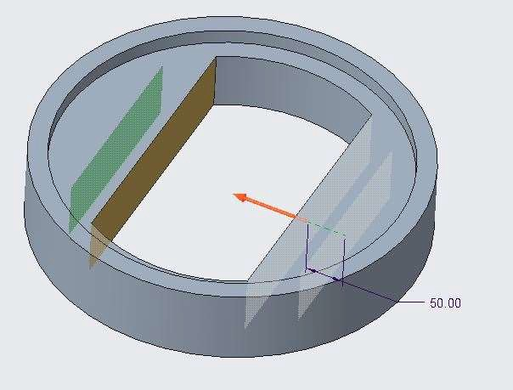Select the curve faces as shown in figure below. ENTER the offset value as 50.
4. Click the middle mouse button to complete the operation and observe the result.

## *MANAGING TANGENCY*

When you make any changes to the geometry, you can manage the tangent connections of the adjacent geometry by controlling the generation of the geometric edits to tangentially attached surfaces.

1. Open Managing_Tangency.prt. Select the Offset command from the Edit Group.
2. Select the face as shown in below figure and ENTER the offset value 50.

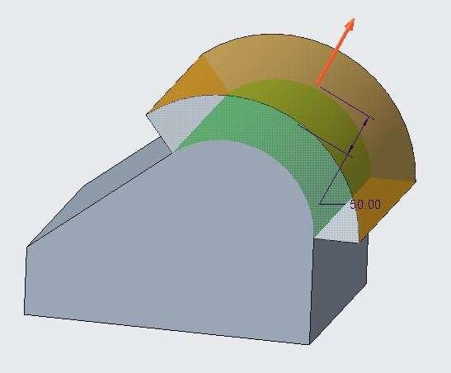

1. 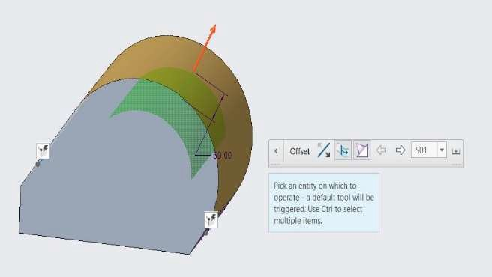Select Maintain Tangency option from the live option toolbar.
2. Observe the result. The adjacent faces become tangent to curve face.
3. From the Live tool bar option select Uncheck Use Default Conditions.
4. The adjacent faces maintains the shape of the geometry.
5. 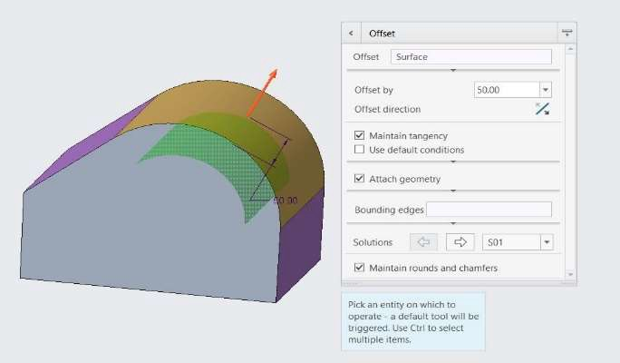Click the middle mouse button to complete the operation and observe the result.

## *MODIFYING ANALYTIC SURFACES*

The dimension of the analytic shapes can be changed with help of analytic tool.

1. Open Modify_Analytics.prt. Select the Modify Analytic command from the Edit Group.
2. Select the Cylindrical hole and change the displayed diameter to 15.
3. Click the middle mouse button to complete the operation and observe the result.

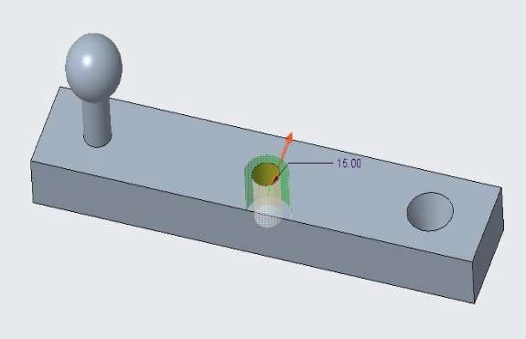

1. Again, Select the Modify Analytic command from the Edit Group.
2. 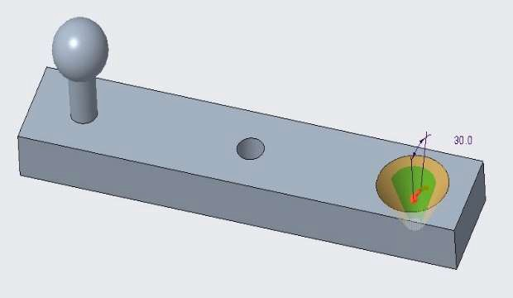Select the Conical hole and change the displayed angle to 30.
3. Click the middle mouse button to complete the operation and observe the result.
4. Again, Select the Modify Analytic command from the Edit Group.
5. 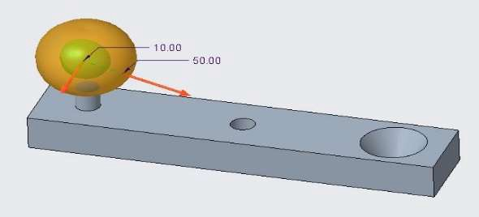Select the Spherical shape and change the displayed diameter fron 0 to 10 and to 30 to 50.
6. Click the middle mouse button to complete the operation and observe the result.

## *REMOVING GEOMETRY*

A surface or set of surfaces can be removed from a solid and void is filled to maintain the closed volume requirement for the solid.

1. Open Remove_Geometry.prt. Select the Remove command from the Edit Group.
2. Select the cut section faces as shown in figure.

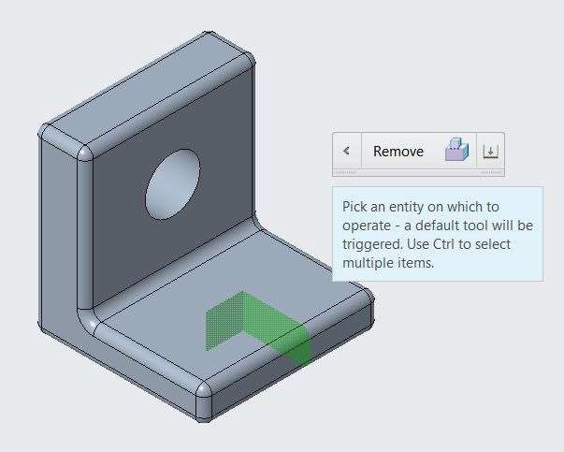

1. Click the middle mouse button to complete the operation and observe the result.
2. Again, Select the Remove command from the Edit Group.
3. 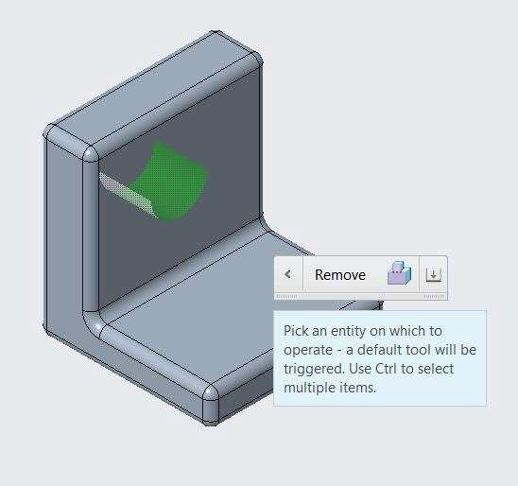Select hole section as shown in figure.
4. Click the middle mouse button to complete the operation and observe the result.
5. Again, Select the Remove command from the Edit Group.
6. 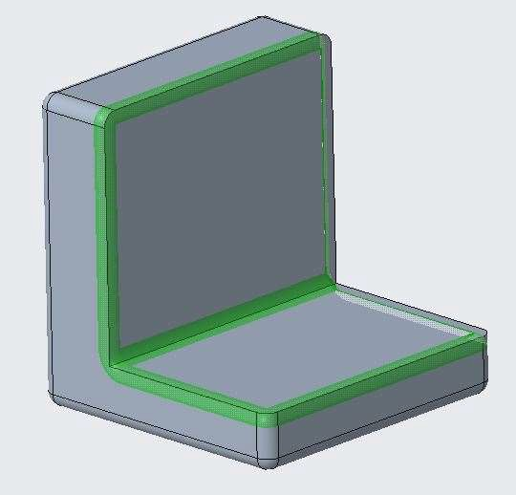Select Round faces as shown in figure.
7. Click the middle mouse button to complete the operation and observe the result.

# *MODULE 17 - WORKING WITH ASSEMBLIES*

*For the activity files browse to folder Working With Assemblies.*

## *ANALYZING COMPONENT DISPLAY*

In an assembly, there are different types of display options for the components that comprise the assembly. The following are the different component display types available.

* Modifying Component Color
* Hiding and Unhiding Components
* Activating and Deactivating Components

To Modify the color of assembly components.

1. Open Creo Direct. In the ribbon click Open from the data group. Browse to Press Tool Assembly folder.
2. Open Press_Tool_Assembly. Disable all Datum Display types.

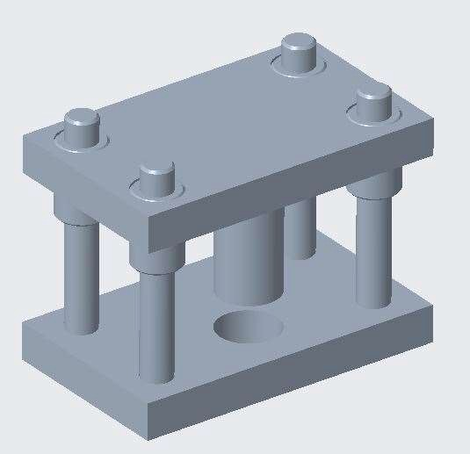

1. Notice that all components are gray.
2. In the model tree, press CTRL and select all four Guide_Pillar component.
3. Click Color from the Live toolbar.
4. In the Options toolbar, click Color and select the 6th color from the the 2nd row.
5. Middle-click to accept the color change.

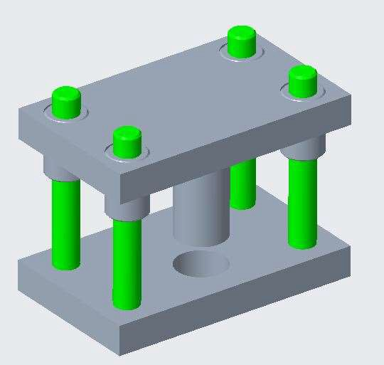

1. In the model tree, press CTRL and select all four Guide_Bush component.
2. Click Color from the Live toolbar.
3. In the Options toolbar, click Color and select the 1st color from the the 2nd row.
4. Middle-click to accept the color change.

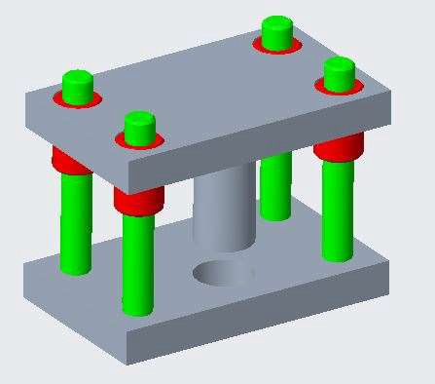

To Hide and unhide assembly Components.

1. Select all the Guide Pillar from the model tree, and select hide

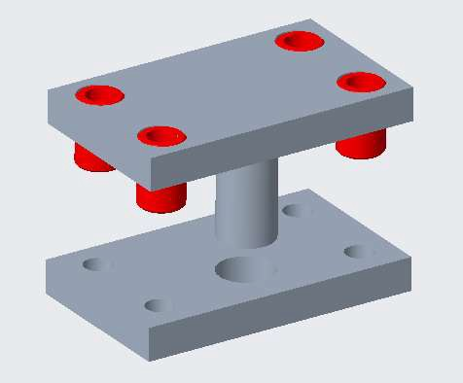

1. Select all the Guide Pillar from the model tree, and select unhide. The components visibility resumes.
2. Select all the Guide Bush from the model tree, and hide all except Selected 

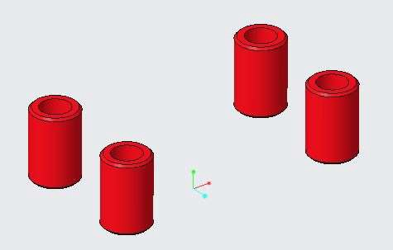

1. Press Undo from the Quick Access tool bar to resume the visibility.

To Activate a component and perform an operation on it.

1. Select Top_Plate from the model tree, and click Activate .
2. Notice that the other components become transparent gray.
3. Notice that the part operations become available in the ribbon.
4. Click Rounds from the Engineering group and select Round.
5. Press CTRL and select the two edges.
6. Edit the round radius to 5.

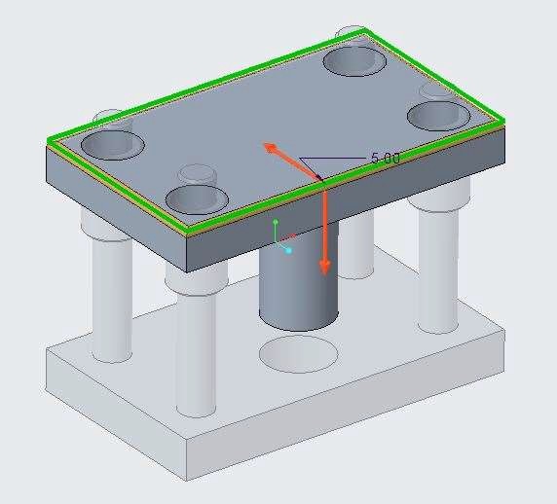

1. Middle Click mouse button to complete.
2. In the model tree, right-click Press_Tool_Assembly.ASM and select Activate .

## *EDITING COMPONENT POSITION*

You can edit the position of components in an assembly. Select the component or components and click Position from either the Live toolbar or from the Components group in the ribbon. You can select multiple components using Marquee selection or by pressing CTRL, and you can click Position either before or after selecting the components.

To Reposition components in an assembly.

1. Open Creo Direct. In the ribbon click Open from the data group. Browse to Editing Position Folder.
2. Open Nut_Bolt.asm. Disable all Datum Display types.

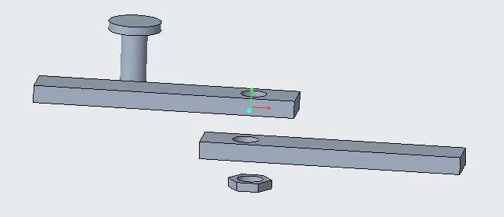

1. In the graphics window, cursor over component Plate_2.prt until it highlights, and then select it.

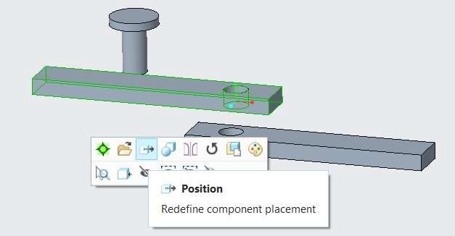

*Note: Typically, placing the cursor near the edge of the model pre-selects the entire model.*

1. Set Constraint type as Coincident from the Option toolbar.
2. In the Options toolbar, click Component reference collector and select Top face of Plate_1 and Bottom face of Plate_2.

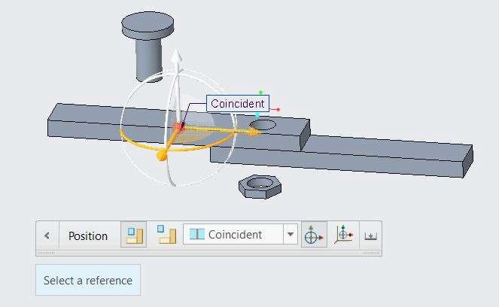

1. Enable Axis display types from the datum display group.
2. Select Axis of hole in Plate_1 and Axis of hole in Plate_2.
3. Click middle mouse button to complete the component placement.

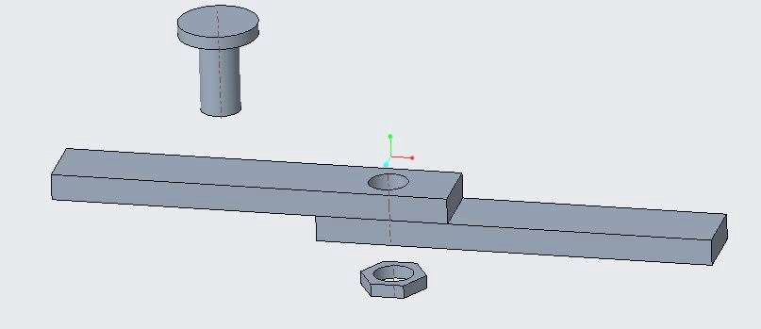

1. Select Position from the components group.
2. Select Bolt.prt from the model tree.
3. Set Constraint type as Coincident from the Option toolbar.
4. In the Options toolbar, click Component reference collector and select Top face of Plate_2 and Bottom face of Bolt Head.

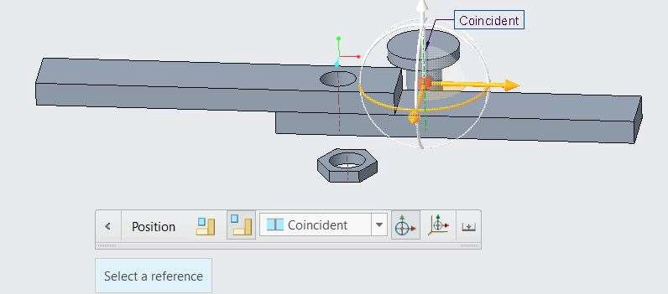

1. Select Axis of Bolt and Axis of hole in Plate_2.

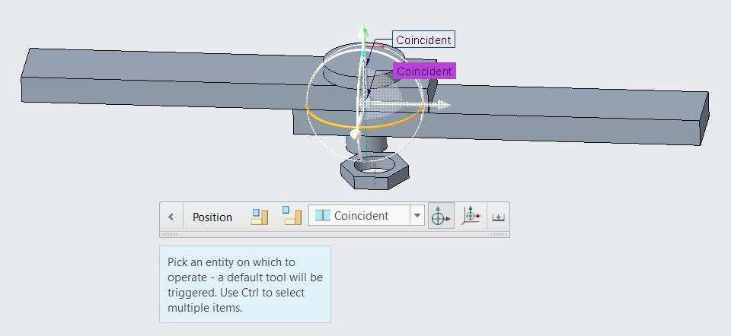

1. Click middle mouse button to complete the component placement.
2. Select Position from the components group.
3. Select Nut.prt from the model tree.
4. Set Constraint type as Coincident from the Option toolbar.
5. In the Options toolbar, click Component reference collector and select Bottom face of Plate_1 and Top face of Nut.

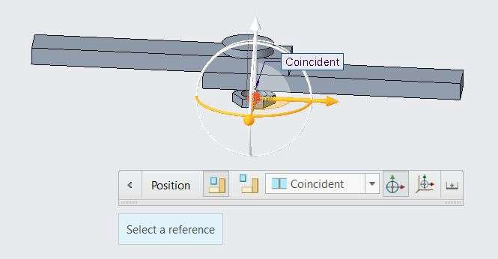

1. Select Axis of Nut and Axis of hole in Plate_1.

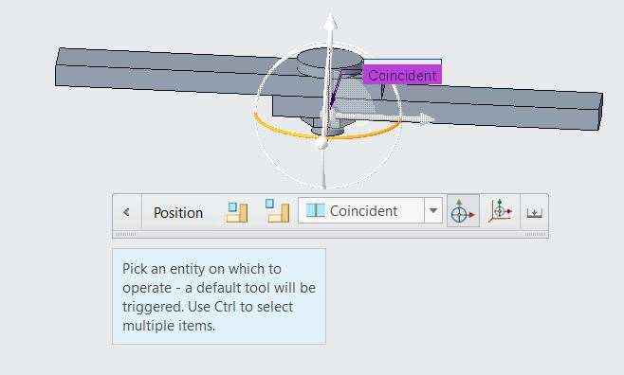

1. Click middle mouse button to complete the component placement.

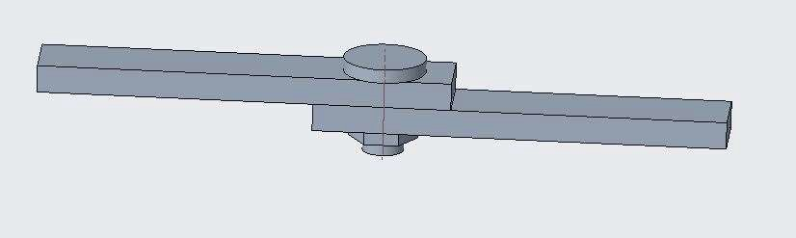

## *CREATING ASSEMBLIES AND INSERTING COMPONENTS*

An assembly is a collection of inserted parts and other sub-assemblies. An assembly has an *.asm file extension. You can create a new assembly by Inserting components, repositioning the component to the desired orientation and placement. You can also delete component.

To Create a new assembly and insert components.

1. In the ribbon, click New from the Data group.
2. In the New dialog box, select Assembly as the Type.
3. Type Block_Piston_Assembly as the Name.
4. Clear the Use default template check box and click OK.

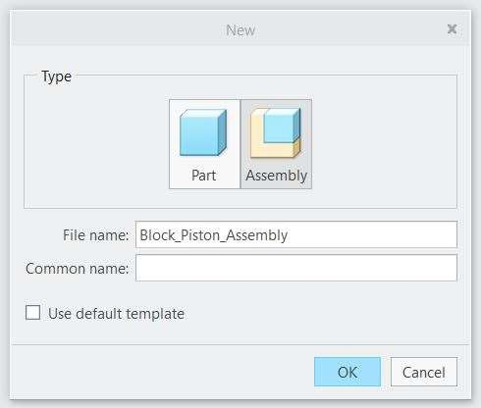

1. In the New File Options dialog box, select template mmns_asm_design and click OK.

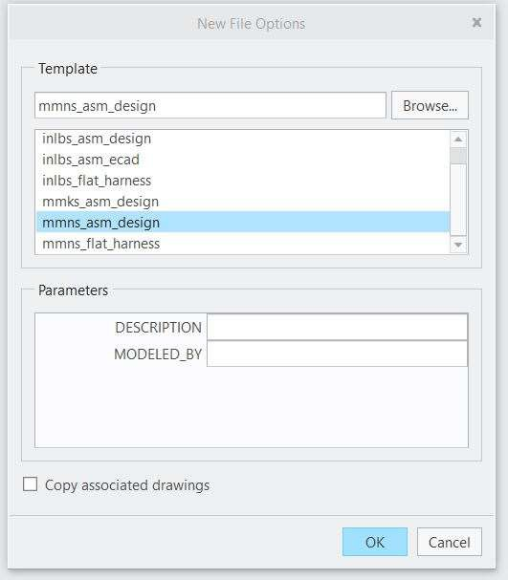

1. Disable all Datum Display types.
2. Click Insert from the Component group.
3. Browse to Block Piston Assembly folder in Working with Assemblies folder.
4. Select Block and click open

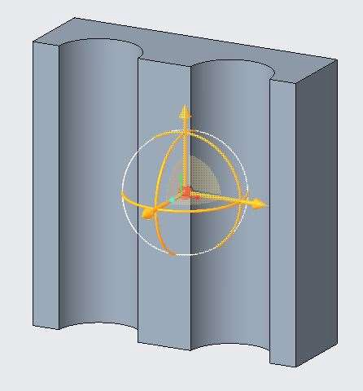

1. Double middle-click to place the component at the assembly origin and complete the placement.
2. Click Insert from the Component group and select Piston and click open.
3. Left Click to place the component.
4. Set Constraint type as Coincident from the live toolbar.
5. Select cylindrical face of Piston and right slot cylindrical face of Block.
6. Set Constraint type as Coincident from the live toolbar.
7. Select bottom face of Block and bottom face of Piston.
8. Click middle mouse button to complete the component placement.

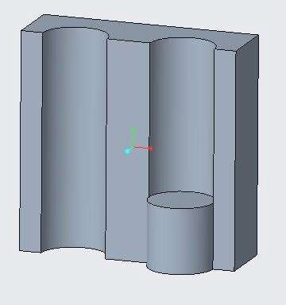

1. Click Insert from the Component group and select Piston and click open.
2. Left Click to place the component.
3. Set Constraint type as Coincident from the live toolbar.
4. Select cylindrical face of Piston and left slot cylindrical face of Block.
5. Set Constraint type as Coincident from the live toolbar.
6. Select top of Block and top face of Piston.
7. Click middle mouse button to complete the component placement.

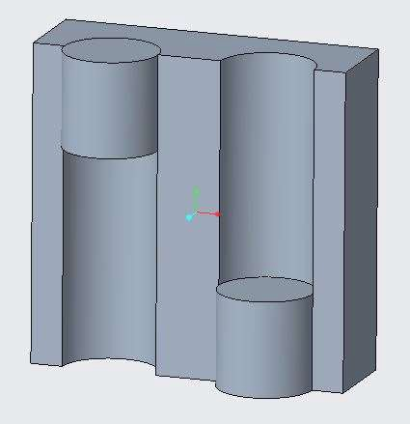

1. Click Insert from the Component group and select Piston_rod and click open.
2. Left Click to place the component.
3. Set Constraint type as Coincident from the live toolbar.
4. Select bottom face of Piston_Rod and top face of right bottom Piston.
5. Enable the Axis display from the Datum display group.
6. Select axis of Piston_Rod and axis of right bottom Piston.
7. Click middle mouse button to complete the component placement.

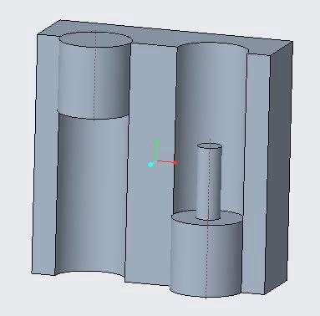

1. Click Insert from the Component group and select Piston_rod and click open.
2. Set Constraint type as Coincident from the live toolbar.
3. Select bottom face of Piston_Rod and top face of left top Piston.
4. Select axis of Piston_Rod and axis of left top Piston.
5. Click middle mouse button to complete the component placement.

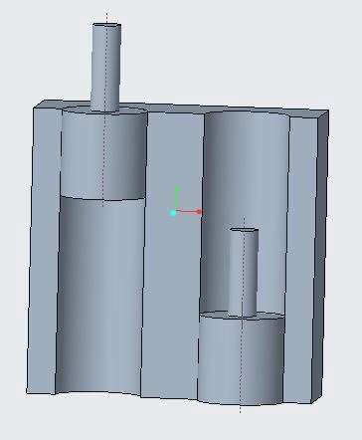

1. Block Piston Assembly is completed.

## *CREATING COMPONENTS*

You can create new components and reuse existing components in an assembly. The following are the three different methods available:

* + Shared Occurrence
  + Copy as New Occurrence
  + New Component

To Create a shared occurrence of a component.

1. Click Open from the data group. Browse to Creating Components folder.
2. 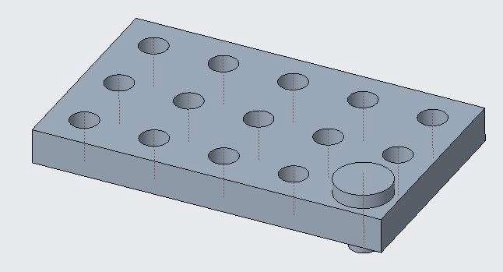Open Plate_Bolt.asm. Display only Axis Datum types.
3. Select Bolt from the model tree.
4. 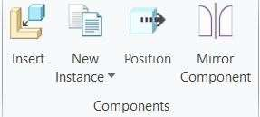In the ribbon, click New Instance from the Components group and select Shared Occurrence.
5. Left Click to place the component.
6. Set Constraint type as Coincident from the live toolbar.
7. 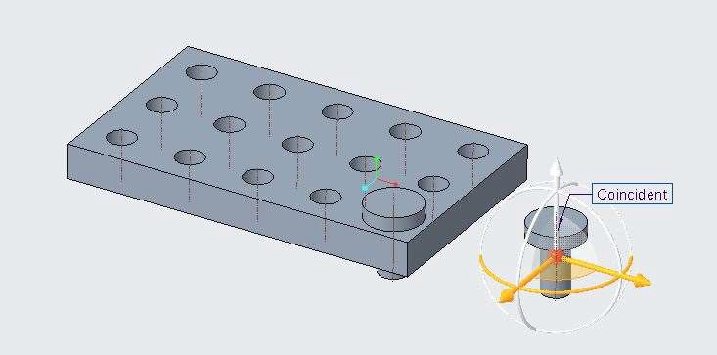Select Bottom face of the bolt head and top face of the plate.
8. Set Constraint type as Coincident from the live toolbar.
9. 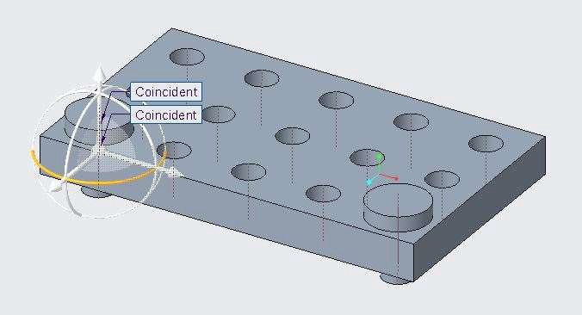Select Axis of the bolt and Axis of the left bottom hole of plate.
10. Click middle mouse button to place the component. To Create a new copied occurrence.
11. In the model tree, select the second Bolt.prt.
12. Click New Instance from the Components group and select Copy as New Occurrence.
13. In the Copy Component dialog box, edit the Name to Bolt_2 and click OK.
14. Left click to place the component.
15. Set Constraint type as Coincident from the live toolbar.
16. Select Bottom face of the bolt head and top face of the plate.
17. Set Constraint type as Coincident from the live toolbar.
18. Select Axis of the bolt and Axis of the left top hole of plate.
19. 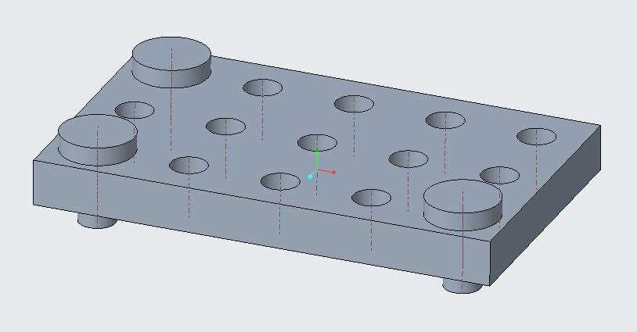Click middle mouse button to place the component.
20. Click Move and Rotate from the Edit group.
21. Select the top surface of the lower-right Bolt.prt.
22. 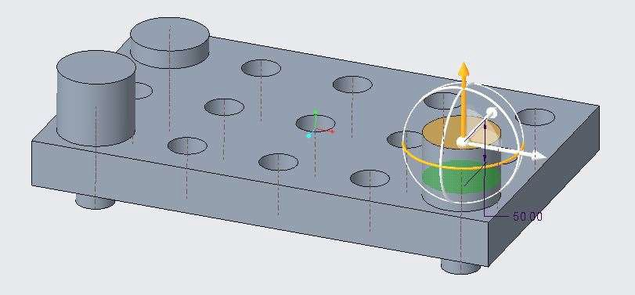Drag the height up and edit the offset to 50.
23. 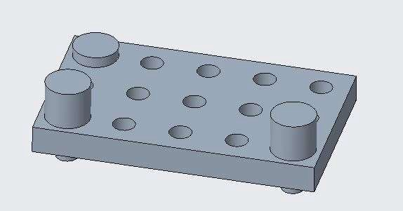Click middle mouse button to complete the move.

*Note: The shared occurrence is the same component as the original Bolt.prt and it therefore increases in Bolt Head height, also. The second component was copied as a new occurrence, and therefore is completely unrelated and does not increase in Bolt Head height.*

## *DESIGNING COMPONENTS IN ASSEMBLY*

Creo Direct enables you to design parts in an assembly. Once a model is inserted into an assembly, you can activate it to create or edit geometry in the context of the assembly, using other components as a guide.

To Insert the CAP.PRT, create a base feature, and reposition it.

1. Open Designing_Components.prt. Enable only the Datum Plane Display types.
2. Hide all the Datum Planes of Base and Pipe components from the model tree.
3. Observe the existing assembly.

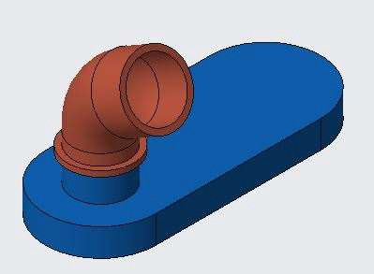

1. From the In Graphics toolbar, click Saved Orientations and select 3D1.
2. Click Insert from the Components group.
3. In the Open dialog box, select Cover.prt and click Open.
4. Click to position the Cover.prt approximately as shown.

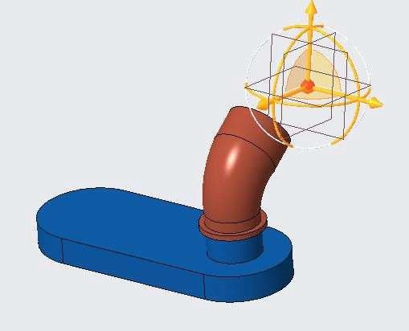

1. Use the Dragger to reorient Cover.prt so the datum plane is approximately parallel to the NECK.PRT surface.
2. Middle-click to place the Cover.prt component.

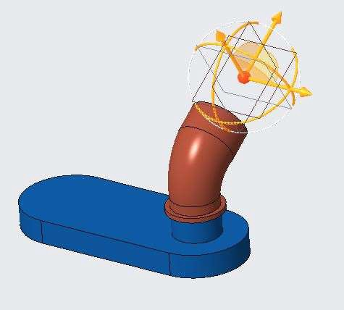

1. In the model tree, select Cover.prt and click Activate from the Live toolbar.
2. Click 2D and select the datum plane as shown below to ENTER 2-D mode.

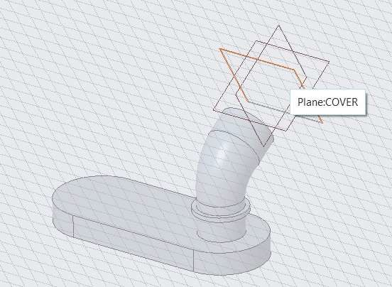

1. Select CENTER and Point from the Circle types drop-down menu in the Sketch group.
2. Type 0 for the X value in the precision panel.
3. Press TAB, type 0 for the Y value, and press ENTER. Click to Activate the Diameter panel.
4. Move the cursor slightly, and ENTER diameter as 45 in the precision panel and press ENTER.
5. Click to finish the Circle.
6. Click Complete Sketch from the Sketch group.

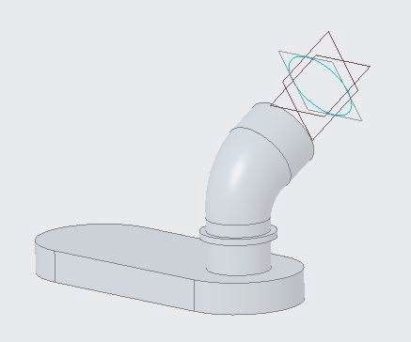

1. In the ribbon, click Extrude from the Shape group and select the circle sketch.
2. Edit the depth value to 15.
3. In the Options toolbar, click Taper and edit the angle to 7.

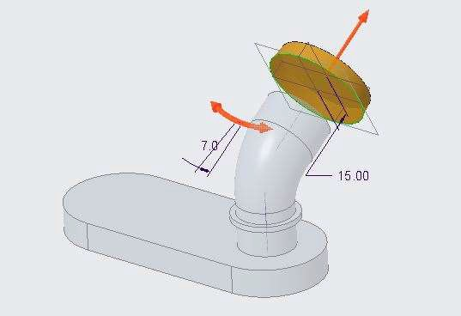

1. Middle-click to complete the extrude.
2. In the model tree, right-click Designing_Components.asm and select Activate.
3. In the ribbon, click Position from the Components group and select Cover.prt.
4. In the Options toolbar, verify the constraint type is Coincident.
5. Click Component reference collector and select the conical surface on Cover.prt.
6. Select the cylindrical surface on the assembly neck.

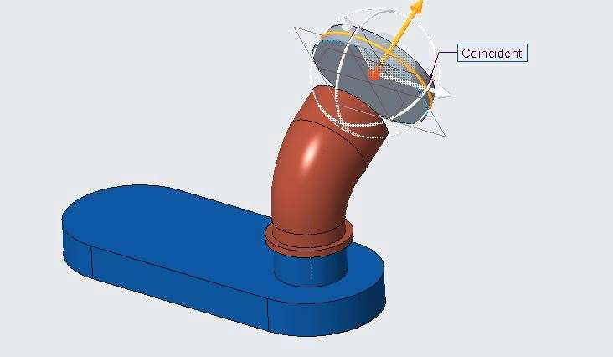

1. Drag Cover.prt towards the neck assembly or away from it as necessary.
2. Select the pair of mating surfaces.

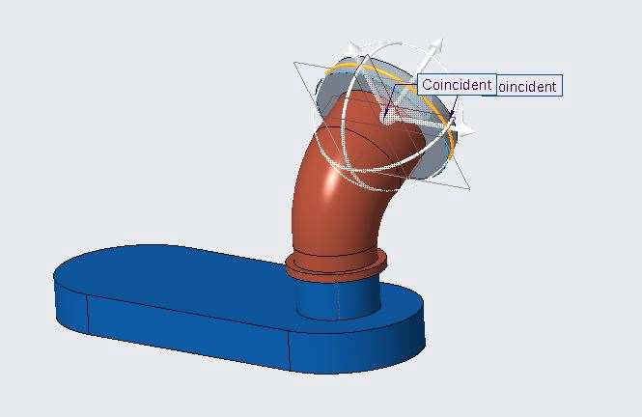

1. Middle-click to complete the component.

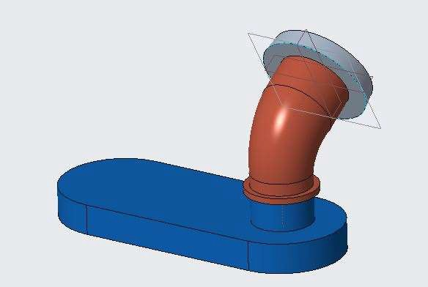

To Model the cap geometry.

1. In the model tree, right-click Cover.prt and select Open.
2. Select Select (with default) from the Select types drop-down menu in the Selection group.
3. Click 2D and select the bottom surface of Cover.
4. Click CENTER and Point Circle command, touch the existing circle, cursor to the right of the existing circle cENTER point, and snap to the Horizontal Alignment guide.
5. Type 45 for the Length value in the precision panel and press ENTER.

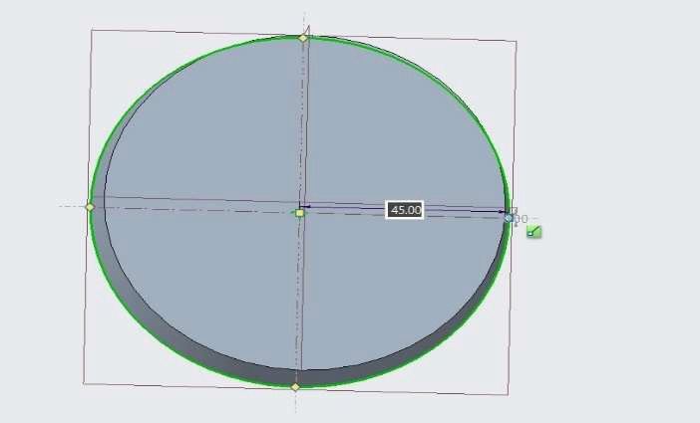

1. Move the cursor slightly, type 3 for the radius in the precision panel, and press ENTER.

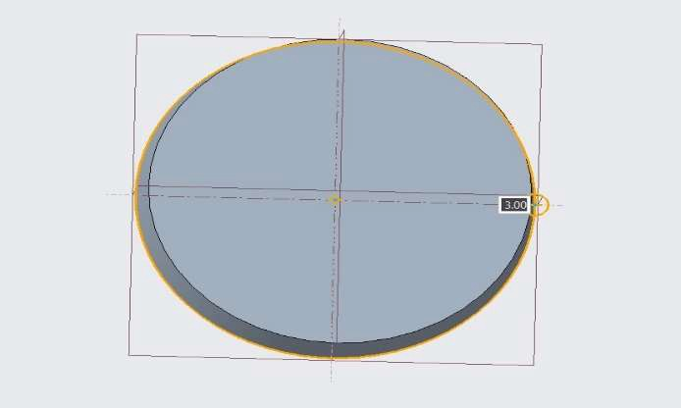

1. Click Complete Sketch.
2. Query-select the smaller sketch region in the smaller circle.
3. Drag the extrude depth upward to 15.
4. In the Options toolbar, click Remove Material.
5. Click Taper and edit the value to -3.

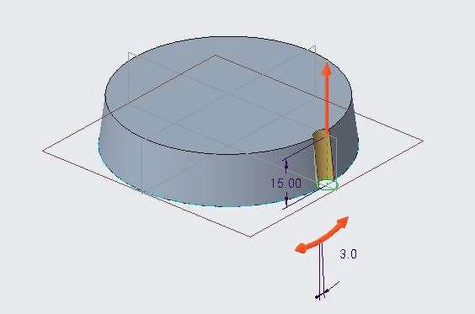

1. Middle-click to complete the extrude.
2. Enable Axis Display and click Axis from the Datum group.
3. Select the conical surface and middle-click to complete the axis.

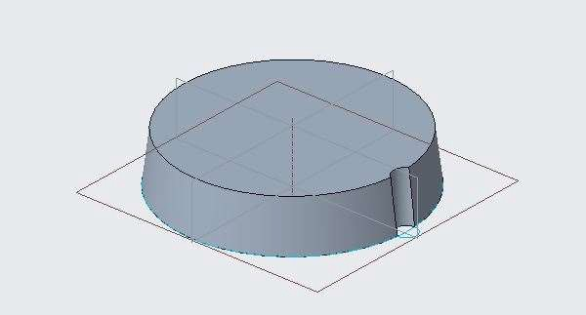

1. Click Pattern from the Engineering group and select the arc surface.
2. In the Options toolbar, click Rotational and select the datum axis.
3. Edit the angle value to 60 and edit the number of pattern members to 6.
4. Click Attach Geometry from the livetoolbar.

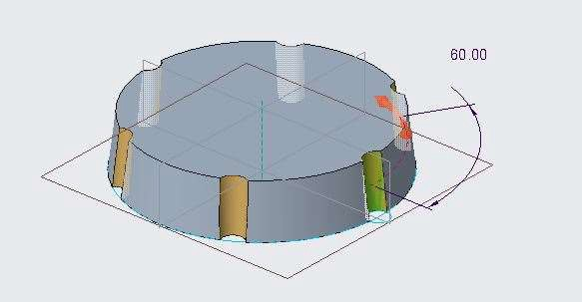

1. Middle-click to complete the pattern.
2. Disable Axis Display and Plane Display.
3. In the model tree, clear the Sketches node check box.
4. Orient the model approximately as shown.
5. Click Rounds from the Engineering group and select Round.
6. Drag a marquee around the upper surface, from upper-left to lower-right.

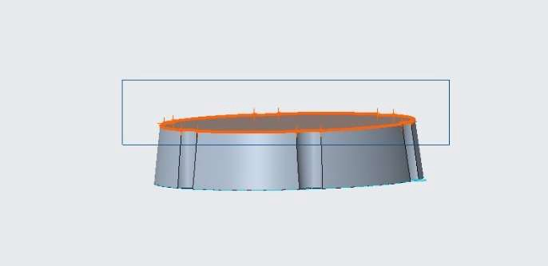

1. Edit the round radius to 5 and middle-click to complete the round.

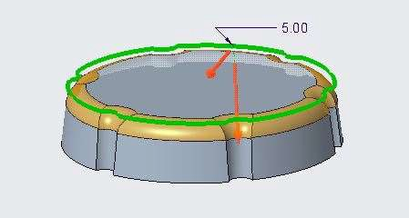

1. Reorient the model approximately as shown.
2. Select the bottom surface and click Shell from the Engineering group.
3. Edit the shell thickness to 3 and middle-click to complete the shell.

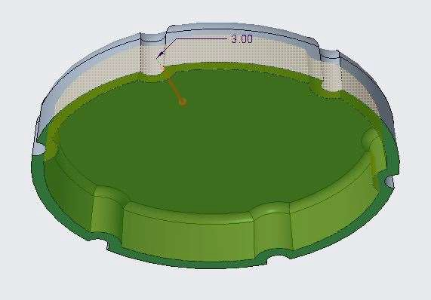

1. Click Close from the Quick Access toolbar to return to the assembly.

To Project references to complete the Cover.prt.

1. In the model tree, select Cover.prt, right-click, and select Activate.
2. Click 2D and select the bottom, thin surface of the cap.
3. Click Project from the Sketch group and select the four arcs from the inner and outer diameters on Pipe.prt.

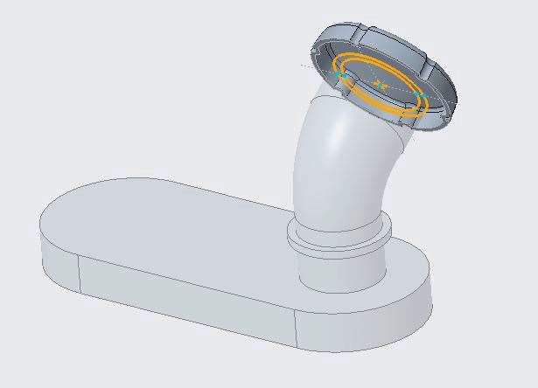

1. Click Complete Sketch.
2. Press CTRL+A to activate the top level assembly.
3. In the model tree, clear the Pipe.prt check box.

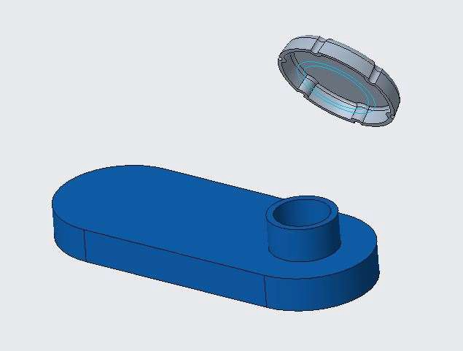

1. In the model tree, select Cover.prt and click Activate.
2. Select the larger circular sketch.
3. Drag the depth upward and edit the depth value to 12.

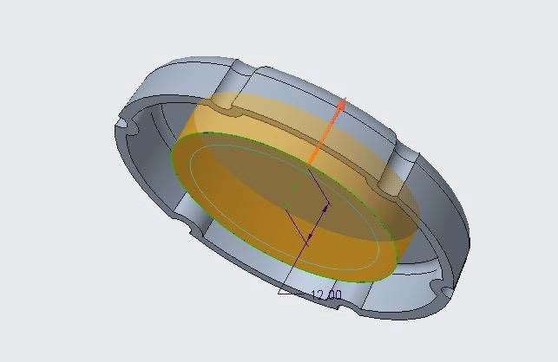

1. Middle-click to complete the extrude.
2. Select the smaller circular sketch region.
3. Drag the depth downward and edit the depth value to 10.

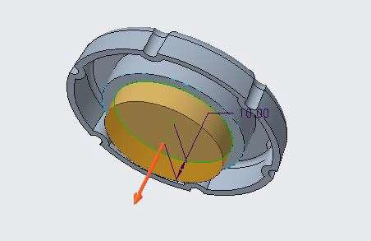

1. Middle-click to complete the extrude.
2. Press CTRL+A to activate the top level assembly.
3. In the model tree, select the Pipe.prt check box to unhide it.

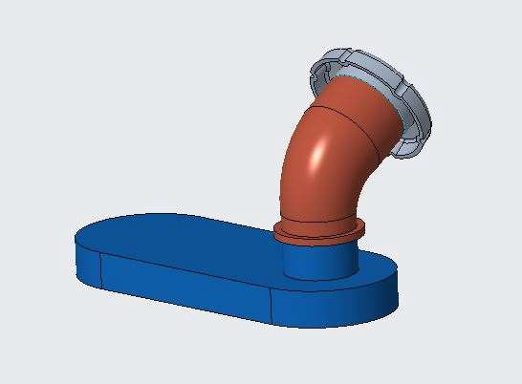

To Use the Move and Rotate tool to modify two parts at once.

1. Orient the Assembly as shown below.
2. Drag a marquee around the Cover.prt and upper surface of the Pipe.prt.

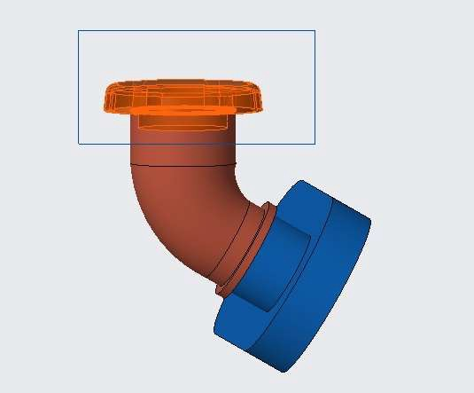

1. In the Live toolbar, click Move and Rotate.
2. In the Options toolbar, click Place dragger and select the top surface of Cover.prt.
3. Click Saved Orientations and select FRONT.

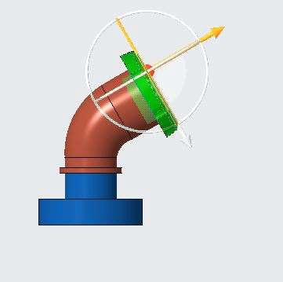

1. Drag the arrow upward to a depth of approximately 30.

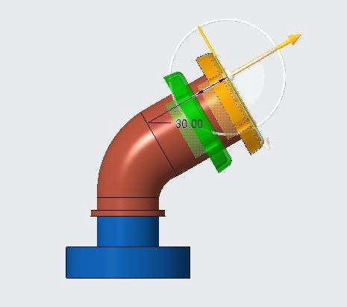

1. Middle-click to complete the move.

